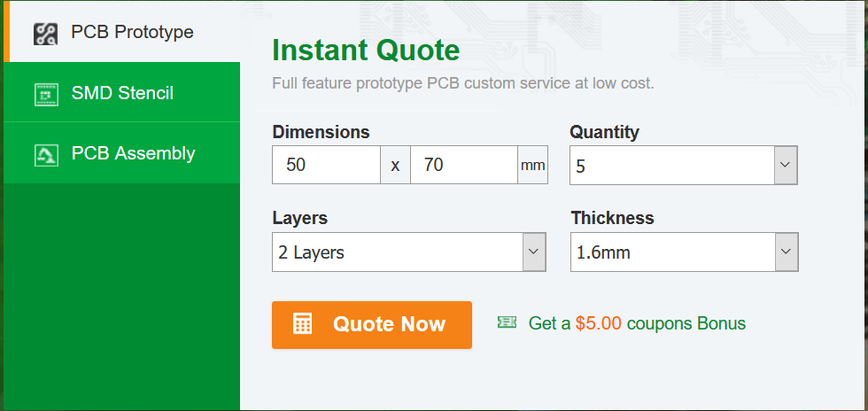

Height: 50mm

Width: 70mm

Quantity: test batch – 10 seems to have the same prices as 5

Thickness: between 1-1.6mm suggested, 1.6 seems default

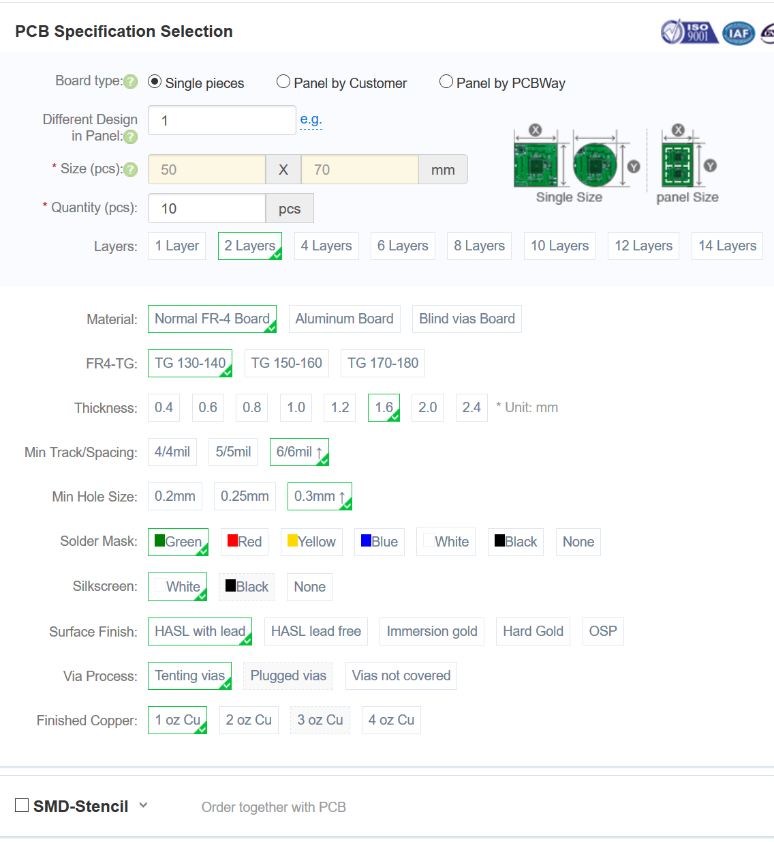

Single Pieces (no panel yet, those are for larger quantity runs)

1 design

50x70mm

10pcs seems to be same price as 5 pieces

FR-4 is the standard PCB material

TG: temperature grade, 130-140 is fine, we shouldn’t have any high temperatures to deal with

Thickness: under1mm becomes fragile, I would suggest 1.6mm – thickness/weight isn’t an issue

Min Track/Spacing: 6/6mil, smaller is more expensive

Min Hole Size: same as track spacing, we don’t need smaller holes and it increases price

Solder mask: main color, any color would be fine (but would prefer a solder mask, i.e. not None)

Silkscreen: text/accent color, any color is fine, but limited by Solder Mask color

Surface Finish: either HASL is fine, I believe for sales in the U.S. it should be lead free however (i.e. lead is restricted except for special use – it does increase the price a bit though to get lead free, and I don’t have a preference)

Via Process – Tented is probably preferred, as it looks nicer and offers more protection, but uncovered is easier to debug via multimeter probes – I would still suggest tented however

Finished copper – the standard 1oz is fine, more copper is used for higher current/power applications, which isn’t necessary for this board

SMD-Stencil: we shouldn’t need a stencil for this

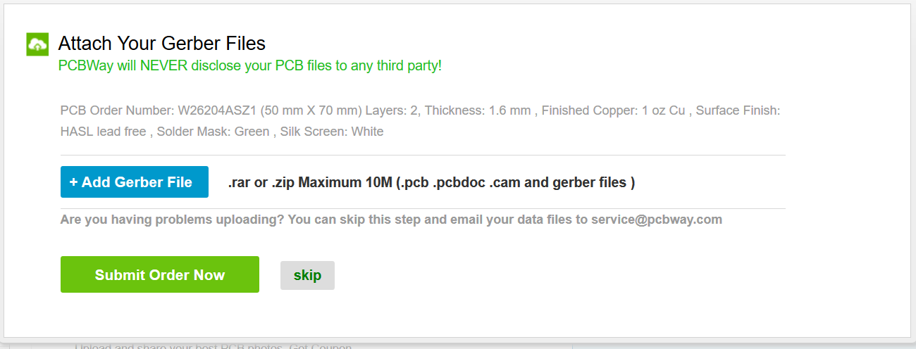



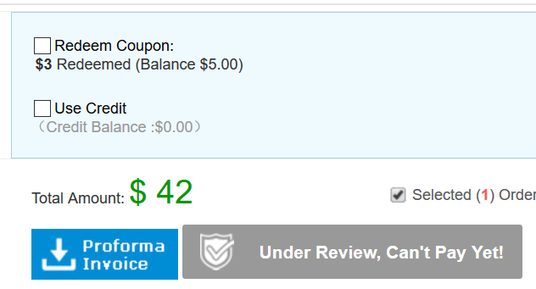

It seems it may take a while for them to review it, I haven’t used pcbway before so I am not sure how long it will take