**10 Great Natural Language Processing (NLP) Blogs To Follow**

**One important benefit resulting from the popularity of Natural Language Processing (NLP) is increased connections and collaborative discussion across different audiences—from industries such as healthcare, education, and retail or job roles like data scientist, Chief Technology Officer, or integrated marketing manager, to name a few. Whether you understand the nuances of NLP or you’re just learning about the technology, this resource list includes a bit of something for everyone. There are fewer “traditional” blogs for NLP, but what’s apparent is how many resources reflect ongoing dialogue and represent a cross-section of the technology. If you’re so inclined after taking a look at some of these, offer your own perspective on NLP and join the discussion.**

[**1. awesome-nlp**](https://github.com/keon/awesome-nlp)

**Run By: Keon Kim, Martin Seongsoon Park, Nirant Kasliwal, Dhruv Apte Website link:**[**GitHub**](https://github.com/keon/awesome-nlp)**This is an extensive, curated list of NLP resources that is useful for anyone in the analytics field. It includes up-to-date research, trends, and documented NLP breakthroughs from conferences like the annual Association for Computational Linguistics or Empirical Methods in Natural Language Processing. It also features tutorials, courses, programming libraries, techniques, services, and datasets. An added bonus is that it links to other resource lists you may find useful, now or in the future.**

[**2. Awesome Deep Learning for Natural Language Processing**](https://github.com/brianspiering/awesome-dl4nlp)

**Run By: Brian Spiering Website link:**[**GitHub**](https://github.com/brianspiering/awesome-dl4nlp)**Another informative resource repository that you’ll find on GitHub is curated by a Professor of Computer Science / Data Science at the University of San Francisco with concentration on research and university courses from Stanford, Carnegie Mellon, and Oxford. There’s a slant toward the Deep Learning aspect of NLP, which means the class of machine learning algorithms that can be used for NLP. Tutorials, lectures, research papers, an exhaustive list of Deep Learning books, frameworks and datasets, and more are included. It’s a lot of information right at your fingertips.**

[**3. Natural Language Processing Course**](https://www.youtube.com/playlist?list=PLoROMvodv4rOFZnDyrlW3-nI7tMLtmiJZ)

**Run By: Dan Jurafsky and Chris Manning Website link:**[**YouTube.com**](https://www.youtube.com/playlist?list=PLoROMvodv4rOFZnDyrlW3-nI7tMLtmiJZ)**This is a video series that captures the popular Natural Language Processing course taught by Stanford professors Dan Jurafsky and Chris Manning in 2012. The course was one of the first 20 courses offered on Coursera, but now lives on Stanford Online’s YouTube playlist and the**[**lecture slides**](https://web.stanford.edu/~jurafsky/NLPCourseraSlides.html)**are available on Dan Jurafsky’s Stanford page. Related content: Jurafsky has his**[**own YouTube channel**](https://www.youtube.com/channel/UC_48v322owNVtORXuMeRmpA/featured)**where videos from his Stanford courses can be found.**

[**4. NLPers**](https://twitter.com/jasonbaldridge/lists/nlpers)

**Run By: Jason Baldridge Website link:**[**Twitter.com/JasonBaldridge/lists/NLPers**](https://twitter.com/jasonbaldridge/lists/nlpers)**This is a representative Twitter list of some of the who’s who in NLP, curated by Jason Baldridge, a research scientist working on NLP at Google Mountain View. Subscribe to this list with your Twitter account to see new posts by scientists in the field. While following a feed of over 850 people seems overwhelming, you’ll uncover the most relevant accounts that fill in gaps of expertise, offer useful informational tidbits, and inspire continued learning.**

[**5. NLP Stories**](https://twitter.com/nlp_stories)

**Run By: Martin Seongsoon Park Website link:**[**Twitter.com/nlp_stories**](https://twitter.com/nlp_stories)**There are other Twitter resources for NLP news. NLP Stories, an account run by a contributor to the “awesome-nlp” GitHub resource, retweets related stories on Natural Language Processing, Deep Learning, and Artificial Intelligence. Or you can follow the**[**#NLProc hashtag**](https://twitter.com/hashtag/nlproc)**to see all relevant conversations.**

**Create beautiful visualizations with your data.**

[**Try Tableau for free**](https://www.tableau.com/trial)

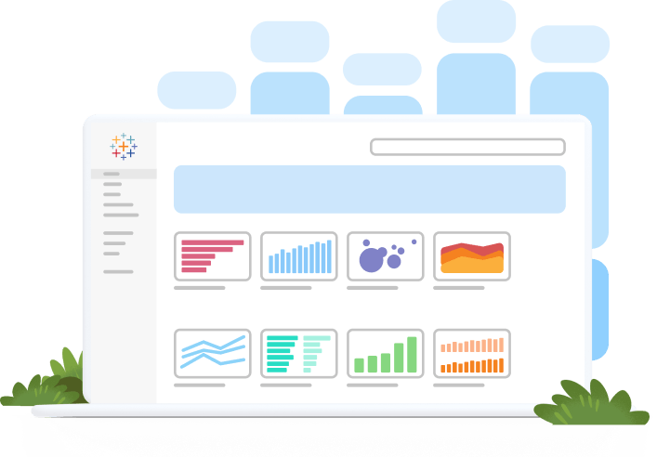

[**6. NLP Highlights**](https://soundcloud.com/nlp-highlights)

**Run By: Allen Institute for Artificial Intelligence Website link:**[**Soundcloud.com/NLP-Highlights**](https://soundcloud.com/nlp-highlights)**Run by the Allen Institute for Artificial Intelligence, this podcast discusses recent work in NLP. It features two research scientists, Matt Gardner and Waleed Ammar, who discuss interesting NLP papers and then interview the authors about their work. You’ll find it on Soundcloud so you can listen to it anywhere. With 74 episodes and counting, there is plenty to absorb and learn from.**

[**7. /r/LanguageTechnology**](https://www.reddit.com/r/LanguageTechnology)

**Run By: Reddit Website link:**[**Reddit.com/r/LanguageTechnology**](https://www.reddit.com/r/LanguageTechnology)**This is another social site that has helpful nuggets of information about NLP. Smaller, technical subreddits tend to do well when it comes to specialized interest and you can get a great dialogue going with others in the field or find new information shared in links.**

[**8. The Stanford Natural Language Processing Group**](https://nlp.stanford.edu/blog/)

**Run By: Stanford University Website link:**[**NLP.Stanford.edu**](https://nlp.stanford.edu/blog/)**The Stanford Natural Language Processing Group is run by Dan Jurafsky and Chris Manning who taught the popular NLP course at Stanford, as well as professor Percy Liang. Jurafsky and Manning were also referenced in**[**this list of top NLP books**](https://www.tableau.com/learn/articles/natural-language-processing-books)**to have on your list. The blog posts tend to be sporadic, but they are certainly worth a look. A post even offers a mailing list for relevant NLP software.**

[**9. Sebastian Ruder**](http://ruder.io/)

**Run By: Sebastian Ruder Website link:**[**Ruder.io/**](http://ruder.io/)**This is a personal blog by Sebastian Ruder, a PhD student in NLP and a research scientist at AYLIEN. He offers frequent opinions and covers a wide array of NLP-related topics, including Machine Learning and Deep Learning. It includes a repository for tracking progress in Natural Language Processing and helpful beginning resources.**

[**10. NLP News**](http://newsletter.ruder.io/)

**Run By: Sebastian Ruder Website link:**[**Newsletter.Ruder.io**](http://newsletter.ruder.io/)**For those wanting regular NLP updates, this monthly newsletter that’s also curated by Sebastian Ruder, focuses on industry and research highlights in NLP. If you don’t wish to receive updates in your inbox, previous issues are one click away. Sebastian has published 34 issues and they’re distributed every two weeks.**

**Honorable Mention: Let’s Talk about Natural Language Interfaces for Data Visualization**

**Authored By: Arjun Srinivasan Website link:**[**Medium**](https://medium.com/multiple-views-visualization-research-explained/lets-talk-about-natural-language-interfaces-for-data-visualization-b8aaad90c798)**This recent blog summarizes research on natural language interfaces for data visualization and discusses the potential role of system-generated natural language or how visual data analysis can be complemented by question answering. A more comprehensive review of some systems described in the blog post and additional research can be found in a**[**paper**](https://arjun010.github.io/static/papers/nli-vis-eurovis17.pdf)**authored by Arjun and**[**John Stasko**](https://www.cc.gatech.edu/home/stasko/)**, Director of the Information Interfaces Research Group and Regents Professor, School of Interactive Computing, Georgia Institute of Technology. *Disclaimer: Tableau does not officially endorse any products, publications, or opinions therein listed on this webpage, and as such this page does not engage with any affiliate link programs. This article is intended purely for educational purposes and the above information is made available so that readers can make informed decisions for themselves.***