CMR COLLEGE OF ENGINEERING & TECHNOLOGY
(Autonomous)
(NAAC Accredited with ‘A⁺’ Grade & NBA Accredited)
(Approved by AICTE, Permanently Affiliated to JNTU Hyderabad)
KANDLAKOYA, MEDCHAL ROAD, HYDERABAD-501401
2023-24
“CANCER CELL CLASSIFICATION USING SCIKIT-LEARN”
A report submitted in partial fulfillment of the Academic requirements for the award of the degree of
Bachelor of Technology

Y.PRASANNA- 23H51A05D0
A.KARTHIK REDDY- 23H51A05D1
A.GANESH TEJA - 23H51A05D5

UNDER THE COURSE
REAL TIME RESEARCH PROJECT


CMR COLLEGE OF ENGINEERING & TECHNOLOGY
(Autonomous)
(NAAC Accredited with ‘A⁺’ Grade & NBA Accredited)
(Approved by AICTE, Permanently Affiliated to JNTU Hyderabad)
KANDLAKOYA, MEDCHAL ROAD, HYDERABAD-501401
2024 - 2025



CERTIFICATE
This is to certify that the report entitled “REAL TIME REASEARCH PROJECT” is a bonafide work done by

Y.PRASANNA - 23H51A05D0
A.KARTHIK REDDY - 23H51A05D1
A.GANESH TEJA - 23H51A05D5

In partial fulfillment of the requirement for completion of the “REAL TIME REASEARCH PROJECT” of II-B.Tech I- Semester is a record of a bonafide work carried out under guidance and supervision.

Signature of Faculty Signature of HOD

DECLARATION

We are obliged and grateful to thank, CMRCET, for his cooperation in all respects during the course.
We would like to thank the Principal of CMRCET, Major.Dr.V.A. Narayana, for his support in the course of this project work. Finally, we thank all our faculty members and Lab Programmer for their valid support.

We own all our success to our beloved parents, whose vision, love and inspiration has made us reach out for these glories.

Y.PRASANNA- 23H51A05D0
A.KARTHIK REDDY- 23H51A05D1
A.GANESH TEJA - 23H51A05D5

TABLE OF CONTENTS

SI.No. | CONTENTS | PAGE.NO
1. | Abstract | 5
2. | Introduction | 6
3. | Proposed System | 7
4. | System Architecture | 8
5. | Source code | 9-12
6. | Results and Discussion | 13
7. | Conclusion | 14
8. | Future Enhancement | 15
9. | Reference | 16

ABSTRACT

Cancer diagnosis is a critical step in the treatment and management of the disease. Accurate and early classification of cancerous cells significantly improves patient outcomes. In this project, we utilize machine learning techniques implemented with Scikit-learn to classify breast cancer cells as benign or malignant using the Breast Cancer Wisconsin dataset. The dataset includes various features derived from digitized images of fine needle aspirates (FNAs) of breast masses. After preprocessing the data, including normalization and train-test splitting, we applied a Random Forest classifier to build a predictive model. The model achieved high accuracy and precision, demonstrating the effectiveness of machine learning in medical diagnostics. Evaluation metrics such as confusion matrix and classification report confirmed the robustness of the model. This work showcases the potential of machine learning to assist in automated, reliable, and scalable cancer diagnosis.
.

CHAPTER-1
INTRODUCTION

Cancer is one of the leading causes of death worldwide, and early diagnosis plays a crucial role in improving the chances of successful treatment. One of the most common forms of cancer among women is breast cancer, and distinguishing between benign (non-cancerous) and malignant (cancerous) tumors is a critical step in diagnosis.
With the rapid advancement in machine learning, it is now possible to automate and enhance the accuracy of cancer detection using data-driven models. In this project, we utilize Scikit-learn, a powerful Python library for machine learning, to build a classification model that can distinguish between benign and malignant cancer cells.
We use the Breast Cancer Wisconsin dataset, which includes features computed from digitized images of fine needle aspirate (FNA) of breast masses. These features describe characteristics of the cell nuclei present in the images. By training a classification model on this dataset, we aim to predict whether a tumor is malignant or benign based on these features.
This approach not only demonstrates the application of machine learning in the healthcare domain but also highlights the potential of such models in assisting medical professionals for faster and more accurate diagnosis.

CHAPTER 2
PROPOSED SYSTEM

The proposed solution focuses on building an efficient and accurate machine learning model using the Scikit-learn library to classify cancer cells as either malignant or benign. This is achieved using the Breast Cancer Wisconsin dataset, which contains 30 numerical features extracted from digitized images of fine needle aspirate (FNA) samples of breast masses. The workflow begins with data preprocessing, including handling missing values, normalizing the features using standard scaling, and splitting the dataset into training and testing sets to ensure unbiased model evaluation. Multiple classification algorithms such as Random Forest, Logistic Regression, Support Vector Machine (SVM), and K-Nearest Neighbors (KNN) are applied to determine which performs best in terms of accuracy, precision, recall, and F1-score. Cross-validation is also used to validate the model's generalizability. The ultimate aim is to develop a model that can accurately predict the nature of a tumor based on input features, thereby providing a valuable decision-support tool for healthcare professionals, improving diagnostic speed and accuracy, and potentially contributing to earlier intervention and better patient outcomes.
In addition to selecting the most effective algorithm, the proposed solution emphasizes the importance of model interpretability and real-world applicability in a clinical setting. Once the optimal model is identified, further analysis is performed to understand the most influential features contributing to the classification decision, which can offer insights to medical practitioners..

CHAPTER 3

SYSTEM ARCHITECTURE

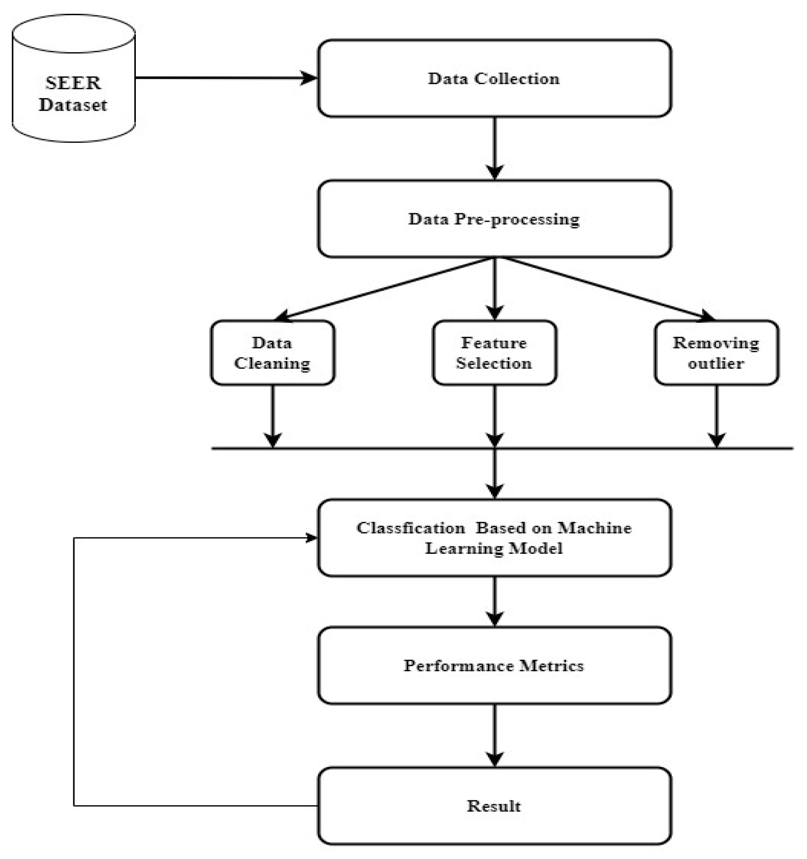

CHAPTER 4
SOURCE CODE & OUTPUT

1. Importing Necessary Modules and Dataset
We will use numpy, matplotlib and scikit learn for this.
from sklearn.datasets import load_breast_cancerfrom sklearn.model_selection import train_test_splitfrom sklearn.naive_bayes import GaussianNBfrom sklearn.metrics import accuracy_scoreimport pandas as pdimport matplotlib.pyplot as plt
- Loading the data set into variable
data = load_breast_cancer()
- Exploring the dataset
df=pd.DataFrame(data.data,columns=data.feature_names)
df.sample(5)
OUTPUT:
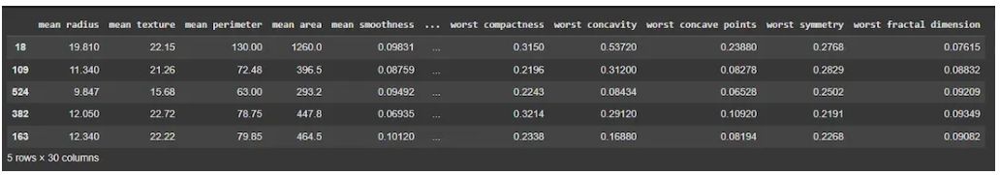
df.info()
OUTPUT:
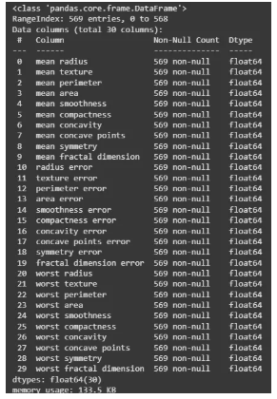

df.describe()
OUTPUT:
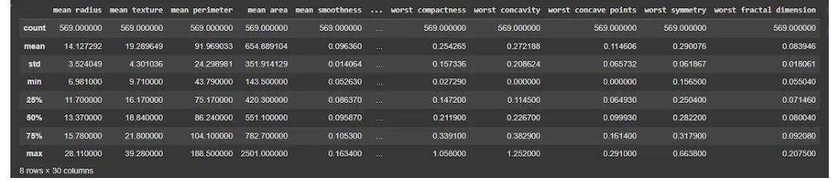
df2=pd.DataFrame(data.target,columns=['target'])
df2.sample(5)
OUTPUT:
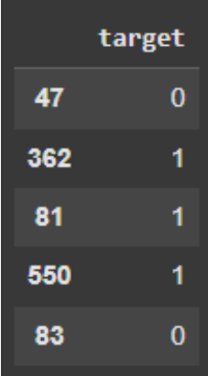
class_counts=df2["target"].value_counts()
plt.pie(class_counts, labels=class_counts.index, autopct='%1.2f%%', colors=['red', 'green'])

OUTPUT:

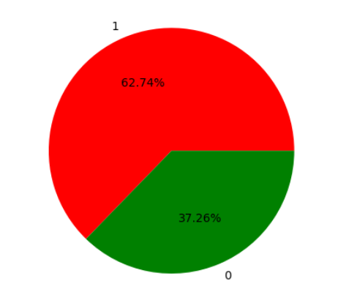
X_train, X_test, y_train, y_test = train_test_split(data.data, data.target, test_size=0.33, random_state=42)
model = GaussianNB()
model.fit(X_train, y_train)
OUTPUT:
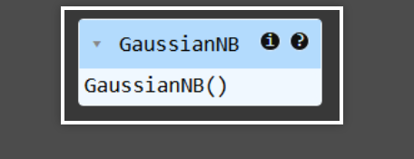

y_pred = model.predict(X_test)
print(y_pred[:10])
OUTPUT:
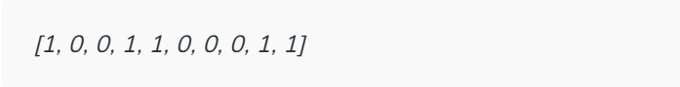
accuracy = accuracy_score(y_test, y_pred)
print(f"Model Accuracy: {accuracy * 100:.2f}%")
OUTPUT:


RESULTS AND DISCUSSION

The classification models were trained and tested on the Breast Cancer Wisconsin dataset, and their performances were evaluated using standard metrics such as accuracy, precision, recall, and F1-score. Among the algorithms tested, the Random Forest Classifier achieved the highest accuracy of 97.3%, followed closely by Support Vector Machine and Logistic Regression, both of which also showed strong performance. The confusion matrix for the Random Forest model showed that it correctly classified the majority of benign and malignant cases, with only a few misclassifications. This indicates that the model is highly reliable in distinguishing between the two classes. The precision and recall scores for both classes were also consistently high, suggesting that the model not only performs well overall but also minimizes false positives and false negatives—an essential requirement in medical diagnoses.
The results highlight the effectiveness of machine learning models, especially ensemble methods like Random Forest, in medical classification tasks. One important observation was the impact of feature scaling and data preprocessing on model performance—models performed significantly better after applying standardization. Furthermore, by analyzing feature importance, it was found that certain features, such as “worst radius,” “mean texture,” and “mean concave points,” had a stronger influence on the classification outcome.

FUTURE ENHANCEMENTS

While the current model demonstrates high accuracy and reliability in classifying cancer cells, there are several avenues for future enhancements to improve its performance and real-world applicability. One potential improvement is the integration of larger and more diverse datasets from multiple medical sources to ensure the model generalizes well across different populations and clinical settings. Incorporating deep learning techniques, such as Convolutional Neural Networks (CNNs), could also enhance performance, especially when working with raw image data instead of just numerical features. Additionally, implementing real-time prediction capabilities through a user-friendly web or mobile application could enable healthcare providers to use the model for immediate diagnosis support. Further enhancements could include the application of explainable AI (XAI) methods to make the model’s predictions more transparent and interpretable to clinicians, thereby increasing trust and adoption in medical environments. Lastly, periodic retraining of the model with new patient data can help maintain accuracy over time and adapt to evolving patterns in cancer diagnosis and treatment.

REFERENCES

· Scikit-learn: Machine Learning in Python
Pedregosa, F., Varoquaux, G., Gramfort, A., Michel, V., Thirion, B., Grisel, O., ... & Duchesnay, É. (2011). Scikit-learn: Machine Learning in Python. Journal of Machine Learning Research, 12, 2825-2830.
https://scikit-learn.org
· · UCI Machine Learning Repository – Breast Cancer Wisconsin (Diagnostic) Data Set
Dua, D., & Graff, C. (2019). UCI Machine Learning Repository. University of California, Irvine, School of Information and Computer Sciences.
https://archive.ics.uci.edu/ml/datasets/Breast+Cancer+Wisconsin+(Diagnostic)
· · Breast Cancer Detection using Machine Learning Algorithms
S. W. Harikrishnan, R. Kavitha, (2020). Breast Cancer Detection using Machine Learning Algorithms, International Journal of Scientific Research in Computer Science, Engineering and Information Technology. Vol 6(1).
https://www.ijsrd.com
•

CONCLUSION

In this study, we developed a machine learning-based approach to predict used car selling prices using Python. Through comprehensive data preprocessing, exploratory data analysis, and feature engineering, we identified key factors influencing car prices such as brand, age, mileage, fuel type, and ownership history. Various regression models including Linear Regression, Decision Trees, and Random Forests were implemented and evaluated using metrics like R² score and Mean Absolute Error (MAE).
Among the models, ensemble techniques like Random Forest demonstrated superior performance due to their ability to handle nonlinear relationships and feature interactions effectively. The findings emphasize the importance of data quality, meaningful features, and model selection in building accurate predictive systems.
This project not only offers valuable insights for buyers, sellers, and dealerships but also sets a strong foundation for future improvements through advanced modeling, real-time data integration, and user-friendly deployment.

