Cryptocurrency forecasting

A Project Report

Submitted in the partial fulfilment of the requirements for the

award of the degree of

Bachelor of Technology

in

Department of Computer Science and Engineering

By

ERANKI RAMA SUMANTH (2010030051)

SIVA KARTHIK (2010030329)

KAMEPALLI SNEHITH (2010030341)

under the supervision of

Dr. Arpita Gupta

Department of Computer Science and Engineering

K L University Hyderabad,

Aziz Nagar, Moinabad Road, Hyderabad – 500 075, Telangana, India.

March, 2022

**Declaration**

The Project Report entitled “Cryptocurrency forecasting” is a record of bonafide work of Siva Karthik Reddy (2010030329), Eranki Summanth (2010030051), Kamepalli Snehith (2010030341), submitted in partial fulfilment for the award of B.Tech in the Department of Computer Science and Engineering to the KL University, Hyderabad. The results embodied in this report have not been copied from any other Departments/ University/ Institute.

Siva Karthik Reddy

Eranki Rama Sumanth

Kamepalli Snehith

**Certificate**

This is to certify that the Project Report entitled “Cryptocurrency forecasting” is being submitted by Siva Karthik Reddy (2010030329), Eranki Rama Sumanth (2010030051), Kamepalli Snehith (2010030341), submitted in partial fulfilment for the award of B. Tech in Computer Science Engineering to the K L University, Hyderabad is a record of bonafide work carried out under our guidance and supervision. The results embodied in this report have not been copied from any other departments University/Institute.

**Signature of the Supervisor**

**Signature of the HOD Signature of the External Examiner**

**ACKNOWLEDGEMENT**

First and foremost, we thank the lord almighty for all his grace & mercy showered upon us, for completing this project successfully.

We take grateful opportunity to thank our beloved Founder and Chairman who has given constant encouragement during our course and motivated us to do this project. We are grateful to our Principal **Dr. L. Koteswara Rao** who has been constantly bearing the torch for all the curricular activities undertaken by us.

We pay our grateful acknowledgement & sincere thanks to our Head of the Department **Dr. Chiranjeevi Manike** for her exemplary guidance, monitoring and constant encouragement throughout the course of the project. We thank Dr. Arpita Gupta of our department who has supported throughout this project holding a position of supervisor.

We whole heartedly thank all the teaching and non-teaching staff of our department without whom we won’t have made this project a reality. We would like to extend our sincere thanks especially to our parent, our family members and friends who have supported us to make this project a grand success.

TABLE OF CONTENTS: -

|  |  |  |
| --- | --- | --- |
| S.No. | Title | Pg. No. |
| 1 | Abstract | 8 |
| 2 | Introduction | 9 |
| 3 | Literature Review | 10 |
| 4 | Flow Process | 11 |
| 5 | Methods | 12 |
| 6 | Implementation | 14 |
| 7 | Conclusion | 29 |
| 8 | References | 30 |

Abstract: -

Trading in cryptocurrency is trading in a lot of uncertainty and different variables need to be kept in mind as compared to trading in fiat currencies. Fiat currencies generally are less volatility compared to cryptocurrencies. Traders who have traded in other markets like Stocks and Commodities have repeatedly mentioned that the cryptocurrency market is the most unpredictable place in the world right now. We cannot exactly determine the price of cryptocurrency and it is very unpredictable for people in general. So, Crypto market involves a lot of risk. But by using time series analysis, predicting the crypto market prices is possible. Hence by using time series, we can forecast the cryptocurrency price of coming weeks.

Introduction: -

Cryptocurrency is one of the many forms of money exchange in the modern days, cryptocurrency is not real cash or object but a virtual form of cash it can’t be touched and buying a cryptocurrency is like holding an asset in internet with hash address

The cryptocurrency came to existence by rapid evolving of the form of money in olden days there is no money so trade of good for another good is done but people are unsatisfied so they changed to iron money like coins but coins being weight people changed to cash. Now in modern society, due to development of internet and the security of the crypto currency people are moving towards crypto currency and are interested in investing in it.

This project helps to forecast the prices of Bitcoin, Ethereum, Sandbox by analysing historical data.

Literature review:

Referred documentations for this project: -

|  |  |  |  |  |
| --- | --- | --- | --- | --- |
| s/no | AUTHOR | TITLE | DATASET/  ALGORTHIM | CONCLUSION |
| 1 | Rama k.malladi, Praksh deeriya | "Time Series Analysis of Cryptocurrency Returns and Volatilities" | ARMAX, GARCH, VAR | In this report prediction of cryptocurrency is done using  ARMAX, GARC, VAR models |
| 2 | Iohannis E. Livieris, Niki Kiriakou, Stavros Stavroyiannis and Panagiotis Pintelas | An Advanced CNN-LSTM Model for Cryptocurrency Forecasting | CNN-LSTM | In this report prediction was done using cnn-lstm model |
| 3 | Do-Hyung Kwon, Ju-Bong Kim, Ju-Sung Heo, Chan-Myung Kim, and Youn-Hee Han | Time Series Classification of Cryptocurrency Price Trend Based on a Recurrent LSTM Neural Network | LSTM | In this report prediction of crypto currencies is done using LSTM model |
| 4 | Nashirah Abu Bakar, Sofian Rosbi2 | ARIMA Model for Forecasting Cryptocurrency Exchange Rate in High Volatility Environment: A New Insight of Bitcoin | ARIMA | This report shows the prediction of bitcoin using ARIMA model |

Flow Process: -

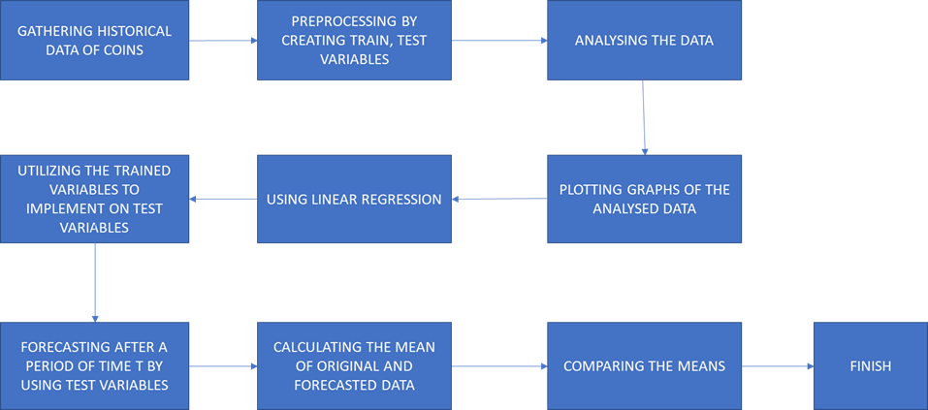

Fig. 1. Flow process of project

METHODS OR MODELS:

Linear regression:

Linear Regression is a machine learning algorithm based on supervised learning. It performs a regression task. Regression models a target prediction value based on independent variables. It is mostly used for finding out the relationship between variables and forecasting. Linear regression performs the task to predict a dependent variable value (y) based on a given independent variable (x). So, this regression technique finds out a linear relationship between x and y .We are given a scatter plot of the dependent variable y versus the independent variable x, we can find a line that fits the data well.

Time series regression is a statistical method for predicting a future response based on the response history and the transfer of dynamics from relevant predictors. Time series regression can help you understand and predict the behaviour of dynamic systems from experimental or observational data. Common uses of time series regression include modelling and forecasting of economic, financial, biological, and engineering systems.

HARDWARE AND SOFTWARE REQUIREMENTS:

3.1 Software Requirement:

● PYCHARM

● FRONT END: PYTHON, HTML

● PLATFORM: WINDOWS 10/11

3.2 Hardware Requirement:

● RAM: 8 GB PROCESSOR: Intel CORE i7 8th gen

● HARD DISK: 128 SSD 1TB HDD

IMPLEMENTATION:

1. Ethereum :

Code :

ETH.PY:

from application import app

from flask import render_template, url_for

import pandas as pd

import json

import plotly

import plotly.express as px

@app.route("/")

def index():

# Graph One

df = pd.read_csv("C:\\2 ND YEAR\\PROJECTS\\AI FOR DS PROJECT\\AI FOR DS PROJECT\\ETHERUM\\ETH-USD.csv")

fig1 = px.bar(df, x="Date", y="Close",title="ETHEREUMS INFO")

graph1JSON = json.dumps(fig1, cls=plotly.utils.PlotlyJSONEncoder)

# Graph two

df2 = pd.read_csv("C:\\2 ND YEAR\\PROJECTS\\AI FOR DS PROJECT\\ETHERUMFORECASTIN.csv")

fig2 = px.line(df2, x="DATE", y="PREDICTION",title="ETHEREUMS PREDICTION VALUE")

graph2JSON = json.dumps(fig2, cls=plotly.utils.PlotlyJSONEncoder)

# # Graph three

# fig3 = px.bar(df, x="category_id", y="views",title="views from each category")

# graph3JSON = json.dumps(fig3, cls=plotly.utils.PlotlyJSONEncoder)

return render_template('index.html', graph1JSON=graph1JSON, graph2JSON=graph2JSON)

@app.route("/dataset")

def dataset_display():

return render_template("dataset.html")

# @app.route("/ml")

# def ml_display():

# return render_template("ml.html")

@app.route("/home")

def home_page():

return render_template("home.html")

Run.py:

from application import app

if name=="main":

app.run(debug=True)

Index.html:

fg {% extends "layout.html" %}

{% block content %}

<div class="site-header-logo">

<h1 class="text-center">

Analytics

</h1>

</div>

<div class="row p-4">

<div class="card m-auto" style="width: 90%;" data-aos="fade-left">

<div class="card-body">

<div id="chart1"></div>

<p class="card-text">Ethereum is a decentralized, open-source blockchain with smart contract functionality. Ether (ETH or Ξ) is the native cryptocurrency of the platform. Among cryptocurrencies, Ether is second only to Bitcoin in market capitalization.

Ethereum was conceived in 2013 by programmer Vitalik Buterin.Additional founders of Ethereum included Gavin Wood, Charles Hoskinson, Anthony Di Iorio and Joseph Lubin.In 2014, crowdfunded development work began; went live on 30 July 2015.Ethereum allows anyone to deploy permanent and immutable decentralized applications onto it, with which users can interact.Decentralized finance (DeFi) applications provide a broad array of financial services without the need for typical financial intermediaries like brokerages, exchanges, or banks, such as allowing cryptocurrency users to borrow against their holdings or lend them out for interest.Ethereum also allows users to create and exchange NFTs, which are unique tokens representing ownership of an associated asset or privilege, as recognized by any number of institutions. Additionally, many other cryptocurrencies utilize the ERC-20 token standard on top of the Ethereum blockchain and have utilized the platform for initial coin offerings. </p>

</div>

</div>

</div>

<div class="card mb-4 m-auto" style="width: 90%;" data-aos="fade-left">

<div class="card-body">

<h1 class="card-text"></h1>

<div id="chart2"></div>

</div>

</div>

<!-- plotly CDN -->

<script src="https://cdn.plot.ly/plotly-latest.min.js"></script>

<script src="https://unpkg.com/aos@next/dist/aos.js"></script>

<script type="text/javascript">

var graphs1 = {{ graph1JSON | safe}};

Plotly.plot("chart1", graphs1,{});

var graphs2 = {{ graph2JSON | safe}};

Plotly.plot("chart2", graphs2,{});

</script>

{% endblock %}

2) Bitcoin:

Code:

BTC.py:

from application import app

from flask import render_template, url_for

import pandas as pd

import json

import plotly

import plotly.express as px

@app.route("/")

def index():

# Graph One

df = pd.read_csv("C:\\2 ND YEAR\\PROJECTS\\AI FOR DS PROJECT NEW\\BITCOINPREDICTION\\BTC-USD.csv")

fig1 = px.bar(df, x="Date", y="Close",title="BITCOIN INFO")

graph1JSON = json.dumps(fig1, cls=plotly.utils.PlotlyJSONEncoder)

# Graph two

df2 = pd.read_csv("C:\\2 ND YEAR\\PROJECTS\\AI FOR DS PROJECT NEW\\BITCOINPREDICTION\\BTCPREDC.csv")

fig2 = px.line(df2, x="DATE", y="PREDICTION",title="BITCOIN PREDICTION VALUE")

graph2JSON = json.dumps(fig2, cls=plotly.utils.PlotlyJSONEncoder)

# # Graph three

# fig3 = px.bar(df, x="category_id", y="views",title="views from each category")

# graph3JSON = json.dumps(fig3, cls=plotly.utils.PlotlyJSONEncoder)

return render_template('index.html', graph1JSON=graph1JSON, graph2JSON=graph2JSON)

@app.route("/dataset")

def dataset_display():

return render_template("dataset.html")

# @app.route("/ml")

# def ml_display():

# return render_template("ml.html")

@app.route("/home")

def home_page():

return render_template("home.html")

Index.html:

{% extends "layout.html" %}

{% block content %}

<div class="site-header-logo">

<h1 class="text-center">

Analytics

</h1>

</div>

<div class="row p-4">

<div class="card m-auto" style="width: 90%;" data-aos="fade-left">

<div class="card-body">

<div id="chart1"></div>

<p class="card-text">Bitcoin (₿) is a decentralized digital currency, without a central bank or single administrator, that can be sent from user to user on the peer-to-peer bitcoin network without the need for intermediaries.Transactions are verified by network nodes through cryptography and recorded in a public distributed ledger called a blockchain. The cryptocurrency was invented in 2008 by an unknown person or group of people using the name Satoshi Nakamoto. The currency began use in 2009 when its implementation was released as open-source software.

Bitcoins are created as a reward for a process known as mining. They can be exchanged for other currencies, products, and services. Bitcoin has been criticized for its use in illegal transactions, the large amount of electricity (and thus carbon footprint) used by mining, price volatility, and thefts from exchanges. Some investors and economists have characterized it as a speculative bubble at various times. Others have used it as an investment, although several regulatory agencies have issued investor alerts about bitcoin.

A few local and national governments are officially using Bitcoin in some capacity, with two countries, El Salvador and the Central African Republic, adopting it as a legal tender.

The word bitcoin was defined in a white paper published on 31 October 2008.It is a compound of the words bit and coin.No uniform convention for bitcoin capitalization exists; some sources use Bitcoin, capitalized, to refer to the technology and network and bitcoin, lowercase, for the unit of account. The Wall Street Journal The Chronicle of Higher Education and the Oxford English Dictionary advocate the use of lowercase bitcoin in all cases.</p>

</div>

</div>

</div>

<div class="card mb-4 m-auto" style="width: 90%;" data-aos="fade-left">

<div class="card-body">

<h1 class="card-text"></h1>

<div id="chart2"></div>

</div>

</div>

<!-- plotly CDN -->

<script src="https://cdn.plot.ly/plotly-latest.min.js"></script>

<script src="https://unpkg.com/aos@next/dist/aos.js"></script>

<script type="text/javascript">

var graphs1 = {{ graph1JSON | safe}};

Plotly.plot("chart1", graphs1,{});

var graphs2 = {{ graph2JSON | safe}};

Plotly.plot("chart2", graphs2,{});

</script>

{% endblock %}

Run.py:

from application import app

if name=="main":

app.run(debug=True)

init.py:

from flask import Flask

app=Flask(name)

from application import BTC

3) Sandbox:

Code:

Sandbox.py

from application import app

from flask import render_template, url_for

import pandas as pd

import json

import plotly

import plotly.express as px

@app.route("/")

def index():

# Graph One

df = pd.read_csv("C:\\2 ND YEAR\\PROJECTS\\AI FOR DS PROJECT NEW\\SANDBOX\\SAND-USD.csv")

fig1 = px.bar(df, x="Date", y="Close",title="SANDBOX'S INFO")

graph1JSON = json.dumps(fig1, cls=plotly.utils.PlotlyJSONEncoder)

# Graph two

df2 = pd.read_csv("C:\\2 ND YEAR\\PROJECTS\\AI FOR DS PROJECT NEW\\SANDBOX\\SANDPREDC-1.csv")

fig2 = px.line(df2, x="DATE", y="PREDICTION",title="SANDBOX'S PREDICTION VALUE")

graph2JSON = json.dumps(fig2, cls=plotly.utils.PlotlyJSONEncoder)

# # Graph three

# fig3 = px.bar(df, x="category_id", y="views",title="views from each category")

# graph3JSON = json.dumps(fig3, cls=plotly.utils.PlotlyJSONEncoder)

return render_template('index.html', graph1JSON=graph1JSON, graph2JSON=graph2JSON)

@app.route("/dataset")

def dataset_display():

return render_template("dataset.html")

# @app.route("/ml")

# def ml_display():

# return render_template("ml.html")

@app.route("/home")

def home_page():

return render_template("home.html")

sandindex.html:

{% extends "layout.html" %}

{% block content %}

<div class="site-header-logo">

<h1 class="text-center">

Analytics

</h1>

</div>

<div class="row p-4">

<div class="card m-auto" style="width: 90%;" data-aos="fade-left">

<div class="card-body">

<div id="chart1"></div>

<p class="card-text">The Sandbox is a virtual world in the sandbox genre. The project’s metavirtual universe resembles Minecraft, which uses “cubic” graphics. Users can freely develop a virtual world, create real estate and objects, move and participate in mini-games.

The project is built on the Ethereum blockchain. Players own portions of the metaworld, which are non-interchangeable LAND tokens. Users create virtual world objects represented as NFTs.

Digital real estate and objects are traded on The Sandbox Marketplace. SAND utility tokens are used for interaction with the metaviverse, calculations on the platform and other purposes. </p>

</div>

</div>

</div>

<div class="card mb-4 m-auto" style="width: 90%;" data-aos="fade-left">

<div class="card-body">

<h1 class="card-text"></h1>

<div id="chart2"></div>

</div>

</div>

<!-- plotly CDN -->

<script src="https://cdn.plot.ly/plotly-latest.min.js"></script>

<script src="https://unpkg.com/aos@next/dist/aos.js"></script>

<script type="text/javascript">

var graphs1 = {{ graph1JSON | safe}};

Plotly.plot("chart1", graphs1,{});

var graphs2 = {{ graph2JSON | safe}};

Plotly.plot("chart2", graphs2,{});

</script>

{% endblock %}

Output:

1) Ethereum:

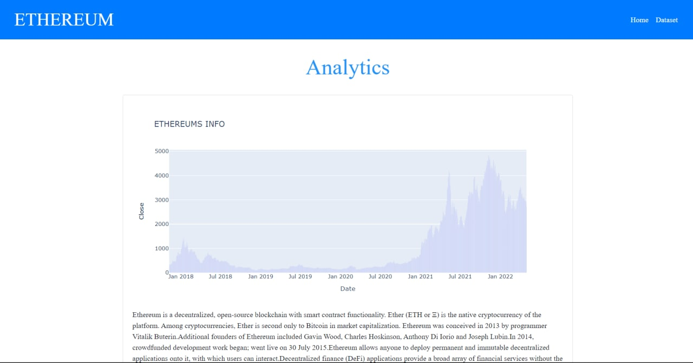

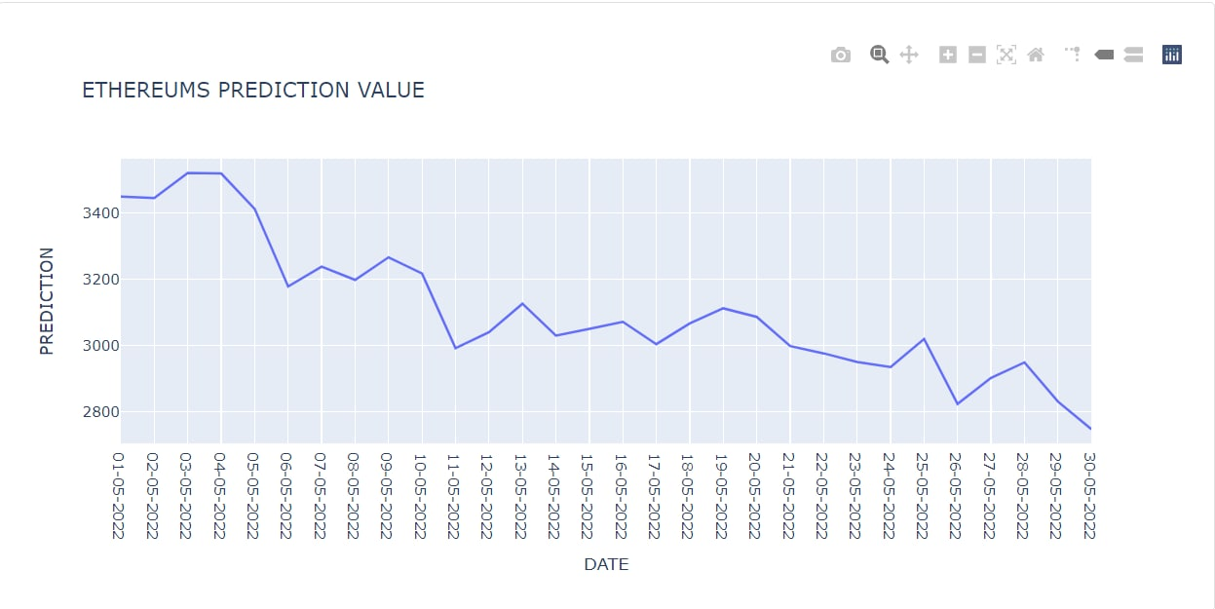

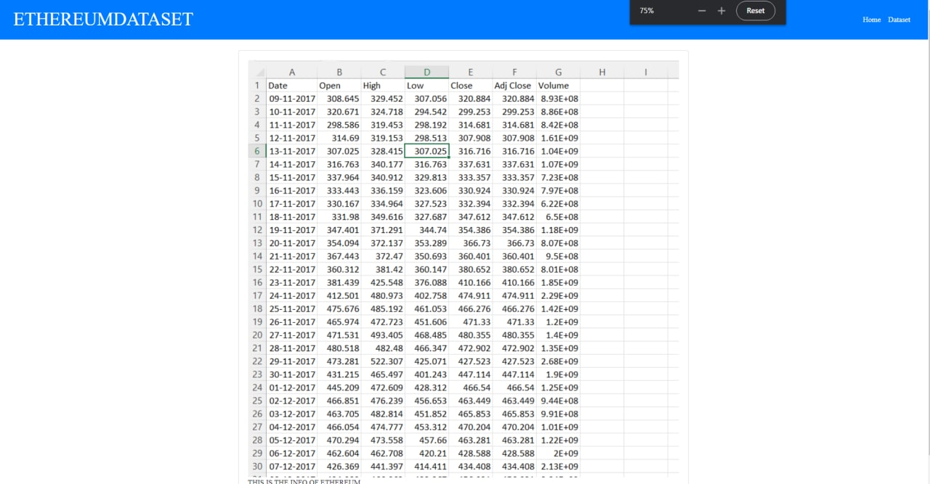

2) Bitcoin:

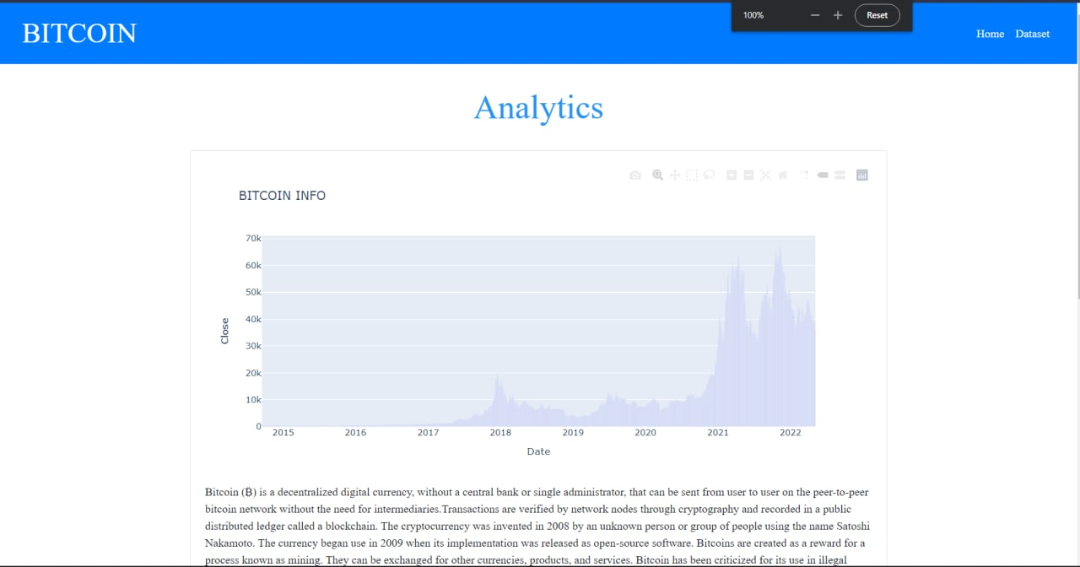

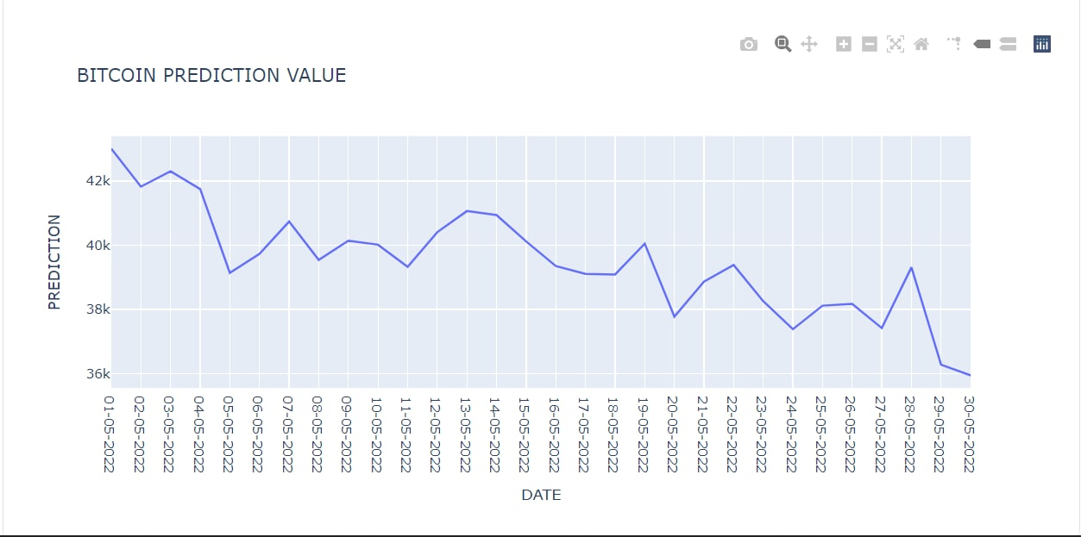

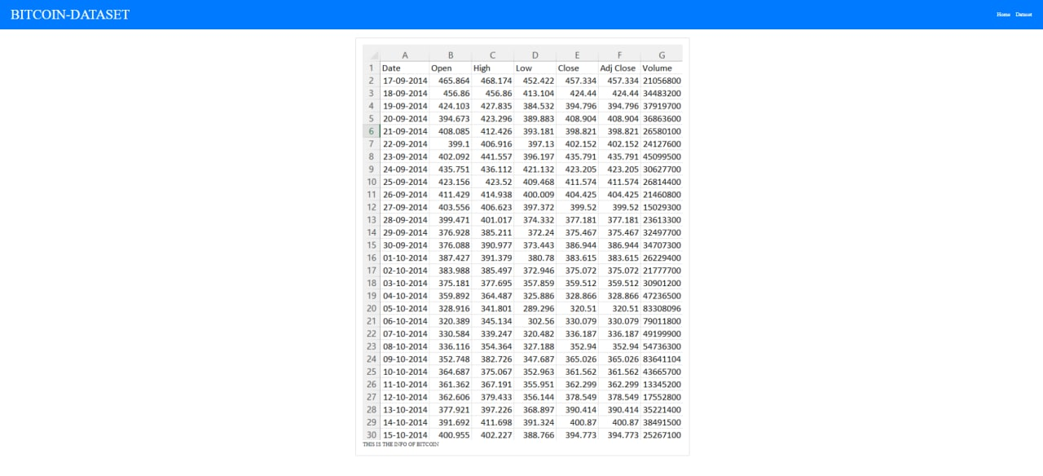

3) Sandbox:

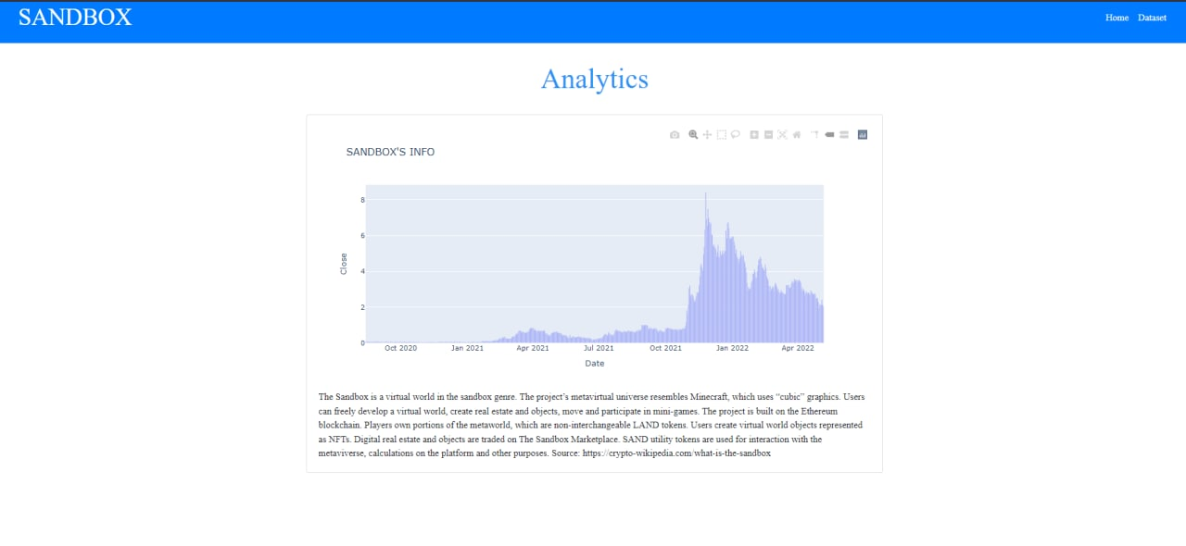

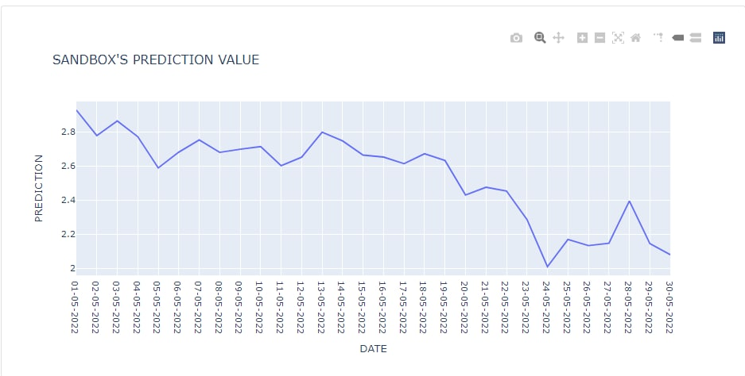

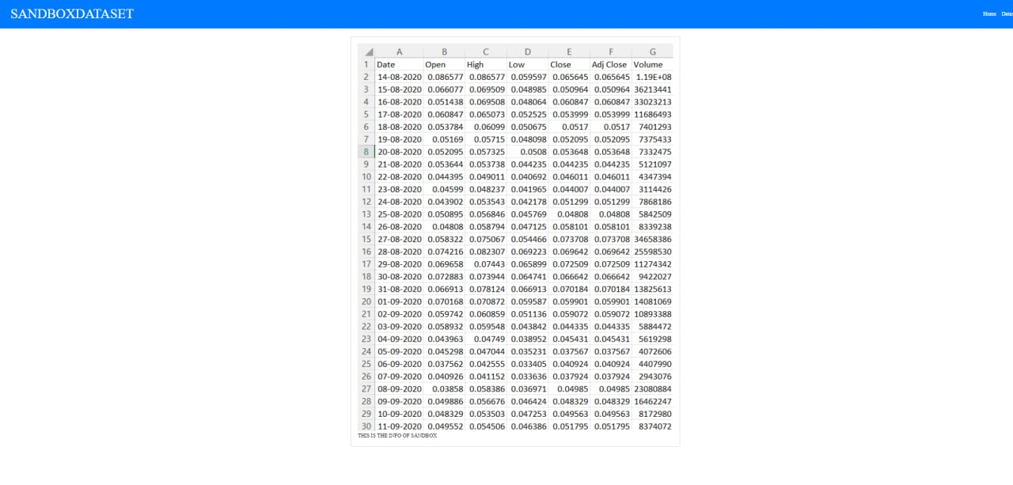

CONCLUSION:

This project we forecasted the prices of bitcoin, Ethereum, Sandbox. we choose these coins cause Bitcoin, Ethereum, Sandbox. Bitcoin, Ethereum are two biggest coins in present crypto market while sandbox is one of the emerging metaverse so we choose these coins for our project from the project.

We used time series analysis and analysed next following days that the prices of Bitcoin, Ethereum, Sandbox will fall very much this may be due to decreasing in popularity of cryptocurrency.

REFERENCES:

[1] Olufunke G. Darley, *, Abayomi I. O. Yussuff, Adetokunbo A. Adenowo: Price Analysis and Forecasting for Bitcoin Using Auto Regressive Integrated Moving Average Model

[2] Murat AKDAĞ1 & Hatıra SADEGHZADEH: EFFECT OF MONETARY GROWTHIN USA ON SELECTED ASSETS: S&P500, GOLD & BITCOIN ESTIMATES WITH FACEBOOK PROPHET

[3] Ioannis E. Livieris 1, *, Niki Kiriakidou 2, Stavros Stavroyiannis 3 and Panagiotis Pintelas 1: An Advanced CNN-LSTM Model for Cryptocurrency Forecasting