**Monument Recognition**

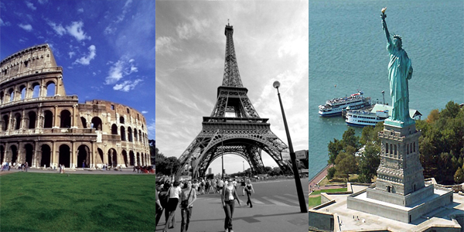

**By,**

**Team -5**

**Panja,Kumara Satya Gopal(kpqmd@mail.umkc.edu)**

**Linga,Sivarama Krishna(slhx4@mail.umkc.edu**

**Vikesh Padarthi (vpn7d@mail.umkc.edu)**

**Vundela,Karthik Reddy(kvxc5@mail.umkc.edu)**

**Project Report -1**

**Big Data Analytics and Applications**

**1 Introduction:**

Nowadays finding the matching of images in order to establish a measure of similarity is a major problem. Here we introduce a “Monument Recognition System”. It takes monument image as input from user and gives description about that images as output. For this first we want create our own data set for different monuments. Based on different algorithms, we can find input belongs to which category. Based on that monument category and apis we can give description about that monument.

**2 Project Objectives:**

**2.1 Significance:**

Whenever we visit a place we not only want to take the pictures in front of it but we would like to know history about that place. So instead of relying on some guide or go through the Google and search, a simple website which will help to know about the place in details in both text and audio format. Our objective is to develop a simple website where for the website we will accept input as a image which might be a statue or a building. we will learn about the image and know what it is like statue of liberty and we will get the details of that image like who developed and where it is etc and we will display about it. And we want to turn this text into voice and user should be able to listen to it.

**2.2 Features:**

* User can open the application on web browser and see the home page. On clicking on home page user will see signin and signup pages.
* User needs to create an account by clicking on signup page.
* User can login by using his credentials
* On Successful login we navigate user to main page.
* In main page, user can upload an image.
* User can learn about the monument
* User can find related places
* User can hear the speech about monument.

**3 Approach**

**3.1 Data Sources:**

Here we can create our own data set for different monuments. And we can use google and some apis for retrieving data about monuments**.**

**3.2 Expected Inputs/Outputs:**

When we finish developing this system, it should be able to provide movies recommendation to users. Based on user preferences, out system will recommend movies to users.

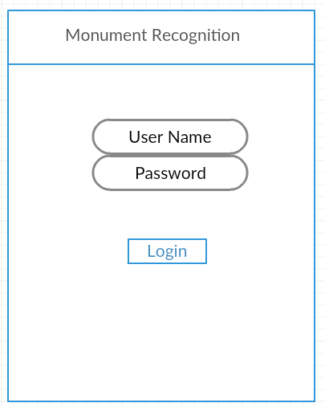

When the user opens our application, first it shows login page. User need to create an account. By using the user credentials, he can login into the application. On successful login, it will navigate into main page.

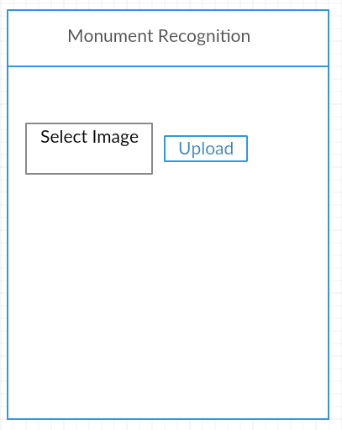

User can upload monument image

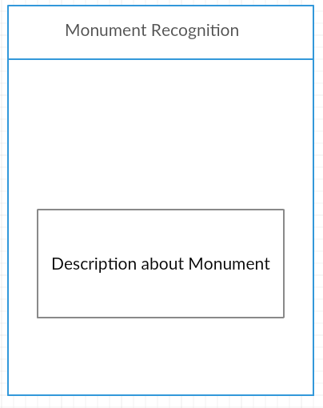

User can see the description about that monument

**4 Related Work:**

**5 Application Specification:**

**5.1 Software Architecture:**

**5.2 Work flow Diagram:**

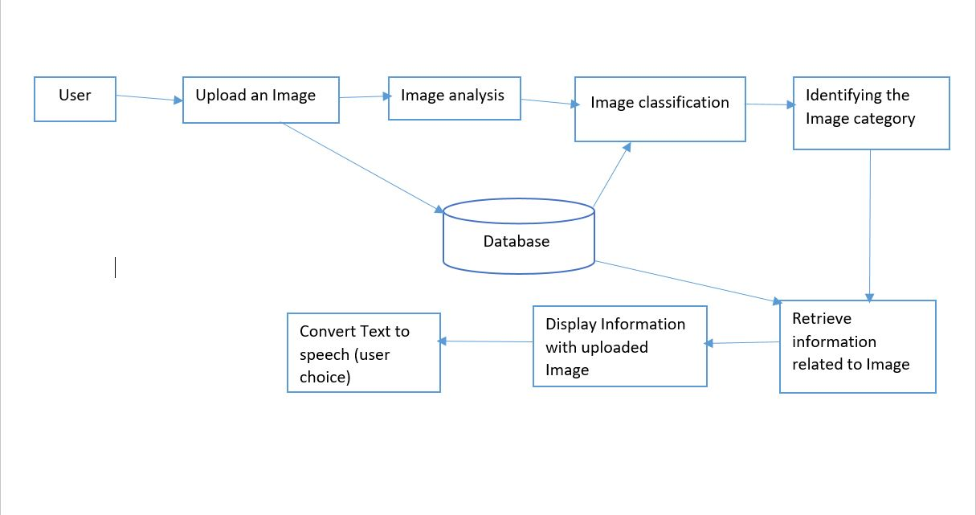

**5.3 Sequence Diagaram:**

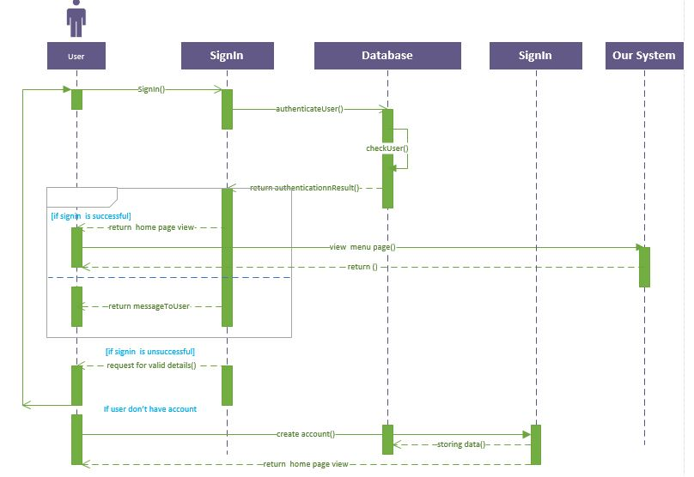

**6. Implementation:**

**6.1 Clarifai API outputs:**

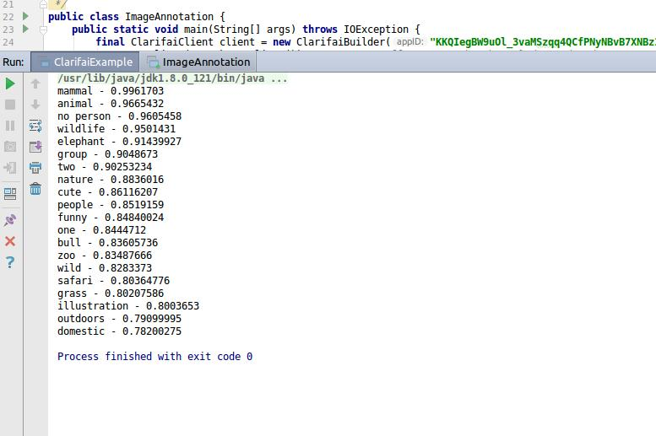

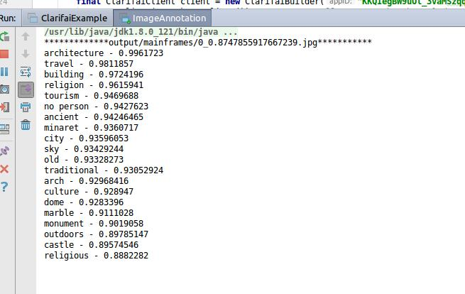

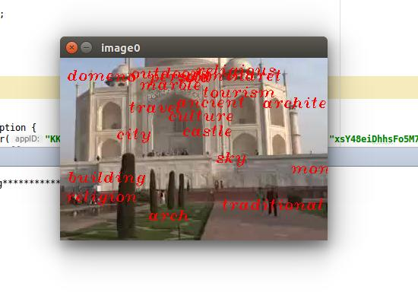

**6.2 Google Conversation API outputs:**

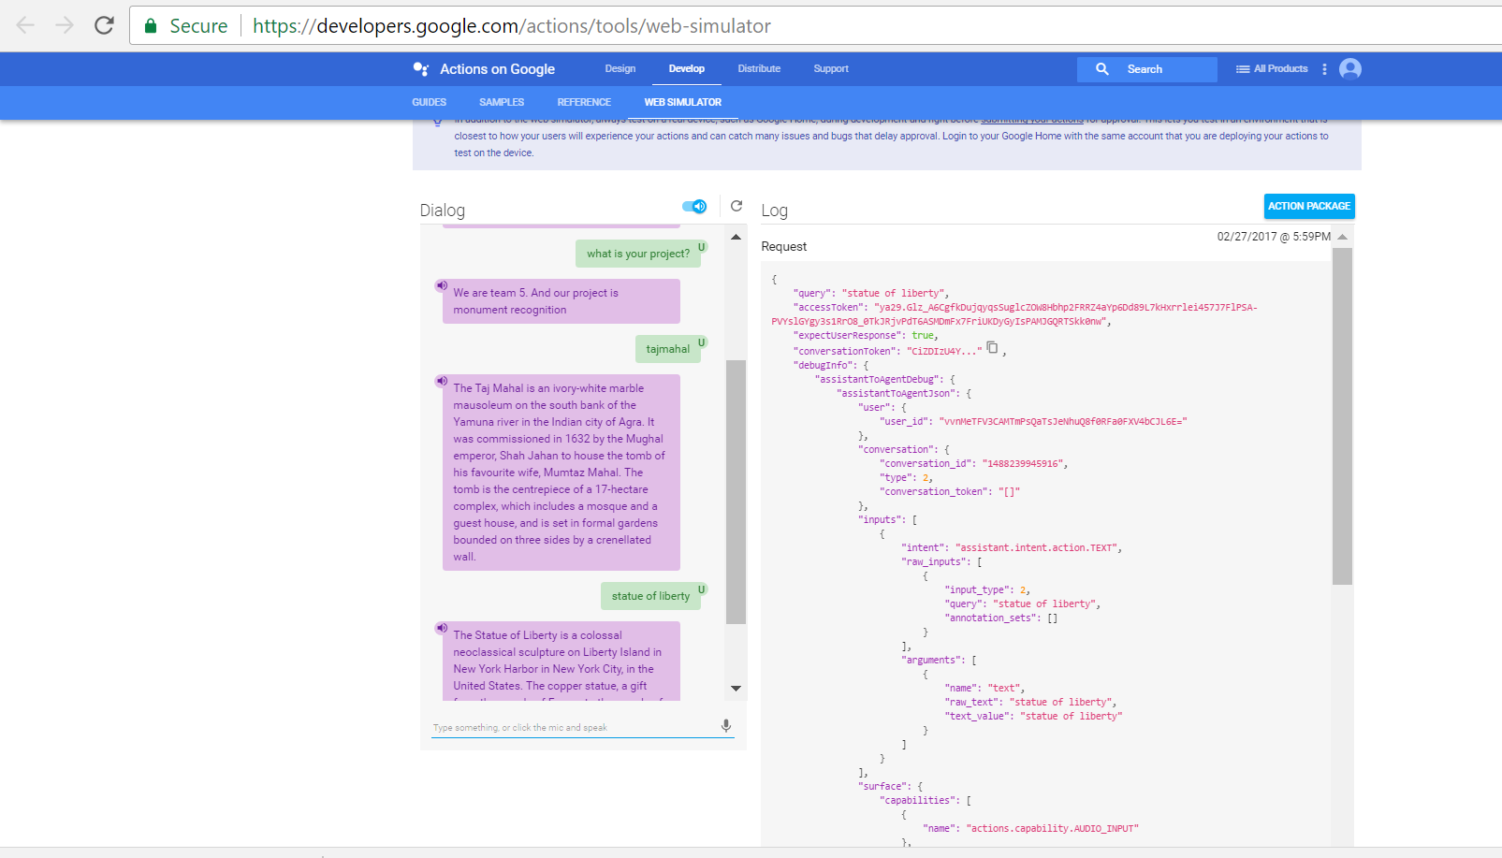

**7 Project Management:**

**7.1 Contribution of Team Mates:**

|  |  |  |
| --- | --- | --- |
| **Class Id** | **Name** | **Responsilbilty** |
| 32 | Panja, Kumara Satya Goal | Google Conversation API, Desgining UML diagrams and Expected outcomes |
| 21 | Linga, Siva Rama Krishna | Clarifai API, Workflow Diagaram, Data collection |
| 30 | Padarthi, Vikesh | Architecture Diagram, User Interface, Testing |
| 43 | Vundela, Karhik | Project Management, Gathering Requirements, Documentation |

**7.2 Issues:**

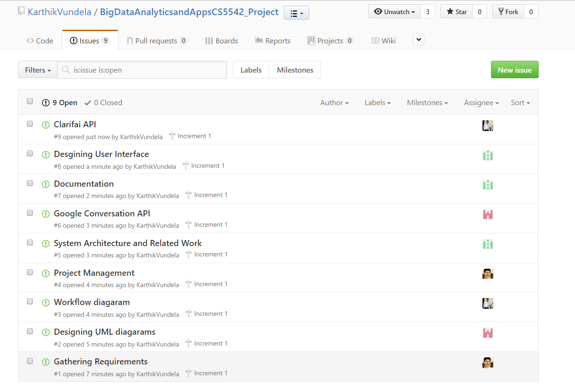

**7.3 Burndown Chart of Increment 1:**

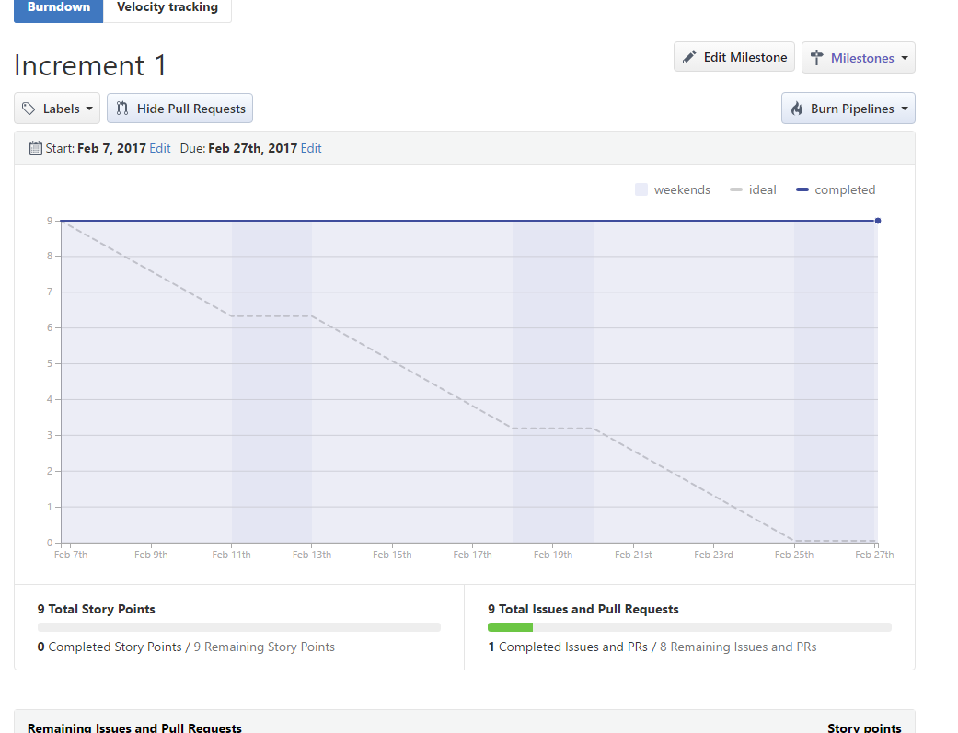

**Zenhub Board:**

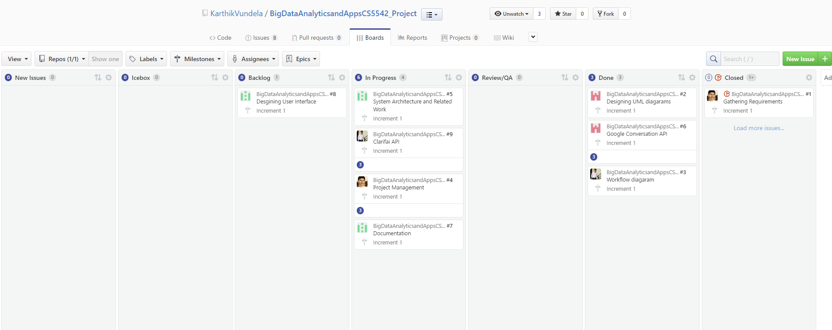

**Work Completed:**

**Work need to be Completed:**

**8 References:**

Tutorial code 3,5