Mini Project: RBAC-Based Access Control Simulation

Created By: Karthika RJ

Date: July 7,2025

Objective: Demonstrating Role-Based Access Implementation in a Simulated IAM Environment

|  |  |  |
| --- | --- | --- |
| Username | Role | Permissions |
| Karthika | IAM Analyst | View users, Reset password |
| Raj | Intern | View only |
| Meena | Manager | View, Approve Access Requests |

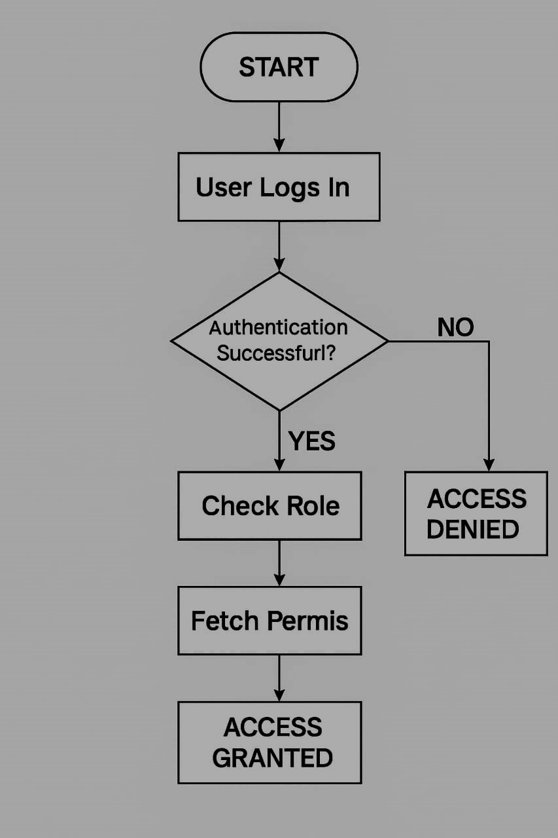Figure 1: Flowchart showing authentication and access flow in RABC.