Smart Healthcare Operations: Leveraging AI for Efficient Staff Allocation and Patient Care

  - Karthika Vellingiri
06 February 2026

Smart Healthcare Operations: Leveraging AI for Efficient Staff Allocation and Patient Care

Topic
This project focuses on improving hospital operations by leveraging artificial intelligence and machine learning to predict patient demand, staff absenteeism, satisfaction, and overtime. The aim is to provide actionable recommendations for equitable staffing, efficient resource allocation, minimizing patient wait times, and reducing refusal counts while maintaining staff well-being.

Business Problem and Research Questions
Hospitals face the ongoing challenge of delivering high-quality patient care while managing limited resources and staff. Staff working under constant pressure or overload may experience burnout, absenteeism, and reduced satisfaction, which can negatively impact patient outcomes. Conversely, insufficient staff or poorly coordinated schedules can result in long patient wait times, higher refusal rates, and inefficient utilization of hospital resources. This project seeks to explore how artificial intelligence can forecast staff satisfaction based on workload, departmental assignments, and historical performance, anticipate absenteeism and overtime risks for better workforce planning, and optimize staffing schedules and hospital resources to improve patient flow, reduce waiting times, and minimize refusal counts while safeguarding staff well-being.

Background and History
Traditional hospital staffing relies primarily on historical trends or manual scheduling. This approach often fails to adapt to fluctuations in patient demand, seasonal outbreaks, or emergency situations. Artificial intelligence models, in contrast, can anticipate patient flow, identify staff absenteeism and overtime risks, and simulate alternative staffing and resource allocation scenarios. By leveraging predictive and prescriptive analytics, hospitals can proactively manage resources, optimize operations, and support both staff and patient outcomes. Hospitals increasingly adopt AI-driven scheduling systems to reduce physician burnout, improve operational efficiency, and enhance patient satisfaction.

Datasets and Data Preparation
This project uses multiple datasets sourced from Kaggle’s healthcare staff scheduling repository. The staff datasets, staff.csv and staff_schedule.csv, provide information about staff roles, departmental assignments, and weekly attendance. The patient dataset, patients.csv, contains records of arrivals, service types, length of stay, and patient satisfaction scores. The weekly services dataset, services_weekly.csv, provides aggregated hospital-level statistics, including bed availability, patient requests, admissions, refusals, staff morale, and external events such as flu outbreaks. Together, these datasets provide sufficient granularity to model relationships between staffing, patient demand, patient wait times, refusal counts, and operational outcomes.
The data was pre-processed by handling missing or inconsistent values, normalizing numerical variables, and encoding categorical variables such as service type and staff role. Additional metrics were derived to enhance the analysis, including patient length of stay, weekly bed occupancy, wait pressure, refusal and admission rates, and staff absenteeism labels based on weekly presence. Data exploration through scatterplots, bar charts, and correlation analysis provided a clear understanding of patterns in patient demand, staff morale, and refusal rates.

Methods
The methodology of this project begins with careful data preprocessing, followed by exploratory data analysis to identify patterns and correlations between staff allocation, patient load, staff satisfaction, absenteeism, patient wait times, and refusal counts. Regression models were used to forecast weekly patient demand and staff satisfaction, while classification models predicted the likelihood of staff absenteeism. Prescriptive analytics was performed to simulate alternative hospital operational scenarios, such as increasing bed capacity, improving staff morale, and combining both measures. Feature importance analysis was conducted to determine the key factors influencing patient demand, refusals, and staff absenteeism, providing actionable insights for decision-making.
Figure 1: Relationship Between Patient Demand and Available Beds
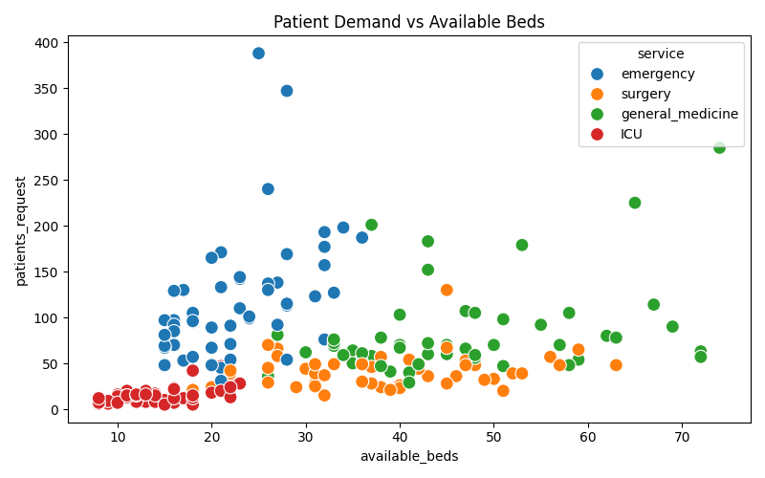

Figure 2: Staff Morale vs Patient Satisfaction Across Services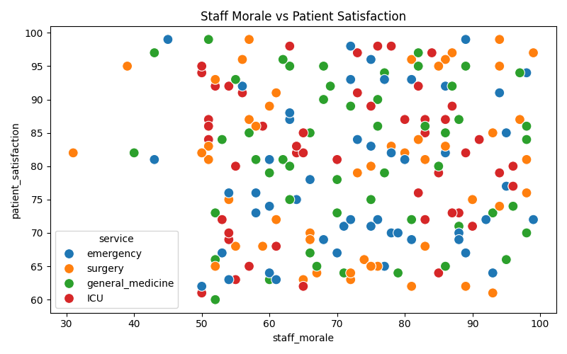
Detailed data preparation steps, model specifications, and prescriptive scenario implementations are provided in the Appendix.

Analysis
The predictive analysis of patient demand demonstrated a mean absolute error of zero, showing highly accurate predictions. The feature impact analysis revealed that available beds and wait pressure were the dominant drivers of patient demand, while staff morale and the month variable had negligible direct effects[A2]. The predictive model for staff absenteeism achieved an accuracy of 0.58. The confusion matrix (Figure. 3) shows the model’s performance, highlighting areas for improvement in predicting absenteeism.
Prescriptive scenarios were simulated to analyse potential operational improvements. Increasing bed capacity by ten percent resulted in higher predicted patient admissions and a reduction in estimated refusal counts, particularly in high-demand services such as emergency and surgery [Figure 4][A5a]. A scenario that increased staff morale by five points had minimal direct impact on patient demand but could indirectly improve patient outcomes through lower absenteeism[Figure 5][A5b].
Figure 3: Staff Absenteeism Prediction Confusion Matrix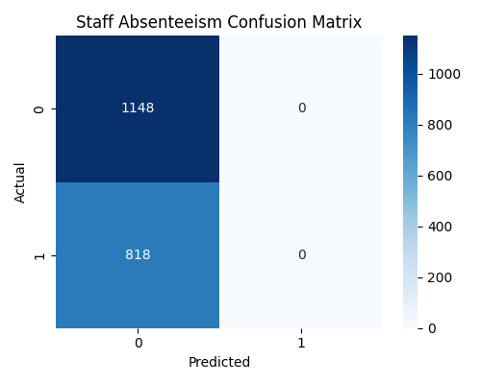
combined scenario of increasing both beds and staff morale yielded the greatest operational benefits, including reduced refusal rates and better staff performance[Figure 6][A5c].
Figure 4: Effect of 10% Increase in Bed Capacity on Patient Refusal Rates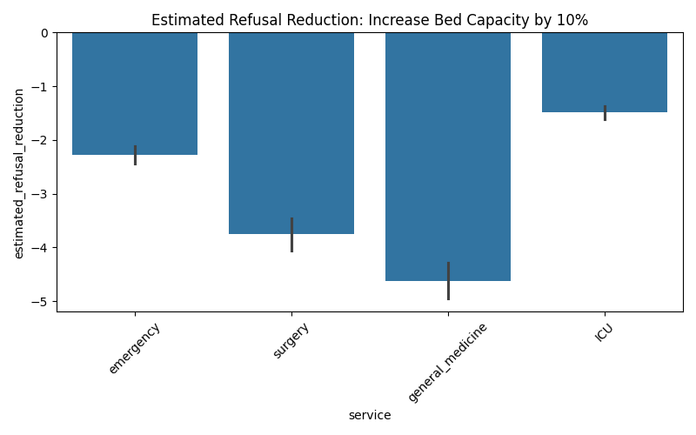
Figure 5: Effect of 5-Point Increase in Staff Morale on Patient Refusal Rates
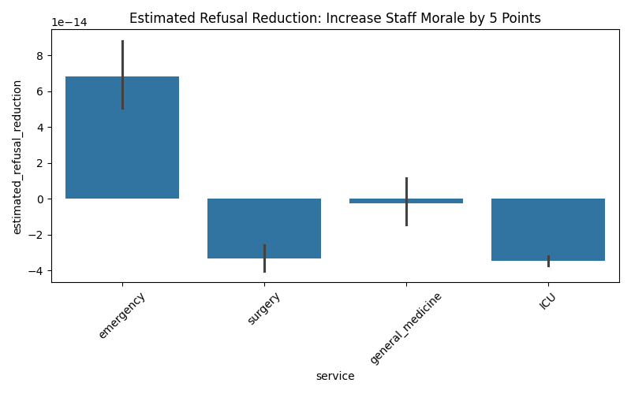
Figure 6: Impact on Refusal Reduction with Increased Beds and Staff Morale
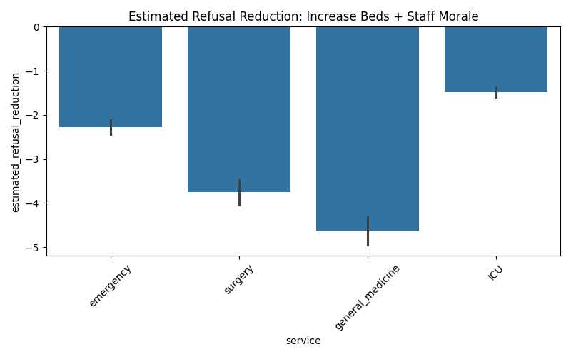
Additionally, the predicted versus actual patient demand visualization (Figure. 8) illustrates the model’s accuracy across services. Bar charts showing refusal rates by service (Figure. 7) support the analysis of high-demand areas needing attention.
Figure 7: Patient Refusal Rate by Service
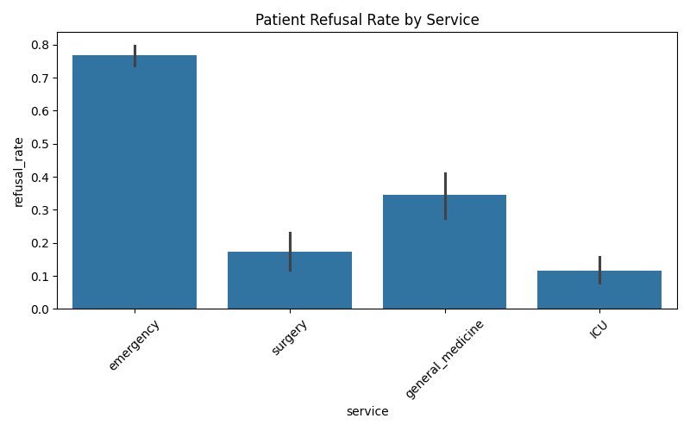
Figure 8: Predicted vs Actual Patient Demand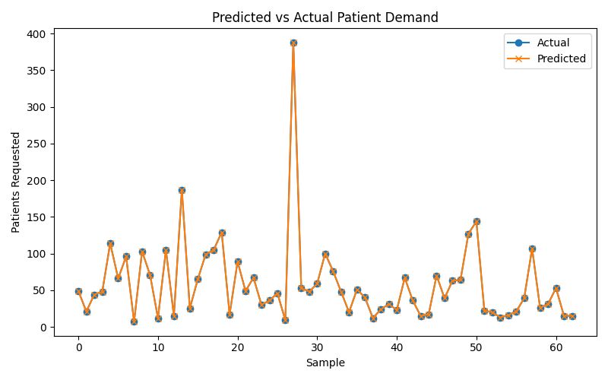
Average length of stay and wait pressure were also calculated for each service. ICU patients had an average length of stay of 7.61 days with minimal wait pressure, while emergency services experienced significant wait pressure of 96.31 with an average stay of 7.16 days [A6]. Surgery and general medicine showed moderate values in both metrics. These operational metrics further inform resource allocation decisions.

Conclusion
The AI-driven predictive and prescriptive analysis demonstrates the feasibility of forecasting patient demand and staff absenteeism, while also evaluating operational scenarios to reduce patient refusals and optimize hospital resource allocation. Increasing bed capacity provides the most immediate reduction in refusal counts, particularly in high-demand departments, while improvements in staff morale may indirectly reduce absenteeism and support long-term operational efficiency. The combination of both interventions offers the greatest overall benefit, ensuring better patient care and staff well-being.

Assumptions
The analysis assumes that historical patterns in patient demand and staff behaviour are indicative of future trends. Staff absenteeism is assumed to be predictable using weekly presence, role, and service variables. The main drivers of patient demand are available beds, wait pressure, month, and staff morale. Prescriptive scenarios are assumed to be implementable without other resource constraints beyond beds and morale.

Limitations
The dataset is limited in size, which may constrain model generalizability. Staff absenteeism predictions have moderate accuracy and may not capture all nuances of real-world behaviour. Unexpected events such as emergencies, outbreaks, or policy changes could significantly affect operational outcomes.

Challenges
Integrating multiple datasets with different granularities and managing missing or inconsistent records posed challenges. Ensuring that predictive and prescriptive outputs were interpretable, actionable, and aligned with practical hospital constraints was critical. Accounting for unpredictable external events remains a limitation.

Future Uses and Additional Applications
The models developed can be integrated into real-time hospital dashboards to provide weekly staffing and bed allocation recommendations. Future expansions may include predictive modeling for patient outcomes, resource utilization, and optimization of hospital logistics beyond bed and staff allocation.

Recommendations
Hospital administrators should prioritize increasing bed capacity in high-demand departments, monitor and improve staff morale to reduce absenteeism, and employ prescriptive analysis to guide proactive operational decisions. These strategies can improve patient care while maintaining staff satisfaction and operational efficiency.

Implementation Plan
Deploy predictive and prescriptive models using hospital data, generate weekly staffing and bed allocation recommendations, and visualize outcomes through interactive dashboards tracking refusals, wait times, patient satisfaction, and staff performance. Model outputs should be regularly updated and validated against real hospital operations.

Ethical Assessment
Patient and staff data is anonymized to protect privacy. The models and recommendations are designed to prevent bias, ensuring fair staffing decisions. Transparency in AI-driven recommendations ensures hospital administrators understand the reasoning behind operational changes. The overall approach prioritizes both staff well-being and patient safety.

Appendix

A1. Data Preparation
Handles missing values, computes patient length of stay, derives service-level metrics, and labels staff absenteeism.
# Handle dates safely
patients["arrival_date"] = pd.to_datetime(patients["arrival_date"], errors="coerce", dayfirst=True)
patients["departure_date"] = pd.to_datetime(patients["departure_date"], errors="coerce", dayfirst=True)
# Compute patient length of stay
patients["length_of_stay"] = (patients["departure_date"] - patients["arrival_date"]).dt.days
# Service-level metrics
services["refusal_rate"] = services["patients_refused"] / services["patients_request"]
services["admission_rate"] = services["patients_admitted"] / services["patients_request"]
services["wait_pressure"] = services["patients_request"] - services["available_beds"]
# Staff absenteeism label
schedule["absent"] = np.where(schedule["present"] == 0, 1, 0)

A2. Patient Demand Feature Impact Analysis
This table presents the relative impact of each feature used in the patient demand regression model.
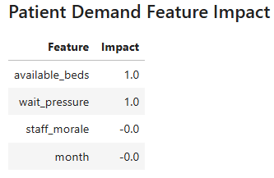

A3. Patient Demand Predictive Model
This section presents the implementation of the regression model used to forecast weekly patient demand based on operational and staffing-related features.
FEATURES = ["available_beds", "staff_morale", "month", "wait_pressure"]
X = services[FEATURES]
y = services["patients_request"]
X_train, X_test, y_train, y_test = train_test_split(X, y, test_size=0.3, random_state=42)
reg_model = LinearRegression()
reg_model.fit(X_train, y_train)
y_pred = reg_model.predict(X_test)
mae = mean_absolute_error(y_test, y_pred)
display(HTML(f"<h3>Patient Demand Forecast MAE: {mae:.2f}</h3>"))

A4. Staff Absenteeism Predictive Model
This section details the classification approach used to predict staff absenteeism using role, service assignment, and temporal features.
staff_weekly = schedule.merge(staff, on=["staff_id", "staff_name", "role", "service"], how="left")
le = LabelEncoder()
staff_weekly["service_enc"] = le.fit_transform(staff_weekly["service"])
staff_weekly["role_enc"] = le.fit_transform(staff_weekly["role"])
X_clf = staff_weekly[["week", "service_enc", "role_enc"]]
y_clf = staff_weekly["absent"]
X_train, X_test, y_train, y_test = train_test_split(X_clf, y_clf, test_size=0.3, random_state=42)
clf = LogisticRegression(max_iter=200)
clf.fit(X_train, y_train)
y_pred = clf.predict(X_test)
accuracy = accuracy_score(y_test, y_pred)
display(HTML(f"<h3>Staff Absenteeism Prediction Accuracy: {accuracy:.2f}</h3>"))

A5. Prescriptive Analysis Scenarios

A5a. Scenario 1: Increase bed capacity by 10%
This table summarizes the estimated changes in patient demand and refusal rates under a 10% increase in bed capacity.
.
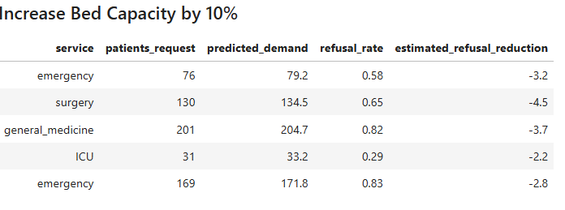

A5b. Scenario 2: Increase staff morale by 5 points
This table presents the estimated impact of improved staff morale on patient demand and refusal rates.

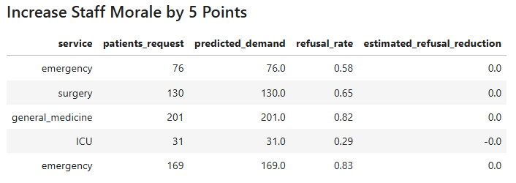

A5c. Scenario 3: Beds + Morale
This table illustrates the combined impact of increased bed capacity and improved staff morale on patient demand and refusal reduction.

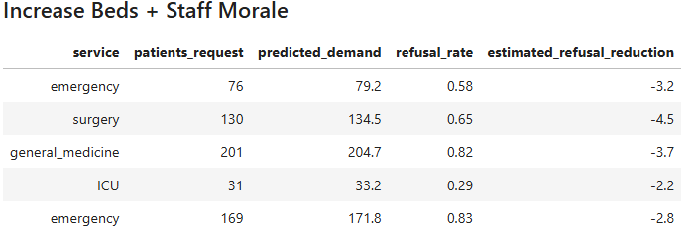

6. Service-Level Operational Metrics
This visual summarizes average patient length of stay by service.
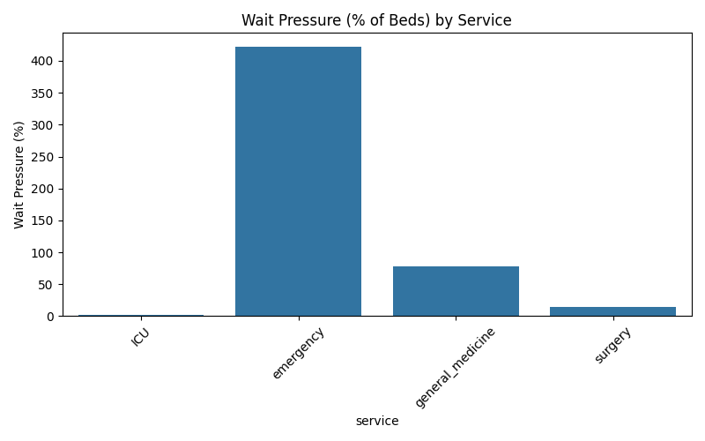

References
Kaggle. (n.d.). Healthcare staff scheduling dataset. Kaggle. https://www.kaggle.com/datasets/kenwasisa/healthcare-staff-scheduling
Cerkl. (n.d.). Predictive workforce analytics. Cerkl. https://cerkl.com/blog/predictive-workforce-analytics
American Society of Anesthesiologists. (2022, January 28). Using AI to create work schedules significantly reduces physician burnout. https://www.asahq.org/about-asa/newsroom/news-releases/2022/01/using-ai-to-create-work-schedules-significantly-reduces-physician-burnout
Honey Health. (n.d.). Can AI help hospitals predict staffing needs more accurately? Honey Health. https://www.honeyhealth.ai/articles/can-ai-help-hospitals-predict-staffing-needs-more-accurately
Workeen AI. (n.d.). Healthcare workforce management with AI-optimized scheduling. Workeen AI. https://workeen.ai/healthcare/

