Banking Loan Portfolio Analysis
Credit risk, defaults and approvals using Python, SQL and Power BI
Portfolio snapshot: 30 June 2025 | Synthetic dataset

1. Executive summary
This project evaluates the health of a bank's loan portfolio and identifies the factors linked to default risk. It covers 12,000 loan applications received between January 2022 and December 2024, of which 4,825 were approved and became loans with an outstanding balance of 387.1 million. The analysis was built in three stages: Python for cleaning and exploration, SQL for business queries, and a four-page Power BI dashboard for interactive reporting.
The portfolio is healthy overall but carries concentrated pockets of risk. The headline findings are:
- Default rate is 6.3%. 304 of 4,825 loans are 90 or more days past due, with 15.2 million of exposure (3.9% of the portfolio).
- Credit score is the strongest risk driver. Borrowers with Poor credit (below 580) default at 34.6%, about 5.5 times the portfolio average, while Excellent borrowers (740+) default at only 0.5%.
- Product matters. Business loans default at 11.7% and Personal loans at 7.5%, against 2.9% for Home loans.
- Delinquency is building. 622 accounts are past due, holding 43.3 million (11.2% of the portfolio). 318 of these are overdue by 1 to 89 days and can still be recovered.
- Concentration risk. Home loans account for 255 million of 387 million in outstanding balances (66%).
- Approval policy is consistent with risk. Only 40.2% of applications are approved, and approval depends mainly on credit score and employment type, not on age or region.

2. Business problem and objectives
A bank needs to know whether its loan book is performing, where losses are likely to come from, and whether its lending rules are working. This project answers five business questions:
- What share of applications is approved, and does it differ by customer segment?
- Which accounts are overdue, and how old is the delinquency?
- Which loan types have the highest default rates?
- How do income, credit score and loan amount relate to default?
- How have default rates and new defaults changed over time?
The results are delivered as clear visual summaries and an interactive dashboard covering default-rate trends, aging analysis and segment-wise approval rates.

3. Data and approach

3.1 Data
The dataset is synthetic, generated with a Python script so that realistic relationships exist (low credit score and high loan-to-income raise default risk) and so that dates, loan types and repayment status are available. It has two tables linked by application_id:
Table | Rows | Content
Loan applications | 12,000 | Every application, approved or rejected, with customer segment, income, credit score, loan type and rejection reason
Loans | 4,825 | Approved loans with amount, tenure, interest rate, status (Current, Closed, Overdue, Default), days past due and outstanding balance

The data deliberately included missing values, duplicates, inconsistent text and outliers, so that a real cleaning step was needed.

3.2 Cleaning and feature engineering (Python)
- Removed 60 duplicate applications and 40 duplicate loans.
- Standardised text such as region names and loan types, and parsed all dates.
- Filled missing income and credit scores with the median (income is skewed), and labelled missing categories as Unknown.
- Capped extreme income values at the 99th percentile.
- Created default and overdue flags, credit-score bands (Poor, Fair, Good, Excellent), income and loan-size quartiles, loan-to-income bands and days-past-due buckets (1-30, 31-60, 61-90, 90+).

3.3 Analysis (SQL)
Twenty-nine queries cover KPIs, approval rate by segment, default rate by loan type and risk band, aging buckets, and flagged overdue accounts. More advanced queries use window functions (LAG, NTILE, RANK) for quarter-over-quarter trends, and common table expressions to find segments with above-average default rates. SQL results were checked against the Python results and matched.

3.4 Reporting (Power BI)
The four-page dashboard is built on the cleaned loans and applications tables. DAX measures calculate default rate, approval rate, overdue exposure, 90+ day exposure and cumulative defaults.

4. Key findings

4.1 Portfolio health
Of 4,825 loans, 3,414 are Current (70.8%), 789 are Closed (16.4%), 318 are Overdue (6.6%) and 304 are in Default (6.3%). The portfolio value is 387.1 million. Overdue and defaulted loans together make up 12.9% of loans by count.

4.2 Default rate by loan type
Loan type | Default rate | Outstanding balance
Business | 11.7% | 41.0M
Personal | 7.5% | 20.9M
Auto | 5.4% | 40.2M
Education | 4.8% | 30.1M
Home | 2.9% | 255.0M

Unsecured and business lending carries the most risk. Home loans are the safest product but hold two thirds of the exposure, so a downturn in housing would have a large impact.

4.3 Risk drivers
Credit score. Default risk falls steeply as credit score rises: Poor 34.6%, Fair 13.1%, Good 4.1% and Excellent 0.5%. Defaults cluster below a score of about 650 and are almost absent above 750. A logistic regression model confirmed credit score as the leading factor and reached a test ROC-AUC of 0.87.
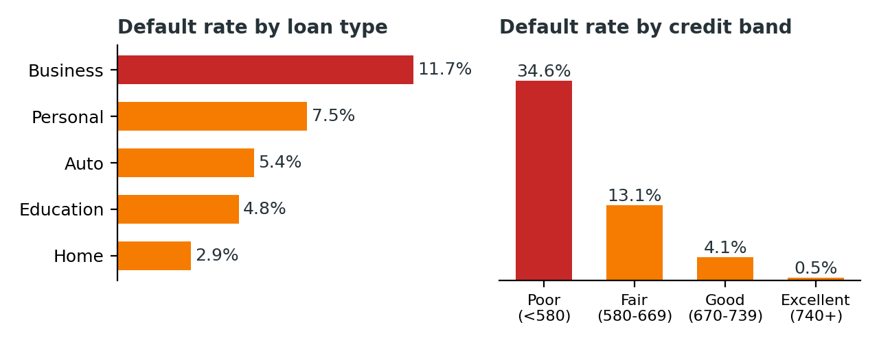
Figure 1. Default rate by loan type and by credit score band.
Income. Default rates decline as income rises, from 9.7% for the lowest income quartile to 2.8% for the highest.
Loan size and loan-to-income. Small loans appear riskiest (9.5%) and loans above 3 times income appear safest (3.3%), but both results are distorted by product mix. Small loans are mostly Personal loans, and high-ratio loans are mostly Home loans. Within a single product, the expected pattern holds: Home loan default rises from 1.6% to about 3.9% as loan-to-income grows, and Business loan default rises from 6.8% to 15.6%. This is an example of Simpson's paradox, and shows why segments should be compared within a product rather than across the whole book.
Combined effect. Poor-credit borrowers in Business and Auto loans default at about 41%, the highest-risk group in the portfolio.

4.4 Aging and overdue accounts
Days past due | Accounts | Exposure
1-30 | 162 | 14.6M
31-60 | 99 | 7.8M
61-90 | 57 | 5.7M
90+ (default) | 304 | 15.2M

The 318 overdue accounts hold 28.1 million, with an average of 34.7 days past due. Home loans carry the largest overdue balance (15.1 million) even though their default rate is the lowest, because the loans are so large. By region, Central has the highest default rate (8.8%) and East the lowest (4.6%).

4.5 Approval patterns
The overall approval rate is 40.2%. Approval is driven by credit score, which ranges from about 11% for Poor credit to about 70% for Excellent credit, and by employment type: Salaried applicants are approved 45.8% of the time, Business Owners 35.8%, Self-Employed 34.5% and Retired applicants 25.8%. Age group and region make almost no difference (39% to 42%), which is a healthy sign of consistent lending.
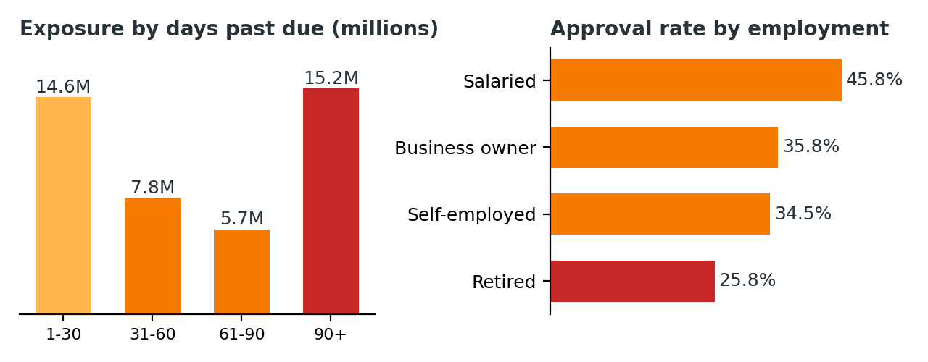
Figure 2. Exposure by days past due, and approval rate by employment type.
Of 7,175 rejections, 3,320 (46%) were for low credit score, 1,490 for insufficient documents, 1,428 for policy mismatch and 937 for high loan-to-income. Retired applicants are approved least and also default most (9.6%), which suggests the stricter approval standard is justified.

4.6 Trends over time
For loans issued up to mid-2024, the quarterly default rate stays between 6% and 8.5%. The sharp fall in later quarters (2.7% in 2024 Q3 and 1.2% in 2024 Q4) is not an improvement: those loans are still too young to have reached 90 days past due. Monthly new defaults rose from 1 to 5 in 2023 to as many as 28 in April and June 2025, and 115 of the 304 defaults (38%) occurred in the first half of 2025, showing that the portfolio is maturing.

5. Dashboard overview
The Power BI dashboard has four pages, each with KPI cards and charts. Every page uses a consistent black and orange design.
Page | Purpose | Main visuals
Portfolio Overview | How healthy is the loan book? | KPI cards, default rate by quarter, new and cumulative defaults, loan status, exposure by loan type, default rate by region
Aging and Overdue | Which accounts are past due and how much is at risk? | Accounts and exposure by days past due, overdue exposure by loan type, flagged accounts table
Risk Drivers | What is linked to default? | Default rate by credit, income, loan size and loan type, scatter plot, loan type by credit band heatmap
Approval Analysis | Who is approved and why are others rejected? | Approval gauge, funnel, rejection waterfall, employment by loan type heatmap

6. Recommendations
- Tighten underwriting for Poor-credit applicants. With a 34.6% default rate, applicants below 580 should face lower limits, higher pricing or additional security, especially for Business and Auto loans, where the default rate for this group is about 41%.
- Start early collections at 30 days. 156 accounts (13.5 million) are 31 to 89 days past due and could roll into default. Outreach at 1 to 30 days (162 accounts, 14.6 million) is the cheapest point to intervene.
- Manage Home loan concentration. Two thirds of the exposure sits in one low-default product. Set concentration limits and stress-test the Home portfolio.
- Review the Central region. Its default rate (8.8%) is nearly twice that of the East. Investigate the loan mix and collection practice there.
- Price and monitor Personal and Business loans by risk. Use risk-based pricing and credit-band limits for products with default rates of 7.5% and 11.7%.
- Monitor by cohort. Track default rates at the same loan age rather than by calendar quarter, so newer loans are not mistaken for better ones.

7. Limitations and next steps
- The data is synthetic, so the specific numbers illustrate the method and should not be read as findings about any real bank.
- Default is defined as 90 or more days past due, and the snapshot date is 30 June 2025. Loans issued in the latest quarters are right-censored.
- The analysis shows association, not causation, and it excludes macroeconomic factors such as interest rates or unemployment.
- Missing income and credit scores were filled with medians, which can slightly understate variation.
Next steps: build a vintage (cohort-by-loan-age) analysis, extend the logistic regression into a scored risk model with a probability-of-default band for each loan, add loss-given-default and expected-loss estimates, and automate the data refresh so the dashboard updates monthly.

