Amazon Fresh Analytics
SQL Project Documentation — E-commerce & Retail Analytics

Task 1: Entity-Relationship (ER) Diagram
The Amazon Fresh database consists of 7 tables. Each box below represents one table, with its Primary Key (PK) and Foreign Keys (FK) listed. Lines show one-to-many (1:N) relationships between tables.
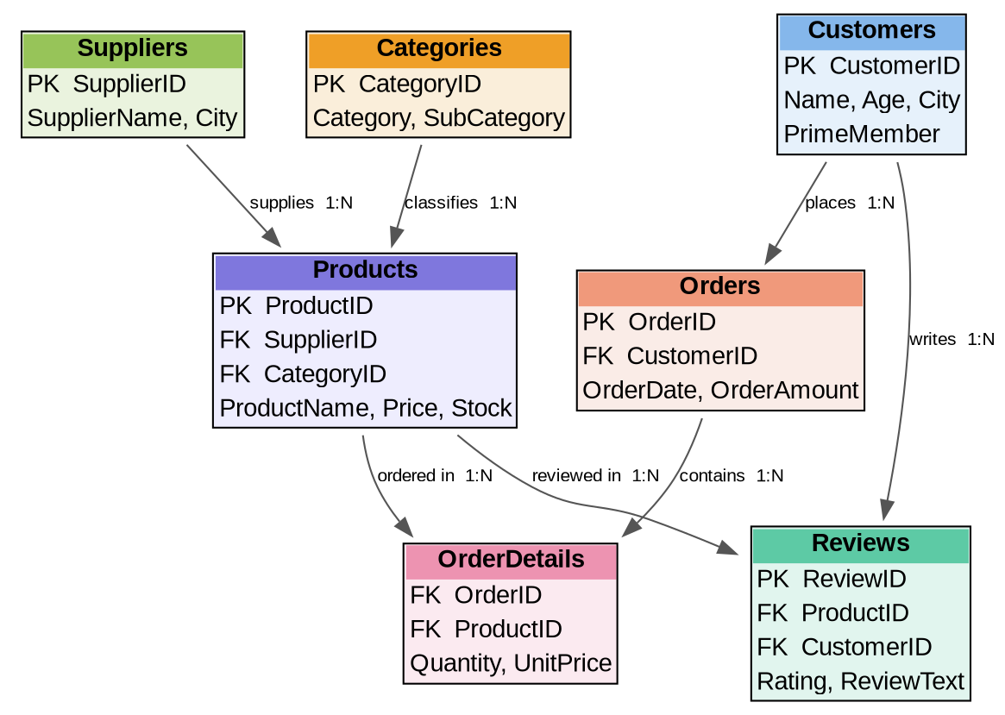

Task 2: Primary Keys and Foreign Keys

Primary Keys
Table | Primary Key
Customers | CustomerID
Suppliers | SupplierID
Products | ProductID
Categories | CategoryID
Orders | OrderID
OrderDetails | OrderDetailID (or composite: OrderID + ProductID)
Reviews | ReviewID

Foreign Keys and Relationships
Table.Column | References
Products.SupplierID | Suppliers.SupplierID
Products.CategoryID | Categories.CategoryID
Orders.CustomerID | Customers.CustomerID
OrderDetails.OrderID | Orders.OrderID
OrderDetails.ProductID | Products.ProductID
Reviews.ProductID | Products.ProductID
Reviews.CustomerID | Customers.CustomerID

Task 3: Basic SELECT + WHERE Queries
Retrieve all customers from a specific city:
SELECT * FROM Customers
WHERE City = 'Christopherland';
Fetch all products under the "Fruits" category:
SELECT * FROM Products
WHERE Category = 'Fruits';

Task 4: DDL — Customers Table with Constraints
CREATE TABLE Customers (
CustomerID VARCHAR(50) PRIMARY KEY,
Name VARCHAR(100) UNIQUE,
Age INT NOT NULL CHECK (Age > 18),
Gender VARCHAR(10),
City VARCHAR(100),
State VARCHAR(100),
Country VARCHAR(100),
SignupDate DATE,
PrimeMember VARCHAR(10)
);

Task 5: INSERT — New Products
INSERT INTO Products (ProductID, ProductName, Category, SubCategory, PricePerUnit, StockQuantity, SupplierID)
VALUES
('a001', 'Cherry', 'Fruits', 'Sub-Fruits-5', 101, 35, NULL),
('a002', 'Jackfruit', 'Fruits', 'Sub-Fruits-6', 117, 89, NULL),
('a003', 'Butter', 'Dairy', 'Sub-Dairy-4', 300, 149, NULL);

Task 6: UPDATE — Stock Quantity
UPDATE Products
SET StockQuantity = 90
WHERE ProductID = 'a002';

Task 7: DELETE — Supplier by City
DELETE FROM Suppliers
WHERE City = 'Schneidermouth';

Task 8: CHECK and DEFAULT Constraints
CHECK constraint — Reviews rating must be between 1 and 5:
ALTER TABLE Reviews
ADD CONSTRAINT chk_rating CHECK (Rating BETWEEN 1 AND 5);
DEFAULT constraint — PrimeMember defaults to 'No':
ALTER TABLE Customers
MODIFY COLUMN PrimeMember VARCHAR(5) DEFAULT 'No';

Task 9: WHERE, HAVING, GROUP BY, ORDER BY
Orders placed after 2024-01-01:
SELECT * FROM Orders
WHERE OrderDate > '2024-01-01';
Products with average rating greater than 4:
SELECT ProductID, AVG(Rating) AS AvgRating
FROM Reviews
GROUP BY ProductID
HAVING AVG(Rating) > 4;
Rank products by total sales:
SELECT ProductID, SUM(Quantity * UnitPrice) AS TotalSales
FROM OrderDetails
GROUP BY ProductID
ORDER BY TotalSales DESC;

Task 10: Identifying High-Value Customers
SELECT CustomerID, SUM(OrderAmount) AS TotalSpending
FROM Orders
GROUP BY CustomerID
HAVING SUM(OrderAmount) > 5000
ORDER BY TotalSpending DESC;

Task 11: Complex Aggregations and Joins
Total revenue per order:
SELECT o.OrderID, SUM(od.Quantity * od.UnitPrice) AS TotalRevenue
FROM Orders o
JOIN OrderDetails od ON o.OrderID = od.OrderID
GROUP BY o.OrderID
ORDER BY TotalRevenue DESC;
Customers with the most orders in a date range:
SELECT CustomerID, COUNT(OrderID) AS N_order
FROM Orders
WHERE OrderDate BETWEEN '2023-01-01' AND '2024-12-31'
GROUP BY CustomerID
ORDER BY N_order DESC
LIMIT 10;
Supplier with the most products in stock:
SELECT s.SupplierID, s.SupplierName, SUM(p.StockQuantity) AS TotalStock
FROM Suppliers s
JOIN Products p ON s.SupplierID = p.SupplierID
GROUP BY s.SupplierID, s.SupplierName
ORDER BY TotalStock DESC
LIMIT 1;

Task 12: Normalization to 3NF
Category and SubCategory were separated into a new Categories table, linked to Products via a Foreign Key (CategoryID):
CREATE TABLE Categories (
CategoryID INT AUTO_INCREMENT PRIMARY KEY,
Category VARCHAR(50),
SubCategory VARCHAR(50)
);

INSERT INTO Categories (Category, SubCategory)
SELECT DISTINCT Category, SubCategory FROM Products;

ALTER TABLE Products ADD COLUMN CategoryID INT;

UPDATE Products p
JOIN Categories c ON p.Category = c.Category AND p.SubCategory = c.SubCategory
SET p.CategoryID = c.CategoryID;

ALTER TABLE Products
ADD CONSTRAINT fk_category FOREIGN KEY (CategoryID) REFERENCES Categories(CategoryID);

Task 13: Subqueries and Nested Queries
Top 3 products by sales revenue:
SELECT * FROM (
SELECT ProductID, SUM(Quantity * UnitPrice) AS TotalRevenue
FROM OrderDetails
GROUP BY ProductID
) AS ProductRevenue
ORDER BY TotalRevenue DESC
LIMIT 3;
Customers who haven't placed any orders:
SELECT CustomerID, Name
FROM Customers
WHERE CustomerID NOT IN (
SELECT DISTINCT CustomerID FROM Orders
);
Result: Out of 1,000 total customers, 989 have placed at least one order, and 11 customers have never ordered.

Task 14: Real-World Business Insights
Cities with the highest concentration of Prime members:
SELECT City, COUNT(*) AS PrimeMemberCount
FROM Customers
WHERE PrimeMember = 'Yes'
GROUP BY City
ORDER BY PrimeMemberCount DESC
LIMIT 10;
Top 3 most frequently ordered categories:
SELECT c.Category, SUM(od.Quantity) AS TotalQuantityOrdered
FROM OrderDetails od
JOIN Products p ON od.ProductID = p.ProductID
JOIN Categories c ON p.CategoryID = c.CategoryID
GROUP BY c.Category
ORDER BY TotalQuantityOrdered DESC
LIMIT 3;

Summary of SQL Concepts Practiced
Category | Concepts
DDL | CREATE TABLE, ALTER TABLE, DROP TABLE
DML | INSERT, UPDATE, DELETE, SELECT
Constraints | PRIMARY KEY, FOREIGN KEY, UNIQUE, NOT NULL, CHECK, DEFAULT
Filtering | WHERE, BETWEEN, IN, NOT IN
Aggregation | COUNT, SUM, AVG, MIN, MAX
Grouping | GROUP BY, HAVING
Sorting | ORDER BY, LIMIT
Joins | INNER JOIN, multi-table JOIN, LEFT JOIN
Subqueries | Nested SELECT, NOT IN filtering
Normalization | 3NF — splitting repeated data into lookup tables
Prepared as part of SQL practice — Amazon Fresh Analytics project (Vinsup Skill Academy).

