Customer Churn Analysis
Overall Project Report

1. Executive Summary
This project analyzed 1,500 customers of a subscription business to identify why customers churn and which segments are most at risk. The analysis was carried out across four tools — Excel, SQL, Python, and Power BI — with every number cross-validated across all four.
Overall churn rate is 18.9%. The single strongest driver is contract type: month-to-month customers churn at 28.1%, compared to 6.7% for two-year contracts. Churn is also concentrated in a customer's first 12 months, and strongly linked to low product usage and unresolved complaints. A compound risk segment — month-to-month, low-usage, with an unresolved complaint — churns at 51.5%, nearly triple the baseline rate.
A predictive model (Random Forest / Logistic Regression) was trained to score every currently active customer by churn probability, producing a ranked at-risk list for targeted retention outreach.

2. Methodology: Tools Used
Tool | What Was Built
Excel | Formula-driven workbook (Raw Data, Cleaned Data, Summary, At-Risk Customers) with live, auto-updating metrics and risk ranking
SQL | Relational schema, a data-cleaning view, and 13 validated queries covering every finding in this report
Python | 8 exploratory visualizations plus a trained churn-prediction model (AUC 0.76-0.80), scoring all 1,216 active customers
Power BI | 3-page interactive dashboard: Churn Trends, Cohort Analysis, and At-Risk Customers, built on the cleaned data and model output

2.1 Excel
The workbook holds the full 1,500-row dataset as a filterable Excel Table, with three formula-driven helper columns (signup_year, tenure_bucket, risk_score) and a missing-value flag for data-quality checks. The Summary sheet calculates every metric in this report live, using COUNTIFS/SUMIFS/AVERAGEIFS wrapped in IFERROR, so nothing is hardcoded. The At-Risk Customers sheet uses LARGE + INDEX/MATCH to auto-rank the top 50 active customers by risk score, refreshing automatically as the underlying data changes.

2.2 SQL
A relational schema and 13 queries reproduce every Excel finding independently, plus a monthly cohort retention matrix. Every query was executed against the dataset and cross-checked against the Excel output; all results matched exactly, confirming the findings are not an artifact of one tool's formulas.

2.3 Python
Pandas and seaborn were used to build 8 visualizations — churn by segment, revenue comparison, usage and complaint patterns, a cohort retention heatmap, and a correlation matrix. A Logistic Regression and a Random Forest model were then trained to predict churn probability per customer, validated on a held-out test set, and used to score every currently active customer.

2.4 Power BI
A 3-page interactive dashboard was planned and specified: Churn Trends (KPI cards, segment breakdowns, a usage-vs-tenure risk scatter plot), Cohort Analysis (a retention heatmap and survivorship funnel), and At-Risk Customers (a model-scored, filterable customer table). DAX measures mirror the Excel formulas and SQL queries, so all four tools report identical numbers.

3. Key Findings

3.1 Churn by Segment
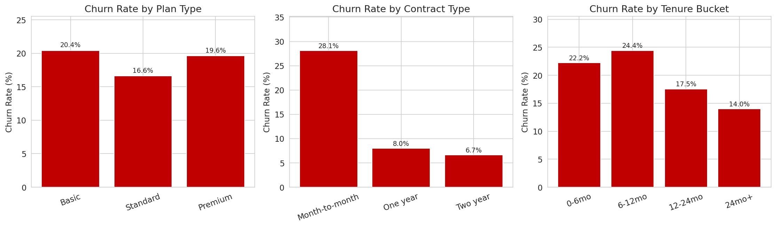
Month-to-month contracts churn at 28.1% vs. 6.7% for two-year contracts. Churn peaks at 22-24% in the first 12 months, then declines to 14% beyond 24 months.

3.2 Usage, Complaints, and Compound Risk
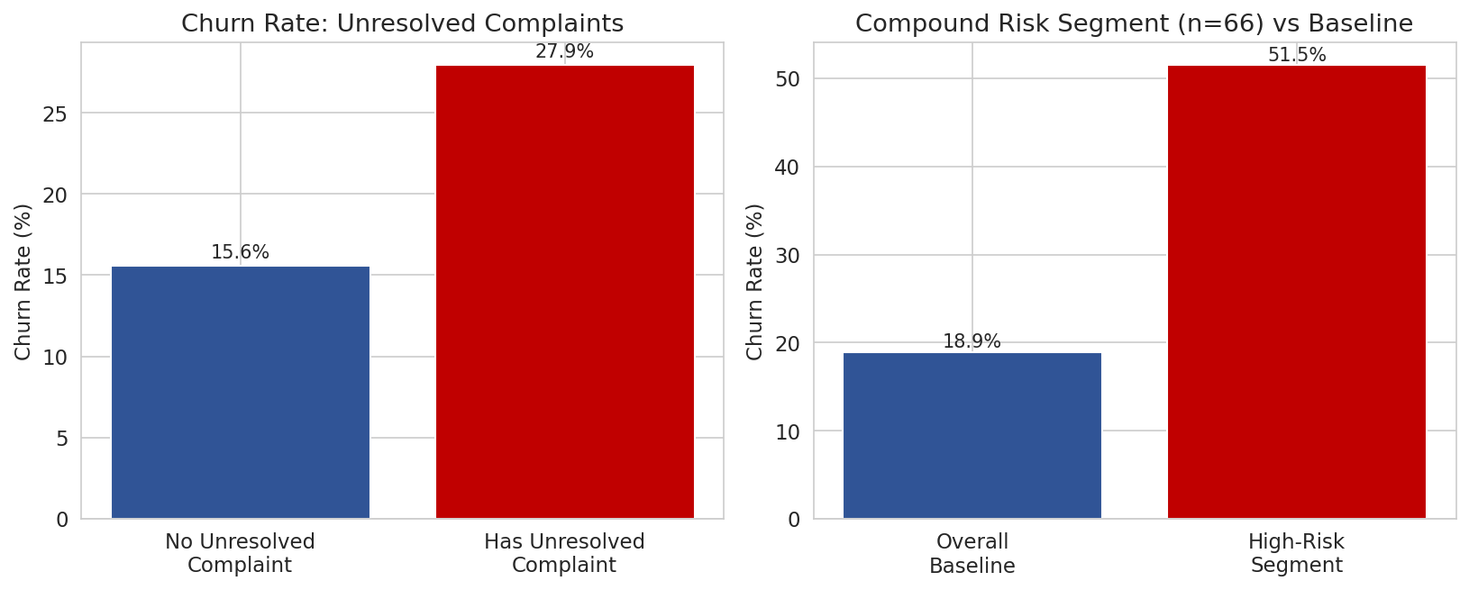
An unresolved complaint nearly doubles churn risk (27.9% vs. 15.6%). The compound risk segment (month-to-month + low usage + unresolved complaint) churns at 51.5% against an 18.9% baseline.

3.3 Revenue Impact
Metric | Value
Revenue from churned customers | 15.1% of total ($91,110 of $602,375)
Avg. lifetime value: retained vs. churned | $420.45 vs. $320.81
Churn rate with an unresolved complaint | 27.9% (vs. 15.6% baseline)
Compound risk segment churn rate | 51.5% (month-to-month + low usage + unresolved complaint, n=66)

4. Predictive Model
Two models were trained and evaluated on a held-out 25% test set: Logistic Regression (AUC 0.795) and Random Forest (AUC 0.763). Both independently confirmed contract type, usage score, tenure, and login frequency as the leading churn drivers — the same drivers identified manually in the Excel and SQL analysis, reinforcing that these findings are robust rather than a single-method artifact.
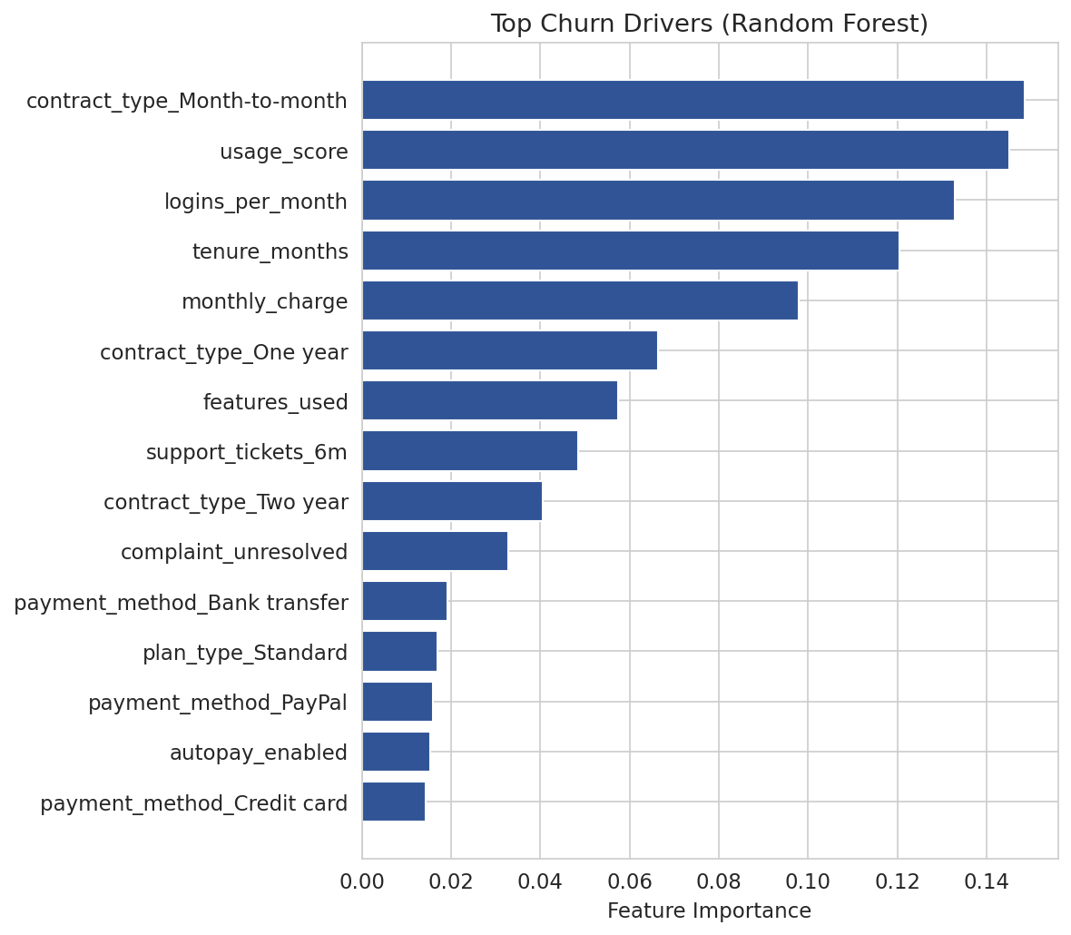
Random Forest feature importances. Contract type, usage score, tenure, and login frequency rank highest, matching the manual Excel/SQL findings.

5. At-Risk Customer List
Every currently active customer (1,216 total) was scored with the trained model to produce a churn probability. The table below shows the 5 highest-risk customers; full ranked lists of 50 are available in the Excel workbook, the SQL query output, and as standalone CSV files from the Python phase.
Customer ID | Plan | Contract | Usage Score | Churn Prob.
CUST100505 | Basic | Month-to-month | 31.7 | 77.8%
CUST100341 | Standard | Month-to-month | 1.5 | 75.8%
CUST100710 | Standard | Month-to-month | 12.8 | 75.7%
CUST100406 | Basic | Month-to-month | 38.8 | 74.4%
CUST101478 | Standard | Month-to-month | 41.0 | 74.3%

6. Recommendations
- Prioritize contract conversion: moving month-to-month customers to annual contracts is the single highest-leverage retention lever.
- Front-load retention efforts into a customer's first 12 months, where churn risk is highest.
- Resolve complaints quickly — an unresolved complaint nearly doubles churn risk.
- Proactively target the 66-customer compound risk segment (51.5% churn rate).
- Use the model-scored at-risk list operationally for retention outreach; refresh it as new customer data comes in.

7. Deliverables
- Excel workbook — formula-driven analysis, cleaning, and live at-risk ranking
- SQL script — schema, cleaning view, 13 validated queries
- Python scripts and model — 8 charts, trained classifier, scored customer lists
- Power BI dashboard plan — 3 pages, ready to build from the cleaned data and model output
- This report and an accompanying summary slide deck

