**MongoDB**

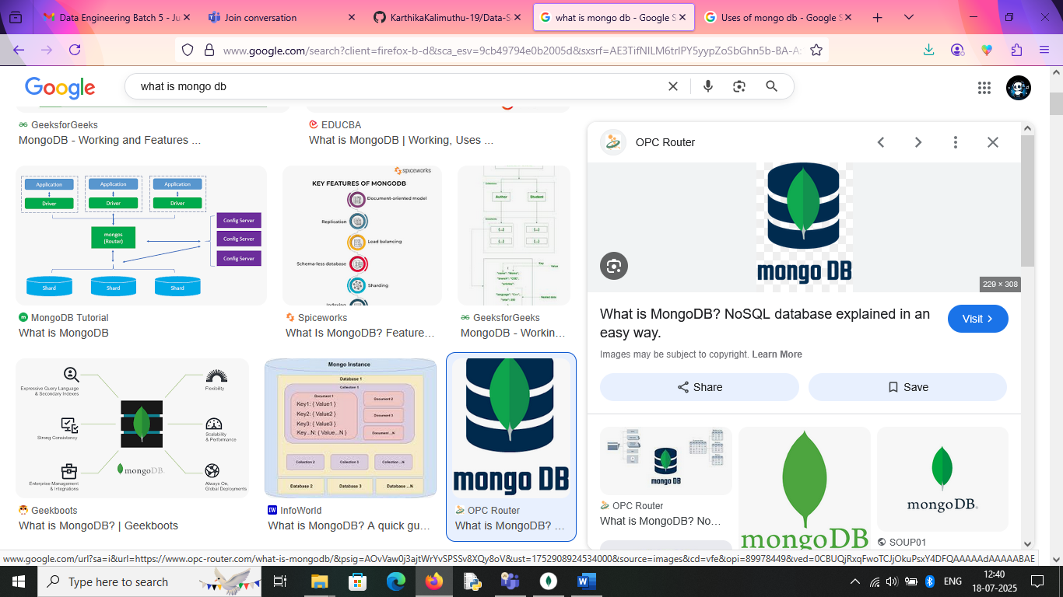MongoDB is an **open-source document-oriented database** that is designed to store a large scale of data and allows us to work with that data efficiently**.** It is categorized under the NoSQL database because the storage and retrieval of data in the MongoDB are not in the form of tables. **MongoDB database** is developed and managed by MongoDB. Inc. under SSPL (Server-Side Public License) and initially released in February 2009.

It also provides official driver support for all the popular languages like C, C++, C#, and .Net, Go, Java, Node.js, Perl, PHP, Python, Motor, Ruby, Scala, Swift, Mongoid. So, that we can create an application using any of these languages. Nowadays there are so many companies that use MongoDB like Facebook, Nokia, eBay, Adobe, Google, etc. to store their large amount of data.

* MongoDB is a NoSQL database, meaning it doesn't rely on the traditional relational database model (SQL).
* Instead of tables and rows, MongoDB stores data in documents, which are essentially key-value pairs, similar to JSON.
* MongoDB's document model allows for dynamic schemas, meaning documents within the same collection can have different fields. This provides greater flexibility when dealing with evolving data requirements.
* MongoDB is designed for high availability and scalability, making it suitable for handling large amounts of data and high traffic.
* MongoDB is widely used in various applications, including content management systems (CMS), mobile apps, e-commerce platforms, and real-time analytics.
* It is one of the most popular NoSQL databases and a widely used tool for developers due to its ease of use and flexible data model.

**Uses of MongoDB**

MongoDB is a popular NoSQL database known for its flexibility, scalability, and performance. It is widely used in various applications across different industries. Here are some common uses of MongoDB:

* MongoDB's flexible schema handles diverse content types (articles, blogs, media) efficiently.
* It manages product catalogs, customer data, and transaction records, scaling to handle high volumes of transactions and complex queries.
* MongoDB excels at ingesting and querying data from various sources in real-time, enabling timely insights.
* IoT applications generate vast amounts of data, which MongoDB can efficiently store and analyze.
* MongoDB handles complex data structures like player profiles, game states, and user interactions.
* It is used to store and synchronize data across devices, providing a seamless user experience for mobile apps.
* MongoDB's ability to manage complex relationships and user-generated content makes it suitable for social media platforms.
* In healthcare, MongoDB manages electronic health records, patient information, and medical imaging data.

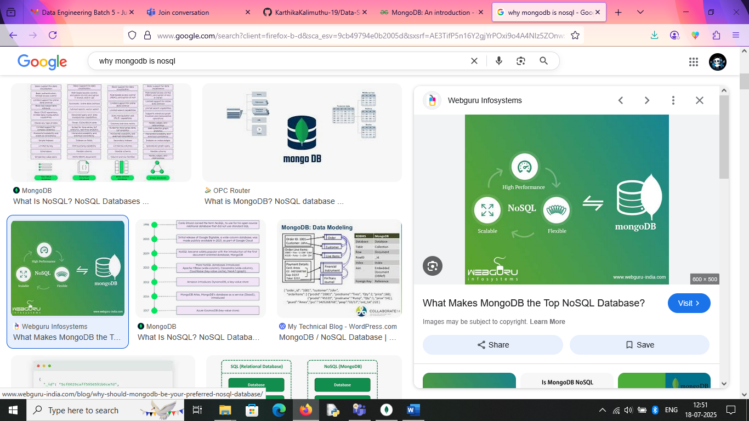**Why NoSQL?**

MongoDB is the most popular NoSQL open-source document-oriented database. The term 'NoSQL' means 'non-relational'. This means that MongoDB is not based on a table like relational database structure but provides an altogether different mechanism for storage and retrieval of data. This format of storage is called BSON (similar to JSON format).

Example:

{  
 "name":"Alice",  
 "age":30,  
 "hobbies":["reading","traveling"]  
 }

* SQL databases store data in tabular format. These data are stored in a predefined data model which is not flexible for highly growing applications in today's real world.
* Modern applications are more social, interactive and networked than ever. Application stores more and more data and accessing them at higher rates.
* Relational Database Management System is not the correct choice when it comes to handle big data by the virtue of their design since they are not horizontally scalable. If the database runs on a single server, then it will reach a scaling limit.
* NoSQL databases are more scalable and provide superior performance. MongoDB scales by adding more and more servers and increases productivity with its flexible document model.

**Advantages**

MongoDB, as a NoSQL database, offers several advantages, primarily due to its flexible document model and scalability features. These include handling diverse data types, easy horizontal scaling, high performance, a strong developer community, and a user-friendly query language. It's also known for its robust indexing system and support for sharding, which enables horizontal scaling and high availability.

* MongoDB stores data in flexible, JSON-like documents, making it easy to handle varying data structures and evolve your data model without major schema changes.
* MongoDB excels at scaling out by distributing data across multiple servers (sharding), allowing it to handle massive datasets and high traffic loads.
* MongoDB provides a powerful query language that supports complex queries, aggregations, and indexing, enabling efficient data retrieval.
* The document model makes it easier to represent complex, nested data structures and relationships compared to traditional relational databases.
* NoSQL databases, including MongoDB, can be more cost-effective than traditional relational databases, especially for large-scale deployments.
* MongoDB's document-oriented approach and intuitive query language make it easier for developers to work with and build applications.

MongoDB's document-oriented structure, scalable architecture through sharding and robust features like indexing and aggregation. It is a preferred choice for modern applications handling large volumes of data. Its ability to manage distributed data effectively and support a wide array of programming languages, [MongoDB](https://www.geeksforgeeks.org/mongodb-tutorial/) continues to empower developers to build scalable and efficient applications.