# 221501057

# 6. FACE DETECTION METHOD IN OPENCV USING PYTHON

|  |  |
| --- | --- |
| **EX.N0 : 6** | **LOAD AND IMPLEMENT THE FACE DETECTION METHOD IN OPENCV USING PYTHON** |
| **DATE : 04/03/2025** |

**AIM:**

To load and implement real-time face detection using OpenCV and Haar Cascade Classifier.

# ALGORITHM:

Step 1: Import OpenCV library.

Step 2: Load the Haar cascade classifier for face detection. Step 3: Access webcam video using cv2.VideoCapture ().

Step 4: Read frames continuously and convert them to grayscale.

Step 5: Detect faces using detectMultiScale() method.

Step 6: Draw rectangles around detected faces and display the video

# PROGRAM:

import cv2

face_cascade = cv2.CascadeClassifier(cv2.data.haarcascades + 'haarcascade_frontalface_default.xml')

cap = cv2.VideoCapture(0) while True:

ret, frame = cap.read() if not ret:

break

gray = cv2.cvtColor(frame, cv2.COLOR_BGR2GRAY)

faces = face_cascade.detectMultiScale(gray, scaleFactor=1.1, minNeighbors=5) for (x, y, w, h) in faces:

221501057

cv2.rectangle(frame, (x, y), (x + w, y + h), (0, 255, 0), 2) cv2.imshow("Face Detection", frame)

if cv2.waitKey(1) & 0xFF == ord('q'): break

cap.release() cv2.destroyAllWindows()

# OUTPUT:

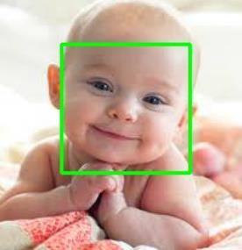

**RESULT:**

Thus the Program has been executed successfully and verified.