Assume that the company you work for is planning to start building houses in Antarctica in the next ten years. Your role is Technical Project Manager. A seminar will soon be organized with experts on issues related to this task. What would you like to clarify with them to start working on the project? Prepare a list of specific questions, answers to which you will need to start designing the houses and the required infrastructure.

Seminar Topic: Technical discussion on building houses in Antarctica in a span of 10 years

Agenda: Clarification on below queries

1. Building Material to use
   1. Raw materials used for building house
   2. Raw materials availability
   3. Raw materials ability to withstand extreme climatic conditions
   4. Raw materials financial feasibility
   5. Customer’s satisfaction towards the material
2. Building Design – utilizing the benefits of climate in its maximum to get the aesthetic appeal, acceptance by customer
3. Building Plumping – Availability of water, maintaining temperature of water
4. Building Drainage – Ways to recycle water, maintain temperature of water so that there is no blockage
5. Building Power – Main source of power, power for heating building, Secondary source of power in case of any emergency
6. Temperature and humidity control – Ways to control temperature and humidity inside the building
7. Legal and environmental impact of building – To clear all the legal issues, get environmental clearance for the building
8. Waste disposal- Ways for disposal of solid waste
9. Transportation challenges – Transportation of labours, raw materials and daily necessities of building including heating cost of building
10. Challenges due to global warming – 3°C/year increase is estimated, building should be able to cope up with change in temperature (e.g., snow may melt and the depth of piling done for building may vary)
11. Disaster Mitigation plan – In case of any disaster, emergency route for escape, ways to let the rescue team know about it
12. Contingency plan in case of medical emergency – Ways to get help from medical team
13. Estimate the number of mechanical weighing scales in operation in the Czech Republic. Nobody knows the exact number but try to estimate it as closely as possible. Explain your reasoning.

**Weighing machinery (excluding balances of a sensitivity of 5 cg or better), including weight operated counting or checking machines; weighing machine weights of all kinds - from Czech Republic in 2022 represented by the following main commodity groups:**

Czech Republic population = 10,827,529.

As per annual international trade statistics of the country, In 2019, 221,913 machines were exported. The export of Weighing machines; weights of all kinds, parts of weighing machinery amounted in the range of **30,061,400 – 29,237,168 USD export value in this range 🡪 Average range, 29,649,284 USD**

**Implies 1 machine cost 133.7 USD( approximate value)**

**In 2022, export value in USD is 31,255,658 and import is 27,700,834. Hence total turnover value is -3554824 USD.**

3554824/133.7 => 26588 machines where exported. (2023 value) . Considering this category include all kind of weighting machines, we take only 27% as mechanical weighting scale. Thus 7178.8 or 7179 machines are exported a year.

Mechanical Weighting scales are used in

565 secondary vocational schools * 3

26 universities * 5

331 laboratories, out of which 169 is medical * 3

weighing in situ – 6 location *4

10% people in poverty, so no chance of buying a mechanical weight 🡺 10,827,52.9

As per annual international trade statistics of the country,

In 2019, 221,913 machines were exported

The export of Weighing machines; weights of all kinds, parts of weighing machinery amounted in the range of **30,061,400 – 29,237,168 USD export value in this range 🡪 Average range , 29,649,284 USD**

**Implies 1 machine cost 133.7 USD( approximate value)**

**In 2022, export value in USD is 31,255,658 and import is 27,700,834. Hence total turnover value is -3554824 USD.**

3554824/133.7 => 26588 machines. (2023 value)

Considering this category include all kind of weighting machines, we take only 27% as mechanical weighting scale. Thus 7178.8 or 7179 machines are exported a year.

laboratories, schools and also for weighing in situ, and in house hold for checking weight

565 secondary vocational schools * 3

26 universities * 5

331 laboratories, out of which 169 is medical * 3

weighing in situ – 6 location *4

no of houses in **4,496,126.000 2021 2.3 per home**

20-25% of adults are obese, 60% are over weight

Unemployment rate : 3.7%

Getting bare minimum wage – 63%

As per <https://wits.worldbank.org/trade/comtrade/en/country/CZE/year/2019/tradeflow/Exports/partner/ALL/product/842390> , 221,913 around world Weighing machines; weights of all kinds, parts of weighing machinery

221,913 units cost 3,006.14 \***1000USD – 2019 value (export value)**

**30,061,400 – 29,237,168 export value in this range**

**As per page :** [**https://trendeconomy.com/data/h2/CzechRepublic/8423**](https://trendeconomy.com/data/h2/CzechRepublic/8423) **it is** Observed value : 27,700,834 value in US $

[[5]](https://en.wikipedia.org/wiki/Czech_Republic#cite_note-5) ([85th](https://en.wikipedia.org/wiki/List_of_countries_and_dependencies_by_population)) **10,497,005**

**GDP per capita in US dollars 31368.43**

The Czech Republic has about **10.7 million inhabitants**, an average-sized country by European standards. The land area is approximately 78,866 square kilometers, and the population density is roughly 135 people per square kilometer.  The largest city in the country is Prague, which has over 1.3 million inhabitants.

In the Czech Republic lives more than 10% people in poverty

**Source :** <https://www.worldometers.info/world-population/czech-republic-population/>

<https://www.statista.com/statistics/369874/gross-domestic-product-gdp-per-capita-in-czech-republic/>

<https://eurotext.de/en/blog/e-commerce-in-the-czech-republic/>

**Exports structure of 8423 - Weighing machinery (excluding balances of a sensitivity of 5 cg or better), including weight operated counting or checking machines; weighing machine weights of all kinds - from Czech Republic in 2022 represented by the following main commodity groups:**

* **33%** (10.5 million US$): **842310** - Personal weighing machines, incl. baby scales; h-hold. scales
* **20%** (6.43 million US$): **842390** - Weighing machine wts. of all kinds; parts of weighing mach.
* **19.4%** (6.12 million US$): **842389** - Weighing machines; having a maximum weighing capacity exceeding 5000kg
* **10.8%** (3.42 million US$): **842320** - Scales for continuous weighing of gds. on conveyors
* **9.74%** (3.06 million US$): **842330** - Constant wt. scales & scales for discharging a predetermined wt. of mat. into a bag/container, incl. hopper scales
* **3.83%** (1.2 million US$): **842381** - Weighing machines; having a maximum weighing capacity not exceeding 30kg (excluding balances of a sensitivity of 5cg or better)
* **2.06%** (648 thousand US$): **842382** - Weighing machines; having a maximum weighing capacity exceeding 30kg but not exceeding 5000kg

### Imports structure of 8423 - Weighing machinery (excluding balances of a sensitivity of 5 cg or better), including weight operated counting or checking machines; weighing machine weights of all kinds - to Czech Republic in 2022 represented by the following main commodity groups:

* **41%** (11.5 million US$): **842310** - Personal weighing machines, incl. baby scales; h-hold. scales
* **19.2%** (5.34 million US$): **842381** - Weighing machines; having a maximum weighing capacity not exceeding 30kg (excluding balances of a sensitivity of 5cg or better)
* **13.7%** (3.81 million US$): **842390** - Weighing machine wts. of all kinds; parts of weighing mach.
* **10%** (2.79 million US$): **842382** - Weighing machines; having a maximum weighing capacity exceeding 30kg but not exceeding 5000kg
* **8.71%** (2.41 million US$): **842330** - Constant wt. scales & scales for discharging a predetermined wt. of mat. into a bag/container, incl. hopper scales
* **3.39%** (941 thousand US$): **842320** - Scales for continuous weighing of gds. on conveyors
* **3.19%** (886 thousand US$): **842389** - Weighing machines; having a maximum weighing capacity exceeding 5000kg
* Czech Republic population = **10,827,529 people**. ( In 2023)
* As per annual international trade statistics of the country ( In 2019) 221,913 machines were exported. This include export of Weighing machines; weights of all kinds, parts of weighing machinery. It amounted in the range of 30,061,400 – 29,237,168 USD. Thus we are considering average export value in this range 🡪 **29,649,284 USD**

=> **1 machine cost 133.7 USD** ( approximate value)

In 2023, export value in USD is 31,255,658 and import value in USD is 27,700,834. Hence total turnover value is -**3554824 USD.**

=> 3554824/133.7 => 26588 machines where exported. (Taking machine value from 2019) .Considering this category include all kind of weighting machines, we take only 27% as mechanical weighting scale.

Thus 7178.8 or **7179 machines** are exported in 2023. 🡪 (A)

* Mechanical Weighting scales are used :
  + 565 secondary vocational schools * 3 = 1695 machines
  + 26 Universities *5 = 130 machines
  + 331 Laboratories ( 169 medical) = 993 machines
  + 6 Weighting of situ* 4 = 24 machines
  + Total number of machines used = 2842 machines 🡪 (B)
* Out of total population, 60% are overweight (20 – 25% of adults are obese) =

10,827,529 * 60% => 6,496,517.4 people

* Out of total population, 3.7 % are unemployed and 63 % are getting bare minimum wage , so there is no change for them to buy a weighting machine. Thus the % of population buying a mechanical weight is 33.3% = 6,496,517.4*33.3% = 2,163,340.29 people
* Out of this, consider only 45% will be using mechanical weight = 2,163,340.29*45%

= 973,503.13 people

* Ot of total population, each household have 2.3 per home. We are assuming about 20% obese people are from one household. Thus, reducing this amount gives

= 973,503.13*80% = 778,802.50 people

* This implies total Mechanical machines in households amount to 778,803 machines 🡪(C)
* Total number of machines in Czech Republic = (B) + (C) – (A)

= 2842 +778803 -7179

= 774466 Mechanical Weighting Machines

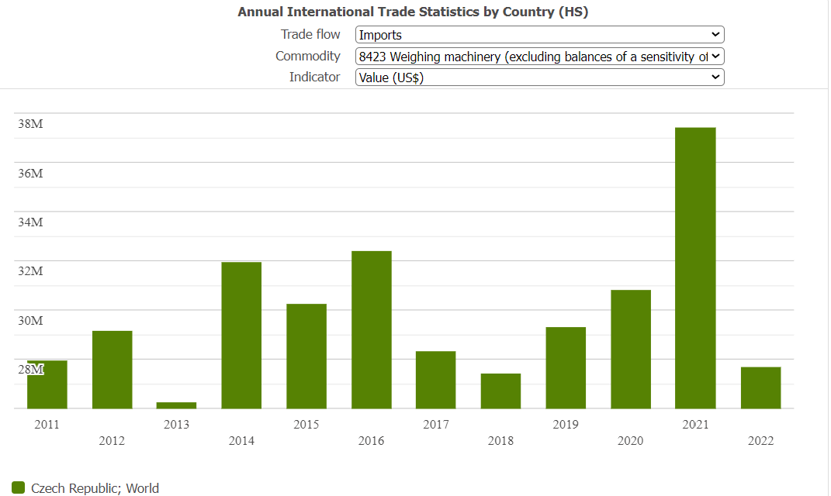

Observed value : 27700834 value in US $

Electric scooters safety test: