There are three separate questions, each requiring a separate simulation. You are to build the simulation model in Excel or R, run the simulation *at least* 100 times and **provide one paragraph as a response**. (Include Graphs, and charts for each question.)

# Q1. Jamming Missiles

The enemy has a new GPS jamming device used to misdirect US Missiles after launch. Our missiles have built in countermeasures used to misinform the jammer.

* Success of our countermeasures are as follows: 12% great success, 64% some success, and 24% no success.
* If we have great success, the enemy jammer is completely ineffective, if we have some success, the missile recognizes it is being jammed and changes its method of target location, if there is no success, the missile is defeated.
* For every minute a missile is in the air, the enemy can get another jamming attack. For our current Area of Concern (AOC), a missiles flight time will follow an exponential distribution with a mean of 90 seconds.
* If a missile is forced to change its method of target location there is a 25% chance of failure.
* If the enemy jammer is completely ineffective, there is a 95% chance of missile success.

Current intelligence estimated it will require 19 successful missile strikes to destroy the enemy’s munitions factory. You are to build a simulation model in Excel or R that represents the above scenario and answer the following questions:

1. On average, how many missiles will we need to launch for success against the enemy’s munitions plant?
2. What is the greatest number of missiles we might use and what is the least we might use?
3. What is the probability we can get the job done with exactly 19 missiles?

# Q2. Fire Fighter Response Time

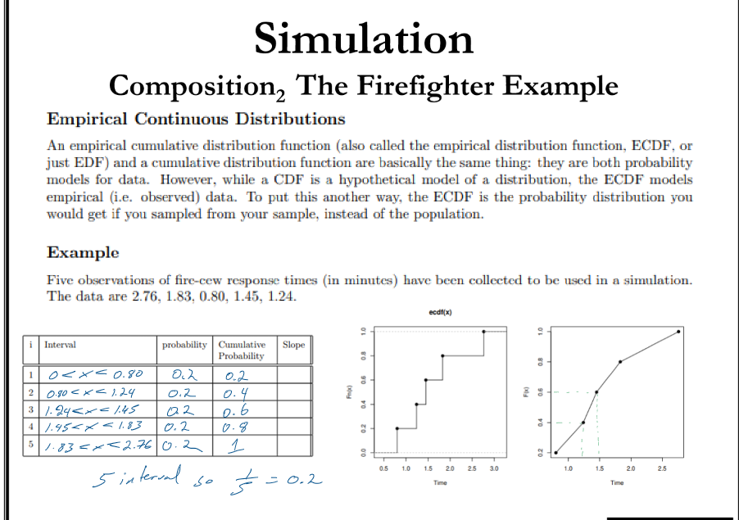

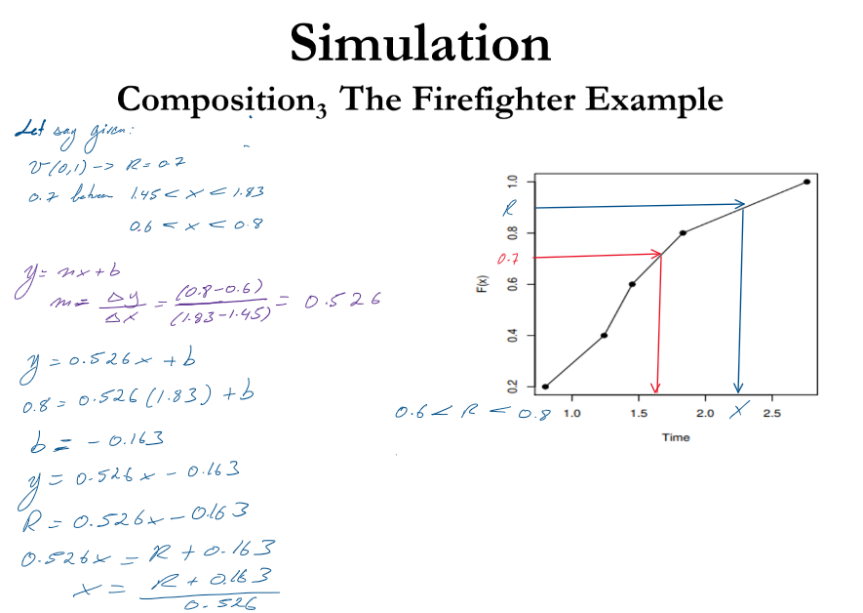

Build a simulation of the firefighter problem. You can use either Excel Spreadsheet, or R. Conduct 100 repetitions of the simulation and answer the following questions:

* + What is the average response time?
  + What was your greatest response time?
  + What is the minimum response time?

# Q3. ID Card Office (25 points)

The Fort Lee ID Card Office has had to reduce staff to one employee and want to know how this impacts operations. People arrive at the office at a rate of 1.7 people per minute (Poisson) and the clerk can serve 3.1 people per minute (Poisson).

Build a discrete event simulation to model 8 hours’ worth of the operation. You can use Excel spreadsheet, or R.

Provide the longest time a customer was in the system and the server utilization rate.