A.

1.

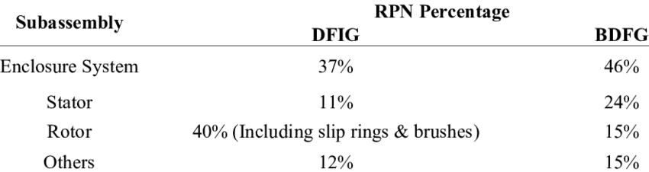

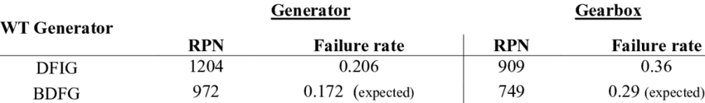

2.

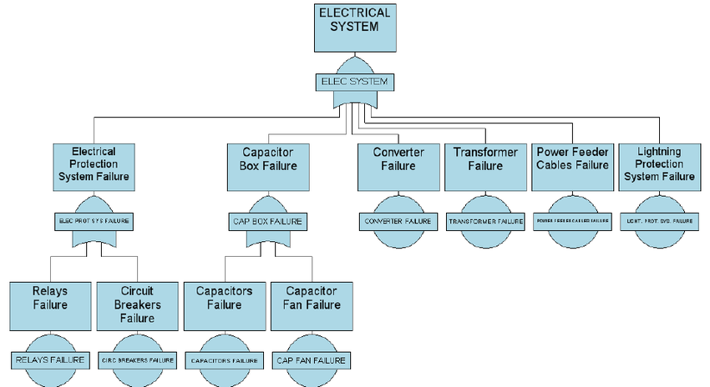

3. $ 22,500

B.

1.

Calculate the energy released in the following spontaneous fission reaction:

238U → 95Sr + 140Xe + 3*n*

given the atomic masses to be *m*(238U) = 238.050784 u, *m*(95Sr) = 94.919388 u, *m*(140Xe) = 139.921610 u, and *m*(*n*) =1.008665 u.

#### **Strategy**

As always, the energy released is equal to the mass destroyed times *c*2, so we must find the difference in mass between the parent 238U and the fission products.

#### **Solution**

The products have a total mass of

mproducts=94.919388 u+139.921610 u+3(1.008665 u)=237.866993 u*mproducts=94.919388 u+139.921610 u+3(1.008665 u)=237.866993 u*

The mass lost is the mass of 238U minus *m*products, or

Δ*m* = 238.050784 u− 237.8669933 u = 0.183791 u,

so the energy released is

E=(Δm)c2=(0.183791 u)931.5 MeV/c2uc2=171.2 MeV*E=(Δm)c2=(0.183791 u)931.5 MeV/c2uc2=171.2 MeV*

#### **Discussion**

A number of important things arise in this example. The 171-MeV energy released is large, but a little less than the earlier estimated 240 MeV. This is because this fission reaction produces neutrons and does not split the nucleus into two equal parts. Fission of a given nuclide, such as 238U , does not always produce the same products. Fission is a statistical process in which an entire range of products are produced with various probabilities. Most fission produces neutrons, although the number varies with each fission. This is an extremely important aspect of fission, because *neutrons can induce more fission*, enabling self-sustaining chain reactions.

2.

## **As probability of fission is 8% only, therefore, actual rate of fission is:** **1008 ×107=8×105s−1**

## **Energy released per fission =200MeV**

## **Power output of fission =8×105×200MeVs−1=16×107MeVs−1**

## **Probability of α−particle decay is 92%.**

## **Therefore, rate of decay of α−particle is: 10092 ×107=92×105s−1** **For α−decay, the equation is:** **(248.072220)96248 Cm →(244.064100)94244 Pu +(4.002603)24 He**

## **Mass of decay products is:** **244.064100+4.002603=248.06673.**

## **Mass defect, Δm=24.072220−248.066703=0.005517u**

## **Energy released per α−decay is:** **92×105×5/1363MeVs−1=4.725×107MeVs−1**

## **Total power output =16×107+4.725×107** **=20.725×107MeVs−1** **=20.725×107×1.6×10−13Js−1** **=33.16×10−6W=33.16μW**

3.

#### **Strategy**

The total energy produced is the number of 235U atoms times the given energy per 235 U fission. We should therefore find the number of 235U atoms in 1.00 kg.

#### **Solution**

The number of 235U atoms in 1.00 kg is Avogadro’s number times the number of moles. One mole of 235U has a mass of 235.04 g; thus, there are (1000 g)/(235.04 g/mol) = 4.25 mol. The number of 235U atoms is therefore,

(4.25 mol)(6.02×1023{235U/mol)=2.56×1024 235U*(4.25 mol)(6.02×1023{235U/mol)=2.56×1024 235U*.

So the total energy released is

E=(2.56×1024235U)(200 MeV235U)(1.60×10−13 JMeV)=8.21×1013 J

C.

1.

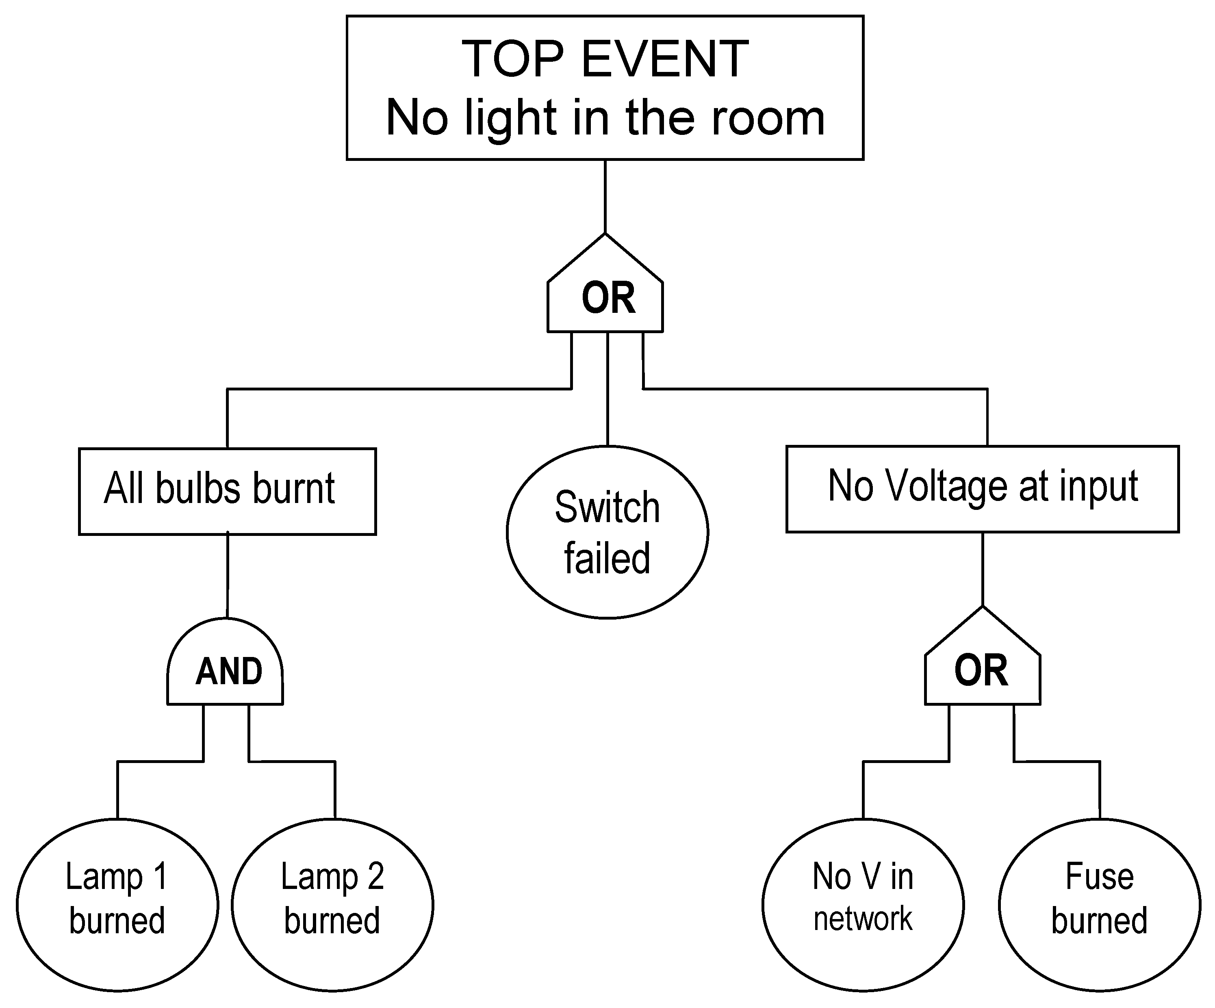

2.

Insert the values into the distribution formula: P(*x*; μ) = (e-μ) (μx) / x!

= (2.71828-5) (59) / 9!

= (0.0067) (1953125) / (3262880)

= 0.036

D.

1.

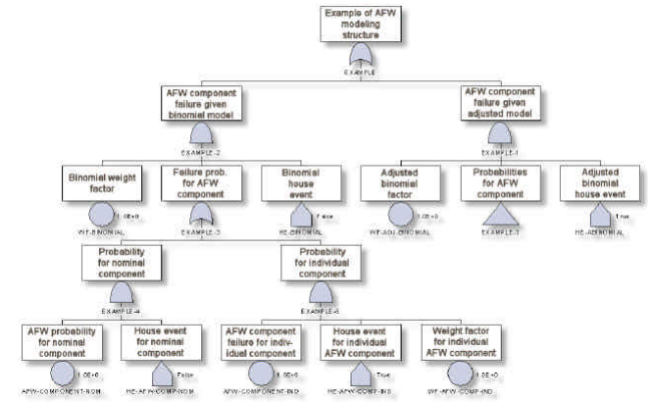

2.

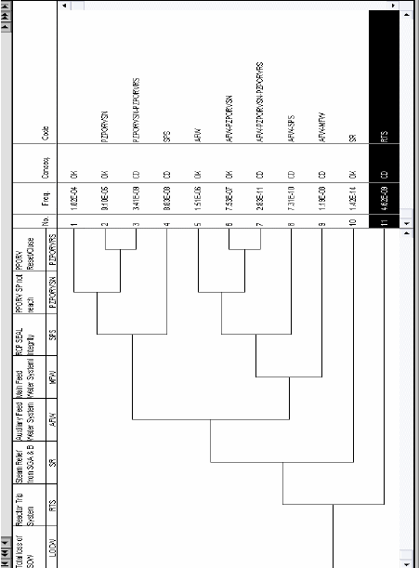

3.

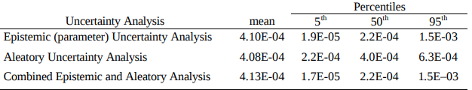

E.

1.

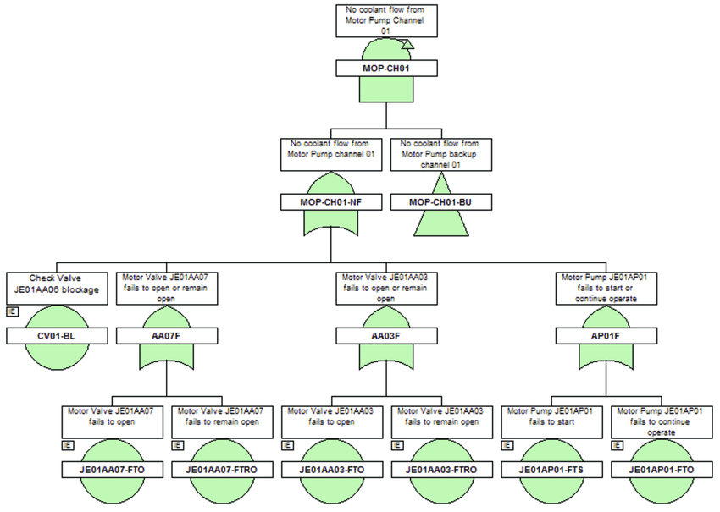

2.

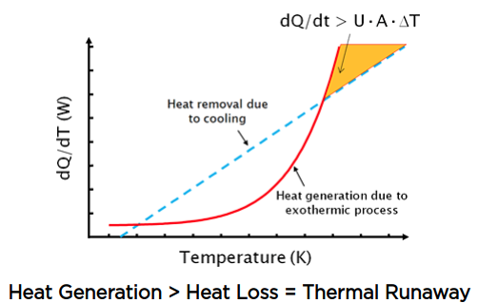

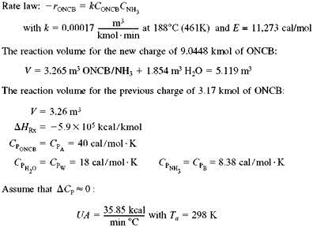

3.

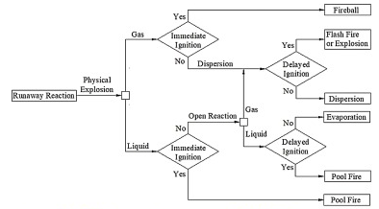

F.

1.

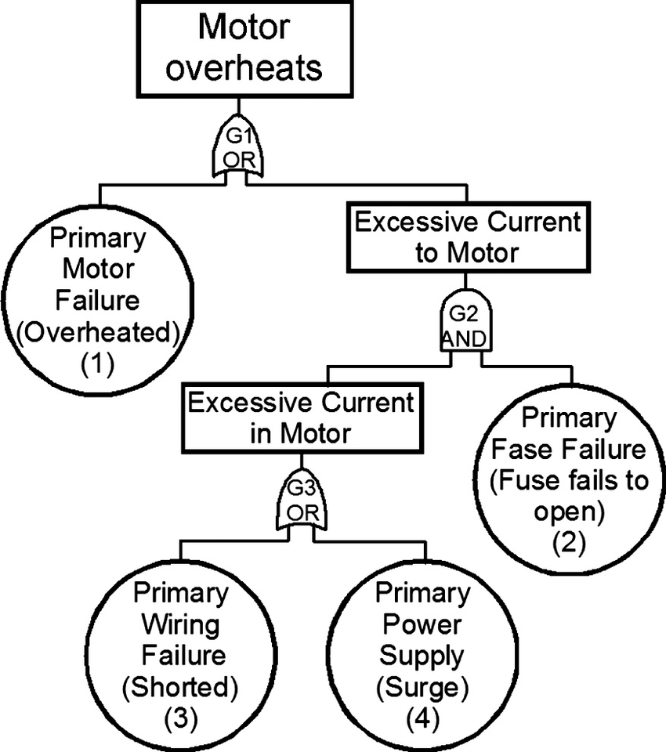

2.

If it has a thermal cutout, it will stop working until it cools down.

If it doesn’t, eventually the insulation on the wires will break down and create shorted turns. This is bad because:

The magnetic field will be partially shorted, so the efficiency will drop off. The wasted energy will appear as heat, causing further temperature rise.

The shorted turn will absorb energy by transformer effect - more heat generation.

The motor will slow down, reducing the back emf, causing it to draw more current, and generating more heat. If a fan is attached, airflow will be reduced, lowering the cooling efficiency.

The remaining wires will increase in resistance as they get hot. Higher resistive losses will generate heat.

The increased current and shorted turns may cause the steel to become magnetically locally “saturated”, effectively reducing the winding inductance and causing more current flow - with more heat.

High current may cause arcing at the brushes, damaging the brushes, brush holder and commutator (for brushed motors).

Too much heat may damage the bearings, allowing the rotary part (rotor/armature) to contact the stator and cause friction losses and heat.

At some stage it will be drawing sufficient current for a fuse to blow / cb to trip or blow an internal wire, breaking the circuit.

Essentially you can get a thermal runaway problem with the result being a total loss. That’s why thermal cutouts are fitted.

G.

1.

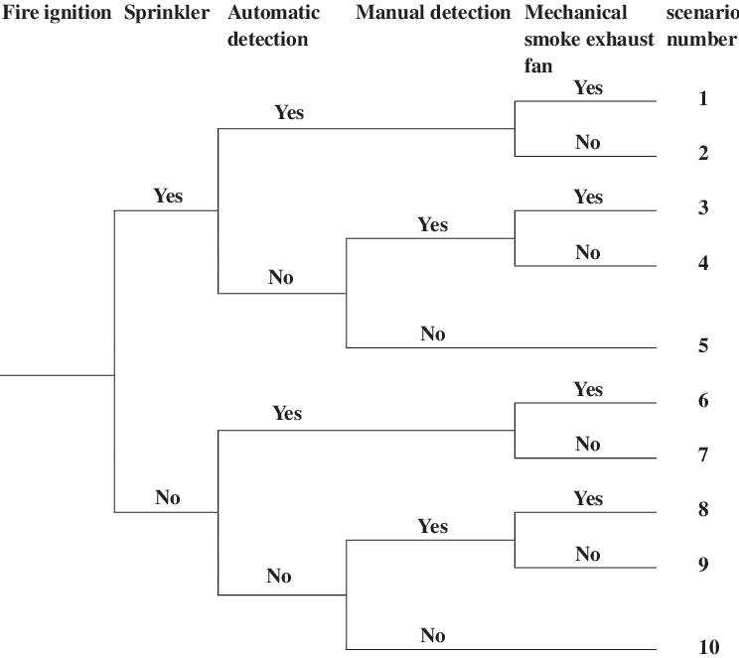

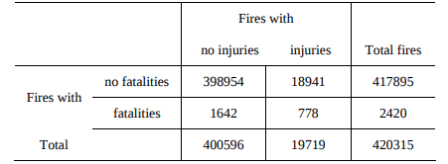

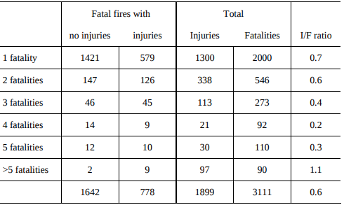

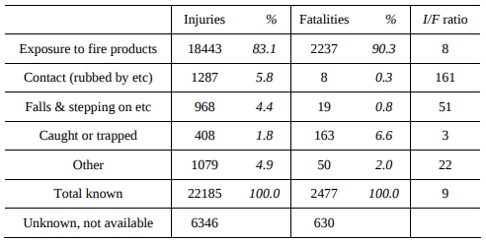

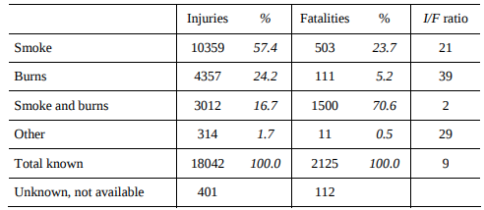

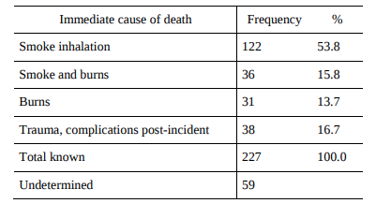

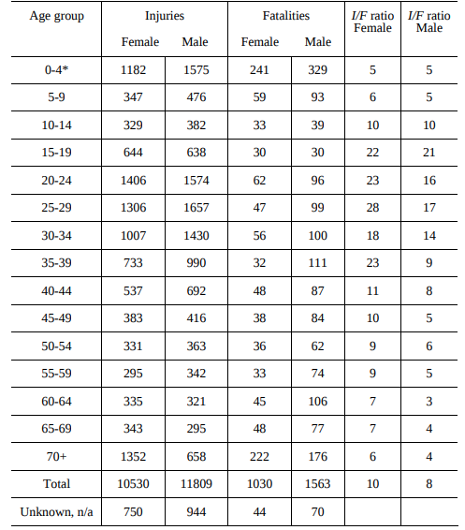

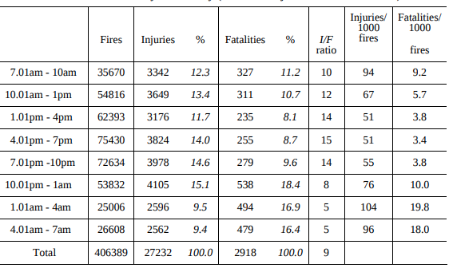

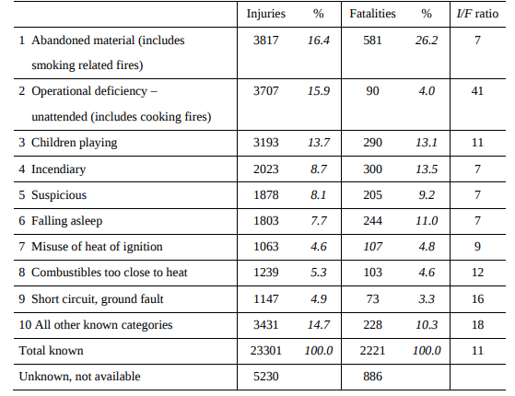

H.



; then the reciprocal of 160.55 years should be taken.



In the average year, we can expect to fail about 0.62%



then the reciprocal of 9.968 years should be taken.



in the average year, we can expect to fail about 10.032%.

You assume, we let the run 24 hours a day, 7 days a week:





, i.e., ~13.9% of these may break down in the average year.

