**Introduction:**

Due to its integrated nature and use in a number of applications, how to utilize ArcGIS in creating national data databases is one of the most in-demand talents these days. Navigating through software, which is one of the most commonly available, may need patience and understanding. Geo analysis and climate forecasting are two of the most significant businesses that demand knowledge. Both governmental and commercial organizations make information about their locations available online for free.

Heat waves may be deadly, resulting in diseases such flash floods and heat waves, as well as death. Warmer temperatures may trigger a chain reaction to other global changes. This is due to the fact that global warming has an impact on the seas, climatic patterns, snow and ice, as well as flora and animals. Deep snow forecasting, on the other hand, is a two-step procedure. First, the amount of water that will fall should be tested, as well as the problem of rainfall forecasting (QPF). Second, the liquid must be turned to ice, after which there is an ice congestion problem. Snow abundance has been the subject of very little research in the past.

The present method for forecasting ice firmness, and hence ice depth, remains a huge non-scientific issue. As a result, even if the QPF predictions were spot-on, substantial mistakes in snow projections (2 to 10 factors) might still occur owing to inaccurate ice strength estimates. We offer a strategy for addressing the complicated topic of snow forecasting in this study.

**Data:**

Due to the restricted quantity of crystal volume that exists in the air, the amount of ice is connected to the structure of the ice-crystal. Cloud-based mechanisms that impact the creation and size of developing ice crystals, sub cloud processes that modify the crystal ice as it falls, and soil compaction due to prevailing meteorological conditions and snowpack metamorphism all influence the amount of ice. Because accurate identification of microphysical cloud processes, thermodynamic profiles, and earth observations is frequently tricky, understanding how these processes impact snow density is challenging.

The goal of this research is to figure out how daily wind speeds affect snowfall. The link between weather and snowfall has been well understood for a long time, particularly in the United States. It's considered that areas with a lot of rain also get a lot of snow. With regard to the issue at hand, experts have discovered that powerful winds brought on by climate change have resulted in a massive snowfall throughout the planet. As a result, it may be necessary to keep track of these data and assess the viability of geo statistics.

The project focuses on South Dakota, which is recognized for having one of the worst winters in the United States. From January through December, the research will aim to investigate the link between typical daily wind speeds and snowfall at three government locations.

1. **Models of statistics**

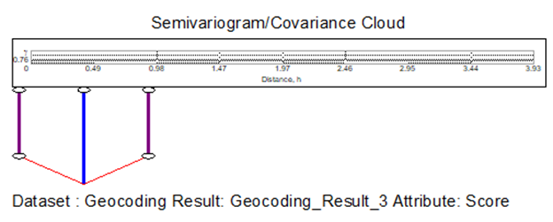

1. **Graph of the Scatterplots**

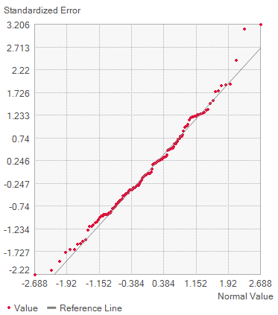

1. **Voronoi Maps**

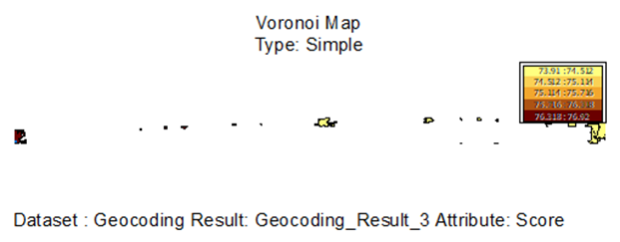

1. **Autocorrelation**

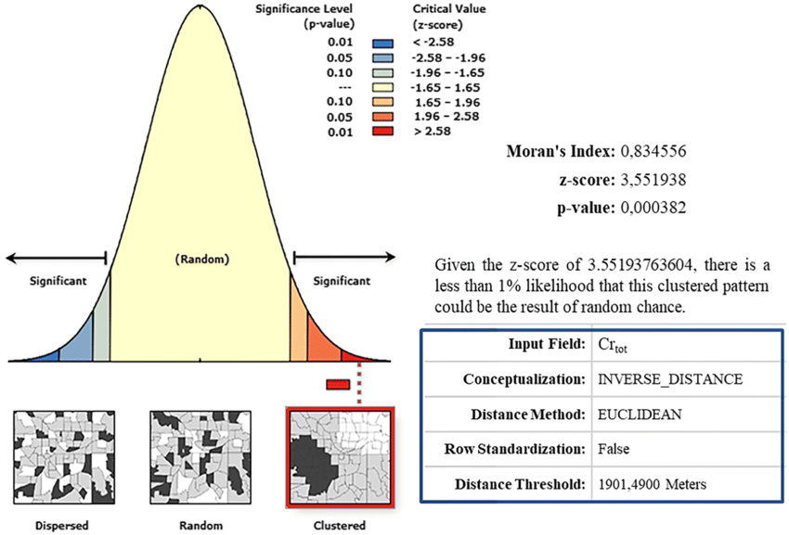

**Interpretation:**

The link between wind speed in the middle of a snowfall has been demonstrated to have a stable relationship based on the data provided by statistical models. Disperse Measures or Variations, such as Width, Variation, and Standard Deviation, are some of the descriptive methods for data that may be utilized in this data. This might be useful because it shows the frequency of schools in terms of intervals. The global climate has shifted since pre-industrial times, and there is evidence that these shifts have had an impact on ecosystems, as well as human and societal systems (high self-esteem). The increase in global warming (GMST), which reached 0.87 degrees Celsius in 2006-2015 compared to 1850-1900, increased the frequency and intensity of the effects (high confidence), reinforcing the evidence that GMST increases of 1.5 degrees Celsius or higher can affect environmental and human systems (1.5 degrees Celsius versus 2 degrees Celsius). Many of the changes in the climate system have already been caused by man-made global warming (high confidence). Increased global and sea temperatures, as well as more frequent temperatures in many regions of the world, are among the changes (greater self-esteem). There has also been an increase in the frequency and length of ocean waves as a result of (high confidence) global warming. Furthermore, there is substantial evidence that man-made global warming has resulted in a rise in the frequency, severity, and/or number of catastrophic worldwide events (moderate confidence), as well as an increased risk of drought in the Mediterranean area (moderate confidence) (moderate confidence).

**Evaluation:**

There is a risk of data loss since there are several times where such data is handled during the data gathering process. While not deviating from the process, this can result in numerous nuances being overlooked and critical data definition being lost. Climate change has resulted in significant changes in summer and winter weather patterns, which has had a negative impact on yield. Significant variations in the sky as well as hot states have been noticed, although the focus of this discussion will be on the hot ones. The following are some recent instances from Pakistan and other areas of the world:

* reasons for falling wheat yields in India's Ludhehana region at a time when the physical plant situation was a major concern, they noted that the appearance of severe heat (temperatures 13 days above usual (2-30C)) in early spring at birth caused with a 28 percent drop in wheat production.
* February 2006 was 2-40C warmer than typical in Sindh and the Punjab region of Pakistan, resulting in severe yield decreases. The wheat was at the grain-making stage; at these temperatures, development is accelerated since the requisite temperature units are fulfilled fast. The characters were unable to find the appropriate size and weight, resulting in a show decrease.
* Temperatures have been low in recent days over the agricultural plains, in addition to the highest agricultural plains. The first week of February and the first decade of March 2010 saw temperatures that were 3-60 degrees Celsius above average. Early maturation prevented the immature grain from reaching its full weight, size, and starch content. It was deemed a superb harvest season in terms of plant vitality, but it delivered 13% less productivity per hectare.
* Breathing at these temperatures throughout the night in 2003 restricted photosynthesis, resulting in a decrease in overall profit. Rice grains produced 10% more when the temperature was raised by 10 degrees Celsius.

**Interpolation:**

**Techniques:**

Other alternative translation techniques based on the integration details mentioned above include Kriging and Cokriging. Data collecting is one of these procedures, and NOAA data is gathered based on the place where it was obtained. The technique of estimating values in additional unknown places by employing points with known values or sample points. It may be used to forecast unknown values in any point area data, such as altitude, rainfall, chemical concentration, and noise levels, among other things.

**Inverse Distance Weight (IDW)**

Each input point has a local impact that diminishes with distance, according to the Inverse Distance Weighting Definition. It makes points that are close to a processing cell bigger than those that are far away. The output value of each location can be determined by using the provided number of points or all points within the defined range. This approach reduces the influence of the variation on the distance from the sample location by using the variance made on the map.

The Inverse Distance Weighting (IDW) method is a mobile translator that is frequently used for data with a lot of variation. Returning to the collecting location and recording a new value that is statistically different from the initial read but within the usual local mode is achievable with certain types of data. The combined area is less than the maximum area value and more than the minimum area value, as determined by the central flow technique.

The IDW translation makes the premise that items that are near together are more similar than those that are far away. IDW will utilize the approximate values surrounding the predicted region to estimate the value of any unmeasured area. The estimated values that are closer to the forecast region will have a bigger influence than the projected value. As a result, IDW believes that each measured location has a local impact that diminishes as the distance between them grows.

When the collection of points is dense enough to account for the size of the local variation necessary for analysis, the IDW function should be employed. IDW calculates cell values by combining the line weights of sample points. The name "opposite distance" comes from the fact that it measures points closer to the predicted area more than the farthest.

The IDW algorithm determines the value of each grid node by examining data points within the user-defined search range. The translation procedure can make use of any or all of the data pieces. The average value of all points is used to determine the node value. Data points that continue to migrate away from the node have a significantly less impact on the computer value than data points that are close to the node. Each node of the grid has a radius around it where data points are chosen for use in the computation. Power, search radius, fixed search radius, flexible search radius, and obstacle are some of the IDW application control settings.

**Best Fit Process:**

When the data is ready, each of the mentioned steps is tested. One key issue discovered was that there were occasions when the data gathered from NOAA provided insufficient information to perform such a merging. Finally, Kriging was the best match of all the methods since it was the only one that could manage all of the data and generate a graphical representation. Because it was possible to convey the key elements needed to portray the merger, the approach employed was deemed acceptable and suitable for the map. Provide more information as needed, particularly if any of the data centers are not readily visible on the map.

**Kriging:**

The local distribution of mineral deposits was defined using the kriging modelling approach, which originated in the field of geostatistical applications. The goal of this method was to better identify possible sites for future excavations so that minerals with the necessary distance structures could be obtained. As this approach is utilized to build weighted coefficients; the kriging model generates speculation as the estimated quantity of the nearest sample data and is subdivided as the opposite distance measurement method.

**Map Series:**

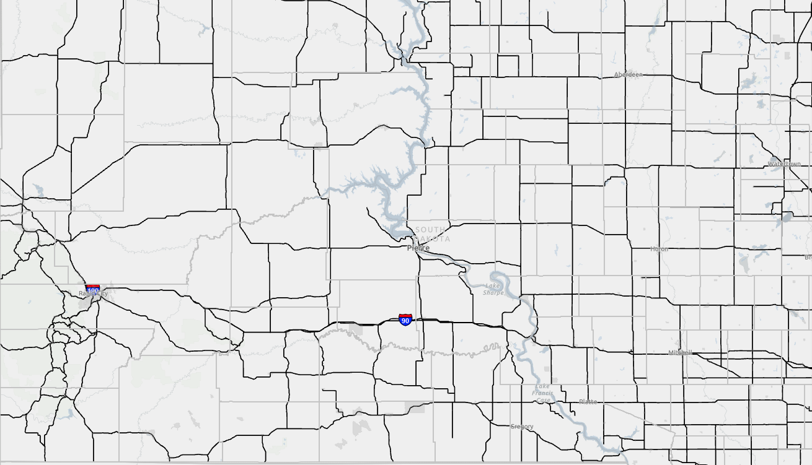

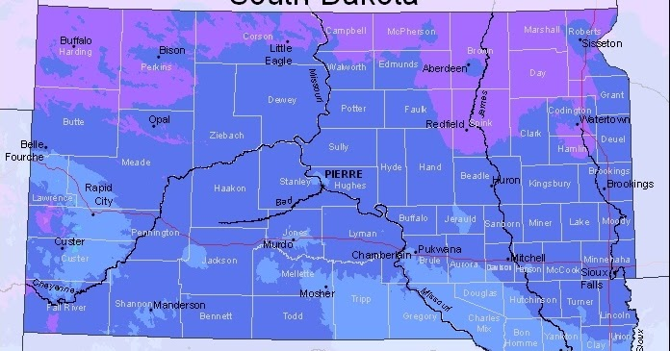

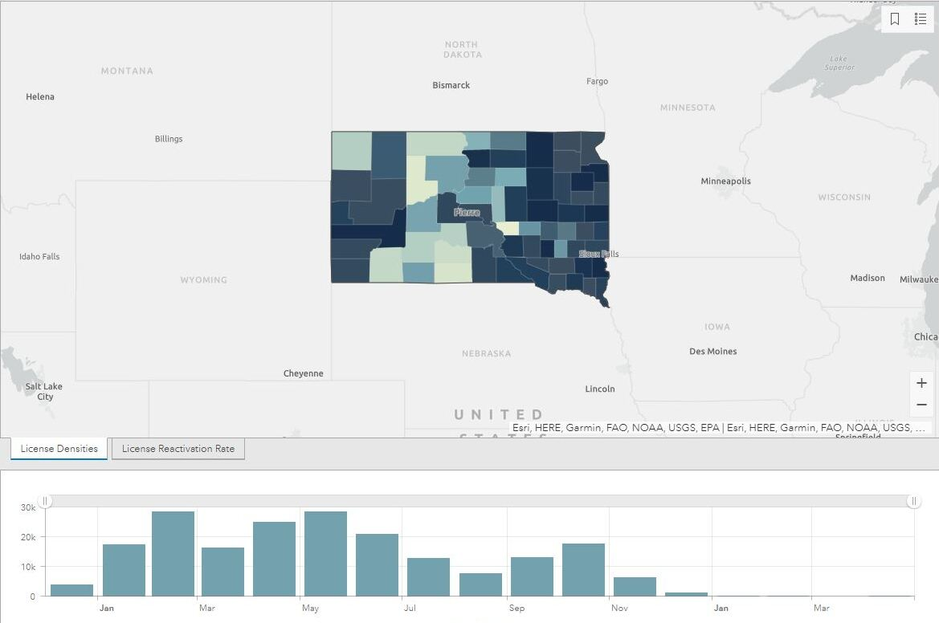

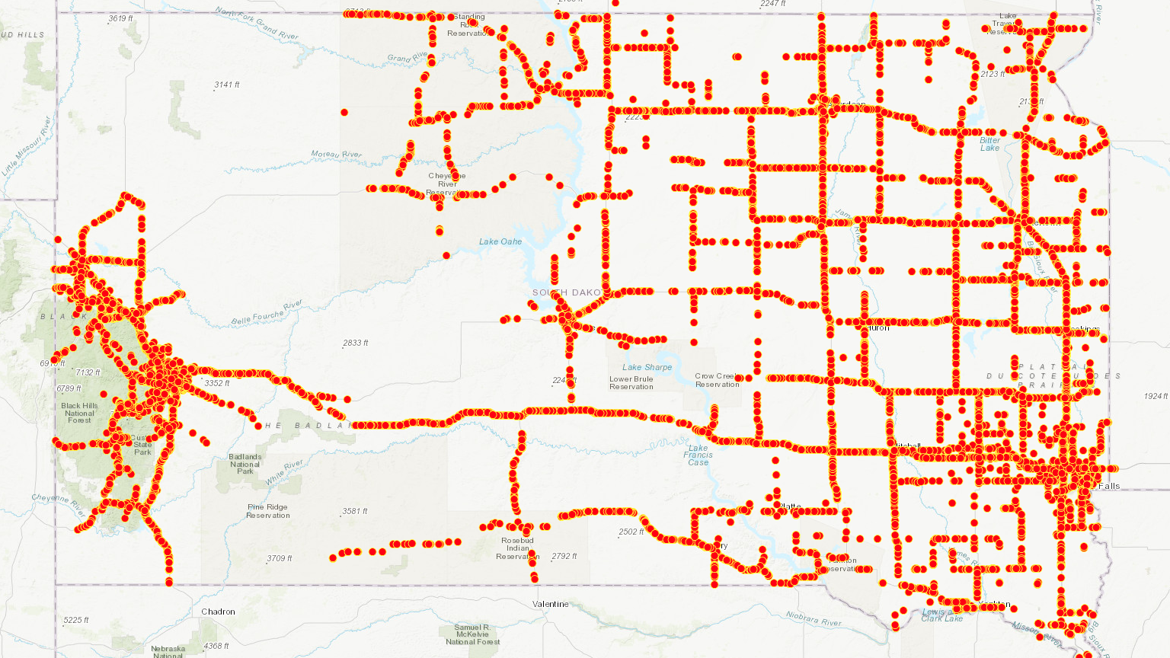

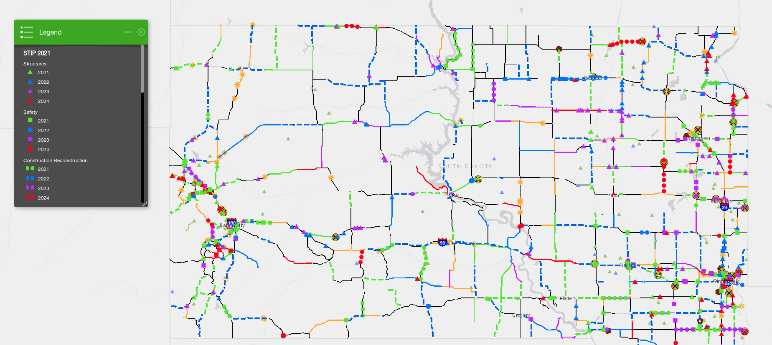

**Result:**

**Testing:**

Based on the maps and details that emerge, it is evident that the speed of the air in the center of a snowstorm has a specific connection. While the wind speed will not be equal to the amount of snowfall, the features on the map will demonstrate that the two are connected.

**Prediction:**

It was obvious to observe that the relationship between the selected data was consistent using the Kriging technique. The correlations discussed in this article are depicted in each of the graphs and maps that follow the Kriging procedure. It would be worthwhile to study more about this subject, as well as the additional information provided.

**Decision Making:**

The user may convey knowledge to others in easy and comprehensible ways by using data, maps, and graphical models. They're also easily available for testing or rectification, which comes in handy when there are issues regarding the results. Some considerations must be taken to guarantee that data, such as basic maps and information from publicly available sources, is directed to the same areas with identical results. Following that, deciding on a mathematical procedure may be required. Overall, it is possible that meticulous planning and decision-making will be crucial to its success.

**Challenge:**

Faced with a variety of obstacles throughout the implementation of this project, the usage of software, ArcGIS, proved to be a farce at times. You simply need to be more selective in the assistance you provide to others. Also misleading was the manipulation of NOAA data to indicate compatibility with the mapping method employed. Finally, the obstacles are overcome by the determination to complete the course and exhibit expertise. Future allocations and projects are expected to be easier, more effective, and dependable as a result of this knowledge and abilities.

**References:**

1. Cressie, Noel. "Spatial prediction and ordinary kriging." Mathematical geology 20.4 (1988): 405-421.
2. D’Orangeville, Loïc, et al. "Beneficial effects of climate warming on boreal tree growth may be transitory." Nature communications 9.1 (2018): 1-10.
3. Janoski, Tyler P., et al. "Effects of climate change on wind-driven heavy-snowfall events over eastern North America." Journal of Climate 31.22 (2018): 9037-9054.
4. Roebber, Paul J., et al. "Improving snowfall forecasting by diagnosing snow density." Weather and forecasting 18.2 (2003): 264-287.
5. Ver Hoef, Jay M., and Ronald Paul Barry. "Constructing and fitting models for cokriging and multivariable spatial prediction." Journal of Statistical Planning and Inference 69.2 (1998): 275-294.
6. Safeeq, Mohammad, et al. "Influence of winter season climate variability on snow–precipitation ratio in the western United States." International Journal of Climatology 36.9 (2016): 3175-3190.
7. Ver Hoef, Jay M., and Ronald Paul Barry. "Constructing and fitting models for cokriging and multivariable spatial prediction." Journal of Statistical Planning and Inference 69.2 (1998): 275-294.
8. Du, Shichang, and Lan Fei. "Co-kriging method for form error estimation incorporating condition variable measurements." Journal of Manufacturing Science and Engineering 138.4 (2016).
9. Keshavarzi, Ali, Fereydoon Sarmadian, and Abbas Ahmadi. "Spatially-based model of land suitability analysis using Block Kriging." Australian Journal of Crop Science 5.12 (2011): 1533-1541.
10. Oliver, M. A., and R. Webster. "A tutorial guide to geostatistics: Computing and modelling variograms and kriging." Catena 113 (2014): 56-69.
11. Fuentes, Montserrat. "A high frequency kriging approach for non‐stationary environmental processes." Environmetrics: The official journal of the International Environmetrics Society 12.5 (2001): 469-483.
12. Jia, Zhenya, et al. "Predictive modeling for pharmaceutical processes using kriging and response surface." Journal of Pharmaceutical Innovation 4.4 (2009): 174-186.
13. Ryu, Je-Seon, et al. "Kriging interpolation methods in geostatistics and DACE model." KSME International Journal 16.5 (2002): 619-632.
14. Barkhordar, Rahmat A., et al. "Evaluation of temperature rise on the outer surface of teeth during root canal obturation techniques." Quintessence International 21.7 (1990).
15. Rasul, G., et al. "Effect of temperature rise on crop growth and productivity." Pak. J. Meteorol 8.15 (2011): 53-62.
16. Law, Michael, and Amy Collins. Getting to know ArcGIS. Redlands: ESRI press, 2015.
17. Scott, Lauren M., and Mark V. Janikas. "Spatial statistics in ArcGIS." Handbook of applied spatial analysis. Springer, Berlin, Heidelberg, 2010. 27-41.