**Overview:**

The face of people is unbelievably lovely. Although 50 years have gone, there is still a choice between your high school student's two pictures with approximately 90 per cent accuracy. For efficient facial recognition the eyes and adjacent regions of the face are more accessible. You will investigate the notion in the laboratory that blurring of the eyes makes it harder to discern a face later on. We also presented two fantastic concepts throughout the lecture which explain how observers are encouraged: the high-thresholder model (HTM) and the theory of sign language detection (SDT). The lab examines the idea that the SDT model offers a better forecast for the performance of face recognition than HTM. As previously, computer-controlled testing is carried out. Two phases of the evaluation:

(a) study phase, followed by

(b) assessment phase.

A sequence of 64 face pictures is presented throughout the reading phase. Eyes are covered with 32 faces, and viewable eyes are around 32 regular faces. Read face to face attentively in 2 seconds of exposure. Your facet memory will be tested with a new 128-face series, half before you saw, and one-half before you saw. Each aspect of the exam is fully visible (i.e., the eyes will not be covered). It's your duty to find out what it's and to bring it to fruition. A confidence rating of six points is used:

1. Make sure you have a new face

2. Imagine a new face

3. Guessing that new face

4. Guess what the old face is

5. Think of an old face

6. Make sure the old face

7. Classification of Gender

Five distinct decision factors accompany a six-point rating scale (e.g., intermediate boundaries each measure of confidence). You may compute from the responses 5 beat rates - false alert rating pairs (HR, FAR) of both facial (eye and eyes) kinds (each pair of those determining procedures). You will assess how well you recall the face with your eyes compared to the face without your eyes. There will also be two different acquisition models to find out which model best predicts visual data.

At the end of the lab, you will be able to:

• Test the model accuracy using Chi-square and Akaike Information Criterion (AIC) statistics for determining whether model is the greatest predictor of what you are seeing, high-range model or theory of signal detection.

• Use the sensitivity measure of signal detection theory to determine if your visual acuity will improve your visibility.

• Calculate and test results by means of a study of the bootstrap.

**The Facial Recognition Experiment:**

**Testing Eye Hypothesis**

We need a particular technique to describe visual performance to see whether visual acuity has been acquired in face-reading for subsequent recognition. Models are a proof that the sensory process and the decision-making process may be expressed numerically. The high threshold model (HTM) is sensitive to p, which can exceed the "boundary." Sensitivity is a distinction between the technique, d'or d ~ a distribution of opportunities representing the various motivating circumstances of the test, represented by the signal acquisition model. In the workshop we will compute sensitivity, p below the highest standard signal detection model and sensitivity (da).

Formulae:

High Threshold $p= \frac{HR-FAR}{1-FAR}$

Signal Detection $d_{a}= \sqrt{\frac{2}{1+b_{1}^{2}} (z\left(HR\right) - b_{1z} (FAR))}$

In visual studies, the word sensitivity refers to the capacity of the observer to make good judgments and avoid incorrect ones. Both p-and-date evaluate the student's capacity to distinguish between new and older face (i.e., "tell the difference") throughout the evaluation phase. More sensitivity is demonstrated by increased p or da; small q or da is indicated by poor sensitivity. These stages will be compared by the two learning scenarios:

(a) the face and visible eyes while reading (eyes), and

(b) a face with hidden eyes during leaning (no).

We will also evaluate whether model of facial recognition data (HTM or SDT) provides the greatest balance. Akaike Information Criterion is the most often used metric (AIC). The suitable test is to assess how successfully the six reaction waves are computed by calculating the parameters of each model using high probability rates under the three stimulus conditions (new face (s0), old eye (s1) and eyes with old eye conditions) (s2).

**Implementation process:**

This work provides an efficient, modular-based PCA face recognition system with increased identification rates for more posing variation, light indicators and facial expression. This approach subdivides face pictures into smaller pictures and uses the PCA method in one of the photos below. The training step in this procedure starts with the extraction, based on the training picture database, of the individual vectors that match the greatest values of the covariance matrix. These vectors are used to construct a vector feature that can differentiate between incoming facial pictures.

* The face recognition technology works with a typical surveillance camera streaming real-time videos and all sides of the image region. These face pictures are analyzed in order to establish who you are in comparison with traits recorded in a database.

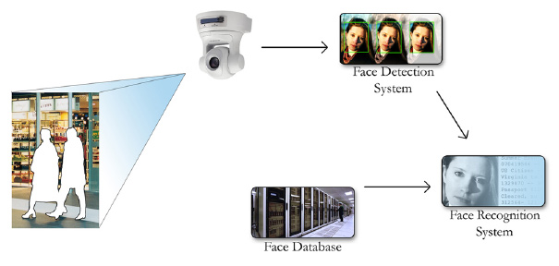

* The software is trained in advance using a familiar facial database to view faces in real time. The modular PCA training technique that produces character vectors of everyone is supplied with training photos. Training images are given.

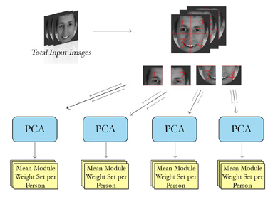

* The real-time notification procedure can commence after successfully training the system. Video is the system input and as a training procedure separated into segments. The rating scale for each module depends on category changes. The bigger the difference, the larger the weight. This enables the system to look in more depth at regions.

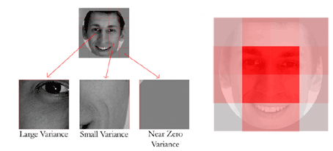

* In order to obtain a picture of the facial image in the system, it then compares the calculation features of the input image with those of a professional website.

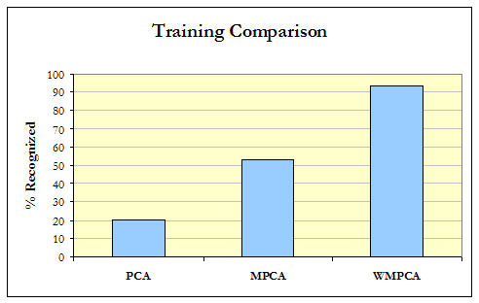

Methodology:

In order to describe complicated manifolds created by pictures of the face/object and a technique to map photos to these variables, we offer a rigorous mathematical model.

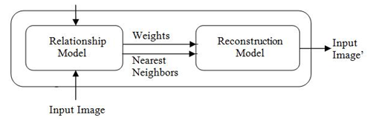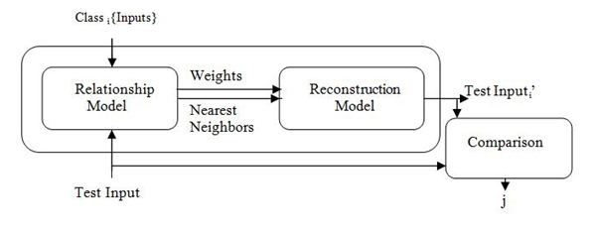

Results:

**Classification of Gender from the observation of given images**

|  |  |
| --- | --- |
| male | female |
| 5 | 9 |
| 5 | 8 |
| 8 | 7 |
| 5 | 7 |
| 6 | 9 |
| 7 | 8 |
| 4 | 8 |
| 5 | 8 |
| 3 | 9 |
| 4 | 10 |
| 8 | 7 |
| 5 | 9 |
| 10 | 8 |
| 6 | 9 |
| 5 | 7 |
| 5 | 9 |
| 8 | 8 |
| 7 | 7 |
| 5 | 9 |
| 6 | 7 |

**Reference:**

1. Akaike, Hirotogu. "Information theory and an extension of the maximum likelihood principle." *Selected papers of hirotugu akaike*. Springer, New York, NY, 1998. 199-213.
2. Akaike, Hirotugu. "A new look at the statistical model identification." *IEEE transactions on automatic control* 19.6 (1974): 716-723.
3. Bahrick, Harry P., Phyllis O. Bahrick, and Roy P. Wittlinger. "Fifty years of memory for names and faces: A cross-sectional approach." *Journal of experimental psychology: General* 104.1 (1975): 54.
4. Harvey Jr, Lewis O., and Andrew J. Mertens. "Lab 3: Face Recognition and Signal Detection Theory: Are Eyes Important?." (2020).
5. deLeeuw, Jan. "Introduction to Akaike (1973) information theory and an extension of the maximum likelihood principle." *Breakthroughs in statistics*. Springer, New York, NY, 1992. 599-609.
6. Lee, Mun Wai, and Surendra Ranganath. "Pose-invariant face recognition using a 3D deformable model." *Pattern recognition* 36.8 (2003): 1835-1846.