**HOMEWORK #1 (Air Pollution, Water Pollution)**

1. The National Ambient Air Quality Standard (NAAQS) for sulfur dioxide (SO2) is 0.144 ppmv (24-hr average). What is the concentration in ug/m3 assuming an air temperature of 25 degrees C?

0.053 ppmv

Temperature of 25 °C + 273.15 = 298.15 K

Pressure of 1 atm

Molar mass (MM) of NO2 = 46,0055 g/mol

**Using the formula :**

﻿[m3mg​]=22.4ppmv∗mol∗ molar mass​∗T(K)273.15K​∗1atmP(atm)​﻿

﻿﻿[m3mg​]=22.40.053∗1mol∗46.0055g/mol​∗298.15273.15K​∗1atm1atm​=0.0997≈0.1﻿﻿ ﻿m3mg​﻿

**Hence, the NO2 concentration in mg/m3 at a temperature of 25 °C and a pressure of 1 atm is 0.1 mg/m3.**

2. A water sample contains 10 mg NO3-/L. What is the concentration in

3. Formaldehyde (CH2O) is commonly found in the indoor air of improperly designed and constructed buildings. If the concentration of formaldehyde in a home is 0.7 ppm, and the inside volume is 800 cubic meters, what mass (in grams) of formaldehyde vapor is inside the home? Assume T=298K, P=1 atm.

4. A water quality analysis of a well water used for drinking water in a rural home found an arsenic concentration of 0.5 micromolar. This value seems very small to you. But you need to see if it still exceeds the drinking water standard of 10 ppbm. Is the well water violating the standard (and therefore the water would require treatment)?

Conc of PPB by mass = 10 ppb

Mass of the solution = 100g

= wb/w x 10^6

= wb/100 x 10^6

Wb = 15 x 100 / 10^6 = 1.5 x 10^-3

Percent mass of solution = wb/w x 100

= 1.5 x 10^-3 x 100 / 100

= 1.5 x 10^-3 %

5. Find out what air or water pollutants are being released in your hometown. Go to the EPA’s Toxics Release Inventory website, <https://www.epa.gov/toxics-release-inventory-tri-program>

a. Go to the search engine at the bottom of the webpage, “Learn More About TRI in Your Community: Get Location-Based Factsheets and Information on Specific Facilities”. Search the zip code of your hometown (or current residence if there are no hits for your hometown). Browse the site—lots of interesting facts on who is releasing what chemicals to the environment. If there are not companies listed at this zip code, either try another zip code or instead search by metropolitan area and enter in the name of any city.

b. Go to the section “Top five facilities by total disposal or other releases”. Click on one of the company names.

c. Review this TRI Facility Report for this company.

d. Report, in a list or table, the company name, what toxic chemicals are used/treated/released there, and what lbs of what chemical(s) was released in the most recent year for data, if these chemicals were air or water releases. Much of this information can be found under the “chemicals” or “releases” tabs.

**HOMEWORK (Risk Assessment)**

1. Consider a carcinogenic VOC with the dose-response curve shown in Figure P4.1 in the Masters & Ela textbook.

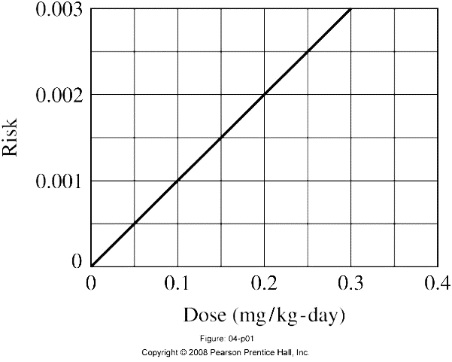

If 70-kg people breathe 20 m3/day of air containing 10-3 mg/m3 of this VOC throughout their entire 70-year lifetime, find the cancer risk (you first need to find the potency). You may assume typical exposure values for air inhalation.

2. Suppose a city’s water supply has 0.2 ppb (1ppb=10-3 mg/L) of polychlorinated biphenyls (PCBs) in it. Using the PCB oral slope factor (7.7 (mg/kg-d)-1 and the EPA recommended exposure factors given in Table 6.14 below,

(a) What would be the individual lifetime cancer risk for an adult male residential consumer?

(b) In a city of 1 million people, use this risk assessment to estimate the number of extra cancers per year caused by the PCBs in the water supply. “Extra” cancers refers to cancers caused by PCBs (as opposed to other causes such as smoking, etc.)

(c) Assume the average cancer death rate in the United States in 193 per 100,000 per year. How many cancer deaths would be expected in a city of 1 million? Do you think the incremental cancers caused by PCBs in the drinking water would be detectable?

3. It has been estimated that about 75 million people in the Ukraine and Byelorussia were exposed to an average of 0.4 rem of radiation as a result of the Chernobyl nuclear accident. Human exposure to radiation is often measured in rems (roentgen-quivalent man) or millirems (mrem). The cancer risk caused by exposure to radiation is thought to be approximately 1 fatal cancer per 8,000 person-rems of exposure (for example, this is like saying when 8000 people are exposed to 1 rem each, one person will die of cancer caused by this exposure).

(a) How many extra cancer deaths might eventually be expected from this exposure?

(b) If the normal probability of dying of cancer from all causes is 0.22 (that is, 22% of any population of people will die of cancer), how many cancer deaths would you normally expect among those 75 million people?

4. A man works in an aluminum smelter for 10 years. The drinking water in the smelter contains 0.070 mg/L arsenic and 0.560 mg/L methylene chloride. His only exposure to these chemicals in water is at work. Recall the total HI (i.e. the total overall risk) is the sum of individual HI values.

(a) What is the hazard index (HI) associated with this exposure?

(b) Does the HI indicate this is a safe level of exposure?

(c) What is the incremental lifetime cancer risk for the man due solely to the water he drinks at work *and* does it seem to be an acceptable risk according to the EPA’s standard of acceptable risk?

Answer: Risk = CDI ×potency = 2.85×10-4 (mg/kg-day) ×0.01 (mg/kg-day)-1 = 2.9×10-6

5. Calculate a risk-based groundwater standard (in ppb) for the chemical 1,2-dichloroethane for a residential homeowner where the person’s well used for drinking water is contaminated with 1,2-dichloroethane. Assume the risk is for an average adult who weighs 70 kg. The state where you work has determined that an acceptable risk is one cancer occurrence per 106 people. Use the values for route of intake, exposure frequency, exposure duration, and averaging time provided for residential use in the following table 6.14. Assume an oral slope factor for 1,2-dichloroethane of 9.2x10-2 per (mg/kg)/day.

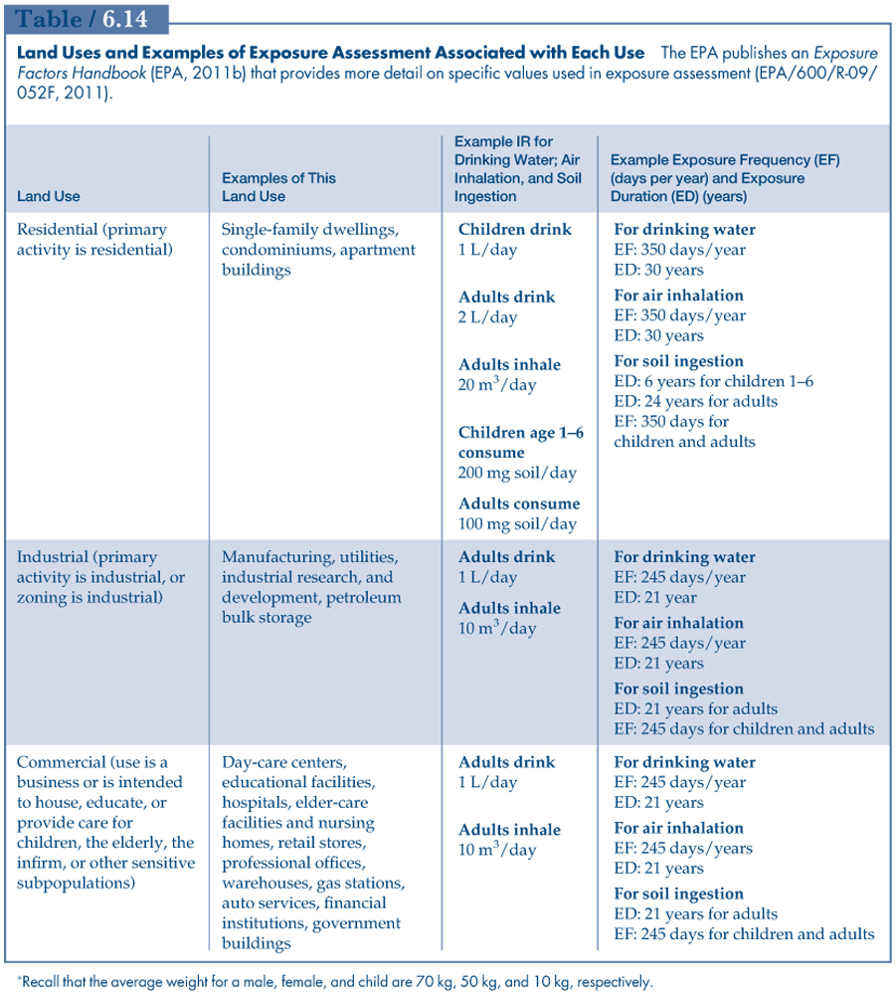

**HOMEWORK (Environmental Chemistry)**

1. Consider the following reaction representing the combustion of propane:

1. Balance the equation.
2. How many moles of oxygen are required to burn 1 mol of propane?
3. How many grams of oxygen are required to burn 100 g of propane?
4. At standard temperature (0 degrees C) and pressure, what volume of oxygen (in cubic meters) would be required to burn 100 g of propane? If air is 21 percent oxygen, what volume of air at STP would be required?
5. At STP, what volume of CO2 (in cubic meters) would be produced when 100 g of propane are burned?

5.6 L of oxygen at STP are required to burn completely 2.2g of propane.

Explanation:-

The balanced chemical equation for the reaction is :-

C₃H₈ + 5O₂ → 3CO₂ + 4H₂O

_______________________________

• Molar mass of Carbon (C) = 12 g/mol

• Molar mass of Hydrogen (H) = 1 g/mol

Hence, molar mass of Propane [C₃H₈] :-

= 12×3 + 1×8

= 36 + 8

= 44 g/mol

Now, from the balnced equation :-

⇒ 44g of C₃H₈ requires 5 moles of O₂

We know that, one mole of any gas at STP occupies a volume of 22.4 L.

∴ 5 mole of O₂ will occupy a volume of :-

= 5×22.4

= 112 L

∴ 44g C₃H₈ requires 112 L O₂

∴ 2.2g of propane will require :-

= 2.2×112/44

= 0.05×112

= 5.6 L O₂

2. Suppose totally world energy consumption of fossil fuels, equal to 3 × 1017 kJ/yr, were to be obtained entirely by combustion of petroleum with the approximate chemical formula C2H3. Combustion of petroleum (with O2) releases an amount of energy about 43 × 103 kJ/kg (seems like a lot of moles of C2H3). Estimate the emissions of CO2 per year in units of kg CO2, assuming complete conversion of all C in petroleum to CO2.

Calorific value is the amount of energy released or produced when 1 kg of fuel burns.

Given that on complete combustion of 2.4 kg of fuel 3,60,000 kJ of heat energy is produced

That is, 360000 kJ of heat for 2.4 kg

It's calorific value will be = 360000/2.4 = 150000 kJ/kg

3. Hydrochloric acid, HCl, completely ionizes to H+ and Cl- when dissolved in water. Calculate the pH of a solution after 25 mg/L of HCl is added to water.

Answer - HCl + H2O → Cl− + H3O+

4. Hydrogen sulfide (H2S) is an odorous gas that can be stripped from solution by bubbling air through the solution. H2S when dissolved in water is also a weak acid that can deprotonate to bisulfide ions which are not removed by air stripping. That reaction is

With equilibrium constant Ka=0.86x10-7.

Find the fraction of hydrogen sulfide in the H2S form at pH 6 and pH 8. At which pH would you expect to have an easier time to strip away H2S gas?

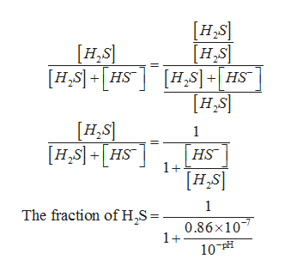

5. Determine the equilibrium pH of aqueous solutions of the following strong acids or bases. Remember, strong acids and bases completely dissociate. (a) 15 mg/L of HSO4-, (b) 10 mM NaOH, (c) 2,500 ug/L of HNO3.

2500 ug = 2500 x 10-6 = 2.5 x 10-3 gm

M = 2.5 x 10-3 / 63 = 2.9 x 10-5

PH = -log [8.9 x 10-5] = 4.3

6. The chemical 1,4-dichlorobenzene (1,4-DCB) is sometimes used as a disinfectant in public lavatories. Its odor could be particularly annoying. At 20°C (68°F) the vapor pressure is 5.3 × 10-4 atm. What would be the concentration in the air in units of g/m3? The molecular weight of l,4-DCB is 147 g/mole.

R=0.08205Latm/moleK

The chemical 1,4-dichlorobezene (1,4-DCB) is used in an enclosed area. At 20ºC the saturated vapor pressure of DCB is 5.3×10-4 atm. What would be the concentration of DCB in the air of the enclosed area (in units g/m 3) at 20ºC. Molecular weight of DCB is 147 g/mole R=0.08205Latm/moleK

7. Pure toluene comes into contact with groundwater. (a) What is the concentration of toluene in the water at equilibrium? (b) This groundwater flows slowly through the soil that has a foc value of 9%. Estimate the concentration (in mg/kg) of toluene in the soil at equilibrium.

A/q to dalton’s alw

Partial pressure = mole fraction x Total press

XaPa = XrPr

For total pressure

Ps = XaPa + Xb

Ps = 0.5 x 37 + 0.5 x 119

Ps = 78 t0rr

Now, XaPa = YaPr

Ya = XaPa/Pt = 0.5 x 37 / 78 = 0.23

**HOMEWORK (Mass Balances, Reactors)**

1. Five million gallons per day (MGD) of wastewater, with a concentration of 10.0 mg/L of a conservative pollutant, is released into a stream having an upstream flow of 10 MGD and pollutant concentration of 3.0 mg/L.

(a) What is the concentration in ppm just downstream?

(b) How many pounds of substance per day pass a given spot downstream?

Answer: a) 5.3 mg/L

b) 66.5.74 lb/day

2. A lake with constant volume 10 × 106 m3 is fed by a pollution-free stream with flow rate 50 m3/s. A factory dumps 5 m3/s of a nonconservative waste with concentration 100 mg/L into the lake. There is one outflow from the lake. The pollutant decays and has a first order reaction rate coefficient *k* of 0.25/day. Assuming the pollutant is well mixed in the lake, find the steady-state concentration of pollutant in the lake.

Vlake= 106 m3

Pollution free stream: Mass of pollutant input = Qstream*conc. = (50.0 m3/s)*0 =0

Industrial effluent: Mass of pollutant input = Qeff*conc.

= (4.5 m3/s)*90mg/L = (4.5*1000 L/s)*90mg/L

=405 g/s = 405*(24*3.600) kg/day=34,992 kg/day

3. A lagoon is to be designed to accommodate an input flow of 0.10 m3/s of nonconservative pollutant with concentration 30.0 mg/L and reaction rate constant 0.20/day. The effluent from the lagoon must have pollutant concentration of less than 10.0 mg/L. Assuming complete mixing, how large must the lagoon be?

Answer: 86,400 m3

4. A lagoon with volume 1,200 m3 has been receiving a steady flow of conservative waste at a rate of 100 m3/day for a long enough time to assume that steady-state conditions apply. The waste entering the lagoon has a concentration of 10 mg/L. Assuming completely mixed conditions, what would be the concentration of pollutant in the effluent leaving the lagoon?

Answer: 3,430 mg/L

5. Repeat problem 4 for a nonconservative pollutant with rate constant *k*=0.20/d.

Answer: 2,760 mg/L

6. A mixture of two gas flows is used to calibrate an air pollution measurement instrument. The calibration system is shown below. If the calibration gas concentration Ccal is 4.9 ppmv, the calibration gas flow rate Qcal is 0.010 L/min, and the total gas flow rate Qtotal is 1.000 L/min, what is the concentration of calibration gas after mixing (Cd)? Assume that the concentration upstream of the mixing point is zero.

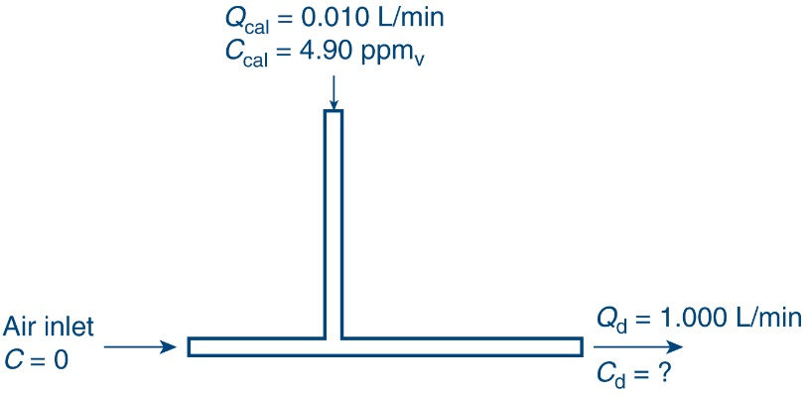

7. Poorly treated municipal wastewater is discharged to a stream. The river flow rate upstream of the discharge point is Qus = 8.7 cubic meters per second. The discharge occurs at a flow of Qd = 0.9 cubic meters per second and has a BOD concentration of 50 mg/L. Assuming that the upstream BOD concentration is negligible. (a) What is the BOD concentration just downstream of the discharge point, after mixing? (b) If the stream has a cross-sectional area of 10 square meters, what would the BOD concentration be 50 km downstream? BOD is removed with a first-order decay rate constant equal to 0.20/day.

8. You are designing a reactor that uses chlorine in a plug flow reactor or a completely stirred tank reactor to destroy pathogens in water. A minimum contact time of 30 min is required to reduce the pathogen concentration from 100 pathogens/L to below 1 pathogen/L through a first-order decay process. You plan on treating water at a rate of 1,000 gal/min. (a) What is the first-order decay rate constant? (b) What is the minimum size (in gallons) of the reactor required for a plug flow reactor? (c) What size (in gallons) of CSTR would be required to reach the same outlet concentration?

**HOMEWORK (Energy balances, Watershed balances)**

1. Two-thirds of the energy content of fuel entering a 1,000-MWe nuclear power plant is removed by condenser cooling water that is withdrawn from a local river (there are no stack losses, as it the case for a fossil fuel-fired plant). Note, the 1,000-MWe refers to the actual electricity generated and sent to the power lines, after waste heat is taken away from cooling water. The river has an upstream flow of 100 m3/s and a temperature of 20˚ C.

(a) If the cooling water is only allowed to rise in temperature by 10˚C, what flow rate from the river would be required?

(b) How much would the river temperature rise as it receives the heated cooling water?

2. A 600-MWe power plant has an efficiency of 36 percent with 15 percent of the waste heat being released to the atmosphere as stack heat and the other 85 percent taken away in the cooling water. Instead of drawing water from a river, heating it, and returning it to the river, this plant uses an evaporative cooling tower wherein heat is released to the atmosphere as cooling water is evaporated to vapor at 100 ˚C. At what rate must 15˚C makeup water be provided from the river to offset the water lost in the cooling tower?

Answer: 401.3 kg/s

Explanation: The power plant has an efficiency of 36%. This means 64% of the heat form the source (q1) will become waste heat. Of the waste heat, 85% will be taken away by water (qw).

qw = 0.85 * q2

q2 = 0.64 * q1

p = 0.36 * q1

q1 = p /0.36

q2 = 0.64/0.36 * p

qw = 0.85 *0.64/0.36 * p

qw = 0.85 *0.64/0.36 * 600 = 907 MW

In evaporation water becomes vapor absorbing heat without going to the boiling point (similar to how sweating takes heat from the human body) The latent heat for the vaporization of water is:

SLH = 2.26 MJ/kg

So, to dissipate 907 MW

G = qw * SLH = 907 / 2.26 = 401.3 kg/s 

3. Your house has an electric water heater. Several friends are visiting you over the weekend and they are taking consecutive showers. Assume that at the maximum heating level, the heater uses 50 kW of electricity. The water use rate is a continuous 4 gallons per minute with the new water saving showerhead you recently installed. Your very old showerhead had used 7 gallons per minute. You replaced the showerhead because you learned that heating water was the second highest energy use in your home. By slowing the flow of water through the heater, the water temperature should increase to a higher temperature. (a) What is the change in temperature (T) for the old showerhead? (b) What is the change in temperature (T) for the new showerhead? Assume the system is at steady sate, and all of the 50 kW energy used is heating the water.

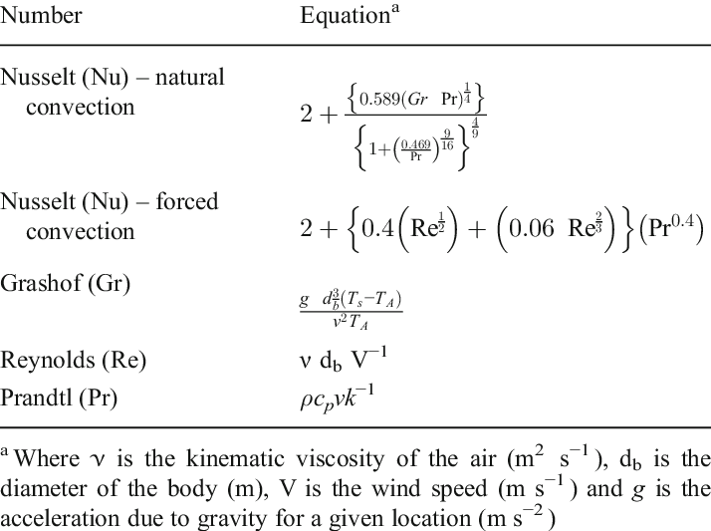

4. Water is taken from a river to cool a power plant. The water accepts waste heat and is returned water back to the river. The return water has a flow rate of 200 gal/min, and the receiving river has a flow rate of 3,000 gal/min and a temperature of 18 degrees C in the summer at the point of mixing. If the maximum allowable temperature of the river after mixing is 22 degrees C before the fish die, what is the maximum allowable temperature of the return water?

Answer: 45-degrees

5. The average annual rainfall in an area is 60 cm. The average annual evapotranspiration is 35 cm. Thirty percent of the rainfall infiltrates and percolates into the underlying aquifer, the remainder is runoff that moves along or near the ground surface. The underlying aquifer is connected to a stream. Assuming there are no other inputs or outputs of water to the underlying aquifer and the aquifer is at steady state (neither gains nor loses water), what is the amount of baseflow contributed to the stream from the groundwater?

In this system the infiltration (I) into the aquifer is equal to 30 percent of the rainfall.

I = 0.3 x 60 cm = 18 cm

Under steady-state conditions baseflow (B) to streams and lakes is defined based on groundwater inputs. Thus, we can equate the infiltration to the baseflow.

B = I = 18 cm

6. A small public well is used to supply drinking water to a small residential community located in a 26 square kilometer watershed. For the month of June, the measured rainfall was 12 cm, the estimated evapotranspiration was 7.5 cm and the surface water runoff entered a small stream with an average flow of 0.32 m3/sec that leaves the watershed. Estimate the average flow (m3/day) from the public well without depleting the underlying aquifer (neither gains nor loses water). Assume that all water that infiltrates will percolate to the aquifer. There is no baseflow.

Answer: 1,76,44,432 (m^3/day)

7. *Estimate* the daily water demand and wastewater generation for a new 8-storey building. The first six floors are occupied by a department store. On each floor are two sets of men’s and women’s lavatories. The seventh floor is an office with 40 employees. The eighth floor is a restaurant that typically serves 220 customers per day. Use table 7.12 in the notes.

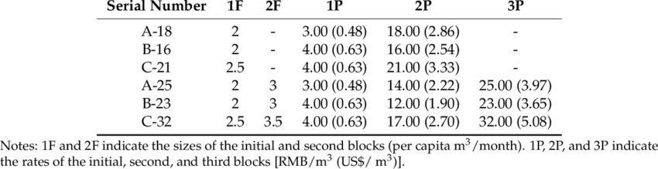

**HOMEWORK (Water Treatment)**

1. You are evaluating the performance of a settling basin within a drinking water treatment plant.

(a) What is the terminal settling velocity of a particle with a specific gravity of 1.4 and a diameter of 0.010 mm in 20˚C water?

(b) Would particles of the size in part a be completely removes in a settling basin with a width of 10.0 , a depth of 3.00 m, a length of 30.0 m, and a flow rate of 7,500 m3/d? Answer yes or no, and prove with calculations.

(c) What is the smallest diameter particle (in micrometers) of specific gravity 1.4 that would be removed in the sedimentation basin described in part b?

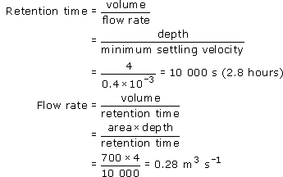

2. You are trying to remove 10.0 μm diameter particles in a water treatment plant, so you design a settling basin. The water is at 20˚C (giving a water density of 998.2 kg/m3, but really you can assume 1000 kg/m3 here), and the particle density is 1.2 g/mL. The plant treats 0.100 m3/s of water. It is proposed to use a 3.5 m deep, rectangular sedimentation tank with a length to width ration of 5:1. What is the minimum required width of the basin?

Answer - 3.64 x 10-5 m

3. You are being consulted for the design of a coagulation-flocculation basin for a water treatment plant. Ferric sulfate is available as a commercial coagulant and is popular at removing turbidity and color. The chemical reaction for its addition to water is:

Fe2(SO4)3 + 3Ca(HCO3)2 ----> 2Fe(OH)3 (s) + 3CaSO4 + 6CO2

Results of a jar test to determine the optimal coagulant dose are provided below. The initial water sample has a pH=6.5 and turbidity of 30 NTU.

Ferric sulfate dose, mg/L: 5 10 15 20 25

Turbudity, NTU: 15 5 1 0.9 2

What is the optimal mass of ferric sulfate you would need to purchase every day to treat 106 gallons/day to a turbidity below 1 NTU (assume 100% purity of the coagulant).

4. A water treatment plant processes 21,000 cubic meters of water per day. Assume two types of flocculated particles enter the basin. You are asked to evaluate the performance of a rectangular sedimentation basin that has dimensions of depth=4 m, width= 6 m, and length= 40 m. The first type of particles has a settling velocity of 0.5 m/hr and the other type has a settling velocity of 1.8 m/hr. What percent of particles are removed for each of the two types of particles?

Answer: 34.3%

5. Chlorine is used for primary disinfection at a water treatment plant that treats 0.20 m3/s of reservoir water. *Giardia* (a protozoan) is the primary pathogen of concern, and the *Giardia* inactivation rate constant for free chlorine disinfection is 0.53 min--1. Note that the inactivation rate constant is *k\** in the simplified Chick-Watson equation where the rate of inactivation r(N):

r(N) = -*k\**N and *k\** = *k*Cn

The plant achieves 3-log removal of *Giardia* at pH 6.0-9.0 in a plug flow contact chamber using free chlorine concentration of 2.0 mg/L.

1. What is the volume of contact chamber?
2. If a CSTR, rather than PFR, contact chamber were used, what would the required volume need to be?
3. What volume of contact chamber would be needed if it were constructed as five separate CSTR chambers in series? The volume asked for is the combined volume of all five separate chambers.
4. Assuming a coefficient of dilution of 1.0, what is the coefficient of specific lethality for *Giardia* under these conditions?

Answer: 156.40 m3

6. Given the following data, graph the data for the *Poliomyelitis* virus, using hypobromite as a disinfectant. Determine the inactivation constant and the time required for 99.99 percent (4 log removals) inactivation of this virus. The concentration of hypobromite is 0.1 mg/L.

Time (s) N (# organisms/L)

0.0 1,000

2.0 350

4.0 78

6.0 20

8.0 6

10.0 2

12.0 1

Area of watershed is 220 km2

Annual precipitation in the watershed area is 4.2*109

Equivalent depth is

4.2*109/ 220*106 = 19.1 m

7. What is the difference between ‘coagulation’ and ‘flocculation’.

The concentrations and flocculation of undesirable compounds are two of the most often utilized water treatment procedures. However, any suspension procedure can typically be approved. Coagulation includes the application of a coagulant that can remove charged particles pre-charged from the suspension. In contrast, stability in the slope is caused by physical approaches, such mixing solution, and the inclusion of polymers in some cases. The distinction between coagulation and flocculation is crucial.

8. Explain the meaning of the term “Ct” in disinfection processes design.

The current disinfection standard in Alberta is CT Disinfection. It is used to show your water's degree of disinfection. During the interaction with your water chlorine is merely an injection of chlorine in your fluids. In order to neutralize the usage of free-chlorine bacteria, at least 6 milligrams (6 mg-min/L) should be necessary for the treatment before initial client. This is frequently called "CT." This number. A minimum of 6 mg-min/L (6 mg-min/L) should be essential before initial customer in order to neutralize the use of free-chlorine bacteria. It's often referred to as "CT."

EXTRA CREDIT: Find the schematic of unit operations for the drinking water treatment plant that serves your hometown. Provide this schematic, and label all the unit operations. Below the schematic, write the purpose of each unit operation (that is, what analyte is removed, or how is water quality improved). Write the name of the water treatment plant and/or the name of the town/city.

EXTRA EXTRA CREDIT: You are interested in camping out in the wilderness for several weeks. Your supply of water will be a forest stream. You need a personalized water treatment unit. Find three such water treatment devices online and provide a picture of the device, a schematic of how it works (e.g. cutaway drawing), and a detailed description of how it transforms raw water to potable water.

**HOMEWORK (BOD)**

1. The following data have been obtained in a BOD test that is made to determine how well a wastewater treatment plant is operating. You need to process the data.

|  |  |  |  |  |
| --- | --- | --- | --- | --- |
|  | Initial DO (mg/L) | Final DO (mg/L) | Volume of wastewater (mL) | Volume of dilution water (mL) |
| Untreated sewage | 6.0 | 2.0 | 5 | 295 |
| Treated sewage | 9.0 | 4.0 | 15 | 285 |

What percentage of the BOD is being removed by this treatment plant? If this is a secondary treatment plant that is supposed to remove 85% of the BOD5, would you say it is operating properly?

Answer: 23.67%

2. Some waste has a five-day BOD at 20˚C equal to 210 mg/L and an ultimate BOD of 350 mg/L. Find the five-day BOD at 25˚C. Note, reaction rate coefficients can be adjusted for temperature using the Arrhenius equation, which is kT2 = kT1^(T2-T1), where  is 1.047 typically.

Answer: 0.36

3. For a solution containing 200 mg/L of glycine [CH2(NH2)COOH] whose oxidation can be represented as

2CH2(NH2)COOH + 3O2 4CO2 + 2H2O + 2NH3

NH3 + 2O2 NO3-- + H+ + H2O

1. Find the theoretical CBOD.
2. Find the nitrogenous portion of BOD (BOD only due to oxidation of N compounds).
3. Find the total theoretical BOD.

3O2 = (3)(16)(2)

3O2 = 96g

So three modes of the oxygen oxidizes the two moles of the Glycine(150g / mol)

4. A waste has an ultimate BOD of 1,000 mg/L and a *kL* of 0.1/day. What is its 5-day BOD?

5. (a) Calculate the ultimate BOD of a waste that has a measured 5-day BOD of 20 mg/L, assuming a BOD rate coefficient of 0.15/day measured at 20 degrees C. (b) Estimate the rate coefficient if the temperature of the waste is raised to 30 degrees C. (c) What would be the BOD5 at 30 deg. C? You can use the Arrhenius equation and theta value in question 2.

**HOMEWORK (Wastewater Treatment)**

Questions 1 and 2 refer to a well-mixed aeration pond or aeration lagoon that can be modeled according to the diagram below. The pond is simply a body of water that holds the wastewater for some detention time before the waste degrades or leaves in the effluent stream. There is no recycle line. You should derive a mass balance on X to solve these problems, make sure to include all terms in the mass balance. You may assume no X flows in with the influent.

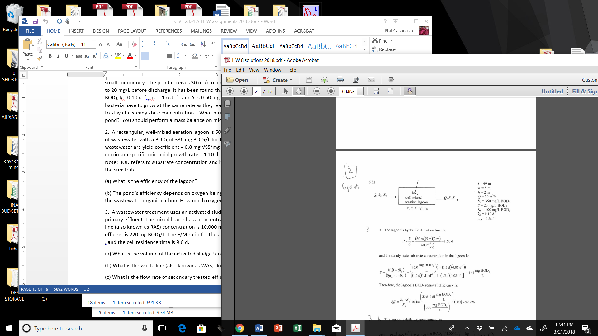

1. The perfectly mixed aeration pond with no recycle (return line) above serves as the biological reactor for a small community. The pond receives 30 m3/d of influent with a BOD5 of 350 mg/L that must be reduced to 20 mg/L before discharge. It has been found that the kinetic constants for the system are Ks=100mg/L BOD5, kd=0.10 d—1 , μm = 1.6 d—1 , and Y is 0.60 mg VSS/mg BOD5. Note: In this system each day, the bacteria have to grow at the same rate as they leave in the effluent, in order for the bacteria population to stay at a steady state concentration. What must the hydraulic detention time be in the aeration pond? You should perform a mass balance on microbe mass to solve this question.

Answer: 10.9 mg / liter

2. A rectangular, well-mixed aeration lagoon that has the same conceptual model above is 60 m long, 5 m wide, and 2 m deep. It receives 400 m3/d of wastewater with a BOD5 of 336 mg BOD5/L for treatment. The biodegradation rate constants for the wastewater are yield coefficient = 0.8 mg VSS/mg BODs, endogenous decay constant = 0.08 d—1 , maximum specific microbial growth rate = 1.10 d—1 , and the half velocity constant = 76.0 mg BOD5/L. Note: BOD refers to substrate concentration and it also refers to how much O2 is required to consume the substrate.

(a) What is the efficiency of BOD5 removal of the lagoon?

(b) The pond’s efficiency of BOD5 removal depends on oxygen being always available for the microbes to use in degrading the wastewater organic carbon. How much oxygen gas (in kg/d) must be supplied daily to the pond?

3. A wastewater treatment uses an activated sludge process for secondary treatment of 0.3 m3/s of primary effluent. The activated sludge has a biomass concentration of 2,100 mg VSS/L, and the return activated sludge line (also known as RAS) concentration is 10,000 mg VSS/L. The substrate concentration in the primary effluent is 220 mg BOD5/L. The F/M ratio for the activated sludge tank is 0.52 mg BOD5 × mg VSS—1 × d—1 , and the cell residence time is 9.0 d.

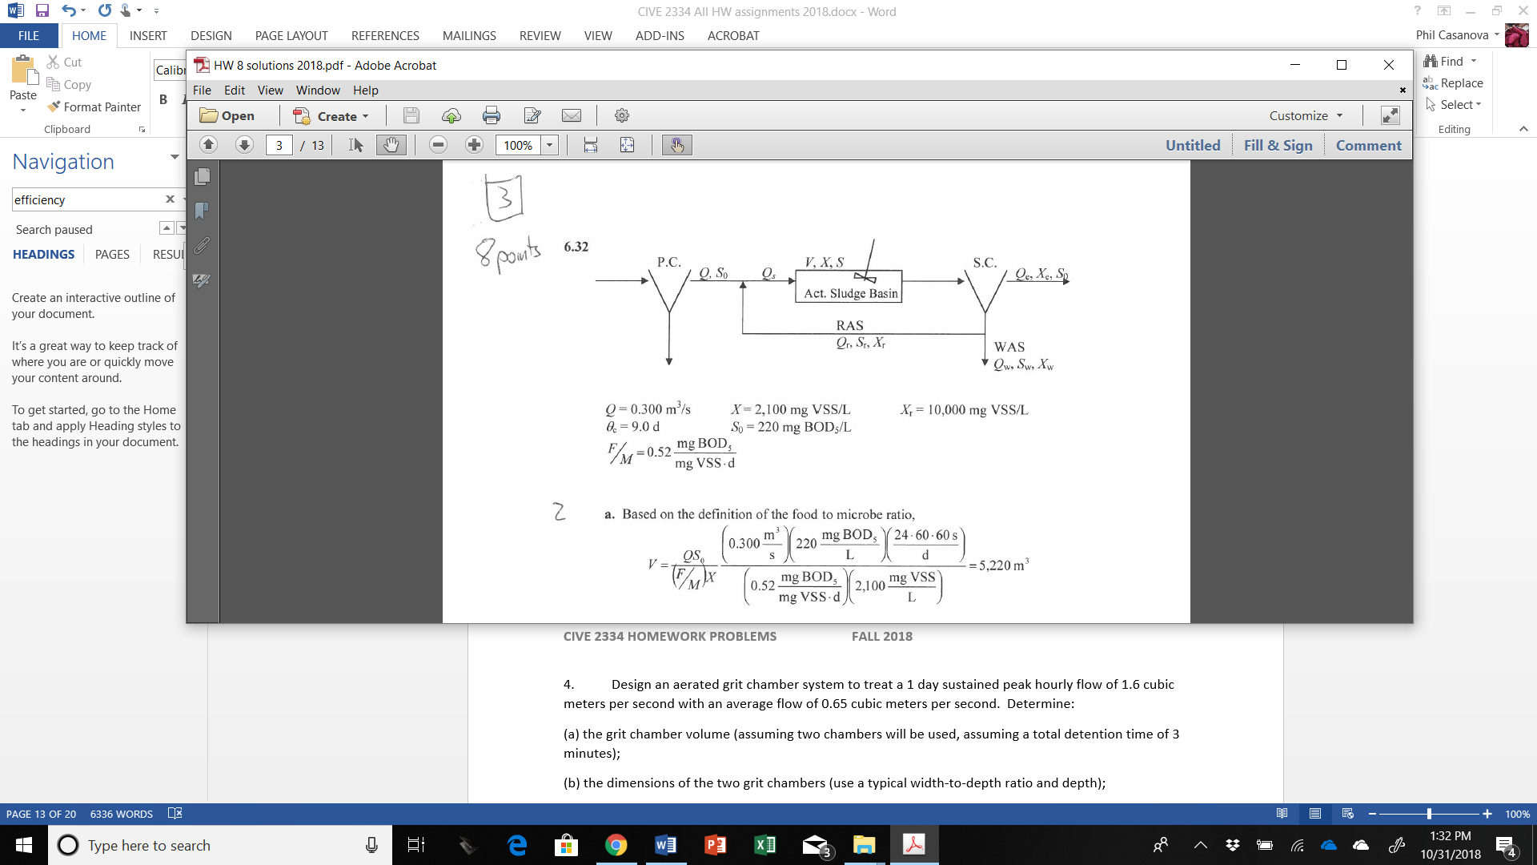

(a) What is the volume of the activated sludge tank?

(b) What is the waste line (also known as WAS) flow rate?

(c) What is the flow rate of the effluent from the entire system?

(d) What is the hydraulic residence time for the activated sludge tank? Hint: You will need to also write a mass balance for biomass X around the secondary clarifier, and a flow balance around the secondary clarifier, as part of the solution.

4. You are provided with the following information about a municipal wastewater treatment plant. This plant uses the traditional activated sludge process. Assume the microorganisms are 60 percent efficient at converting food to biomass (this refers to the yield coefficient), the organisms have a first order death rate constant of 0.1/day, and the microbes reach half of the maximum growth rate when the BOD5 concentration is 22 mg/L. There are 220,000 people in the community (their wastewater production is 225 L/day-capita, 0.1 kg BOD5/capita-day). The effluent standard is BOD5 = 20 mg/L and TSS = 20 mg/L. Suspended solids were measured as 4,000 mg/L in a wastewater sample obtained from the activated sludge basin (so this is volatile suspended solids), 16,500 mg/L in the secondary sludge, 230 mg/L in the plant influent, and 110 mg/L in the primary clarifier effluent. SRT is equal to 4.5 days.

(a) what is the design volume of the aeration basin (the activated sludge basin) (m3)?

(b what is the plant’s aeration period (the hydraulic retention time) (days)?

(c) How many kg of secondary dry solids (solids removed from the secondary clarifier to waste) need to be processed daily from the treatment plants?

(d) if the sludge wastage rate (Qw) is increased in the plant, will the solids retention time go up, go down, or remain the same?

(e) Determine the F/M ratio in units of mg BOD5/mg VSS-day.

(f) What is the mean cell residence time?

5. The community of San Antonio is located in the Caranavi Province, Bolivia. According to the 2005 year survey, there are 420 habitants of the community. The population is estimated to increase to 940 by the year 2035. The average peak flow is currently 1.2 L/sec and is expected to increase to 2.14 L/sec by 2035. The organic load is estimated to be 45 gram BOD5/capita-day. The community is considering a free surface wetland to treat their wastewater.

(a) What is the BOD5 loading generated in the year 2035 (kg/day)?

(b) Use the BOD loading to estimate the maximum surface area (ha) required for a free surface wetland that would serve the community in 2035 and remove BOD to 30 mg/L.

(c) Assuming you are now considering sizing a facultative lagoon instead of a free surface wetland. Quickly estimate the required surface area (m2) for a facultative lagoon to handle a peak flow in 2035, assuming a design water depth of 4 m and a hydraulic detention time of 20 days.

6. A city of 200,000 people deposits 37 cubic feet per second (cfs) of sewage having a BOD of 28.0 mg/L and 1.8 mg/L of DO into a river that has a flow rate of 250 cfs and a flow speed of 1.2 ft/s. Just upstream of the release point, the river has a BOD of 3.6 mg/L and a DO of 7.6 mg/L. The saturation value of DO is 8.5 mg/L. The deoxygenation coefficient *k*d is 0.61/day, and the reaeration coefficient *k*x is 0.76/day. Assume complete and instantaneous mixing of the sewage and river.

(a) Find the initial oxygen deficit and ultimate BOD just downstream of the outfall.- 6.75 mg / L

(b) Find the time and distance to reach the minimum DO. 20.6 miles

(c) Find the minimum DO. – 5.65 mg / L

(d) Find the DO that could be expected 10 miles downstream. – 5.9 mg/L

7. For the following waste and river characteristic just upstream from the outfall, find the minimum downstream DO that could be expected:

|  |  |  |
| --- | --- | --- |
| Parameter | Wastewater | River |
| Flow (m3/s) | 0.3 | 0.9 |
| Ultimate BOD (mg/L) | 6.4 | 7.0 |
| DO (mg/L) | 1.0 | 6.0 |
| *K*d (day-1) | -- | 0.2 |
| *K*r (day -1) | -- | 0.37 |
| Speed (m/s) | -- | 0.65 |
| DOsat(mg/L) | 8.0 | 8.0 |

8. A river traveling at a velocity of 10 km/day has a dissolved oxygen content of 5 mg/L and an ultimate cBOD of 25 mg/L at distance x=0 km, that is, immediately downstream of a waste discharge. The waste has a cBOD decay coefficient kl of 0.2/day. The stream has a reaeration rate coefficient k2 of 0.4/day and a saturation dissolved oxygen concentration of 9 mg/L.

(a) What is the initial dissolved oxygen deficit?

(b) What is the location of the critical point, in time and distance?

(c) What is the dissolved oxygen deficit at the critical point?

(d) What is the dissolved oxygen concentration at the critical point?

EXTRA CREDIT: Find the schematic of unit operations for the wastewater treatment plant that serves your hometown. Provide this schematic, and label all the unit operations. Below the schematic, write the purpose of each unit operation.

**HOMEWORK (Air Pollution Control)**

1. Consider a new 38% efficient 600-MW power plant burning 9,000 Btu/lb coal containing 1% sulfur. If a 70% efficient scrubber is used, what would be the emission rate of sulfur (lb/hr)?

Coal required per hour = Work done/(power efficiency x burning rate)

={( 2.04728498 x 109 Btu/hour)/(0.38x 9,000 Btu/lb)}

= 598,621.34 lb/hour.

Rate of sulfur = 1% x coal requirement per hour

= (1/100) x 598,621.34 lb/hour.

= 5,986.21 lb/hour

Emission rate of sulfur per hour

= rate of sulfur x Scrubber efficiency

= (5,986.21 lb/hour) x 70/100

= 4,190.35 lb/hr

Therefore, the emission rate of sulfur is 4,190.35 lb/hr

Step-by-step explanation

Word done = 600 MW

This work is equivalent to 2.04728498 x 109 Btu/hour.

power efficiency = 38% = (38/100) = 0.38

Scrubber efficiency = 70% = (70/100) = 0.70

Burning rate = 9,000 Btu/lb

Since it contains 1% sulfur then for every 1 lb Coal the sulfur content is 0.01 lb.

Coal required pere every hour will be ;

Coal required per hour = Work done/(power efficiency x burning rate)

={( 2.04728498 x 109 Btu/hour)/(0.38x 9,000 Btu/lb)}

= 598,621.34 lb/hour.

Rate of sulfur = 1% x coal requirement per hour

= (1/100) x 598,621.34 lb/hour.

= 5,986.21 lb/hour

Emission rate of sulfur per hour

= rate of sulfur x Scrubber efficiency

= (5,986.21 lb/hour) x 70/100

= 4,190.35 lb/hr

2. A new coal-fired power plant has been built using a sulfur emission control system that is 70 percent efficient. If all of the sulfur oxidizes to SO2 and if the emission of SO2 are lmited to 0.6 lb SO2 per million Btu of heat into the power plant, what maximum percent sulfur content can the fuel have if 15,000 Btu/lb coal is burned?

Answer - 27.34 %

3. A point source Gaussian plume model for a power plant uses 50 m as the effective stack height. You are concerned about pollutant levels at night, and the night is typically fully overcast with a wind speed of 5 m/s. Your concern in with ground-level pollution at two house locations, A and B, which are 1.2 and 1.4 km directly downwind from the stack. Figure 7.52 in the Masters & Ela text would be helpful.

(a) At what distance will the maximum concentration of pollution occur under these conditions? Which location (A or B) would have the higher level of pollution?

(b) Suppose during the day the sky clears up, and the atmosphere becomes moderately unstable, and the wind speed stays around 5 m/s. Will the location downwind at which the maximum concentration occurs move? If so, will it move closer to the stack or further away from the stack? (H remains 50 m).

(c) Under the new conditions in part b, which house would experience the most pollution?

Answer: According the Table 7.52, class D stability should be assumed for overcast conditions, day or night, regardless of wind speed.

From Figure under class A conditions and an effective stack height of 50 m, the peak downwind concentration occurs at 1.1 km. Therefore, location A will have a higher level of pollution than location B. For a clear sky and wind speed of less than 5 m/s at night,

 E stability. From Figure the peak downwind concentration now occurs at about 1.4 km, further away from the stack. This makes sense since it takes plumes longer to reach the ground under more stable conditions. Location B will now experience higher pollution than location A

4. A stack emitting 80 g/s of NO has an effective stack height of 100 m. The windspeed is 4 m/s at 10 m, and it is a clear summer day with the sun nearly overhead. Use a P value appropriate for the stability class. Estimate the ground-level NO concentration

(a) Directly downwind at a distance of 2 km. – 45%

(b) at the point downwind where NO is a maximum. – 200 meters

(c) at a point located 2 km downwind and 0.1 km off the downwind axis. - zero

5. A baghouse that employs a shaker collection method is being designed to remove sawdust particles originating from a sawmill plant. What fabric area is required for the baghouse if it treats 15,000 ft3/min of polluted air? How many bags are required if the bags are cylindrical and are 6 inches in diameter and 15 ft long? Assume the filter manufacturer has specified a woven fabric.

Answer: 237 bags are required

6. A thermal oxidizer incinerator operates as a plug flow reactor at a temperature of 250 deg C. The first order rate constant for vinyl chloride removal is 45/sec at 250 degrees C and the inside diameter of the incinerator (which is shaped like a cylinder) is 1 m.

(a) If the pollutant (Vinyl chloride) enters the incinerator at a flow rate of 3,000 m3/min and it is desired to remove 99.99% of the pollutant, what should the length of the incinerator be? 48 meters

(b) What is the length of the incinerator if the desired removal is increased to 99.99995%? 12 meters

7. What is the expected efficiency of an electrostatic precipitator that has a total collector plate area of 5000 square meters, a flow rate of 150 cubic meters per second, and a drift velocity of 0.1 m/s? What is the efficiency if the plate area is increased to 7500 square meters or to 10,000 square meters?

The efficiency of an electrostatic precipitator is given by the formula

η= 1- e(-WA/Q)

Where W is the drift velocity, A is the total collection area, and Q is the airflow rate.

Step-by-step explanation

Here, the total plate area is 5,000 m², the flow rate is 150 m³/s, and drift velocity is 0.15 m/s.

Thus,

η= 1- e(-WA/Q)

=1-e(-0.15*5,000/150)

= 0.9932

=> η = 0.9932

if the area is increased to 7500, that is, A= 7500

η=1-e(-0.15*7500/150)

η = 0.9994

If the area is increased to 10000, that is, A =10000,

η =1-e(-0.15*10000/150)

η = 0.9999

8. A flue gas contains mainly 15 micron sized particles (density 2000 kg/m3) to be removed by a cyclone collector. The body diameter is assumed to be 0.8 m. A high efficiency mode is desired. The inlet velocity is 15 m/s with a density of 1.225 kg/m3. What is the efficiency of removal of the 15 micron sized particles?

Answer: 76%

EXTRA CREDIT: Find a plume from a smokestack, take some photos, and submit those photos via email by the last day of class. Paste the photos within a powerpoint file and indicate with a text box the location (city and state) and time the photo was taken as well as your characterization of the plume shape. The plume must be an actual plume from a smokestack and not just some vapor leaving a steam vent.

**HOMEWORK (Waste Management)**

1.One way to estimate the energy content of wastes is based on an empirical equation described in Rhyner et al. (1995), which utilizes an elemental analysis (also called an ultimate analysis) of the material in question:

HHV (kj/kg) = 339(C) + 1,440(H) – 139(O) + 105(S)

where (C), (H), and (S) are the mass percentages of carbon, hydrogen, oxygen, and sulfur in dry material (for example, cardboard is 43.73 percent carbon, so C=43.73). For the following materials, find the higher heating values (HHV) of the dry waste and the HHV of “as received” waste accounting for the moisture content. Excel may be helpful.

Material Moisture (% as received) Dry Weight Percentages

C H O S

(a)Corrugated boxes 5.20 43.73 5.70 44.93 0.21

(b) Junk mail 4.56 37.87 5.41 42.74 0.09

(c) Mixed garbage 72.0 44.99 6.43 28.76 0.52

(d) Lawn grass 75.24 46.18 5.96 36.43 0.42

(e) Demolition softwood 7.7 51.0 6.2 41.8 0.1

(f) Tires 1.02 79.1 6.8 5.9 1.5

(g) Polystyrene 0.20 87.10 8.45 3.96 0.02

Now, assume a city’s waste is 10% corrugated boxes, 10% junk mail, 40% mixed garbage, 10% lawn grass, 10% demolition softwood, 10% tires, and 10% polystyrene. What is the average “as-received” HHV (kJ/kg) of this waste?

Finally, how much waste needs to be burned per day to power a 4 MW power plant for the city? Assume the efficiency is 50% (that is, 50% of energy created goes to electricity generation).

Answer: 4.02 Tons

2. Suppose a city of 50,000 people generates 40,000 tons of MSW per year. At current recovery and recycling rates, 22 percent of that is recovered or recycled and the rest goes to a landfill. Suppose also that the landfill density is 1,000 lb/yd3, cell depth is 10 ft, and 80 percent of the cell is MSW.

(a) What lift area would be required per year?

(b) If the current landfill site covers 50 acres, including 10 acres needed for access roads and auxiliary facilities, and two more lifts are envisioned, how long would it take to complete this landfill?

Volume of MSW generated by town per year = (0.05x1000) x500000/500 = 50000 m3

Land fill lift per year = [50000/(0.85)]/(0.8x150x100)= 4.902 m

No. of years for which the land fill can be used=25/4.902=5.1 years

3. If the city described in problem 2 increases its recovery and recycling rate to 40 percent, how many years would it take to complete the landfill?

Answer – 3.2 years

4. A new solid waste landfill site is being designed. The landfill will serve a population of 250,000 residents that generates 1 kg solid waste/day-person. Assume that yard waste makes up 15% of the total waste (by weight), paper makes up 40% of the total waste (by weight), and metals make up 10% of the waste (by weight). The municipality bans the placement of yardwaste in landfills and has a recycling program that collects one half of all discarded metals (the other half of metals goes to the landfill). What is the volume of waste that is discarded by the community every day? Assume a waste density at the curb of 140 kg/m3.

Answer: 1.21 x 10^6 m^3

5. Daily cells for a landfill are operated so that the following conditions are maintained: thickness of daily cover= 0.2 m; slope (horizontal:vertical)= 3:1, working face for refuse= 30 m; height of refuse= 3 m; and volume of daily refuse= 1,800 m3/day. The landfill is interested in reducing requirements for daily cover soil over its 20 year life and is considering three options (that is, have a lower Vs/Vr). Which option should be the best? Why?

Option 1: Increase height of refuse to 4 m.

Option 2: Increase daily refuse volume to 2000 m3/day.

Option 3: Decrease working face to 20 m.

The initial daily length is given by:

Vr = H x L x W

1,800 m3 /day = 3 m x L x 30 m

L = 20 m

Vs/Vr = [(1 + 0.2/3)(1 +(3 x 0.2)/20)(1 + (3 x 0.2)/30)] – 1 = 0.121

The other options will need to have a lower Vs/Vr to be better.

Option 1:

Vr = 1,800 m3 /day = 4 m x L x 30 m

L = 15 m

Vs/Vr = 0.114 (better than current situation)

Option 2:

Vr = 2,000 m3 /day = 3 m x L x 30 m

L = 22.2 m

Vs/Vr = 0.117 (better, but not as good as option 1)

Option 3:

Vr = 1,800 m3 /day = 3 m x L x 20 m

L = 30 m

Vs/Vr = 0.121 (same as current situation)

Option 1, because the same 0.2 layer will be used to cover 4 m instead of 3 m and that gives 25% more refuse to cover ratio.