

Student Number |__|__|__|__|__|__|__|__|__|

Family Name _____________________

First Name _____________________

**School of Business**

**EXAMINATION**

Semester 2 Main, 2021

**ITEC201 Fundamentals of Information Technology - North Sydney, Melbourne, Backdown, Brisbane**

Lecturer: Kamanashis Biswas

Examination Duration: 0 minutes

Weighting: 50%

**Exam Conditions:**

*You must answer all questions.*

**Materials Permitted In The Exam Venue:**

N/A - Hosting a Take-Home Exam

**Materials To Be Supplied To Students:**

None

**Instructions To Students:**

Please note, this take-home examination is due by the closing date/time. Late submissions will not be accepted. To verify the date/time your assessment is due, please refer to submission link in the relevant LEO EXAM unit.

**Question 1 (5 Marks)**

a) Let’s say, a system’s performance is enhanced and it is now 10 times faster than the original system. However, the system is usable only 60% of the time. Determine the overall performance gain by the enhancement using Amdhal’s law (**3 marks**).

### Se = 10

## F = 60/100 = 0.6

## So = 1 / (( 1 - F) + F/Se)

## = 1/ (0.4 + 0.6/10)

## = 1/0.64 = 1.56.

b) Why is it predicted that Moore’s law will be dead by the end of 2022? Do you agree or not with this prediction? Justify your answers (**2 marks**).

Moore's Law, which predicted the development of more robust computer systems (with more transistors), is coming to an end due to engineers' inability to produce circuits with smaller (and more numerous) transistors.

**Question 2 (5 Marks)**

a) Demonstrate the Fetch-Execute cycle using a micro-program (**3 marks**).

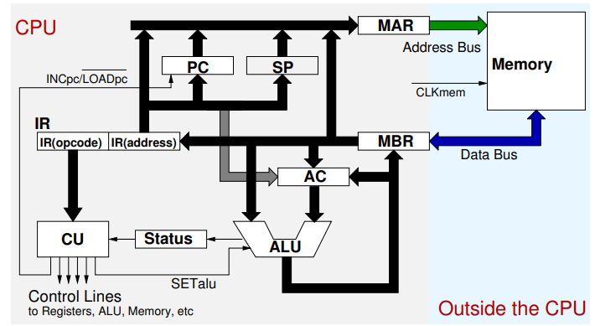

b) The following figure shows the memory addresses and contents (not in a contiguous format). A program is fetching values from the memory and storing them in the accumulator register (once at a time). Fill up the following table using the figure (**2 marks**).

|  |  |
| --- | --- |
| **Memory Address** | **Content** |
| 800 | 700 |
| 900 | 500 |
| 1000 | 1400 |
| 1100 | 1600 |
| 1200 | 1300 |
| 1300 | 1100 |
| 1400 | 900 |
| 1500 | 650 |
| 1600 | 700 |

|  |  |  |  |
| --- | --- | --- | --- |
| **Operand 1000** | | **Operand 1400** | |
| **Mode** | **Value in Accumulator** | **Mode** | **Value in Accumulator** |
| Immediate | 1000 | Immediate | 1400 |
| Direct | 1300 | Direct | 1100 |
| Indirect | 1400 | Indirect | 900 |

**Question 3 (5 Marks)**

a). Subtract the following decimal numbers using **2’s complement**. You **must** show all steps involved in this subtraction process (**3 marks**).

|  |
| --- |
| **47** |
| **- 17** |
|  |

101111 – 10001 = 011110

b) What would be the hexa-decimal representation of ***ItEc201***? You can use the ASCII chart provided in the Appendix section (**2 marks**).

49 74 45 63 32 30 31

**Question 4 (5 Marks)**

a) Consider the following figure. Represent the discrete samples into their corresponding hex values. Draw the analog signal (**3 marks**).

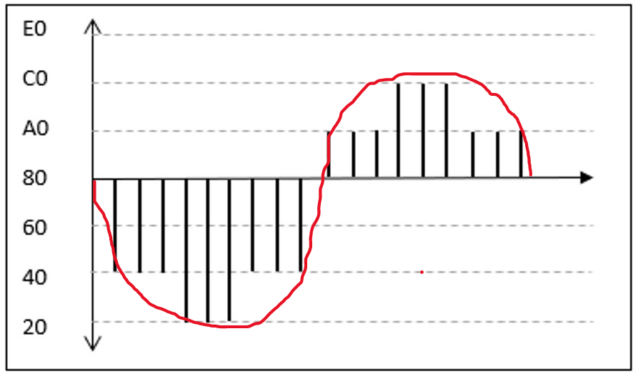

b) Fill up the following table (**2 marks**).

|  |  |  |
| --- | --- | --- |
| **Image Type** | **Bits/Pixels** | **Number of Colours** |
| *Bitmap* | 24 | 256 |
| *GreyScale* | 8 | 254 |
| *Colour-Mapped* | 16 | 65 thousand |
| *True-Colour* | 24 | 16m |

**Question 5 (5 Marks)**

a) Construct the truth table for the following circuit. Can this circuit be replaced by a single gate? If so, draw the gate (**2 marks**).

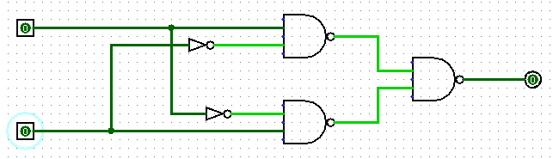

b) Suppose the voice channels of 7 subscribers of a local telephone exchange in the Sydney are multiplexed and sent on a single carrier to Brisbane. How many selection input bits are needed by the decoder of this simple multiplexer? Draw a block diagram showing the inputs and outputs only (**3 marks**).

**Question 6 (5 Marks)**

a) Why *Shift* operation is important? Multiply between the following decimal numbers using **Shift** operation: **15 x 9**. You **must** show the outcomes of each shift operation **(3 marks**).

A shift operator manipulates data by shifting the bits of its first operand to the right or left. The shift operators available in the Java programming language are summarised in the table below. Each operator moves the first operand's bits by the number of places specified by the second operand.

b) Distinguish between combinatorial logic and sequential logic with figure (**2 marks**).

Combinational circuits are described as time independent circuits that do not rely on past inputs to create any output. Sequential circuits are ones that are time-dependent and rely on both current and previous inputs to create any output.

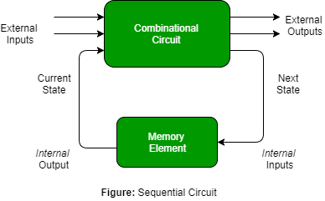

**Question 7 (5 Marks)**

a) Convert the decimal number 912 to its corresponding IEEE754 format (**3 marks**).

**division = quotient +remainder**

**912 ÷ 2 = 456 +0**

**456 ÷ 2 = 228 +0**

**228 ÷ 2 = 114 +0**

**114 ÷ 2 = 57 +0**

**57 ÷ 2 = 28 +1**

**28 ÷ 2 = 14 +0**

**14 ÷ 2 = 7 +0**

**7 ÷ 2 = 3 +1**

**3 ÷ 2 = 1 +1**

**1 ÷ 2 = 0 +1**

912(10) = 11 1001 0000(2)

912(10) = 0-10001000-11001000000000000000000

b) Consider the following structure with two integer variables. The first variable is 4 bytes long whereas the second variable takes 2 bytes space in the memory. Show the memory occupation by the structure in both big-endian and little-endian format (**2 marks**).

Struct **Endian** {

int32_t *firstVar* = 0x09080c0d;

int16_t *secondVar* = 0x0a0b;

}

**Big-Endian Little-Endian**

|  |  |  |  |  |
| --- | --- | --- | --- | --- |
| 00 |  |  |  |  |
| 04 |  |  |  |  |
| 08 |  |  |  |  |

|  |  |  |  |  |
| --- | --- | --- | --- | --- |
| 00 |  |  |  |  |
| 04 |  |  |  |  |
| 08 |  |  |  |  |

**Question 8 (5 Marks)**

a) Define the following terms: i) bootstrapping, ii) context switching (**2 marks**).

Bootstrapping refers to a circumstance in which an entrepreneur begins a business with minimal cash and relies on funds other than outside financing. When an individual attempts to create and develop a firm using personal funds or the new company's operational income, they are said to be bootstrapping. Bootstrapping also refers to a method for calculating the zero-coupon yield curve from market data.

Context Switching is the act of saving a process's context or state so that it may be reloaded when needed and execution can be restarted from the same place as before. This is a feature of a multitasking operating system that allows many processes to share a single CPU.

b) Consider the following jobs that the CPU will be executing.

|  |  |  |  |
| --- | --- | --- | --- |
| **Job id** | **Arrival time** | **Execution time (s)** | **Priority** |
| 1 | 00:00:20 | 20 | 2 |
| 2 | 00:00:30 | 15 | 1 |
| 3 | 00:00:30 | 10 | 3 |

Show the execution sequence for each of the following algorithms (**3 marks**).

|  |  |
| --- | --- |
| **Scheduling Algorithms** | **Job Execution Sequence** |
| FCFS | 1-2-3 |
| Priority Scheduling | 2-1-3 |
| Shortest Jobs First | 3-2-1 |

**Question 9 (5 marks)**

a) Why IP address is not enough to communicate between 2 different systems in a network? What other types of addresses are used in computer networks (**2 marks**)?

Port and Mac Address

b) Let A (*IP: 192.168.10.10, MAC: 00-AA-BB-CC-DD-FF, Port:80*) is sending a packet to B (*IP: 192.168.20.10, MAC: 10-AA-BB-CC-DD-FF, Port: 8080*). Identify what information would be added at each layer using data encapsulation process (**3 marks**).

|  |  |  |
| --- | --- | --- |
| Application Layer | AL Header | Data |

|  |  |  |  |
| --- | --- | --- | --- |
| Transport Layer | ? | ? | AL Data |

|  |  |  |  |
| --- | --- | --- | --- |
| Network Layer | ? | ? | TL Data |

|  |  |  |  |  |
| --- | --- | --- | --- | --- |
| Data Link Layer | ? | ? | NL Data | FCS |

**Question 10 (5 marks)**

a) Read the case study on “[delivery services](https://www.abc.net.au/news/2018-09-21/gig-economy-workers-rights-subject-of-victorian-gov-inquiry/10290696)”. Answer the following questions based on your critical analysis and research on the case study.

i) What are the ethical concerns (**1 mark**)?

ii) What are the implications of working as contractor as opposed to an employee (**1 mark**)?

iii) What workplace rights are being denied? What are causing that (**1 mark**)?

iv) What SD goals are affected? What are the social concerns (**2 marks**)?

**END OF EXAMINATION**

**Appendix: ASCII Table**

|  |  |  |  |  |  |  |  |  |  |
| --- | --- | --- | --- | --- | --- | --- | --- | --- | --- |
| **HEX** | **MSD** | **0** | **1** | **2** | **3** | **4** | **5** | **6** | **7** |
| **LSD** | **BITS** | **0000** | **0001** | **0010** | **0011** | **0100** | **0101** | **0110** | **0111** |
| **0** | **0000** | **NUL** | **DLE** | **space** | **0** | **@** | **P** | **`** | **P** |
| **1** | **0001** | **SOH** | **DC1** | **!** | **1** | **A** | **Q** | **a** | **Q** |
| **2** | **0010** | **STX** | **DC2** | **“** | **2** | **B** | **R** | **b** | **R** |
| **3** | **0011** | **ETX** | **DC3** | **#** | **3** | **C** | **S** | **c** | **S** |
| **4** | **0100** | **EOT** | **DC4** | **$** | **4** | **D** | **T** | **d** | **T** |
| **5** | **0101** | **ENQ** | **NAK** | **%** | **5** | **E** | **U** | **e** | **U** |
| **6** | **0110** | **ACK** | **SYN** | **&** | **6** | **F** | **V** | **f** | **V** |
| **7** | **0111** | **BEL** |  | **‘** | **7** | **G** | **W** | **g** | **W** |
| **8** | **1000** | **BS** |  | **(** | **8** | **H** | **X** | **h** | **X** |
| **9** | **1001** | **TAB** |  | **)** | **9** | **I** | **Y** | **i** | **Y** |
| **A** | **1010** | **LF** |  | **\*** | **:** | **J** | **Z** | **j** | **Z** |
| **B** | **1011** | **VT** | **ESC** | **+** | **;** | **K** | **[** | **k** | **{** |
| **C** | **1100** | **FF** |  | **,** | **<** | **L** | **\** | **l** | **|** |
| **D** | **1101** | **CR** |  | **-** | **=** | **M** | **[** | **m** | **}** |
| **E** | **1110** | **SO** |  | **.** | **>** | **N** | **^** | **n** | **~** |
| **F** | **1111** | **SI** |  | **/** | **?** | **O** | **_** | **o** |  |