1.

N=int(input("Enter Total number of elements in list : "))

lists=[]

for i in range(N):

value=int(input("Enter a number :"))

lists.append(value)

test = [each for each in lists if each>0]

print(test)

"""for i in lists:

if i>0:

print(i)"""

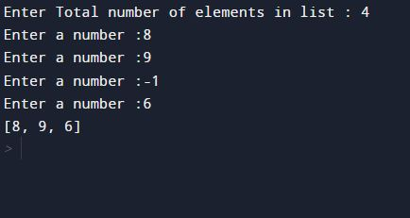

2. N = int(input("ENTER THE TOTAL NUMBER OF ELEMENTS:"))

lists=[]

for i in range(N):

value=int(input("Enter a number :"))

lists.append(value)

squared_numbers = [number ** 2 for number in lists]

print(squared_numbers)

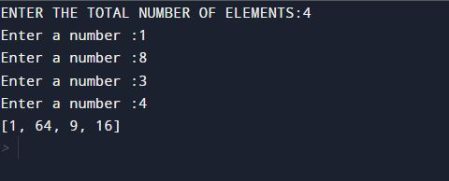

3.

a= input("ENTER THE WORD:")

vowels="AaEeIiOoUu"

ans=set(each for each in a if each in vowels)

print(ans)

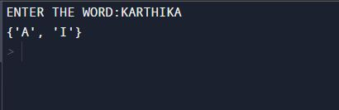

4.

a= input("ENTER A STRING:")

for element in a:

print(ord(element))

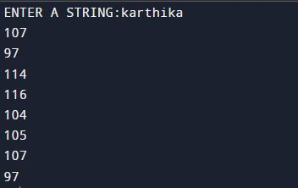

5.

def word_count(str):

counts = dict()

words = str.split()

for word in words:

if word in counts:

counts[word] += 1

else:

counts[word] = 1

return counts

print( word_count('This course introduces a basic step towards program writing and develops the logical ability and problem-solving skill using Python Programming Language'))

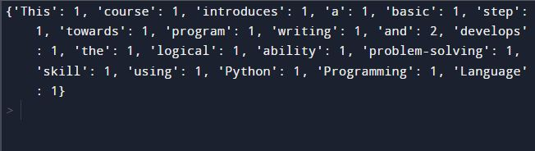

6.

lst=[]

n=int(input('Enter the number of elements: '))

for i in range(0,n):

ele=int(input("Enter the elements: "))

lst.append(ele)

if(lst[i]>=100):

lst[i]="Over"

print (lst)

elif(lst[i]<100):

print (lst)

else:

print("Invalid value.")

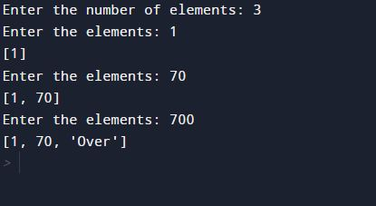

7.

N=int(input("Number of names : "))

listed = []

count=0

for i in range(N):

name = input("Enter name : ")

listed.append(name)

for i in listed:

for j in i:

if(j=="a"):

count=count+1;

print(count)

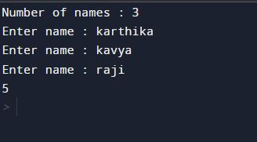

8.

list1=[]

list2=[]

list3=[]

n1=int(input("Total elements in first list : "))

for i in range(n1):

value=int(input("Input no : "))

list1.append(value)

n2=int(input("Total elements in second list : "))

for i in range(n2):

value=int(input("Input no : "))

list2.append(value)

if(n1 == n2):

print("Same length")

else:

print("Not same length ")

if(sum(list1)==sum(list2)):

print("Same sum ")

else:

print("Sum are different")

list3=[each for each in list1 if each in list2]

print("Same members are :",list3)

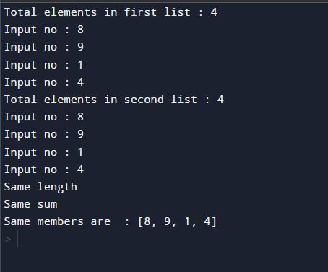

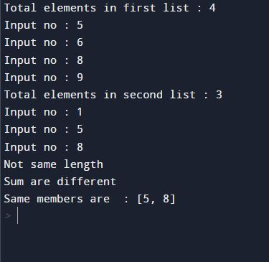

9.

def change_char(str1):

char = str1[0]

str1 = str1.replace(char, '$')

str1 = char + str1[1:]

return str1

print(change_char('onion'))

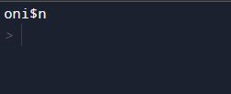

10.

str = input("Enter a string : ")

new_str = str[-1:] + str[1:-1] + str[:1]

print(new_str)

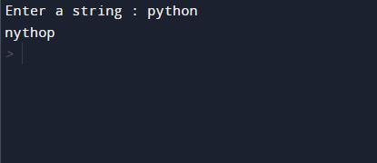

11.

r = int(input("Enter the radius : "))

a = 3.14*r*r

print(a)

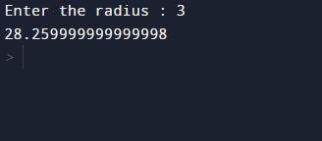

12.

a=int(input("Enter the first number: "))

b=int(input("Enter the second number: "))

c=int(input("Enter the third number: "))

if a>b and a>c:

print(a,"is the largest number")

elif b>c:

print(b,"is the largest number")

else:

print(c,"is the largest number")

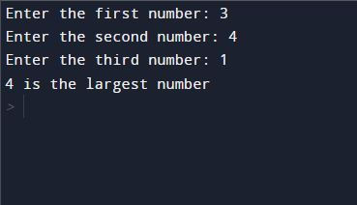

13.

filename = input("Input the Filename: ")

f_extns = filename.split(".")

print ("The extension of the file is : " + repr(f_extns[-1]))

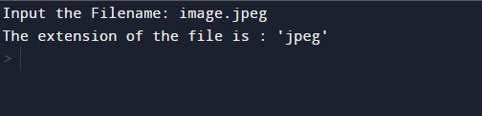

14.

print ("Print leap year between two given years")

print ("Enter start year")

startYear = int(input())

print ("Enter last year")

endYear = int(input())

print ("List of leap years:")

for year in range(startYear, endYear):

if (year%4 == 0) and (year%100!= 0) or (year%400==0):

print (year)

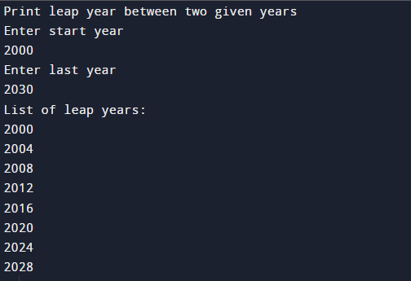

15.

n=int(input("Enter an integer: "))

a=n+n*n+n*n*n

print(a)

n.JPG

16.

color_list_1 =set(["White","Black","Red"])

color_list_2 =set(["Red","Green"])

print(color_list_1.difference(color_list_2))

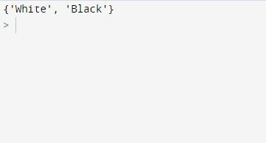

17.

defchars_mix_up(a, b):

new_a = b[:1] + a[1:]

new_b = a[:1] + b[1:]

returnnew_a + ' ' + new_b

print(chars_mix_up('abc', 'xyz'))

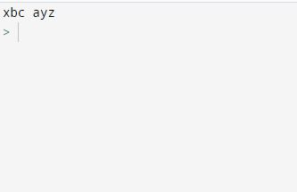

18.

d = {1: 2, 3: 4, 4: 3, 2: 1, 0: 0}

print('Original dictionary : ',d)

x = sorted(d)

print("Ascending order:",x)

x=sorted(d,reverse=True)

print("Descending order:",x)

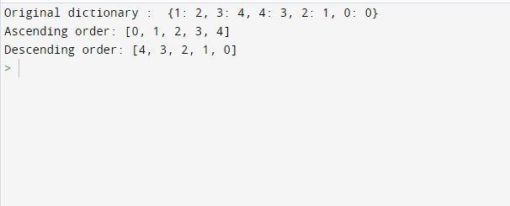

19.

dict1 = { 'Ritika': 5, 'Sam': 7, 'John' : 10 }

dict2 = {'Aadi': 8,'Sam': 20,'Mark' : 11 }

dict3 = {**dict1 , **dict2}

print('Merged dictionary :')

print(dict3)

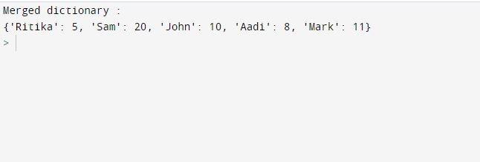

20.

defcompute_hcf(x, y):

if x > y:

smaller = y

else:

smaller = x

fori in range(1, smaller+1):

if((x % i == 0) and (y % i == 0)):

hcf = i

returnhcf

num1 = int(input("Enter the first number: "))

num2 = int(input("Enter the second number: "))

print("The H.C.F. is", compute_hcf(num1, num2))

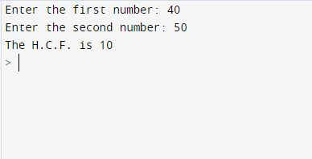

21.

list = [11, 22, 33, 44, 55,56]

print ("Original list:")

print (list)

fori in list:

if(i%2 == 0):

list.remove(i)

print ("List after removing EVEN numbers:")

print (list)

