1.

n=int(input("Enter the number: "))

f=1

while n!=0:

f=f*n

n=n-1

print(f)

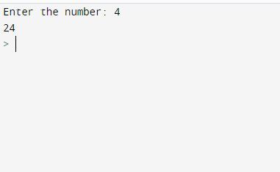

2.

n=int(input("Enter the number of values: "))

n1, n2 = 0, 1

count = 0

if n <= 0:

print("Please enter a positive integer")

elif n == 1:

print("Fibonacci sequence upto",nterms,":")

print(n1)

else:

print("Fibonacci sequence:")

while count < n:

print(n1)

nth = n1 + n2

n1 = n2

n2 = nth

count += 1

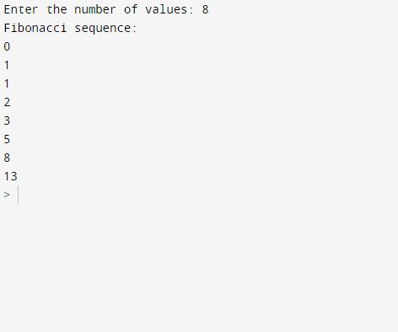

3.

total = 0

list1=[]

l = int(input("Enter the number of elements: "))

forele in range(0,l):

a=int(input("Enter the elements: "))

list1.append(a)

total = total + list1[ele]

print("Sum of all elements in given list: ", total)

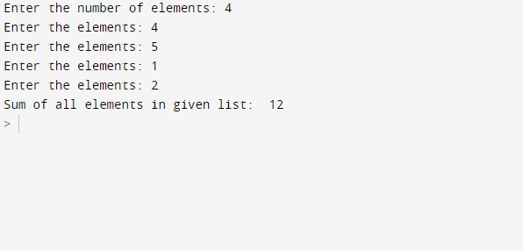

4.

N = int(input("Enter the number of rows: "))

for i in range(1,N+1):

for j in range(1,i+1):

print(i * j," ", end="")

print()

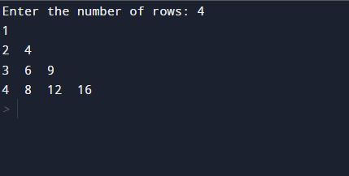

5.

word=input("Enter a string: ")

characters=0

for char in word:

characters+= 1

print(characters)

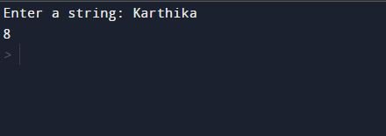

6.

def add_string(str1):

length = len(str1)

if str1[-3:] == 'ing':

str1 += 'ly'

else:

str1 += 'ing'

return str1

s=input("Enter a string: ")

print(add_string(s))

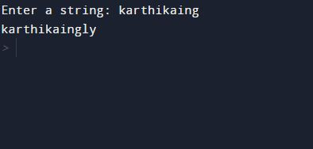

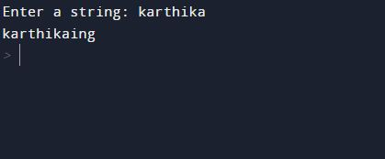

7.

a=[]

n= int(input("Enter the number of elements in list:"))

for x in range(0,n):

element=input("Enter the elements: ")

a.append(element)

max1=len(a[0])

temp=a[0]

for i in a:

if(len(i)>max1):

max1=len(i)

temp=i

print("The word with the longest length is:")

print(temp)

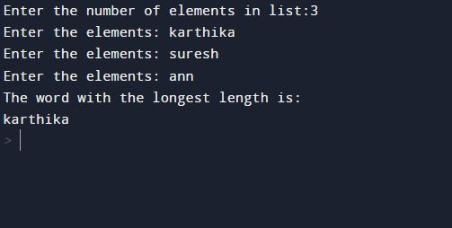

8.

rows = int(input("Enter the number of rows: "))

for i in range(0, rows):

for j in range(0, i + 1):

print("*", end=' ')

print(" ")

for i in range(rows + 1, 0, -1):

for j in range(0, i - 1):

print("*", end=' ')

print(" ")

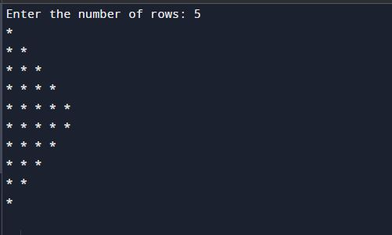

9.

def print_factors(x):

print("The factors of",x,"are:")

for i in range(1,x+1):

if x % i == 0:

print(i)

num = int(input("Enter a number: "))

print_factors(num)

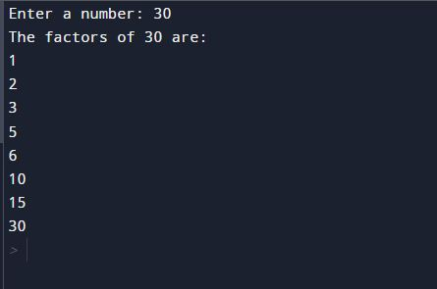

10.

area_of_a_rectangle = lambda l,b : l*b

area_of_a_square=lambda a: a*a

area_of_a_triangle=lambda l,b: (1/2)*l*b

print("Area of rectangle is:", area_of_a_rectangle(3,4))

print("Area of square is:", area_of_a_square(5))

print("Area of triangle is:", area_of_a_triangle(6,7))

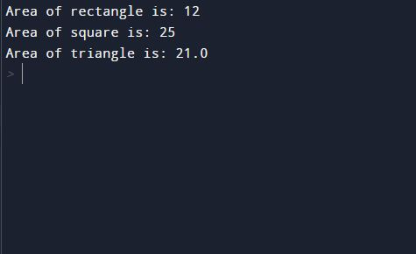

11.

n=int(input("Enter the number of elements: "))

list=[]

for i in range(0,n):

a=int(input("Enter the numbers: "))

b=a*a

if ((b>=1000) and (b<=9999)):

list.append(b)

print(list)

