8. N=int(input("Enter Total number of elements in list : "))

lists=[]

for i in range(N):

value=int(input("Enter a number :"))

lists.append(value)

test = [each for each in lists if each>0]

print(test)

"""for i in lists:

if i>0:

print(i)"""

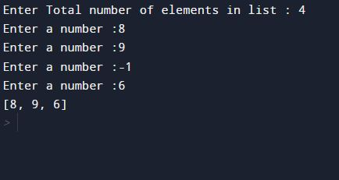

11.

5.

def word_count(str):

counts = dict()

words = str.split()

for word in words:

if word in counts:

counts[word] += 1

else:

counts[word] = 1

return counts

print( word_count('This course introduces a basic step towards program writing and develops the logical ability and problem-solving skill using Python Programming Language'))

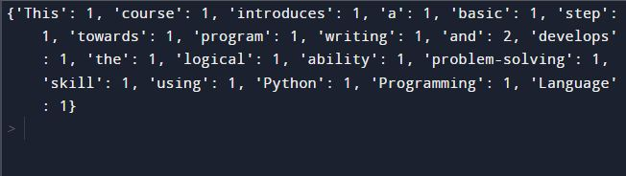

12.

d = {1: 2, 3: 4, 4: 3, 2: 1, 0: 0}

print('Original dictionary : ',d)

x = sorted(d)

print("Ascending order:",x)

x=sorted(d,reverse=True)

print("Descending order:",x)

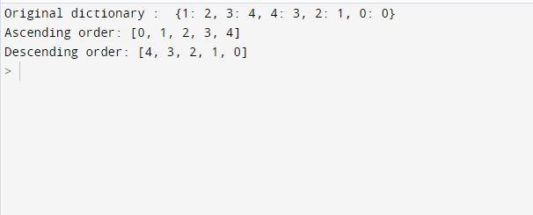

13.

dict1 = { 'Ritika': 5, 'Sam': 7, 'John' : 10 }

dict2 = {'Aadi': 8,'Sam': 20,'Mark' : 11 }

dict3 = {**dict1 , **dict2}

print('Merged dictionary :')

print(dict3)

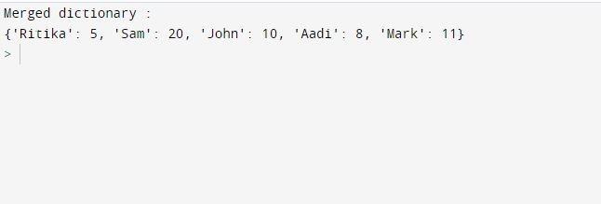

18

area_of_a_rectangle = lambda l,b : l*b

area_of_a_square=lambda a: a*a

area_of_a_triangle=lambda l,b: (1/2)*l*b

print("Area of rectangle is:", area_of_a_rectangle(3,4))

print("Area of square is:", area_of_a_square(5))

print("Area of triangle is:", area_of_a_triangle(6,7))

