1. **paddinginternalcss.html**

<html>

<head>

<style>

div {

border: 1px solid black;

background-color: lightblue;

padding-top: 5px;

padding-right: 10px;

padding-bottom: 80px;

padding-left: 5px;

}

</style>

</head>

<body>

<h2>Using individual padding properties</h2>

<div>This div element has a top padding of 50px, a right padding of 30px,

a bottom padding of 50px, and a left padding of 80px.</div>

</body>

</html>

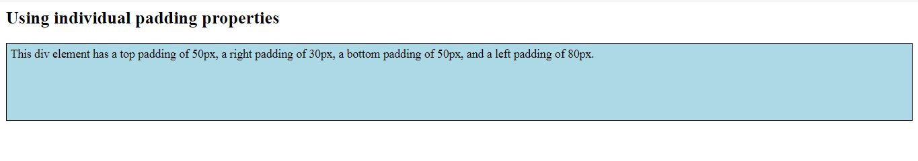

1. **style1.css**

body {

background-color: lightblue;

}

h1 {

color: red;

margin-left: 20px;

}

p

{

color: yellow;

margin-left: 40px;

}

div {

border: 1px solid black;

margin-top: 100px;

margin-bottom: 100px;

margin-right: 150px;

margin-left: 80px;

background-color: lightblue;

}

**externalcss.html**

<html>

<head>

<link rel="stylesheet" href="style1.css">

</head>

<body>

<div>

<h1>This is a heading</h1>

<p>This is a paragraph.</p>

</div>

</body>

</html>

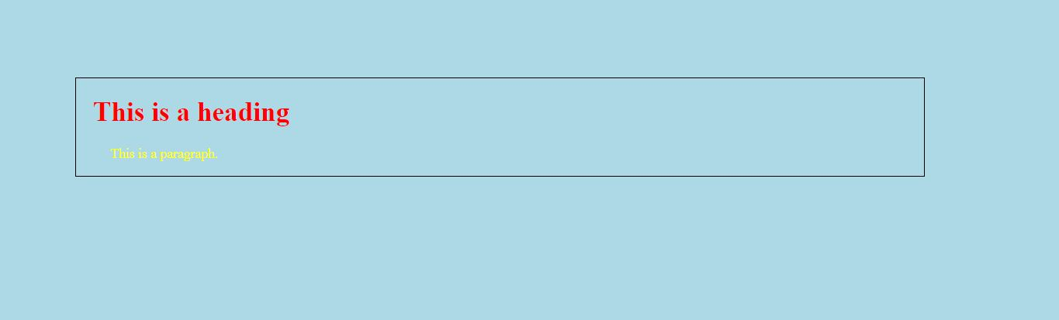

1. **inlinecss.html**

<!DOCTYPE html>

<html>

<body style="background-color:yellow;">

<h1 style="color:blue;margin-left:40px;">A Blue Heading</h1>

<p style="color:red;">A red paragraph.</p>

</body>

</html>

