DataRobot Deployment Report

This is an automated Deployment Report of "Churn predictions 2025-06-11 14:28:16.413179" (<https://app.datarobot.com/deployments/684a3a3e48166d9c69e683ca/overview>). This report was automatically created by DataRobot MLOps and the contents of this report include a snapshot of model monitoring activity from June 12, 2025 through June 13, 2025. This includes aspects of Data Drift, Accuracy, and Service Health.

Copyright ©2025, DataRobot, Inc.



|  |  |
| --- | --- |
| Deployment Information | |
| Deployment Name | Churn predictions 2025-06-11 14:28:16.413179 |
| Deployment ID | [684a3a3e48166d9c69e683ca](https://app.datarobot.com/deployments/684a3a3e48166d9c69e683ca/overview) |
| Project ID | [68498e568bfab2bde976b5de](https://app.datarobot.com/projects/68498e568bfab2bde976b5de/models) |
| Model Package | <https://app.datarobot.com/model-registry/model-packages/684992821f2e05c702a36f38> |
| Target Type | binary |
| Target Name | Churn |
| Prediction Threshold | 0.5 |
| End Point | None |

.

|  |  |
| --- | --- |
| Governance Information | |
| Importance | High |
| Build Env. | DataRobot |
| Approval Status | Approved |
| Owners | Boya karthik |
| Model Age | 0 days |

.

|  |  |
| --- | --- |
| Performance Summary | |
| Health Indicators  The Service Health, Data Drift, and Accuracy summaries below provide an at-a-glance indication of health and accuracy for the Churn predictions 2025-06-11 14:28:16.413179 deployment. Additional detail is throughout this report. | |
| Monitoring Period | June 12, 2025 - June 13, 2025 |
| Service Status | |  |  | | --- | --- | |  | Service health unknown. | |
| Data Drift | Not enough predictions (100) have been made.   |  |  | | --- | --- | |  | Drift is unknown. | |
| Accuracy | |  |  | | --- | --- | |  | Accuracy is unavailable. | |

Table of Contents

* 1 Data Drift
* 1.1 Feature Drift
* 1.2 Feature Drift Thresholds
* 1.3 Feature Drift Over Time
* 1.4 Feature Details
* 1.5 Predictions Over Time
* 2 Accuracy
* 2.1 Accuracy Over Time
* 3 Service Health
* 3.1 Monitoring Service Health With DataRobot
* 3.2 Service Health Results

1 Data Drift

1.1 Feature Drift

By leveraging training data (also known as learning data) and scoring data (also known as inference data) that is added to your deployment, Data Drift helps you to analyze a model’s performance after it has been deployed. Drift tracking is particularly important in applications where the outcomes of predictions are not immediately known (for instance, predicting whether an action will be taken in the next twelve months).

Feature Drift vs. Feature Importance displays how much features have drifted since training time compared to their importance. Drift is a measurement that compares how the data used for scoring differs from the data used for training. Drift in features with high importance can be a warning flag about your model’s accuracy. The deployment is using Population Stability Index as its Drift metric with a threshold of 0.15 for Drift and 0.5 for Feature Importance. In the chart below, the Drift of each feature is plotted against its Importance, which is calculated from training time:

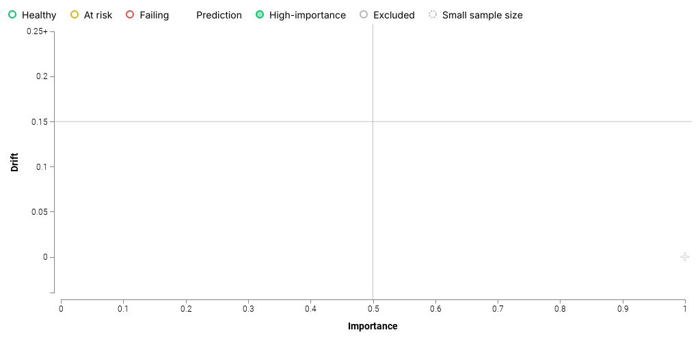

Feature Importance is represented by the X-axis and Drift is represented by the Y-axis. The target (the double green point) and the most important feature in the model will always have an Importance value of 1.

The table below shows the features that have “risk” or “fail” statuses for Data Drift and their Importance and Drift values:

|  |  |  |  |
| --- | --- | --- | --- |
| Feature Name | Status | Importance | Drift |

1.2 Feature Drift Thresholds

The Feature Drift vs. Feature Importance Thresholds are used for notifications of the model’s Drift status. The tables below show the thresholds for Feature Drift and Feature Importance and the rules for notifications about Drift:

|  |  |  |
| --- | --- | --- |
| Type | Metric | Threshold |
| Feature Drift | Population Stability Index | 0.15 |
| Feature Importance | Permutation Importance (Feature Impact) | 0.5 |

Deployment Drift status (currently unknown) is based on checking the number of low-importance features (features that are below the Feature Importance Metric) and the number of high-importance features (features that are above the Feature Importance Metric) that are above the Drift Threshold.

|  |  |  |
| --- | --- | --- |
| Drift Status Rules | | |
| Number of low-importance features above drift threshold for the deployment to be considered… | at risk: 1 or more features. | failing: N/A |
| Number of high-importance features above drift threshold for the deployment to be considered… | at risk: N/A | failing: 1 or more features. |

1.3 Feature Drift Over Time

The Feature Drift Over Time chart illustrates the change in a feature's data distribution over time, comparing the training dataset of the deployed model to the datasets used to generate predictions in production.

The change in Population Stability Index (PSI) over time for each of a model's top 5 features (determined by Permutation Importance) is presented below:

1.4 Feature Details

The Feature Details chart provides a histogram that compares the distribution of a selected feature in the training data to the distribution of that feature in the scoring data. From the results you can easily identify details of changed values (which values became more or less frequent), helping to assess the severity of the problem as well as its causes and resolutions.

A histogram chart of the top 5 features as measured by Permutation Importance is presented below:

1.5 Predictions Over Time

Viewing the predictions over time allows you to see changes in the values the deployment typically predicts. A change in the predictions can be an indication of model degradation.

The continuous Predictions Over Time plot shows the average predicted values the deployment made over time.

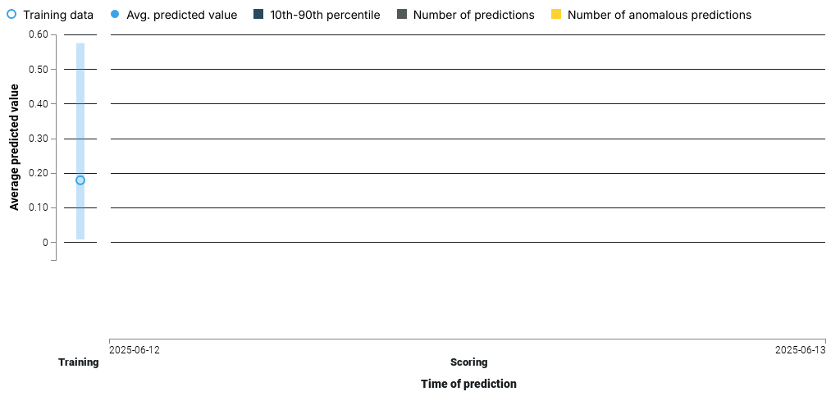

The binary Predictions Over Time plot mode takes the prediction threshold (0.5) into account and shows the percentage of predictions made for each possible class.

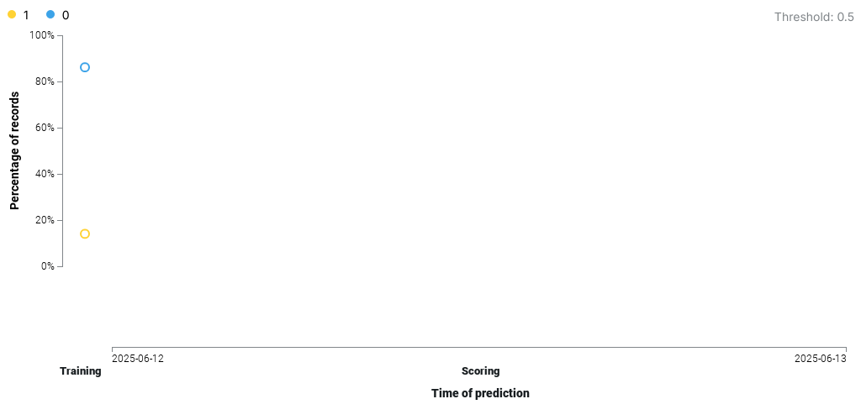

2 Accuracy

2.1 Accuracy Over Time

DataRobot’s Accuracy monitoring provides performance information of model deployments over time, using standard statistical measures and visualizations.

Accuracy has not be enabled for this deployment. Enable Accuracy in the Settings > Data tab.

3 Service Health

3.1 Monitoring Service Health With DataRobot

The Service Health tracks metrics about a deployment’s ability to respond to prediction requests quickly and reliably. This helps identify bottlenecks and assess capacity, which is critical to proper provisioning. DataRobot Service Health reports on the following metrics:

|  |  |  |
| --- | --- | --- |
| Metric | Definition ` | Value for this Deployment |
| Total Predictions | The number of predictions the deployment has made. | 0 |
| Total Requests | The number of prediction requests the deployment has received (a single request can contain multiple prediction requests). | 0 |
| Requests Over 2,000 ms | The number of requests where the response time was longer than 2,000 milliseconds. | 0 |
| Response Time | The median time (in milliseconds) DataRobot spent receiving a prediction request, calculating the request, and returning a response to the user. The report does not include time due to network latency. | Nonems |
| Execution Time | Median time (in milliseconds) DataRobot spent calculating a prediction request. | Nonems |
| Median/Peak Load | The median and maximum number of requests per minute. | 0.0, 0.0 |
| Data Error Rate | The percentage of requests that result in a 4xx error (problems with the prediction request submission). This is a component of the value reported as the Service Health Summary in the Churn predictions 2025-06-11 14:28:16.413179 page top banner. | 0.0%  N/A |
| System Error Rate | The percentage of well-formed requests that result in a 5xx error (problem with the DataRobot prediction server). This is a component of the value reported as the Service Health Summary in the Churn predictions 2025-06-11 14:28:16.413179 page top banner. | 0.0%  N/A |
| Consumers | The number of distinct users (identified by API token) who have made prediction requests against this deployment. | 0 |
| Cache Hit Rate | Percentage of requests that used a model in cache. | 0.0% |

3.2 Service Health Results

The graphs below correspond to the period of this performance analysis for 1-days: June 12, 2025 to June 13, 2025 with a weekly resolution.

Total Predictions: The deployment scored a total of 0 predictions.

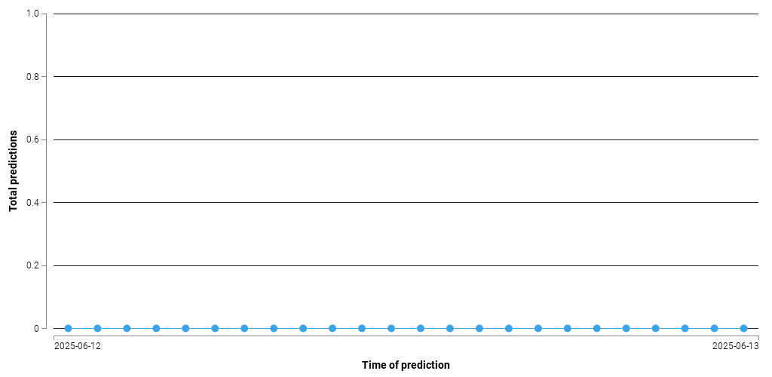

Requests Over 2000 ms: There were 0 predictions that took longer than 2000 ms.

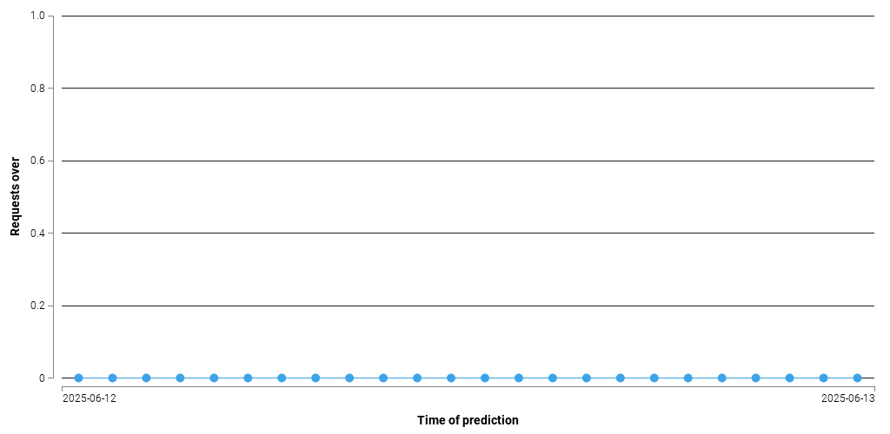

Median Response Time (ms): The median response time of predictions was None ms.

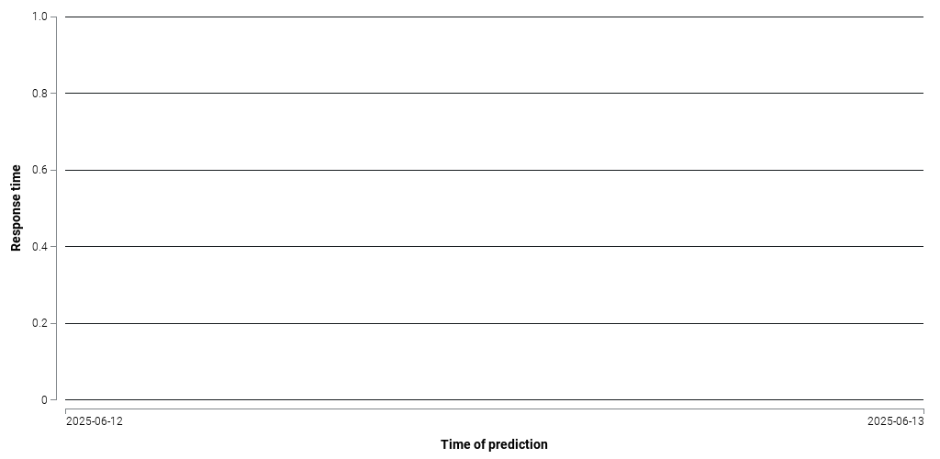

Median Execution Time (ms): The median execution time of prediction (request time not including network latency) was None ms.

