# UNIT-5

**SOLE PROPRIETORSHIP**

**MEANING:**

A business that runs under the exclusive ownership and control of an individual is called sole proprietorship or single entrepreneurship.

**FEATURES OF SOLE PROPRIETORSHIP**

**(i) Single Ownership:** This is owned by one man and nobody else contributes capital.

**(ii) Own Control:** He has absolute control over the affairs of the concern. His decision is final. Since he need not consult others, he can take quick decision and gain enormously

**(iii) Own Profit:** The attraction of reaping the entire profits motivates him to put forth the best in him. He strives tirelessly for the improvement and expansion of his business.

**(iv) Unlimited Liability:** The liability of the sole proprietor is unlimited. As a result, when his business assets are not adequate for paying the debts, his private properties have to be sold.

**(v) Absence of Government Regulation:** A sole proprietor concern is free from Government regulations. No formalities are to be observed in its formation, management or in its closure..

**(vi) Limited Capital:** Since capital is contributed by only one individual it is bound to be small.

**MERITS OF SOLE PROPRIETORSHIP:-**

**(i) Easy to Form and Dissolve : I**t is most easy to start a business as a sole proprietary concern. Sometimes, a few restrictions are placed by local bodies such as municipalities, etc., from the view point of maintenance of health and sanitation. Just as it is easy to form, it is equally convenient to dissolve a sole proprietorship concern.

**(ii) Direct Motivation:** In this form, there is a direct relationship between rewards and efforts. The sole proprietor enjoys the entire profits and hence is inspired, induced and motivated to give his best of efforts and skills in running the business.

**(iii) Absolute Control:** The proprietor is free to prepare any plans and policies and execute them for the success of his business without any interference or clash of interest from any quarter. He is free to direct and control the operations of his business.

**(iv) Business Secrecy:** To face the challenge of competition in the market, maintenance of business secrecy provides and edge to the firm over its rival firms. The degree of retention of business secrecy is the highest in this form of organization.

**(v) Promptness in Decision-Making:** A sole proprietor being a single owner is not required to consult anyone while taking decisions. This enables him to take prompt and quick decisions taking advantage of the opportunities which may arise in business from time to time.

**(vi) Flexibility in Operations:** If the situation demands changes in strategy, the same can be easily brought about to meet the changed situation without causing least of unsought consequences.

**(vii) Personal Relations:** Normally, the size of a sole proprietary business being small, the owner maintains a personal touch with his employees and customers.

**(Viii) Independence & Development:** It provides an opportunity of business career to many people with available resources and there by utilizing their capacity and skills in the field of business. Since a sole proprietor has to face all kinds of problems and challenges single handed, the qualities of initiative, self-reliance and responsibilities get developed in him.

**DEMERITS OF SOLE PROPRIETORSHIP**

**(i) Limited Capital:** Since the capital is contributed by one individual only, business operations have necessarily to be on a limited scale. Even when he wants to raise funds by borrowing, the borrowing capacity of one individual is bound to be limited. Thus large scale units which require enormous capital cannot be started by an individual.

**(ii) Limited Managerial Skill:** Whoever may be a person his resourcefulness and business management will be less effective beyond a certain stage. Further, since he has to keep his fingers on everything and has to work under severe stress, he likely to take wrong-decisions.

**(iii) Unlimited Liability:** The liability of a sole trader being unlimited, even his private assets are in danger of being lost.

**(iv) Uncertainty of Continuity:** Since the success of the sole trading concern hinges on the personal qualities of the proprietor, any prolonged illness or permanent disability or death brings the business to a standstill.

**(v) Inability to Avail of Specialization:** Since the business unit is small and the financial resources limited experts in different fields cannot be employed to secure maximum advantage. He alone has to handle production, marketing, correspondence, etc. It is common knowledge that one cannot be an expert in all these varied fields of business activities, as a result, efficiency suffers.

**(vi) Hasty Decision:** Though quick decision is a definite advantage, sometimes the decision taken in a hurry is likely to spell ruin to the business. One has to agree with the proverb, ‘haste makes waste’

**PARTNERSHIP**

**INTRODUCTION: A partnership is an association of two or more person’s examples nearly 20 who carry on business together for the purpose of earning profits.**

**MEANING:** Section 4 of the Indian Partnership Act, 1932 defines ***partnership as “the relation between persons who have agreed to share the profits of a business carried on by all or any of them acting for all.”***

**FEATURES:** The essential features of a partnership firm are discussed below:-

**(i) TWO OR MORE PERSONS:** There must be at least two persons to form a Partnership. The partnership Act fixes no maximum limit on the number of partners of a partnership firm. But the Companies Act, 1956 lays down that any partnership or association of more than 10 persons in case of banking business and 20 persons in other business operations.

**(ii) CONTRACTUAL RELATION:** There must be an agreement between two or more persons to enter into partnership. Such an agreement may be oral, written or implied. Since partnership is an out-come of a partnership the persons who enter into an agreement of partnership must be competent to enter into contract.

**(iii) LAWFUL BUSINESS:** The partners must agree to carry some lawful business. Mere holding of property in joint ownership cannot be considered as partnership unless it is accompanied by certain business activities and possesses other features of partnership.

**(iv) SHARING OF PROFIT:** There must be an agreement to share the profits and losses of the business of the partnership firm. This is at the very root of bringing the persons together to carry on a business. However, sharing of profit is not a conclusive proof of partnership..

**(v) UNLIMITED LIABILITY:** As a result of contractual relationship between the partners of a firm, all the partners are liable jointly and severally for all debts and obligations of the firm to an unlimited concern

**(vi) NON-TRANSFERABILITY OF INTEREST:** A partner cannot transfer his proprietary interest to any person (except those who are already the partners) without the unanimous consent of other partners.

**KINDS OF PARTNERS:**

Partners can be classified from different start points-on the basic of business interest, The important categories of partners are as follows:

**(i) ACTIVE OR ACTUAL PARTNER:** Partners who take an active part in the conduct of the partnership business are called actual partners. They are full-fledged partners in the real sense of the term, such a partner must give public notice of his retirement from the firm in order to free himself from liability for acts after retirement.

**(ii) SLEEPING OR DORMANT PARTNER:** Sometimes, however, there are persons who merely put in their capital (or even without capital they may become partners) and do not take active part in the conduct of the partnership business. They are known as ‘sleeping’ or ‘dormant’ partners. They do share profits and losses (usually less then proportionately).

**(iii) PARTNER IN PROFITS ONLY :** A partner who has stipulated with other partners that he will be entitle to a certain share of profits, without being liable for the losses, is known as ‘partner in profits only’

**(iv) PARTNER BY ESTOPPEL:** If a person represents the outside world, by words spoken or written or by his conduct or by lending his name that he is a partner in a certain partnership firm, he is then estoppel from denying his being partner, and is liable as a partner in that firm to any one who has on the faith of such representation granted credit to the firm.

**MERITS OF PARTNERSHIP:**

**(I) EASE OF FORMATION:** Like sole proprietorship, the partnership is also relatively free from legal formalities in terms of its formation.

**(II) LARGER RESOURCES:** This form enables the pooling of larger resource than sole proprietorship, for a number of persons (partners) contribute to the capital of the business. Not only this, the credit worthiness, which can also be used for borrowing larger sums of money.

**(iii) COMBINED ABILITIES AND JUDGMENT:** In addition to the pooling of capital resources, the partnership combines abilities and skills of two or more persons (partners), and thus ensures better management of the business. Combined abilities and judgment, when properly integrated produces the good results.

**(IV) FLEXIBILITY: Here the** flexibility in its operation. It can change its business whenever the partners like. Moreover, it is easier to change the line of business if the firm is not successful in one line of business because of its small scale operations.

**(v) QUICK DECISIONS:** A partnership firm is able to make decisions without delay because partners can meet and discuss the business problems more frequently

**(vi) CAUTIOUS OPERATIONS:** Since the liability of the partners is unlimited, they are more cautious in running the business.

**(vii) SURVIVAL CAPACITY:** The survival capacity of the partnership firm is greater as compared to the sole trader ship concern. The partnership business need not come to an end on the death of a partner if the partnership deed does not provide so. Moreover, a partnership firm can undertake more than one line of business because it has more capital resources and it can compensate its loss in one line by the profit in other lines of business.

**(VIII) BETTER HUMAN OR PUBLIC RELATIONS:** Every partner can be made to develop healthy and cordial relations with employees, customers, suppliers and citizens, etc. The fruits of such a relationship may be reflected in higher accomplishments and larger profits for the business. This will also result in enhancing the goodwill of the firm and pave the way towards its steady progress.

**DEMERITS OF PARTNERSHIP FIRM:**

**(i) LACK OF HARMONY:** The partnership business works steady as long as there is harmony and mutual understanding among the partners. If there is any occasion when this harmony is adversely affected that is the beginning of the end of a good partnership

**(II) LIMITED RESOURCES :** Since maximum number of partners cannot exceed 20 in ordinary business and 10 in banking business, the amount of capital resources is limited to the contribution to be made by the partners..

**(iii) RISK OF IMPLIED AUTHORITY:** A partner having implied authority to bind the firm by his acts of commission and omission, the firm may find itself difficulty in any moment.

**(v) UNLIMITED LIABILITY:** From this stand-point, a partnership is even worse than sole proprietorship because a partner is liable to the extent of his private property not only for his own mistakes and lapses but also for the mistakes, lapses and even dishonesty of his fellow partner or partners.

**(vi) NON-TRANSFERABILITY OF INTEREST:** Since no partner can transfer his interest to an outsider without the unanimous consent of all the partners, it makes investment in partnership business reluctantly shy.

**THE JOINT STOCK COMPANY**

**MEANING:** A company is an incorporated voluntary association of persons in business having joint capital divided into transferable shares of a fixed value, along with the features of limited liability, common seal and perpetual succession.

**FEATURES:**

**(i) ARTIFICIAL LEGAL PERSON:** A joint stock company is an artificial person created by law to achieve the objectives for which it is formed. A company exists only in the contemplation of law. It is invisible, intangible, immortal (law alone can dissolve it), and exists only in the eyes of law.

**(ii) DISTINCT LEGAL ENTITY:** A company is a legal person having a juristic personality entirely distinct from and independent of the individual persons who are its members (owners). It has the right to own and transfer the title to property in any way it likes. It can sue and be sued in its own name by its members as well as outsiders similarly.

**(iii) PERPETUAL SUCCESSION:** A joint stock company has a continuous existence and its life is not affected by the death, lunacy, insolvency or retirement of its members or directors. Members may come and go, but the company continues its operations so long as it fulfills the requirements of the law under which it has been formed.

**(iv) COMMON SEAL:** A company being an artificial person cannot sign documents for itself whereas a natural person can do. Any document bearing the common seal of the company and duly witnessed (signed) by at least two directors will be legally binding on the company.

**(v) LIMITED LIABILITY:** Liability of the members of a limited company is limited to the value of the shares subscribed to or the amount of guarantee given by them. Members cannot be asked to pay anything more than what is due or unpaid on the shares of the company held by them even though the assets of the company are not sufficient to satisfy fully the claims of creditors of the company in the event of its winding up.

**(VI) TRANSFERABILITY OF SHARES:** Members of a public limited company are free to transfer the shares held by them to anyone else. Shares can be sold and purchased through the stock exchange.

**(vii) SEPARATION OF OWNERSHIP AND MANAGEMENT:** Ordinarily, the number of shareholders, who are the owners of the company, is fairly large and hence all of them or most of them cannot participate in the day-to-day management of the company. The law, therefore, provides for the Board of Directors, elected by members (owners) in the general body meeting of the company, to govern the affairs of the company.

**MERITS OF A COMPANY:**

**(i) LARGE FINANCIAL RESOURCES:** The joint stock company can raise large amount of money or capital by issuing shares and debentures to the public. The capital of the company is divided into shares of small denominations of Rs.20, Rs50, or Rs.100 which attract person for investment with small income. The ease with which the investor can transfer his share holding is another attraction for the investors to raise vast funds to undertake its business activities from a position of strength.

**(ii) LIMITED LIABILITY:** The liability of shareholders of a company is limited to the face value of the shares held by them. Thus, this form of organization is a great attraction to persons who are not willing to take risk as is inherent in other forms of organization.

**(III) CONTINUITY:** A company being an artificial person created by law and enjoying a distinct and separate personality of its own is not affected by the entry and exit of its members. It continues to be in existence even if all the persons who promoted it leave or desert it or give up their membership. Hence as a body corporate, it enjoys perpetual existence.

**(IV) TRANSFERABILITY OF SHARES:** The right of the shareholders of public companies to transfer the shares held by them imparts liquidity to the investments and thereby encourages investment of funds in the company. The existence of stock exchange and continuity of operations in it facilitate further the transferability of shares especially in respect of those which are listed on the stock exchange.

**(V) BENEFITS OF LARGE SCALE OPERATION:** A company is in a position to raise large amount of capital and thereby undertake large scale operations. The largeness of the operations results in the economies in production, purchase, selling, management, advertising, etc.

**(Vi) PUBLIC CONFIDENCE:** From inception to its winding up all the activities of a company are regulated by the provisions of the Companies Act. The companies are under legal obligation to get their accounts audited by a qualified Chartered Accountant and publicize their audited accounts, Director’s Report, etc.

**(Vii) SOCIAL BENEFITS:** The company form of organization is an effective medium, of mobilizing the scattered savings of the community and investing them in different commercial and industrial enterprises. It is also indirectly helping the growth of financial institutions like banks, insurance companies etc., by providing avenues for the investment of their funds into shares and debentures. It offers many people both skilled and unskilled employees.

.

**DEMERITS OF A COMPANY**

The following are the demerits of the company form of organization “

**(i) FORMATION OF COMPANY IS A LONG DRAWN PROCEDURE:** Promoting a joint stock company involves long drawn procedure. it is expensive and involves large number of legal formalities

**(ii) LACK OF PERSONAL TOUCH:** There is a divorce between ownership and management of the joint stock company. The affairs of the company are managed by the professional managers. This may be responsible for lack of personal involvement in Joint Stock Company.

**(III) OLIGARCHIC MANAGEMENT:** The management of a company which is supposed to be conducted as per desires of the shareholders (or) owner turns out to be a play thing of a few individuals. In theory, every shareholder has a right to participate in the Annual General Meeting and other meetings of the company and to exercise his right to elect directors, to appoint auditors and participate in other matters. But in practice, companies are managed by a small number of persons who are able to perpetuate their reign over the company from year to year. This is because of a number of factors like lack of interest on the part of the shareholders, low literacy level among the shareholders, and lack of sufficient information about the working of the company.

**(iv) HIGH DEGREE OF GOVERNMENT INTERFERENCE**: The government brings out a number of rules and regulations governing the internal conduct of the operations.

**THE COOPERATIVE FORM AN ORGANIZATION**

**Meaning:** A cooperative organization is “an association of persons, usually of limited means, who have voluntarily joined together to achieve a common economic end, through the formation of a democratically controlled business organization, making equitable contributions to the capital required and accepting a fair share of risks and benefits of the undertaking.”

**FEATURES OF CO-OPERATIVE ORGANISATION:**

**(I) VOLUNTARY ASSOCIATION:** People join the society on their own. They have a common interest of improving their economic status through joint efforts.

**(II) SERVICE MOTIVE:** The main objective of the members is not to make profits but to improve their economic well being.

**(III) CAPITAL:** The capital of the co-operative organization is procured from its members in the form of share capital. However, the share capital constitutes only a limited source of business finance, the major part of which is raised by the cooperative organization either by way of loan from the Government and the apex cooperative institutions, or by way of grants and assistance from the government.

**(IV) RETURN ON CAPITAL:** The return on capital subscribed by the members is in the form of a fixed rate of dividend which is a charge on the trading surplus of the organization.

**(V) STATE REGULATION:** A co-operative organization right from its inception up to its end is subjected to detailed regulation under the Co-operative Societies Act, 1919 or other State Co-operative Societies Act. A co-operative organization in order to be registered with Registrar of Co-operative Societies has to fulfill certain requirements.

**MERITS OF COOPERATIVE SOCIETY FORM OF BUSINESS**:

These are as follows;

**(I) EASY FORMATION:** Being a voluntary association, it is easy to form as it does not require long and complicated legal preliminaries. Any 10 adult persons can voluntarily form themselves into an association and get it registered with the Registrar of Cooperatives.

**(II) DEMOCRATIC FUNCTIONING:** The executive members are elected in a democratic way. Any member can contest for the executive committee.

**(iii) LIMITED LIABILITY:** Like the liability of the shareholders in company form of organization the liability of the members in a co-operative organization is also limited to their capital contribution. The effect of limited liability is mentioned in the bye-laws of the co-operative which is checked by the registrar at the time of registering the same.

**(iv) CONTINUITY:** Like the company, the co-operative enjoys a separate legal entity of its own independent of the entity of its members who own it. Hence the life of co-operative organization remains unaffected by the death, insolvency or conviction of a member.

**(V) STATE ASSISTANCE:** Since, Co-operatives have been adopted by the Government as an instrument of economic policy, a number of grants, loans and financial assistance are offered to them to make them function efficiently.

**DEMERITS OF COOPERATIVE SOCIETY FORM OF BUSINESS:**

**(i) LIMITED CAPITAL:** The amount of capital that a co-operative can muster is extremely limited because of the membership remaining confined to particular locality or region and also because of the principle of ‘one man-one vote’ and the divined restrictions.

**(ii) PLENTY OF STATE REGULATION:** Under the existing arrangement the co-operatives are subjected to a variety of regulations from the co-operative department of the State Government partly because the state offers a number of financial helps and partly because it is always anxious to see that the movement succeeds. All this has led to excessive state regulations in the day to day functioning of the co-operative which, at times, amounts to interference.

**(III) LACK OF MANAGERIAL TALENT:** Co-operatives at the primary level generally suffer from extremely limited managerial talent because they depend on the personnel drawn from amongst their own members to serve on the managing committee which, in turn, manages the day to day affairs of the co-operatives.

**(iv) DIFFERENCES AMONG MEMBERS:** Although co-operatives are formed with great fanfare and with the great ideals of co-operation and self-help, but soon these higher values of human life disappear with the passage of time.

**(v) MANY LEGAL FORMALATIES:** the society is registered under the societies act. The formation, administration, conducting meetings. Liquidation and so on are subjected to the procedures laid in the act.

# INTRODUCTION TO FINANCIAL STATEMENT ANALYSIS

**Accounting Introduction:** Accounting has rightly been termed as the language of business the basic function of language is to serve as a means of communication. Accounting was practiced in India thousand years ago and there is a clear evidence for this. Accounting in India is now a fast developing discipline. The two premier accounting institutes in India are chartered accountants of India and the Institute of cost and works accountants of India are making continuous and substantial contributions.

**Definition:**

1. According to “ American Institute of certified public Accountants” (AICPA) the art of recording, classifying and summarizing in a significant manner and in terms of many transactions and events, which are in part at least, of a financial character and interpreting the results there of.
2. According to Smith and Ashburn “Accounting is a means of measuring and reporting the results of economic activities.
3. According to R.N Anthony “Accounting system is a means of collecting, summarizing, analyzing and reporting in monetary terms, the information about the business”.

According to Professor G.A. Lee the accounting system has two stages.

**THE FIRST STAGE IS BOOK KEEPING, SECOND STAGE IS ACCOUNTING.**

* **Book Keeping:** It involves the chronological records of financial transactions in a set of books in a systematic manner.
* **Accounting:** It is concerned with the maintenance of accounts giving stress to the design of the system of records, the preparation of reports based on the recorded data and the interpretation of the reports.

**Thus, the terms, book-keeping and accounting are very closely related, through there is a subtle difference as mentioned below.**

**1. Object:**  The object of book-keeping is to prepare original books of Accounts. It is restricted to journal, subsidiary book and ledge accounts only. On the other hand, the main object of accounting is to record analyse and interpret the business transactions.

**2. Level of Work:** Book-keeping is restricted to level of work. Clerical work is mainly involved in it. Accountancy on the other hand, is concerned with all level of management.

**3. Principles of Accountancy:** In Book-keeping Accounting concepts and conventions will be followed by all without any difference. On the other hand, various firms follow various methods of reporting and interpretation in accounting.

**4. Final Result:** In Book-Keeping it is not possible to know the final result of business every year,

**Branches of Accounting:**

The important branches of accounting are:

1. **Financial Accounting:** The purpose of Accounting is to ascertain the financial results i.e. profit or loss in the operations during a specific period. It is also aimed at knowing the financial position, i.e. assets, liabilities and equity position at the end of the period. It also provides other relevant information to the management as a basic for decision-making for planning and controlling the operations of the business.
2. **Cost Accounting:**  The purpose of this branch of accounting is to ascertain the cost of a product / operation / project and the costs incurred for carrying out various activities. It also assist the management in controlling the costs. The necessary data and information are gatherr4ed form financial and other sources.
3. **Management Accounting:**  Its aim to assist the management in taking correct policy decision and to evaluate the impact of its decisions and actions. The data required for this purpose are drawn accounting and cost-accounting.
4. **Inflation Accounting:** It is concerned with the adjustment in the values of assest and of profit in light of changes in the price level. In a way it is concerned with the overcoming of limitations that arise in financial statements on account of the cost assumption (i.e recording of the assets at their historical or original cost) and the assumption of stable monetary unit.
5. **Human Resource Accounting :** It is a branch of accounting which seeks to report and emphasize the importance of human resources in a company’s earning process and total assets. It is concerned with the process of identifying and measuring data about human resources and communicating this information to interested parties. In simple words, it is accounting for people as organizational resources.

**FUNCTIONS OF AN ACCOUNTANT**

The job of an accountant involves the following types of accounting works:

1. **Designing Work:** It includes the designing of the accounting system, basis for identification and classification of financial transactions and events, forms, methods, procedures, etc.
2. **Recording Work :** The financial transactions are identified, classified and recorded in appropriate books of accounts according to principles. This is “Book Keeping”. The recording of transactions tends to be mechanical and repetitive.
3. **Summarizing Work :** The recorded transactions are summarized into significant form according to generally accepted accounting principles. The work includes the preparation of profit and loss account, balance sheet. This phase is called ‘preparation of final accounts’
4. **Analysis and Interpretation Work:** The financial statements are analysed by using ratio analysis, break-even analysis, funds flow and cash flow analysis.
5. **Reporting Work:**  The summarized statements along with analysis and interpretation are communicated to the interested parties or whoever has the right to receive them. For Ex. Share holders. In addition, the accou8nting departments has to prepare and send regular reports so as to assist the management in decision making. This is ‘Reporting’.
6. **Preparation of Budget :** The management must be able to reasonably estimate the future requirements and opportunities. As an aid to this process, the accountant has to prepare budgets, like cash budget, capital budget, purchase budget, sales budget etc. this is ‘Budgeting’.
7. **Taxation Work :** The accountant has to prepare various statements and returns pertaining to income-tax, sales-tax, excise or customs duties etc., and file the returns with the authorities concerned.
8. **Auditing :** It involves a critical review and verification of the books of accounts statements and reports with a view to verifying their accuracy. This is ‘Auditing’

**Classification of accounting principles**: Accounting principles can be broadly classified in to two categories:

1. 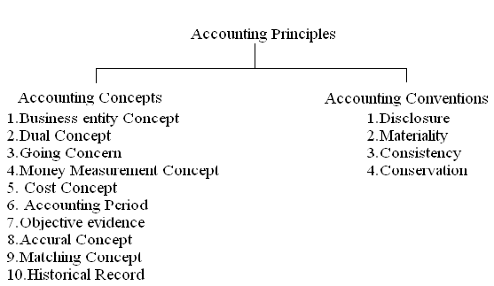Accounting Concepts. 2. Accounting Conventions

**Accounting Concepts:**

* **Business Entity Concept:** It implies that the business is different from the persons who own it. If the owner takes any cash or goods from the business, the drawings account is Debited and cash or goods account is credited.
* **Dual Aspect Concept:** This concept throws on the point that each transaction has two fold affect the receiving of the benefit and giving of the benefit. The receiving aspect is termed as debit, where the giving aspect as Credit. For each debit there will be a credit.

**Eg:**  If we purchase furniture for Rs 5,000, we receive furniture on one hand and give Rs 5000 on the other hand.

* **Going Concern Concept:** It is assumed that the business will continue for a long time with this assumption fixed assets are recorded in the books at their original cost.
* **Money measurement Concept:** While recording the business transactions we do not record them in terms of Kilograms, Quintals, Meters, Liters etc. we record them in a common denomination so as to see that they become homogeneous and meaningful, money does this function. Hence recording is done in terms of standard currency of the country.
* **Objectives Evidence Concept:** According to this concept all accounting transaction should be evidenced and supported by objective documents. The documents include invoices, receipts cash memos etc.
* **Cost Concept:** All the transactions will be recorded at cash in the books. At the end of every year the accountant shows the reduced value of the asset, after providing for depreciation.
* **Accounting Period Concept:** It is the period by a business concern for maintaining accounts to know profit/loss. Usually one year will be the accounting period starting from 1st April and ending 31st March(Financial Year) or 1st January to December 31st (Calendar year).
* **Accrual Concept:** The accrual system is a method where by revenues and expenses are identified with specific periods of time like a Month, Half year or a year. It implies recording of revenues and expenses of a particular accounting period.

If there is an excess of revenues over expenses is called “Income”, if the expenses is more than revenue it is “Loss”.

* **Matching Cost Concept**: According to these principles, the expenses incurred in an accounting period should be matched with the revenues recognized in that period.
* **Historical Record Concept**: The accountant shows only those transactions which have actually taken place and not those which may take place in future. All transactions in accounting are to be recorded in the books in chronological (proper) order. This means the preparation of a historical record for all transactions.

**Accounting Conventions:**

* **Full Disclosure Concept:** This concept with the convention that all information which is of material importance should be disclosed in the accounting statements. The companies Act 1956 makes it compulsory to provide all the information in the prescribed form. The accounting reports should disclose full and fair information to the proprietors, creditors, investors and others.
* **Materiality Concept:** Under this concept the trader records important facts about the commercial activities in the form of financial statements. If any unimportant information is to be given for the sake of clarity, it will be given as foot notes.
* **Consistency Concept:** It is used in the preparation of various accounts should be followed in the years to come. Eg: A Company may adopt straight line method, written down value method, or any other method of providing depreciation on fixed assets.
* **Conservatism Concept:** This Convention warns the trader not to take unrealized income into account. The practice of valuing stock at cost or Market price, whichever is in Vogue (General Liking) this policy is a playing safe?

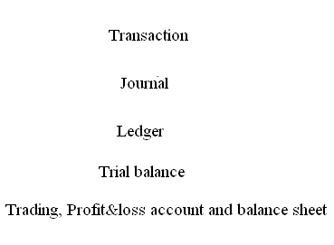 **Accounting Cycle**: The Accounting cycle can be generated as follows:

**CLASSIFICATION OF BUSINESS TRANSACTIONS**

**or**

**Classification of Accounts:**  All business transactions are broadly classified into **three** categories:

* Relating to persons.
* Relating to property (Assets).
* Relating to income and expenses.

These three classes of accounts are maintained for recording all business transactions. They are

1. Personal Accounts (A/c)
2. Real Accounts (A/c)
3. Nominal Accounts (A/c)

**Personal Account**: Accounts which show transactions with persons are called “Personal Accounts”. A Separate account is kept in the name of each person for recording the benefits.

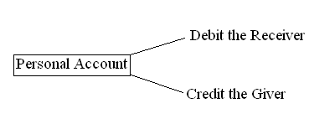Eg: Krishna A/c, Gopal A/c, etc

**Real Accounts**: Accounts relating to properties or assets are known as Real Accounts. Every business needs assets such as machinery, Furniture etc for running its activities. A separate account is maintained for each asset owned by the business. If the asset coming into the business is treated as **“Debit”**, going outside of the business is treated as **“Credit”.**

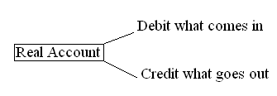

**Nominal Account:** Accounts relating to expenses, losses, incomes and gains are known as Nominal accounts. If any expenses or losses generated it is treated as **Debit**, any income or gains is treated as **Credit.**

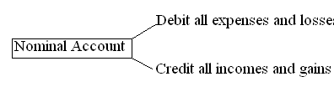

**Journal:** The word journal is derived from the Latin word “Journo”, which means a day. Therefore journal means a day book where day to day business transactions are recorded in a proper order.

Journal is treated as the books of original entry or first entry. All the business transactions are first entered in this book, later posted in the ledger.

The journal is a complete and chronological(in order of dates) record of business transactions. It is recorded in a systematic manner. The process of recording a transaction in the journal is called “JOURNALISING”. The entries made in the book are called “Journal Entries”.

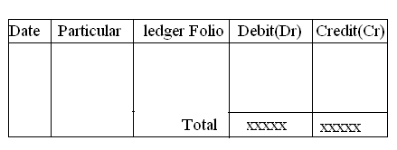

. The proforma of Journal is given below.

|  |  |  |  |  |
| --- | --- | --- | --- | --- |
| Date Date | Particulars | L.F. no | Debit  Amount  RS. | Credit  Amount  RS. |
| 1998 Jan 1 | Purchases account DR  To cash account  (Being goods purchased for cash) |  | 10,000/- | 10,000/- |

**Ledger**

All the transactions in a journal are recorded in a chronological order. After a certain period, if we want to know whether a particular account is showing a debit or credit balance it becomes very difficult. So, the ledger is designed to accommodate the various accounts maintained the trader. It contains the final or permanent record of all the transactions in duly classified form. “A ledger is a book which contains various accounts.” The process of transferring entries from journal to ledger is called “POSTING”.

Posting is the process of entering in the ledger the entries given in the journal. Posting into ledger is done periodically, may be weekly or fortnightly as per the convenience of the business. The following are the guidelines for posting transactions in the ledger.

1. After the completion of Journal entries only posting is to be made in the ledger.
2. For each item in the Journal a separate account is to be opened. Further, for each new item a new account is to be opened.
3. Depending upon the number of transactions space for each account is to be determined in the ledger.
4. For each account there must be a name. This should be written in the top of the table. At the end of the name, the word “Account” is to be added.
5. The debit side of the Journal entry is to be posted on the debit side of the account, by starting with “TO”.
6. The credit side of the Journal entry is to be posted on the debit side of the account, by starting with “BY”.

*Proforma for ledger:* ***LEDGER BOOK***

*DR* Particulars account *CR*

|  |  |  |  |  |  |  |  |
| --- | --- | --- | --- | --- | --- | --- | --- |
| Date | Particulars | Jfno | Amount | Date | Particulars | Jfno | Amount |
|  |  |  |  |  |  |  |  |

*DR* sales account *CR*

|  |  |  |  |  |  |  |  |
| --- | --- | --- | --- | --- | --- | --- | --- |
| Date | Particulars | Jfno | Amount | Date | Particulars | Jfno | Amount |
|  |  |  |  |  |  |  |  |

*DR* cash account *CR*

|  |  |  |  |  |  |  |  |
| --- | --- | --- | --- | --- | --- | --- | --- |
| Date | Particulars | Jfno | Amount | Date | Particulars | Jfno | Amount |
|  |  |  |  |  |  |  |  |

**TRAIL BALANCE**

The first step in the preparation of final accounts is the preparation of trail balance. In the double entry system of book keeping, there will be credit for every debit and there will not be any debit without credit. When this principle is followed in writing journal entries, the total amount of all debits is equal to the total amount all credits.

A trail balance is a statement of debit and credit balances. It is prepared on a particular date with the object of checking the accuracy of the books of accounts. It indicates that all the transactions for a particular period have been duly entered in the book, properly posted and balanced. The trail balance doesn’t include stock in hand at the end of the period. All adjustments required to be done at the end of the period including closing stock are generally given under the trail balance.

*DEFINITIONS:* A trail balance is a list of all the balances standing on the ledger accounts and cash book of a concern at any given date.

*J.R.BATLIBOI:*

A trail balance is a statement of debit and credit balances extracted from the ledger with a view to test the arithmetical accuracy of the books.

*PROFORMA FOR TRAIL BALANCE*:

Trail balance for MR…………………………………… as on …………

|  |  |  |  |
| --- | --- | --- | --- |
| NO | NAME OF ACCOUNT  (PARTICULARS) | DEBIT AMOUNT(RS) | CREDIT AMOUNT(RS.) |
|  |  |  |  |

**Specimen of trial balance**

|  |  |  |  |
| --- | --- | --- | --- |
| 1 | Capital | Credit | Loan |
| 2 | Opening stock | Debit | Asset |
| 3 | Purchases | Debit | Expense |
| 4 | Sales | Credit | Gain |
| 5 | Returns inwards | Debit | Loss |
| 6 | Returns outwards | Debit | Gain |
| 7 | Wages | Debit | Expense |
| 8 | Freight | Debit | Expense |
| 9 | Transport expenses | Debit | Expense |
| 10 | Royalities on production | Debit | Expense |
| 11 | Gas, fuel | Debit | Expense |
| 12 | Discount received | Credit | Revenue |
| 13 | Discount allowed | Debit | Loss |
| 14 | Bas debts | Debit | Loss |
| 15 | Dab debts reserve | Credit | Gain |
| 16 | Commission received | Credit | Revenue |
| 17 | Repairs | Debit | Expense |
| 18 | Rent | Debit | Expense |
| 19 | Salaries | Debit | Expense |
| 20 | Loan Taken | Credit | Loan |
| 21 | Interest received | Credit | Revenue |
| 22 | Interest paid | Debit | Expense |
| 23 | Insurance | Debit | Expense |
| 24 | Carriage outwards | Debit | Expense |
| 25 | Advertisements | Debit | Expense |
| 26 | Petty expenses | Debit | Expense |
| 27 | Trade expenses | Debit | Expense |
| 28 | Petty receipts | Credit | Revenue |
| 29 | Income tax | Debit | Drawings |
| 30 | Office expenses | Debit | Expense |
| 31 | Customs duty | Debit | Expense |
| 32 | Sales tax | Debit | Expense |
| 33 | Provision for discount on debtors | Debit | Liability |
| 34 | Provision for discount on creditors | Debit | Asset |
| 35 | Debtors | Debit | Asset |
| 36 | Creditors | Credit | Liability |
| 37 | Goodwill | Debit | Asset |
| 38 | Plant, machinery | Debit | Asset |
| 39 | Land, buildings | Debit | Asset |
| 40 | Furniture, fittings | Debit | Asset |
| 41 | Investments | Debit | Asset |
| 42 | Cash in hand | Debit | Asset |
| 43 | Cash at bank | Debit | Asset |
| 44 | Reserve fund | Credit | Liability |
| 45 | Loan advances | Debit | Asset |
| 46 | Horse, carts | Debit | Asset |
| 47 | Excise duty | Debit | Expense |
| 48 | General reserve | Credit | Liability |
| 49 | Provision for depreciation | Credit | Liability |
| 50 | Bills receivable | Debit | Asset |
| 51 | Bills payable | Credit | Liability |
| 52 | Depreciation | Debit | Loss |
| 53 | Bank overdraft | Credit | Liability |
| 54 | Outstanding salaries | Credit | Liability |
| 55 | Prepaid insurance | Debit | Asset |
| 56 | Bad debt reserve | Credit | Revenue |
| 57 | Patents & Trademarks | Debit | Asset |
| 58 | Motor vehicle | Debit | Asset |
| 59 | Outstanding rent | Credit | Revenue |

**FINAL ACCOUNTS**

In every business, the business man is interested in knowing whether the business has resulted in profit or loss and what the financial position of the business is at a given time. In brief, he wants to know (i)The profitability of the business and (ii) The soundness of the business.

The trader can ascertain this by preparing the final accounts. The final accounts are prepared from the trial balance. Hence the trial balance is said to be the link between the ledger accounts and the final accounts. The final accounts of a firm can be divided into two stages. The first stage is preparing the trading and profit and loss account and the second stage is preparing the balance sheet.

**TRADING ACCOUNT**

The first step in the preparation of final account is the preparation of trading account. The main purpose of preparing the trading account is to ascertain gross profit or gross loss as a result of buying and selling the goods.

|  |  |  |  |
| --- | --- | --- | --- |
| **Trading A/C of __________ For the year ended 31st March 2024** | | | |
| **Particulars** | **Amount (Dr)** | **Particulars** | **Amount (Cr)** |
| **To Opening Stock a/c** | **XXX** | **By Sales a/c** |  |
| **To Purchases a/c** |  | **Less: Sales returns** | **XXXXX** |
| **Less: Purchase returns a/c** | **XXXX** | **By Closing stock a/c** | **XXXXX** |
| **To Wages a/c** | **XXXXX** | **By Gross loss (transferred to P&L a/c)** | **XXXXX** |
| **To freight, customs duty, octroi** |  |  |  |
| **To carriages on Purchases ( carriage inwards)** | **XXXX** |  |  |
| **To Factory rent a/c** | **XXXX** |  |  |
| **To Factory lighting a/c** | **XXXX** |  |  |
| **To Factory heating a/c** | **XXXX** |  |  |
| **To Factory power a/c** | **XXXX** |  |  |
| **To factory insurance a/c** | **XXXX** |  |  |
| **To fuel and gas a/c** | **XXXX** |  |  |
| **To Customs duties a/c** | **XXX** |  |  |
| **To duck dues a/c** | **XXXX** |  |  |
| **To Gross profit ( transferred to P & L a/c)** |  |  |  |
|  | **XXXXXX** |  | **XXXXXX** |

Finally, a ledger may be defined as a summary statement of all the transactions relating to a person , asset, expense or income which have taken place during a given period of time. The up-to-date state of any account can be easily known by referring to the ledger.

**PROFIT AND LOSS ACCOUNT**

The business man is always interested in knowing his net income or net profit.Net profit represents the excess of gross profit plus the other revenue incomes over administrative, sales, Financial and other expenses. The debit side of profit and loss account shows the expenses and the credit side the incomes. If the total of the credit side is more, it will be the net profit. And if the debit side is more, it will be net loss.

|  |  |  |  |
| --- | --- | --- | --- |
| **Profit & Loss a/c of _______ for the year ended 31st march 2024** | | | |
| **Particulars** | **Amount (Dr)** | **Particulars** | **Amount (Cr)** |
| **To Gross loss transferred from Trading a/c** | **XXXX** | **By Gross profit transferred from Trading a/c** | **XXXX** |
| **To Rent a/c** | **XXX** | **By Rent( received ) a/c** | **XXX** |
| **To Salaries a/c** | **XXX** | **By Commission (received) a/c** | **XXX** |
| **To Expenses a/c** | **XX** | **By Interest (received ) a/c** | **XXXX** |
| **To Depreciation a/c** | **XXX** | **By Dividend (received) a/c** | **XXX** |
| **To Amortization on goodwill a/c** | **XX** | **By Discount (received ) a/c** | **XXXX** |
| **To Carriage on sales a/c (Carriage outwards)** | **XXX** | **By Net loss (transferred to capital a/c)** | **XXX** |
| **To Commission a/c (Paid)** | **XXX** |  |  |
| **To Audit Fees a/c** | **XXX** |  |  |
| **To Bad debts a/c** | **XX** |  |  |
| **To Provision for bad debts a/c** | **XXX** |  |  |
| **To Discount a/c (allowed)** | **XXX** |  |  |
| **To Net profit (transferred to capital a/c)** | **XXX** |  |  |
|  | **XXXXX** |  | **XXXXX** |

**BALANCE SHEET**

The second point of final accounts is the preparation of balance sheet. It is prepared often in the trading and profit, loss accounts have been compiled and closed. A balance sheet may be considered as a statement of the financial position of the concern at a given date.

*DEFINITION:* A balance sheet is an item wise list of assets, liabilities and proprietorship of a business at a certain state.

Thus, Balance sheet is defined as a statement which sets out the assets and liabilities of a business firm and which serves to as certain the financial position of the same on any particular date. On the left-hand side of this statement, the liabilities and the capital are shown. On the right-hand side all the assets are shown. Therefore, the two sides of the balance sheet should be equal. Otherwise, there is an error somewhere.

|  |  |  |  |
| --- | --- | --- | --- |
| **Balance Sheet of _______ as on 31 March 2024** | | | |
| **Liabilities** | **Amount** | **Assets** | **Amount** |
| **Long- term Liabilities** |  | **Fixed Assets** |  |
| **Capital** |  | **Land & Buildings** |  |
| **Add: Interest on Capital** |  | **Plant& Machinery** |  |
| **Add: Net profit** |  | **Goodwill** |  |
| **Less: Drawings** |  | **Furniture & Fixtures** |  |
| **Less : Interest on Drawings** | **XXXX** | Patents, tm ,copyrights |  |
| **Long- term Loans** |  | Investments |  |
| **Debentures** |  | **Current Assets** |  |
| Reserve fund |  | **Closing Stock** |  |
| **Current Liabilities** |  | **Sundry Debtors** |  |
| **Sundry Creditors** |  | **Bills receivable** |  |
| **Bills Payable** |  | **Short-term investments** |  |
| **Bank overdraft** |  | **Income accrued due** |  |
| **Income received in advance** |  | **Prepaid expenses** |  |
| **Outstanding expenses** |  | **Cash in Bank** |  |
|  |  | **Cash in Hand** |  |
|  | **XXXXX** |  | **XXXX** |

*Advantages:* The following are the advantages of final balance .

1. It helps in checking the arithmetical accuracy of books of accounts.
2. It helps in the preparation of financial statements.
3. It helps in detecting errors.
4. It serves as an instrument for carrying out the job of rectification of entries.
5. It is possible to find out the balances of various accounts at one place.

**Adjustments in Final Accounts**

When the books are maintained as per the accrual basis of accounting, the incomes and expenses need to be recorded on an accrual basis. This implies that an income earned in the current financial year whether received or not and an expense incurred for the current financial year whether paid or not needs to be accounted for in the current financial year. This gives rise to the adjustments in final accounts. The adjustments always appear outside the Trial Balance.

### ****Some common adjustments:****

* Closing Stock
* Outstanding Expenses
* Prepaid or Unexpired Expenses
* Accrued or Outstanding Income
* Income Received In Advance or Unearned Income
* Depreciation
* Bad Debts
* Provision for Doubtful Debts
* Provision for Discount on Debtors
* Manager’s Commission
* Interest on Capital
* Goods Distributed among Staff Members for Staff Welfare
* Drawing of Goods for Personal Use
* Abnormal or Accidental Losses

|  |  |  |
| --- | --- | --- |
| **Treatment of Adjustments in Final Accounts** | | |
| **Item** | **Trading a/c Or P&L a/c** | **Balance Sheet** |
| Closing Stock | Credit side Of Trading a /c | Assets side ,  under Current Assets |
| Outstanding Factory expenses | Debit side of Trading a/c | Liabilities side , under Current Liabilities |
| Outstanding administrative, selling and distribution expenses | Debit side of P&L a/c | Liabilities side ,  under Current Liabilities |
| Income Earned but not received | Credit side Of P&L a /c | Assets side ,  under Current Assets |
| Income received in advance (income received but not Earned ) | Deducted from the relevant income on credit side of P&L a/c | Liabilities side ,  under Current Liabilities |
| Depreciation | Debit side of P&L a/c | Subtracted from the concerned  fixed asset, on the Assets side |
| Amortization | Debit side of P&L a/c | Subtracted from the concerned intangible fixed asset, on the Assets side |
| Further bad debts | Debit side of P&L a/c | Subtracted from Sundry debtors on the Assets side  (under current Assets ) |
| New Provision for bad debts | Debit side of P&L a/c | Subtracted from Sundry debtors on the Assets side  (under current Assets ) |

**Illustration :**

Prepare trading account from the following ledger balances presented by P. Sen as on 31st March, 2016.

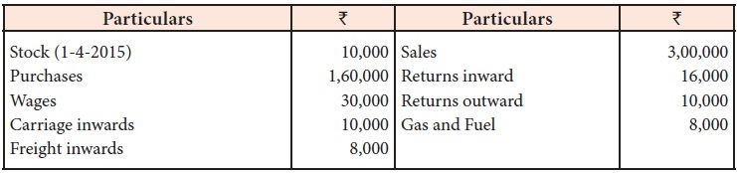

Additional information:

i.               Stock on 31st March, 2016 Rs.  20,000

ii.               Outstanding wages amounted to Rs.  4,000

 iii.               Gas and fuel was paid in advance for Rs.  1,000

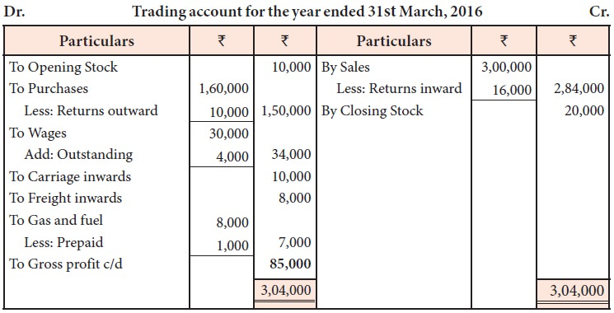

**Illustration**

From the following balances as on 31st December, 2017, prepare profit and loss account.

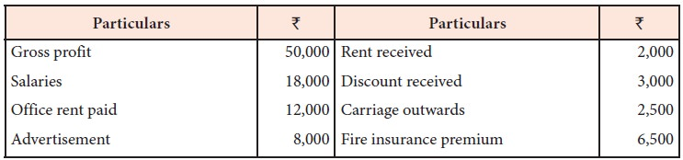

Adjustments:

i.               Rent accrued but not yet received Rs.  500

ii.               Fire insurance premium prepaid to the extent of Rs.  1,50

iii.               Provide manager’s commission at 10% on profits before charging such commission.

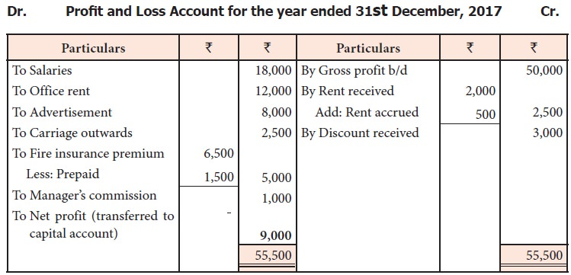

Working note:

https://img.brainkart.com/imagebk35/Jo8SfYn.jpg

Net profit = 55,500 – (18,000 + 12,000 + 8,000 + 2,500 + 5,000) = Rs. 10,000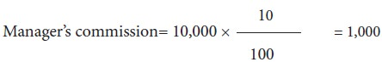

**Illustration**

Given below are the balances extracted from the books of Nagarajan as on 31st March, 2016.

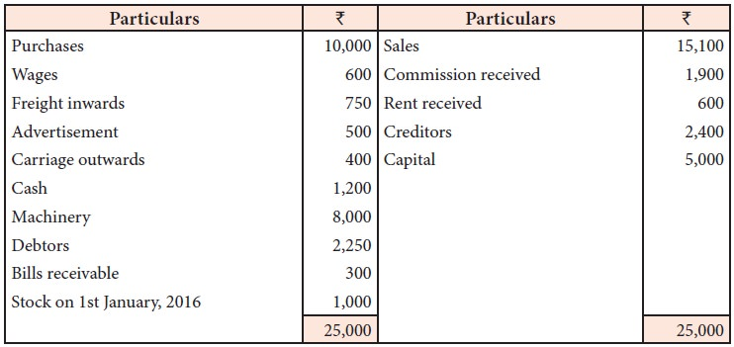

Prepare the trading and profit and loss account for the year ended 31st March, 2016 and the balance sheet as on that date after adjusting the following:

i.               Commission received in advance Rs.  400

ii.               Advertisement paid in advance Rs.  150

iii.               Wages outstanding Rs.  200

iv.               Closing stock on 31st March 2016, Rs.  2,100

**Solution**

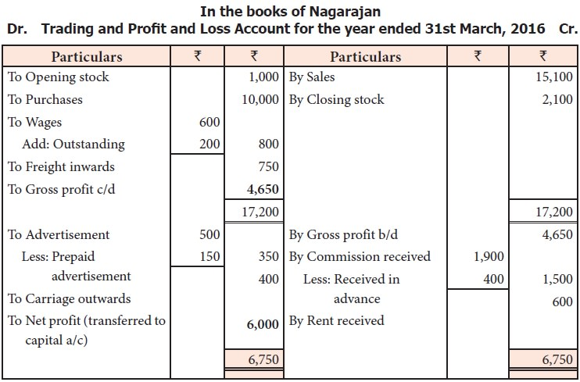

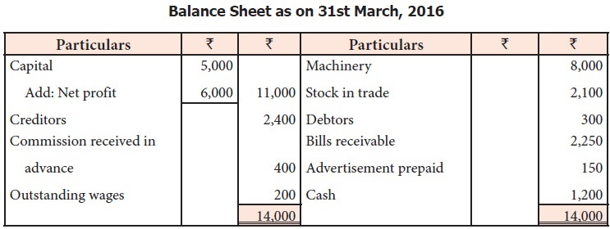

**Ratio Analysis:**

**Introduction;**

Ratio analysis is a useful management tool that will improve your understanding of financial results and trends over time, and provide key indicators of organizational performance. Managers will use ratio analysis to pinpoint strengths and weaknesses from which strategies and initiatives can be formed.

**Definition:**

Single most important [technique](http://www.businessdictionary.com/definition/technique.html) of [financial analysis](http://www.businessdictionary.com/definition/financial-analysis.html) in which [quantities](http://www.businessdictionary.com/definition/quantity.html) are converted into ratios for meaningful comparisons, with past ratios and ratios of other firms in the same or different [industries](http://www.businessdictionary.com/definition/industry.html). Ratio analysis determines [trends](http://www.businessdictionary.com/definition/trend.html) and exposes [strengths](http://www.businessdictionary.com/definition/strength.html) or weaknesses of a firm. -***Bust Noon***

**Objectives of Ratio Analysis**

Financial ratios are true test of the profitability, efficiency and financial soundness of the firm. These ratios have following objectives:

**(1) Measuring the profitability:** Profitability is the profit earning capacity of the business. This can be measured by Gross Profit, Net Profit, Expenses and Other Ratios. If these ratios fall we can take corrective measures.

**(2) Determining operational efficiency:** Operational efficiency of the business can be determined by calculating operating / activity ratios.

**(3) Measuring financial position:** Short-term and long-term financial position of the business can be measured by calculating liquidity and solvency ratios. In case of unhealthy short or long-term position, corrective measures can be taken.

**(4) Facilitating comparative analysis:** Present performance can be compared with past performance to discover the plus and minus points. Comparison with the performance of other competitive firms can also be made.

**(5) Indicating overall efficiency:** Profit and Loss Account shows the amount of net profit and Balance Sheet shows the amount of various assets, liabilities and capital. But the profitability can be known by calculating the financial ratios.

**(6) Budgeting and forecasting:** Ratio analysis is of much help in financial forecasting and planning. Ratios calculated for a number of years work as a guide for the future. Meaningful conclusions can be drawn for future from these ratios.

**Advantages and Disadvantages of Ratio Analysis**

**Advantages**

1. **Performance over time:** Ratio analysis is a strong indicator of the financial performance of a company over time. An analyst can calculate the same ratio across different time periods to identify particular components of a company’s financial performance that may be improving or declining. Ratio analysis uses relative percentages rather than dollar amounts, allowing for ease of comparison across periods. Ratio analysis may help distinguish between firms that may fail and firms that are profitable. Through the careful use of financial ratio analysis, an analyst may be able to detect financial troubles up to five years before a firm fails.
2. **Performance against competitors:** Ratio analysis can be used to assess the performance of a company against other competitors that operate within the same industry. Companies that operate in the same industry generally exhibit similar financial profiles. Thus, a calculated ratio that is significantly above or below the industry average may indicate a particularly strong or particularly weak performance by the company in certain areas.

**Disadvantages**

1. **Narrow Focus:** Ratio analysis may lead to a narrow focus on certain elements of a company’s financial performance. It is important to consider all ratios in relation to one another.

**For example:**

One ratio may indicate low levels of liquidity while another ratio may indicate a high level of operating profitability. Financial ratios should be considered as a whole; in the event of seemingly contradictory information, a more thorough financial statement analysis may be warranted.

1. **Accounting Methodologies:** Certain ratios may be adversely affected by a company’s accounting methodologies.

**For example:**

Accelerated depreciation may overstate the true depreciation cost to the company. Debt may be financed through various subsidiaries or off-balance sheet accounts. Thus, when reviewing the results of a financial ratio analysis, an analyst must be aware of the financial accounting methodologies employed by the company. These are often discussed in the notes to the financial statements

**Types or Classification Of Ratios:**

Several ratios can be grouped into various classes, according to the activity or function they perform. We have, already, discussed in the previous chapter that there are several groups of persons — creditors, investors, lenders, management and public — interested in interpretation of the financial statements. Each group identifies those ratios, relevant to its requirements. They wish to interpret ratios, for those purposes they are interested in, to take appropriate decisions to serve their own individual interests. In view of the diverse requirements of the various users of the ratios, the ratios can be classified into four categories:

Performance of a company is evaluated using the ratio analysis in the following different directions.

**Profitability (Profitability Ratios)**

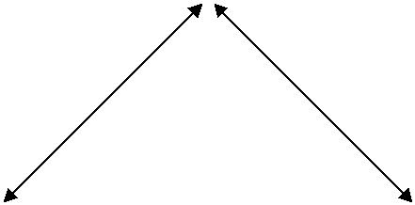

**Efficiency of Assets (Activity Ratios) Short-term Solvency (Liquidity Ratios)**

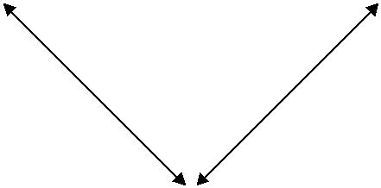

**Long-term Solvency (Leverage Ratios)**

**Evaluation — Performance of Company in the Context of Ratio Analysis**

**A. Liquidity Ratios:** They measure the firm’s ability to meet current obligations.

**B. Leverage Ratios:** These ratios show the proportion of debt and equity in financing thefirm’s assets.

1. **Activity Ratios:** They reflect the firm’s efficiency in utilizing the assets.
2. **Profitability Ratios:** These ratios measure overall performance and effectiveness of thefirm.

**Liquidity Ratios:**

Liquidity ratios are highly useful to creditors and commercial banks that provide short-term credit. Short-term refers to a period not exceeding one year. Liquidity ratios measure the firm’s ability to meet current obligations, as and when they fall due.

**A firm should ensure that it does not suffer from lack of liquidity and also does not have excess liquidity.**

In the absence of adequate liquidity, the firm would not be able to pay creditors, who have supplied goods and services, on the due date promised. Firm’s goodwill suffers, in case of default in payment. In fact, dissatisfied suppliers, normally, refuse to supply, further. Who can finance, indefinitely? Loss of creditworthiness may result in legal problems, finally, culminating in the closure of business of a company, even. If the firm maintains more liquidity, it will not experience any difficulty in making payments. However, a higher degree of liquidity is bad, as idle assets earn nothing, while there is cost for the funds. The firm’s funds will be, unnecessarily, tied up in liquid assets.

**“*Both inadequate and excess liquidity are not desirable. It is necessary for the firm to strike a proper balance between high liquidity and lack of liquidity*”**

To Measure the liquidity of the firm, the following ratios can be calculated**…………..,,,**

**Note:**

The ideal current ratio is 2:1

The ideal quick ratio is 1:1

**Current Ratio:**

**Current ratio is defined as the relationship between current assets and current liabilities.** It is also known as working capital ratio. This is calculated by dividing total currentassets by total current liabilities.

**Computation:** It is calculated on the basis of the following formula:

|  |  |  |
| --- | --- | --- |
| Current Ratio = | Current Assets |  |
| Current Liabilities |  |

**Components:** Following table gives the various items included in the current assets and current liabilities:

|  |  |
| --- | --- |
| **COMPONENTS OF CURRENT RATIO** | |
| **Current Assets** | **Current Liabilities** |
| |  |  |  |  | | --- | --- | --- | --- | | 1. | Cash in Hand | 1. | Sundry Creditors | | 2. | Cash at Bank | 2. | Bills Payable | | 3. | Marketable Securities (short-term) | 3. | Bank Overdraft / Cash Credit | | 4. | Short-term Investments | 4. | Short-term Advances | | 5. | Sundry Debtors | 5. | Outstanding Expenses | | 6. | Bills Receivable | 6. | Income-Tax Payable | | 7. | Inventory – Raw Materials | 7. | Dividend Payable |  * Work in Process * Finished Goods * Prepaid Expenses * Advance Tax paid * Accrued Income | |

**Quick Ratio or Acid Test Ratio or Liquid Ratio or Near Money Ratio.**

Quick ratio (also known as “acid test ratio” and “liquid ratio”) is used to test the ability of a business to pay its short-term debts. It measures the relationship between liquid assets and current liabilities. Liquid assets are equal to total current assets minus inventories and prepaid expenses.

**Formula**

The formula for the calculation of quick ratio is given below:

[quick-ratio-formula](http://www.accountingformanagement.org/wp-content/uploads/2012/09/quick-ratio-formula.png)

Liquid assets = (Total current assets) – (Inventories + Prepaid expenses)

**Leverage / Solvency Ratios**

Long-term solvency ratios analyze the long-term financial position of the organization. Bankers and creditors are interested in the liquidity of the firm, whereas shareholders, debenture holders and financial institutions are concerned with the long term prosperity of the firm. There are thus two aspects of the long-term solvency of a firm.

1. Ability to repay the principal amount when due
2. Regular payment of the interest.

The ratio is based on the relationship between borrowed funds and owner’s capital it is computed from the balance sheet, the second type is calculated from the profit and loss a/c.  The various solvency ratios are.

1. Debt equity ratio
2. Proprietary (Equity) ratio
3. Debt service (Interest coverage) ratio
4. Capital Gearing Ratio.
5. **Debt Equity Ratio or External – Internal Equity Ratio:** Debt equity ratio shows the relative claims of creditors (Outsiders) and owners (Interest) against the assets of the firm. The relationship between borrowed fund and capital is shown in debt-equity ratio. It can be calculated by dividing outsider funds (Debt) by shareholder funds (Equity)

* Debt equity ratio = Outsider Funds (Total Debts) /  Shareholder Funds or Equity (or)
* Long-term Debts / Shareholders funds
* Shareholders fund = Preference capital + Equity capital + Reserves & Surplus – Goodwill & Preliminary expenses
* Outsiders funds = Current liabilities + Debentures + Loans

The ideal ratio is 2:1. High ratio means, the claim of creditors is greater than owners and vice-versa

**How to Calculate the Debt to Equity Ratio**

To calculate the debt to equity ratio, simply divide total debt by total equity. In this calculation, the debt figure should include the residual obligation amount of all leases. The formula is:

**Long-term debt + Short-term debt + Leases  
Equity**

1. **PROPRIETARY (EQUITY) RATIO**

This ratio indicates the proportion of total assets financed by owners.  It is calculated by dividing proprietor (Shareholder) funds by total assets.

**Proprietary (equity) ratio = Shareholder funds / Total Tangible assets**

**The ideal ratio is 1:3**. A ratio below 50% may be alarming for creditors, because they incur loss during winding up.

1. **DEBT SERVICE (INTEREST COVERAGE) RATIO**

This shows the number of times the earnings of the firms are able to cover the fixed interest liability of the firm.  This ratio therefore is also known as Interest coverage or time interest earned ratio.  It is calculated by dividing the earnings before interest and tax (EBIT) by interest charges on loans.

**Debt Service Ratio = Earnings before interest and tax (EBIT) / Interest Charges**

1. **Capital gearing ratio** is a useful tool to analyze the capital structure of a company and is computed by dividing the common stockholders’ equity by fixed interest or dividend bearing funds.

Analyzing capital structure means measuring the relationship between the funds provided by common stockholders and the funds provided by those who receive a periodic interest or dividend at a fixed rate.

A company is said to be low geared if the larger portion of the capital is composed of common stockholders’ equity. On the other hand, the company is said to be highly geared if the larger portion of the capital is composed of fixed interest/dividend bearing funds.

**Formula:**

[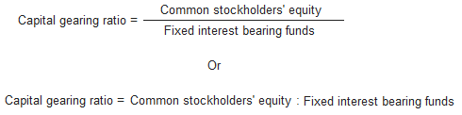](http://www.accountingformanagement.org/wp-content/uploads/2012/10/capital-gearing-ratio-formula1.png)

In the above formula, the numerator consists of common stockholders’ equity that is equal to total stockholders’ equity less preferred stock and the denominator consists of fixed interest or dividend bearing funds that usually include long term loans, bonds, debentures and preferred stock etc.

All the information required to compute capital gearing ratio is available from the balance sheet.

**Profitability ratios:**

Profit is the primary objective of all businesses. All businesses need a consistent improvement in profit to survive and prosper. A business that continually suffers losses cannot survive for a long period.

**Profitability ratios** measure the efficiency of management in the employment of business resources to earn profits. These ratios indicate the success or failure of a business enterprise for a particular period of time.

Profitability ratios are used by almost all the parties connected with the business.

A strong profitability position ensures common stockholders a higher dividend income and appreciation in the value of the common stock in future.

Creditors, financial institutions and preferred stockholders expect a prompt payment of interest and fixed dividend income if the business has good profitability position.

Management needs higher profits to pay dividends and reinvest a portion in the business to increase the production capacity and strengthen the overall financial position of the company.

**Some important profitability ratios are given below:**

1. [Gross profit (GP) ratio](http://www.accountingformanagement.org/gross-profit-ratio/).
2. [Net profit (NP) ratio](http://www.accountingformanagement.org/net-profit-ratio/).
3. [Operating ratio](http://www.accountingformanagement.org/operating-ratio/).
4. Operating Profit Ratio
5. [Expense ratio](http://www.accountingformanagement.org/expense-ratio/).
6. [Return on capital employed ratio](http://www.accountingformanagement.org/return-on-capital-employed-ratio/)
7. [Return on shareholder’s investment/Return on equity](http://www.accountingformanagement.org/return-on-shareholders-investmentnet-worth/).
8. [Earnings per share (EPS) ratio](http://www.accountingformanagement.org/earnings-per-share-eps-ratio/).
9. [Price earnings ratio (P/E ratio)](http://www.accountingformanagement.org/price-earning-ratio/).

**Gross Profit Ratio:** is a profitability ratio that shows the relationship between gross profit and total net sales revenue. It is a popular tool to evaluate the operational performance of the business . The ratio is computed by dividing the gross profit figure by net sales.

**Formula:**

The following formula/equation is used to compute gross profit ratio:

[gross-profit-ratio-formula](http://www.accountingformanagement.org/wp-content/uploads/2012/10/gross-profit-ratio-formula.png)

When gross profit ratio is expressed in percentage form, it is known as gross profit margin or gross profit percentage. The formula of gross profit margin or percentage is given below:

[gross-profit-percentage-formula](http://www.accountingformanagement.org/wp-content/uploads/2012/10/gross-profit-percentage-formula.png)

The basic components of the formula of gross profit ratio (GP ratio) are gross profit and net sales. Gross profit is equal to net sales minus cost of goods sold. Net sales are equal to total gross sales less returns inwards and discount allowed.  The information about gross profit and net sales is normally available from income statement of the company.

**Net profit ratio (NP ratio)** is a popular profitability ratio that shows relationship between net profit after tax and net sales. It is computed by dividing the net profit (after tax) by net sales.

**Formula:**

[net-profit-ratio-formula](http://www.accountingformanagement.org/wp-content/uploads/2012/09/net-profit-ratio-formula.png)

For the purpose of this ratio, net profit is equal to gross profit minus operating expenses and income tax.  All non-operating revenues and expenses are not taken into account because the purpose of this ratio is to evaluate the profitability of the business from its primary operations. Examples of non-operating revenues include interest on investments and income from sale of fixed assets. Examples of non-operating expenses include interest on loan and loss on sale of assets.

The relationship between net profit and net sales may also be expressed in percentage form. When it is shown in percentage form, it is known as net profit margin. The formula of net profit margin is written as follows:

[net-profit-margin-formula](http://www.accountingformanagement.org/wp-content/uploads/2012/09/net-profit-margin-formula.png)

**Operating Ratio**

Operating ratio is computed by dividing operating expenses by net sales. It is expressed in percentage.

**Formula:**

Operating ratio is computed as follows:

[http://www.accountingformanagement.org/wp-content/uploads/2012/10/operating-ratio-formula.png](http://www.accountingformanagement.org/wp-content/uploads/2012/10/operating-ratio-formula.png)

The basic components of the formula are operating cost and net sales. Operating cost is equal to cost of goods sold plus operating expenses. Non-operating expenses such as interest charges, taxes etc., are excluded from the computations.

**Operating Profit Ratio**

Operating net profit ratio is calculated by dividing the operating net profit by sales. This ratio helps in determining the ability of the management in running the business.

**Formula:**

**Operating profit ratio = (Operating profit / Net sales) × 100**

Operating profit = Gross profit - Operating Expenses

**OR**

Operating profit = Net sales - Operating cost

**OR**

Operating profit= Net sales - (Cost of goods sold + Administrative and office expenses + Selling and distribution exp.)

**OR**

(Net profit + Non-operating expenses) - (Non-operating incomes)

Higher the ratio, better it is

**Expenses Ratio:** Expense ratio (expense to sales ratio) is computed to show the relationship between an individual expense or group of expenses and sales. It is computed by dividing a particular expense or group of expenses by net sales.  Expense ratio is expressed in percentage.

**Formula:**

[http://www.accountingformanagement.org/wp-content/uploads/2012/10/expense-ratio-formula.png](http://www.accountingformanagement.org/wp-content/uploads/2012/10/expense-ratio-formula.png)

The numerator may be an individual expense or a group of expenses such as administrative expenses, sales expenses or cost of goods sold.

**Example:**

The following information has been extracted from the income statement of Beta limited:

|  |  |
| --- | --- |
| Net sales | 750,000 |
| Cost of goods sold | 520,000 |
| Administrative expenses | 30,000 |
| Sales expenses | 45,000 |

***Required:*** Compute the cost of goods sold ratio, administrative expenses ratio and sales expenses ratio.

**Solution:**

***1. Cost of goods sold ratio:***

(Cost of goods sold /Net sales ) × 100

($487,500 / $750,000) × 100

65%

***2. Administrative expenses ratio:***

(Administrative expenses /Net sales ) × 100

(30,000 / 750,000) × 100

4%

***3. Selling expenses ratio:***

(Selling expenses /Net sales ) × 100

(45,000 / 750,000) × 100

6%

**Significance and Interpretation:**

Expense ratio shows what percentage of sales is an individual expense or a group of expenses. A lower ratio means more profitability and a higher ratio means less profitability.

Analyst must be careful while interpreting the ratio of a expenses to sales. Some expenses vary with the change in sales (i.e variable expenses). The ratio for such expenses normally does not change significantly as the sales volume increases or decreases.

For fixed expenses (rent of building, fixed salaries etc.), the ratio changes significantly as the sales volume changes.

The ratio is helpful in controlling and estimating future expenses.

**Return on capital Employed Ratio:** is computed by dividing the net income before interest and tax by capital employed. It measures the success of a business in generating satisfactory profit on capital invested. The ratio is expressed in percentage.

**Formula:**

[http://www.accountingformanagement.org/wp-content/uploads/2012/10/return-on-capital-employed-formula.png](http://www.accountingformanagement.org/wp-content/uploads/2012/10/return-on-capital-employed-formula.png)

The basic components of the formula of return on capital employed ratio are net income before interest and tax and capital employed.

***Net income before interest and tax (Operating income):***

Net income before the deduction of interest and tax expenses is frequently referred to as operating income. Here, interest means interest on long term loans. If company pays interest expenses on short-term borrowings, that is deducted to arrive at operating income.

***Capital employed:***

Capital employed is calculated in a number of ways. Some popular methods are given below:

1. Total of fixed and current assets.
2. Total of fixed assets only.
3. Fixed assets plus working capital.
4. Total of long term funds. Long term funds include capital, Reserve and surplus etc.

In managerial accounting, the last method is usually used to calculate capital employed.

**Return on shareholders’ investment ratio** is a measure of overall profitability of the business and is computed by dividing the *net income after interest and tax* by average stockholders’ equity. It is also known as return on equity (ROE) ratio and return on net worth ratio. The ratio is usually expressed in percentage.

**Formula:**

[http://www.accountingformanagement.org/wp-content/uploads/2012/10/return-on-shareholders-investment-ratio1.png](http://www.accountingformanagement.org/wp-content/uploads/2012/10/return-on-shareholders-investment-ratio1.png)

The numerator consists of net income after interest and tax because it is the amount of income available for common and preference stockholders. The denominator is the average of stockholders’ equity (preference and common stock). The information about net income after interest and tax is normally available from income statement and the information about preference and common stock is available from balance sheet.

***Note for students:*** *Analysts usually prefer to use the average stockholders’ equity as denominator. The students can, however, use the closing figure of  stockholders’ equity if the opening figure is not given in the question.*

**Earnings per share (EPS) ratio** measures how many dollars of net income have been earned by each share of common stock. It is computed by dividing net income less preferred dividend by the number of shares of common stock outstanding during the period.  It is a popular measure of overall profitability of the company and is usually expressed in dollars.

**Formula:**

Earnings per share ratio (EPS ratio) is computed by the following formula:

[http://www.accountingformanagement.org/wp-content/uploads/2012/10/earnings-per-share-ratio.png](http://www.accountingformanagement.org/wp-content/uploads/2012/10/earnings-per-share-ratio.png)

The numerator is the net income available for common stockholders’ (net income less preferred dividend) and the denominator is the average number of shares of common stock outstanding during the year.

The formula of EPS ratio is similar to the formula of return on common stockholders’ equity ratio except the denominator of EPS ratio formula is the number of average shares of common stock outstanding rather than the average common stockholders’ equity.

**Price earnings ratios (P/E ratio)** measures how many times the earnings per share (EPS) has been covered by current market price of an ordinary share. It is computed by dividing the current market price of an ordinary share by earnings per share.

**Formula:**

The formula of price earnings ratio is given below:

[price-earnings-ratio-formula](http://www.accountingformanagement.org/wp-content/uploads/2012/10/price-earnings-ratio-formula.png)

**Activity Ratios**

**Activity ratios** (also known as turnover ratios) measure the efficiency of a firm or company in generating revenues by converting its production into cash or sales. Generally a fast conversion increases revenues and profits.

Activity ratios show how frequently the assets are converted into cash or sales and, therefore, are frequently used in conjunction with liquidity ratios for a deep analysis of liquidity.

**Fixed Assets Turnover Ratio:** Fixed assets turnover ratio (also known as sales to fixed assets ratio) is a commonly used activity ratio that measures the efficiency with which a company uses its fixed assets to generate its sales revenue. It is computed by dividing net sales by average fixed assets.

**Formula:**

[fixed-assets-turnover-ratio](http://www.accountingformanagement.org/wp-content/uploads/2012/09/fixed-assets-turnover-ratio.png)

***Note for students:*** Sometime opening balance of fixed assets may not be given in the question. In such a case, closing balance of fixed assets rather than average assets may be used as denominator of the formula.

**Stock Turnover Ratio or Inventory Turnover Ratio :**

**Stock Turnover Ratio or Inventory turnover ratio (ITR)** is  an activity ratio that evaluates the liquidity of inventories of a company. It measures how many times the company has sold and replaced its inventory during a certain period of time. This ratio is computed by dividing the cost of goods sold by average inventory at cost.

**Formula:**

Following formula is used for the calculation of this ratio:

[inventory-turnover-ratio-formula](http://www.accountingformanagement.org/wp-content/uploads/2012/09/inventory-turnover-ratio-formula.png)

Two components of the formula of inventory turnover ratio are cost of goods sold and average inventory at cost. Cost of goods sold is equal to cost of goods manufactured (purchases for trading company) plus opening inventory less closing inventory. Average inventory is equal to opening balance of inventory plus closing balance of inventory divided by two.

If cost of goods sold is unknown, the net sales figure can be used as numerator and if the opening balance of inventory is unknown, closing balance can be used as denominator. If both numerator and denominator are unknown, the formula would be written as follows:

**Inventory turnover ratio = Sales / Inventory**

**Example:**

Compute the inventory turnover ratio and average selling period from the following data of a trading company:

|  |  |  |
| --- | --- | --- |
| Sales | Rs. | 75,000 |
| Gross profit |  | 35,000 |
| Opening inventory |  | 9,000 |
| Closing inventory |  | 7,000 |

**Solution:**

[inventory-turnover-ratio-formula](http://www.accountingformanagement.org/wp-content/uploads/2012/09/inventory-turnover-ratio-formula.png)

Rs.40,000/ Rs.8,000

5 times

*Computation of cost of goods sold and average inventory:*

Rs. 75,000 – $35,000 = Rs.40,000  
(Rs.9,000 + Rs.7,000) / 2

Average selling period is computed by dividing 365 by inventory turnover ratio:

365 days / 5 times

73 days

The company will take 73 days to sell average inventory.

**Significance and Interpretation:**

Inventory turnover ratio vary significantly among industries. A high ratio indicates fast moving inventories and a low ratio, on the other hand, indicates slow moving or obsolete inventories in stock. A low ratio may also be the result of maintaining excessive inventories needlessly. Maintaining excessive inventories unnecessarily indicates poor inventory management because it involves tiding up funds that could be used in other business operations.

Users must also observe various factors that can effect inventory turnover ratio (ITR) before interpreting or making any decision. For example, companies using FIFO cost flow assumption may have a higher ITR in the days of inflation because latest inventory purchased at higher prices remain in the stock under FIFO. On the other hand, companies using LIFO cost flow assumption may have comparatively lower ITR than others because oldest inventory purchased at comparatively lower prices remain in the stock under LIFO.

Another factor that could influence this ratio is the use of just-in-time inventory method. Companies using just in time system of inventory management usually have high inventory turnover ratio as compared to others in the industry.

**Assets Turnover Ratio or Debtors Turnover Ratio:**

It is an activity ratio that measures the efficiency with which assets are used by a company. It is computed by dividing net sales by average total assets for a given period.

**Formula:**

Assets turnover ratio is computed by using the following formula:

[assets-turnover-ratio](http://www.accountingformanagement.org/wp-content/uploads/2012/09/assets-turnover-ratio.png)

The numerator includes net sales i.e., sales less sales returns and discount. The denominator includes average total assets. Average total assets are equal to total assets at the beginning of the period plus total assets at the ending of the period divided by two.

**Example:**

The following data has been taken from the financial statements of TATA industries:

|  |  |  |
| --- | --- | --- |
| Gross sales | Rs. | 65000 |
| Sales returns |  | 2,500 |
| Assets at the beginning of the year |  | 78,000 |
| Assets at the end of the year |  | 72,000 |

***Required:*** Compute assets turnover ratio for the TATA industries.

**Solution:**

[assets-turnover-ratio](http://www.accountingformanagement.org/wp-content/uploads/2012/09/assets-turnover-ratio.png)

65,000 – 2,500  
 (78,000 +72,000)/2

Rs.62,500 / Rs.75,000

0.83

Assets turnover ratio of TATA industries is 0.83. It means every Rupees invested in the assets of TATA industries produces Rs.0.83 of sales.

**Creditors Turnover Ratio / Accounts Payable Turnover Ratio:**

**Accounts payable turnover ratio** (also known as creditors turnover ratio or creditors’ velocity) is computed by dividing the net credit purchases by average accounts payable. It measures the number of times, on average, the accounts payable are paid during a period.  Like [receivables turnover ratio](http://www.accountingformanagement.org/receiveables-turnover-ratio/), it is expressed in times.

## Formula:

[accounts-payable-turnover-ratio-formula](http://www.accountingformanagement.org/wp-content/uploads/2012/09/accounts-payable-turnover-ratio-formula.png)

In above formula, numerator includes only credit purchases. But if credit purchases are not known, the total net purchases should be used.

Average accounts payable are computed by adding opening and closing balances of accounts payable (including notes payable) and dividing by two. If opening balance of accounts payable is not given, the closing balance (including notes payable) should be used.

## Example:

P&G trading company has good relations with suppliers and makes all the purchases on credit.  The following data has been extracted from the financial statements of P&G for the year 2012 and 2011:

|  |  |
| --- | --- |
| **Particulars** | **Rs.** |
| Purchases during 2012 | 220,000 |
| Purchases returns during 2012 | 20,000 |
| Accounts payable on 31 December, 2011 | 40,000 |
| Accounts payable on 31 December, 2012 | 20,000 |
| Notes payable on 31 December, 2011 | 8,000 |
| Notes payable on 31 December, 2012 | 12,000 |

**Required:** Compute accounts payable turnover ratio (creditors’ velocity).

### Solution:

[accounts-payable-turnover-ratio-formula](http://www.accountingformanagement.org/wp-content/uploads/2012/09/accounts-payable-turnover-ratio-formula.png)

= Rs.200, 000 / Rs.40, 000

= 5 times

It means, on average, P&G company pays its creditors 5 times in a year.

220,000 – 20,000  
 [(40,000 + 8,000) + (20,000 + 12,000)] / 2

## Significance and Interpretation:

Accounts payable turnover ratio indicates the creditworthiness of the company. A high ratio means prompt payment to suppliers for the goods purchased on credit and a low ratio may be a sign of delayed payment.

Accounts payable turnover ratio also depends on the credit terms allowed by suppliers. Companies who enjoy longer credit periods allowed by creditors usually have low ratio as compared to others.

A high ratio (prompt payment) is desirable but company should always avail the credit facility allowed by the suppliers.