Comparative Analysis of Quantum Feature Maps
ZFeatureMap vs. ZZFeatureMap vs. PauliFeatureMap on the Iris Dataset
Project 3 — Quantum Computing Portfolio (Simulation-based, AerSimulator)

1. Overview
This project investigates how the choice of quantum feature map affects circuit complexity, feature interactions, and the resulting quantum data representation. The study is structured in two layers: Layer 1 explores the conceptual foundation of quantum data encoding (Basis, Angle, Amplitude, Phase, and Dense encoding) applied directly to real Iris samples; Layer 2 conducts the main experiment, comparing ZFeatureMap, ZZFeatureMap, and PauliFeatureMap across circuit depth, gate counts, entanglement, transpiled complexity, and measurement distributions. All experiments were run on Qiskit's AerSimulator — no real quantum hardware backend was used.
One representative sample was selected per Iris class (setosa, versicolor, virginica), scaled consistently, and passed through every encoding technique and feature map so that comparisons are controlled and directly attributable to the encoding/feature-map choice rather than to preprocessing differences.

2. Layer 1 — Quantum Data Encoding (Conceptual Foundation)
Before the main experiment, five encoding techniques were applied directly to real Iris feature values to illustrate how classical data can be mapped into quantum states:
- Basis Encoding — features discretized into bitstrings, then mapped via X gates. Lossy: continuous measurements are binned into discrete levels.
- Angle Encoding — each feature becomes a rotation angle via RY gates, one qubit per feature.
- Amplitude Encoding — normalized feature values directly become the amplitudes of a 2-qubit statevector.
- Phase Encoding — features are encoded as relative phases via H + P gates; all resulting amplitudes have equal magnitude, with class information stored entirely in phase.
- Dense Encoding — combines rotation and phase per qubit, packing two feature values per qubit and halving the qubit count versus Angle/Phase encoding.
Across all three Iris classes, each encoding produced a distinctly different quantum state for the same classical flower — establishing the core premise that encoding choice fundamentally shapes the quantum representation of data, which motivates the Layer 2 feature map comparison.

3. Layer 2 — Comparative Feature Map Analysis

3.1 Circuit Complexity Analysis
Depth, total gate count, and the single-qubit vs. two-qubit gate split for each feature map (feature_dimension = 4, reps = 2):
Feature Map | Depth | Total Gates | 1Q Gates | 2Q Gates
ZFeatureMap | 4 | 16 | 16 | 0
ZZFeatureMap | 31 | 52 | 28 | 24
PauliFeatureMap | 45 | 108 | 84 | 24

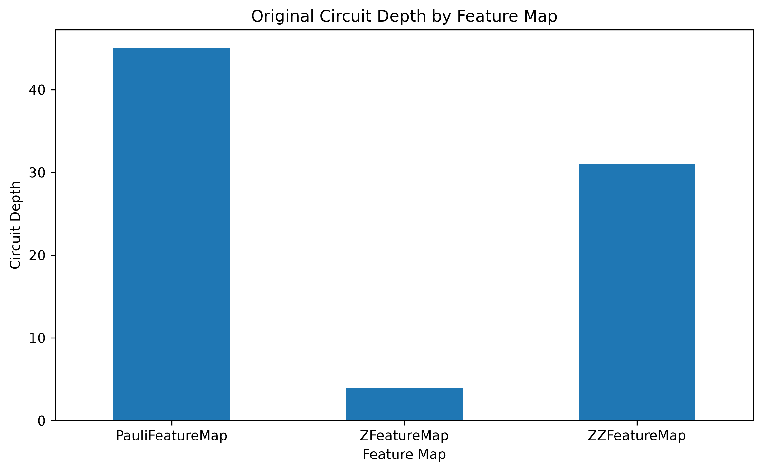
Figure 1. Original circuit depth by feature map.
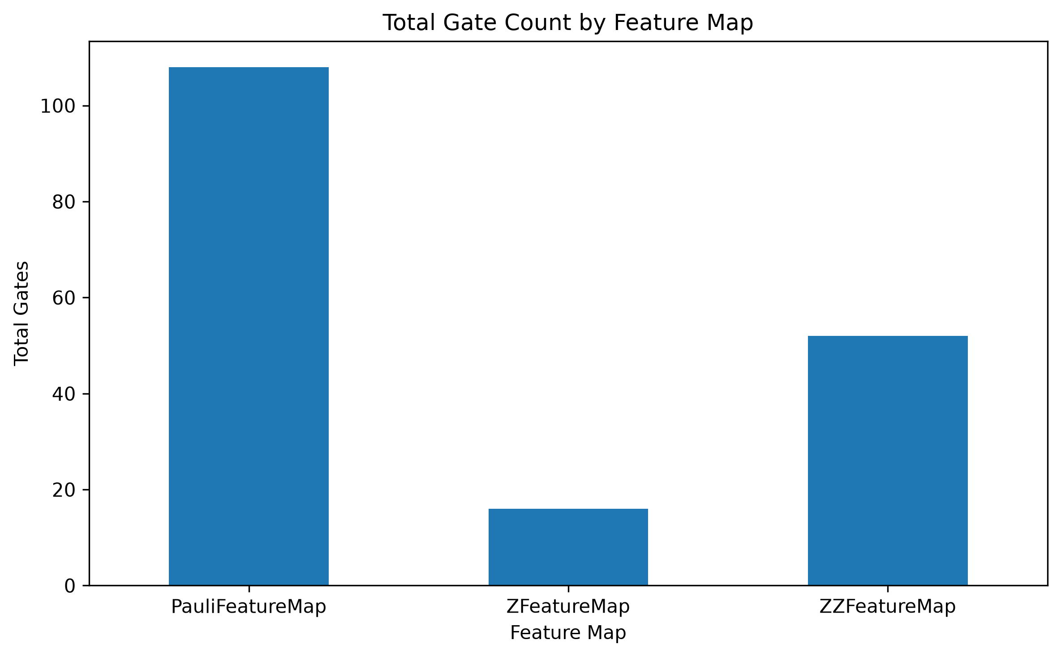
Figure 2. Total gate count by feature map.
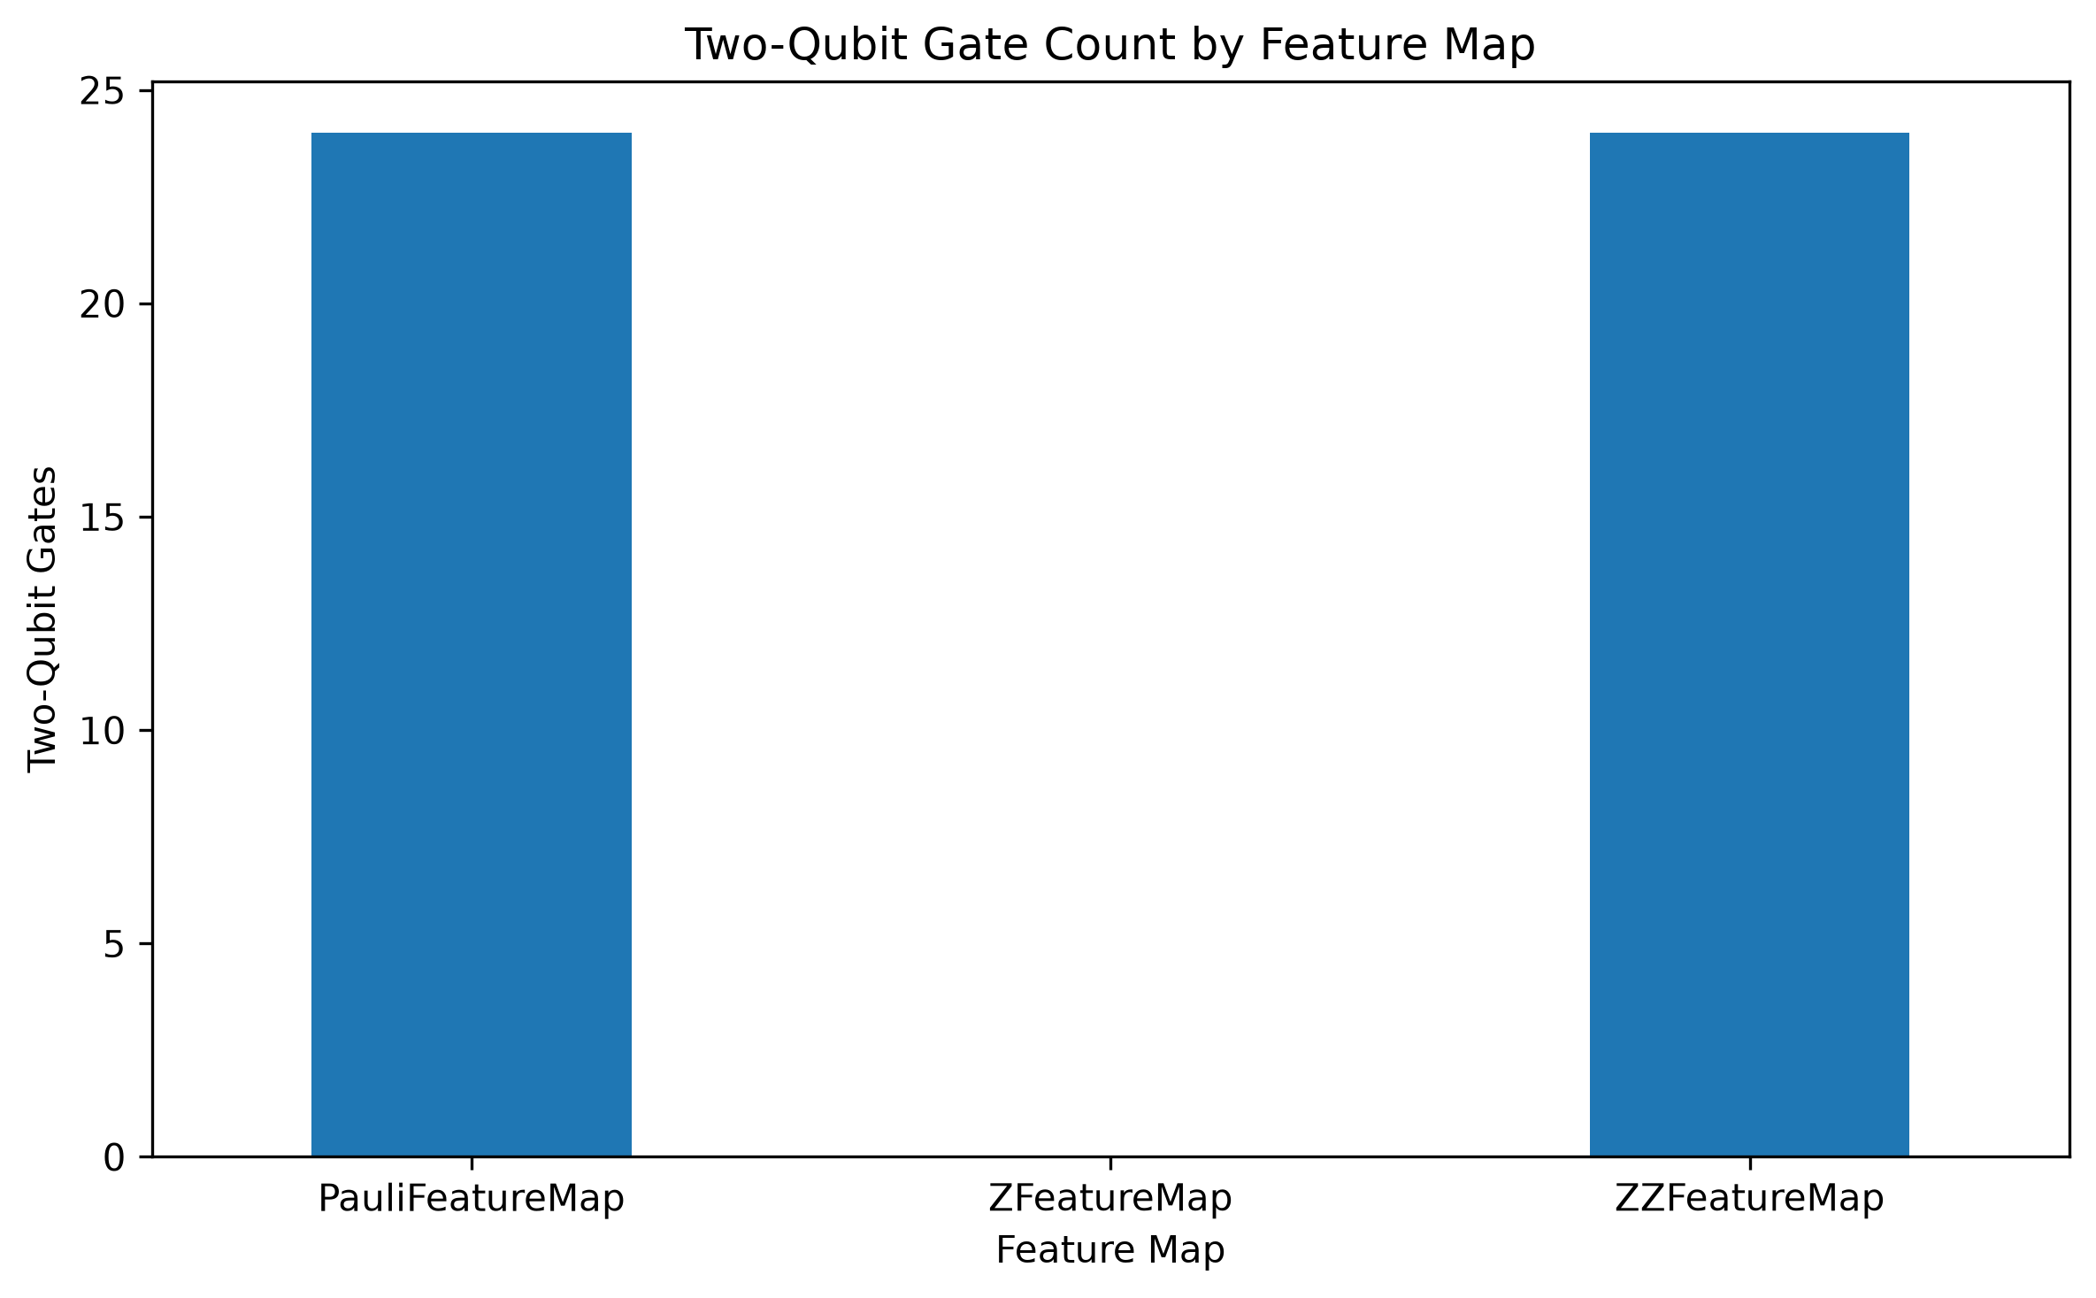
Figure 3. Two-qubit gate count by feature map.
ZFeatureMap is the cheapest by a wide margin, using no entangling gates at all — its 16 total gates are simply H and P pairs applied per qubit. ZZFeatureMap and PauliFeatureMap both use the same 24 two-qubit gates, but PauliFeatureMap's total gate count (108) is roughly double ZZFeatureMap's (52) and nearly 7x ZFeatureMap's, because it layers additional single-qubit Pauli rotation terms (Y-type) on top of the same entangling backbone.

3.2 Entanglement Analysis (Meyer–Wallach Q)
The Meyer-Wallach measure quantifies multipartite entanglement by averaging (1 − purity) of each qubit's reduced density matrix. Q ranges from 0 (no entanglement) to 1 (maximal entanglement).
Iris Class | ZFeatureMap | ZZFeatureMap | PauliFeatureMap
setosa | ~0.000 | 0.756 | 0.734
versicolor | ~0.000 | 0.459 | 0.435
virginica | ~0.000 | 0.848 | 0.914

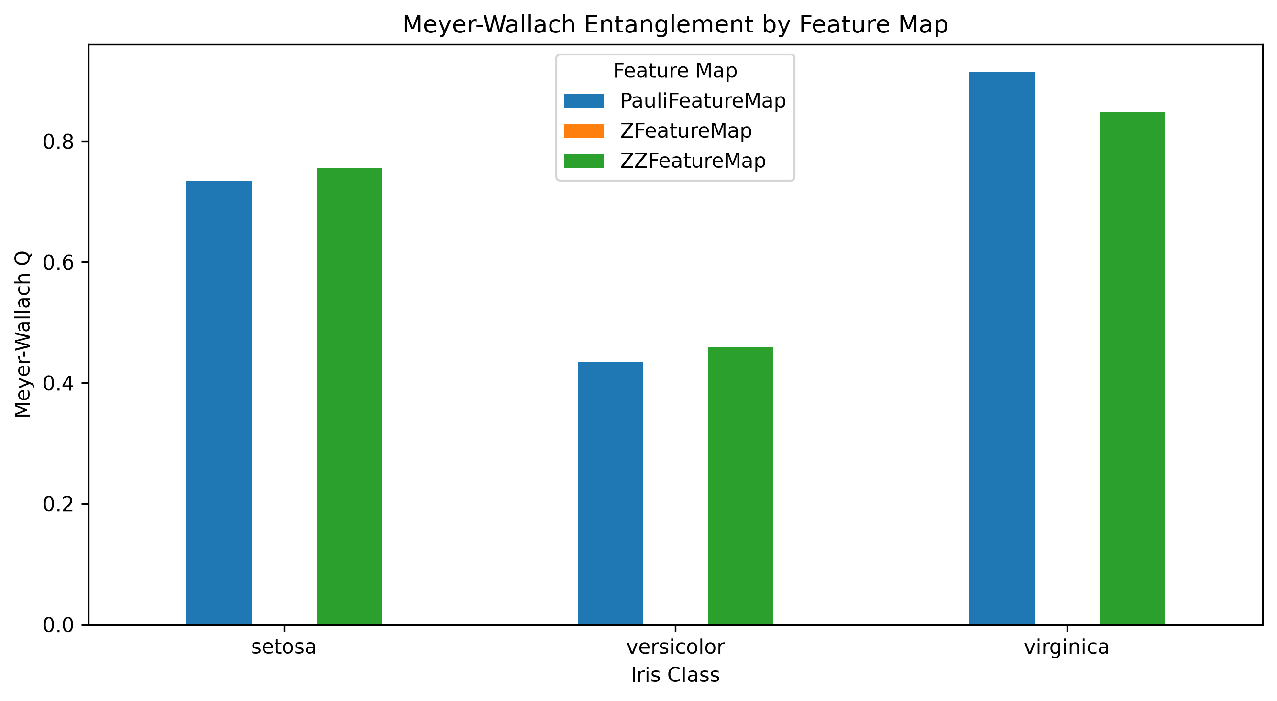
Figure 4. Meyer-Wallach entanglement by feature map and Iris class. ZFeatureMap bars are not visible — its Q is effectively zero (~1e-15, numerical noise) for every class.
ZFeatureMap stays at essentially zero entanglement across every class, confirming purely independent, non-interacting encoding. ZZFeatureMap and PauliFeatureMap track each other closely, but their ranking flips depending on the sample: ZZFeatureMap is slightly higher for setosa and versicolor, while PauliFeatureMap pulls ahead for virginica (0.914 vs. 0.848) — its highest entanglement value across the whole experiment. This shows entanglement is not a fixed property of the circuit template alone; it also depends on the specific data values being encoded.

3.3 Transpilation Analysis
Each feature map circuit was transpiled to a generic basis gate set (cx, rz, sx, x) at optimization level 1 — a simulator-based comparison, with no real hardware backend used.
Feature Map | Depth (orig → transpiled) | 2Q Gates (orig → transpiled)
ZFeatureMap | 4 → 5 | 0 → 0
ZZFeatureMap | 31 → 30 | 24 → 20
PauliFeatureMap | 45 → 34 | 24 → 20

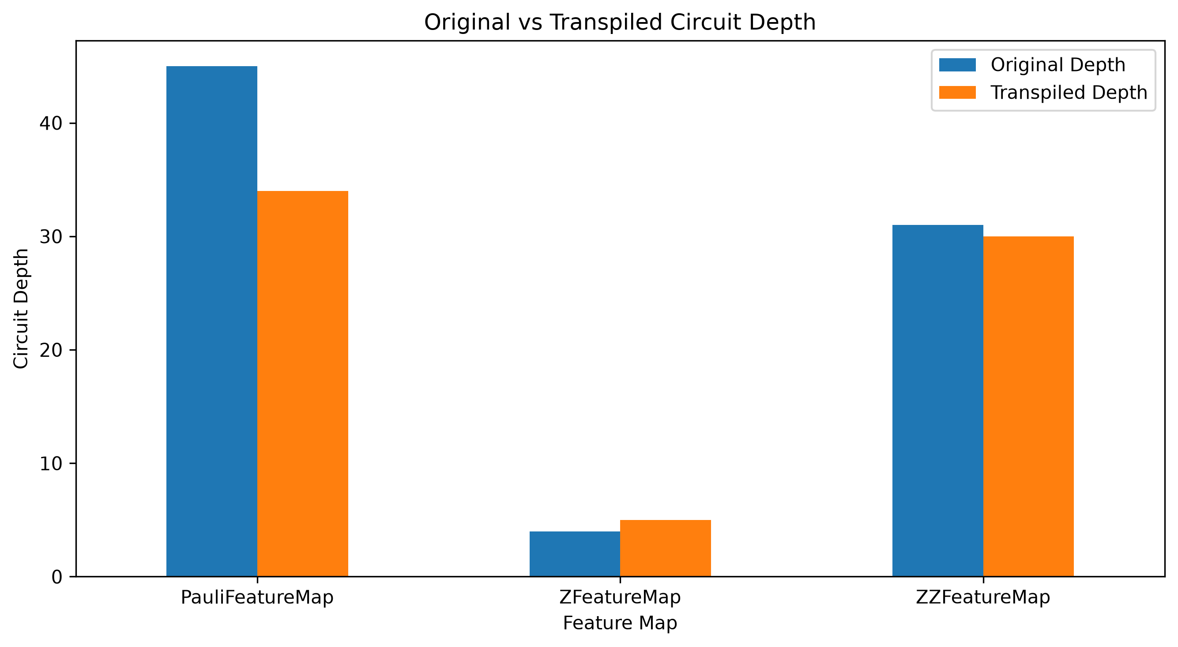
Figure 5. Original vs. transpiled circuit depth.
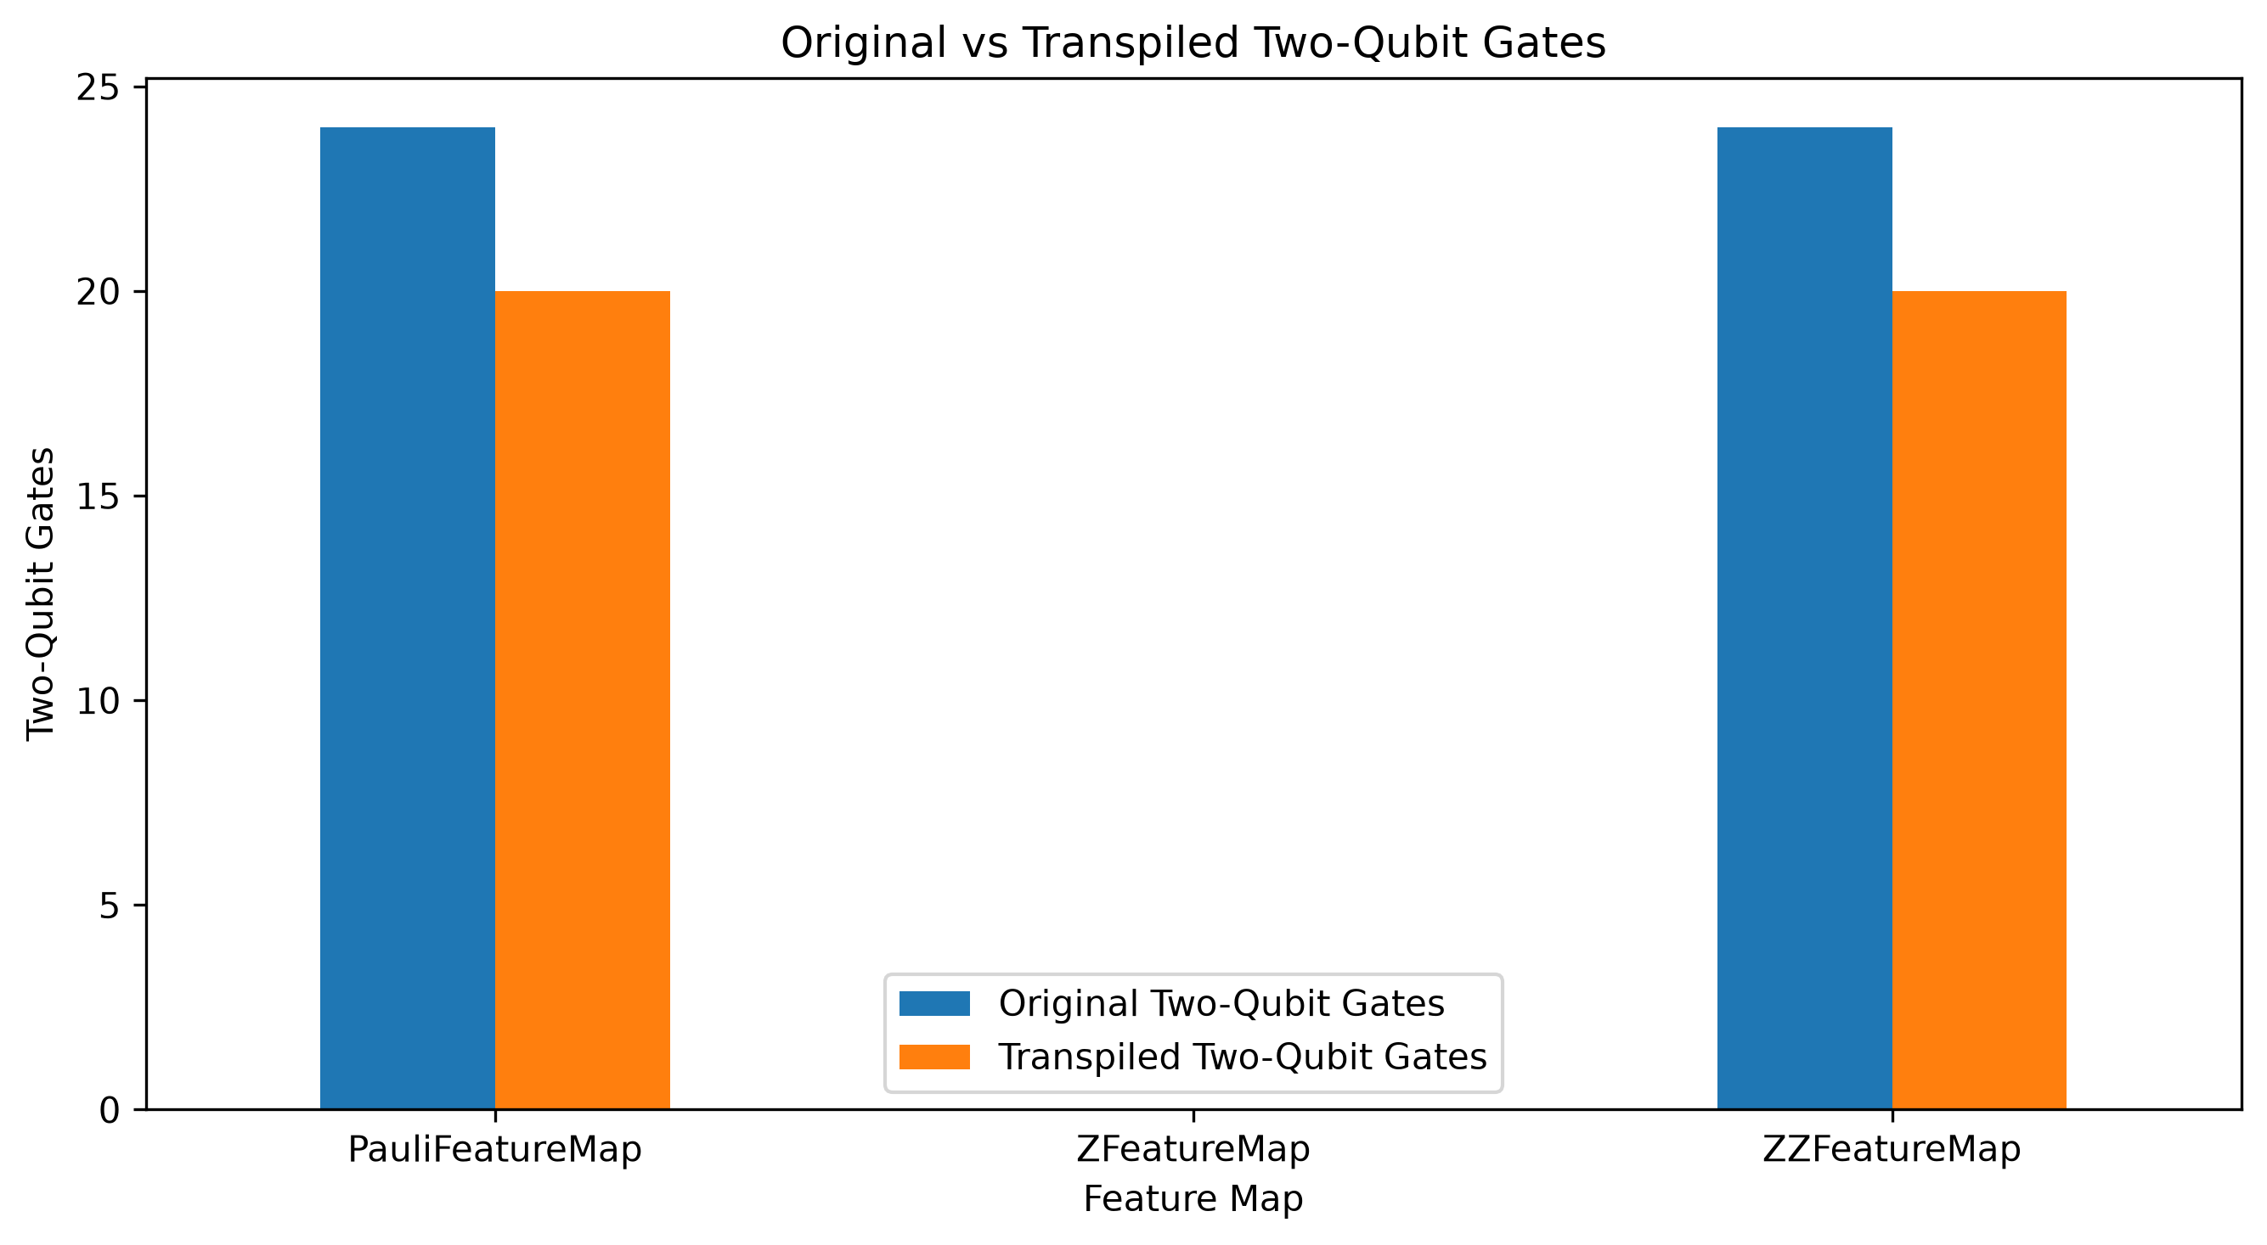
Figure 6. Original vs. transpiled two-qubit gate count.
ZFeatureMap's depth ticks up slightly after transpilation due to basis-gate decomposition overhead, but it remains at zero two-qubit gates throughout. Both ZZFeatureMap and PauliFeatureMap see gate cancellation during optimization — depth drops by 1 and 11 respectively, and both lose 4 two-qubit gates (24 → 20). PauliFeatureMap's proportionally larger depth reduction suggests the transpiler finds more redundancy to eliminate in its more elaborate gate sequence, even though the absolute two-qubit gate reduction is the same for both maps.

3.4 Data Representation Analysis (Measurement Distributions)
For identical classical input, each feature map was measured on AerSimulator (4000 shots) to compare the resulting probability distributions.
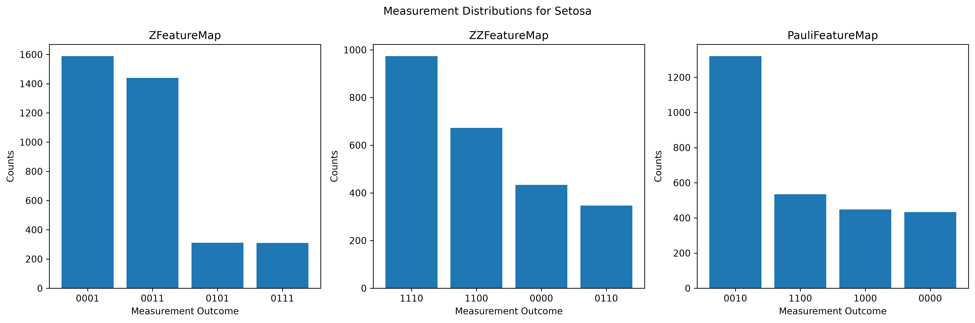
Figure 7. Measurement distributions for setosa.
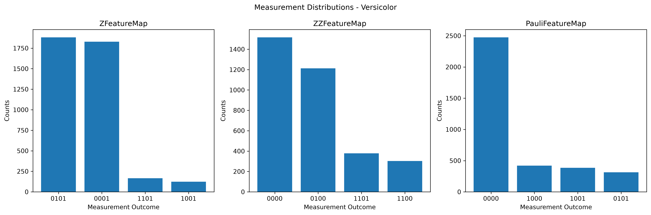
Figure 8. Measurement distributions for versicolor.
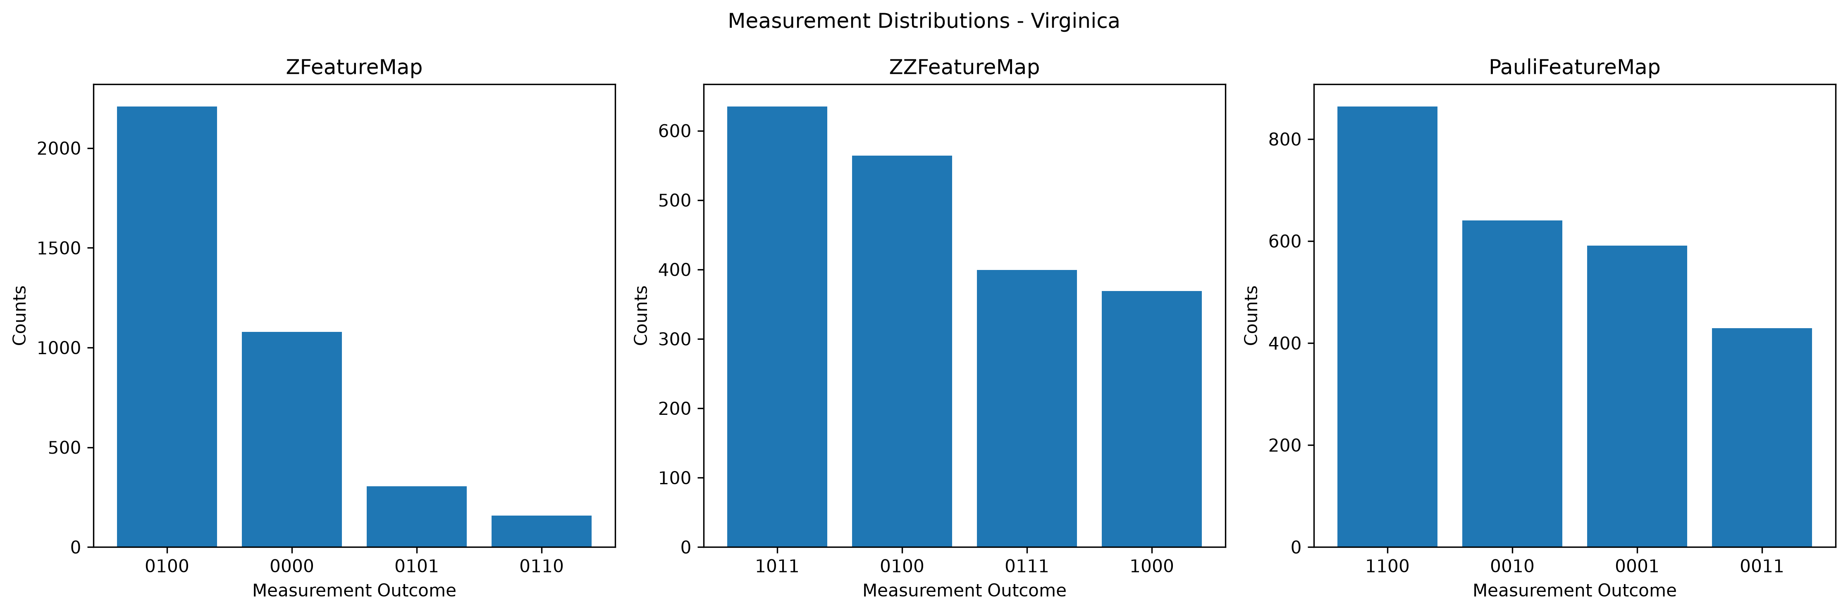
Figure 9. Measurement distributions for virginica.
- Setosa: ZFeatureMap splits between 0001/0011; ZZFeatureMap peaks at 1110; PauliFeatureMap peaks sharply at 0010, capturing roughly half its shots in a single outcome — the most concentrated distribution of the three.
- Versicolor: ZFeatureMap splits between 0101/0001; ZZFeatureMap leans toward 0000; PauliFeatureMap concentrates even more heavily on 0000 (nearly 2500 of 4000 shots), consistent with its extra Pauli terms constructively reinforcing that outcome.
- Virginica: all three feature maps disagree entirely on their leading outcome (0100 for Z, 1011 for ZZ, 1100 for Pauli) — zero overlap in the top result.
Across all three samples, ZFeatureMap's distributions stay concentrated on just two dominant outcomes, consistent with its lack of entanglement, while ZZFeatureMap and especially PauliFeatureMap redistribute probability across a wider or differently-weighted set of outcomes as entanglement increases — directly visualizing how feature-map choice changes the quantum representation of identical classical data.

4. Final Summary Table
Feature Map | Depth | Total Gates | 2Q Gates | Avg. Entanglement (Q) | Transpiled Depth | Transpiled 2Q Gates
ZFeatureMap | 4 | 16 | 0 | ~0.00 | 5 | 0
ZZFeatureMap | 31 | 52 | 24 | 0.69 | 30 | 20
PauliFeatureMap | 45 | 108 | 24 | 0.69 | 34 | 20

5. Conclusion

Research Question
How does the choice of quantum feature map affect circuit complexity, feature interactions, and quantum data representation?

Findings
The three feature maps trace a clear complexity–interaction spectrum. ZFeatureMap sits at one extreme: minimal circuit depth (4), no two-qubit gates, and essentially zero entanglement (Q ≈ 0) across every Iris class — it encodes each feature independently, with no cross-feature information captured in the quantum state. ZZFeatureMap introduces pairwise feature interactions through 24 two-qubit gates, producing substantial entanglement (0.46–0.85 depending on class) at roughly 8x ZFeatureMap's depth. PauliFeatureMap pushes further still, layering additional Pauli rotation terms onto the same entangling backbone — its entanglement is comparable to, and for virginica slightly exceeds, ZZFeatureMap's, but it does so at nearly double the total gate count (108 vs. 52).
Transpilation results show all three feature maps compress somewhat under optimization, with PauliFeatureMap benefiting from the largest proportional depth reduction while still ending with the highest absolute complexity of the three. The measurement distributions confirm that these structural differences translate directly into different quantum representations of identical classical data — each feature map produces a different dominant outcome for the same Iris sample, with PauliFeatureMap's distributions often the most sharply concentrated.

Trade-off Summary
Feature Map | Circuit Cost | Feature Interaction | Best Suited When...
ZFeatureMap | Lowest | None | Hardware resources are scarce, or feature correlations aren't expected to matter
ZZFeatureMap | Moderate | Strong, pairwise | A good default balance between interaction richness and circuit cost
PauliFeatureMap | Highest | Strong, and slightly richer for high-variance classes like virginica | The dataset may benefit from more general Pauli-term interactions and circuit depth is not the binding constraint

Consistent with the project's framing, the conclusion is not that one feature map is categorically “better” — it is that richer feature interactions come at a proportionally, and in PauliFeatureMap's case disproportionately (roughly double the gate count for comparable entanglement), higher circuit cost. The right choice depends on whether the target hardware or simulator budget can absorb that added cost for the interaction richness the dataset actually requires.

