**TASK – 5**

**Capture and Analyze Network Traffic Using Wireshark.**

**1: Ping Test to Google.com**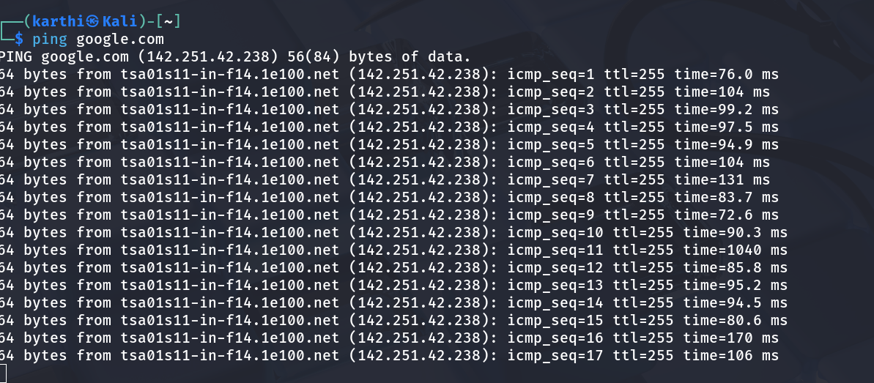

This image shows the use of the ping command to test connectivity to google.com (142.251.42.238). The ping results show:

* 17 ICMP packets sent with sequence numbers 1-17
* Response times ranging from 72.6ms to 1040ms (with one anomalous high latency)
* Average response time around 90-100ms
* TTL (Time To Live) value of 255
* Packet size of 64 bytes each
* Successful connectivity established to Google's servers

**2: Wireshark Capture - ICMP Traffic Analysis (Google.com) :**

This Wireshark capture window displays the ICMP (Internet Control Message Protocol) packets generated during the ping operation.

Key observations:

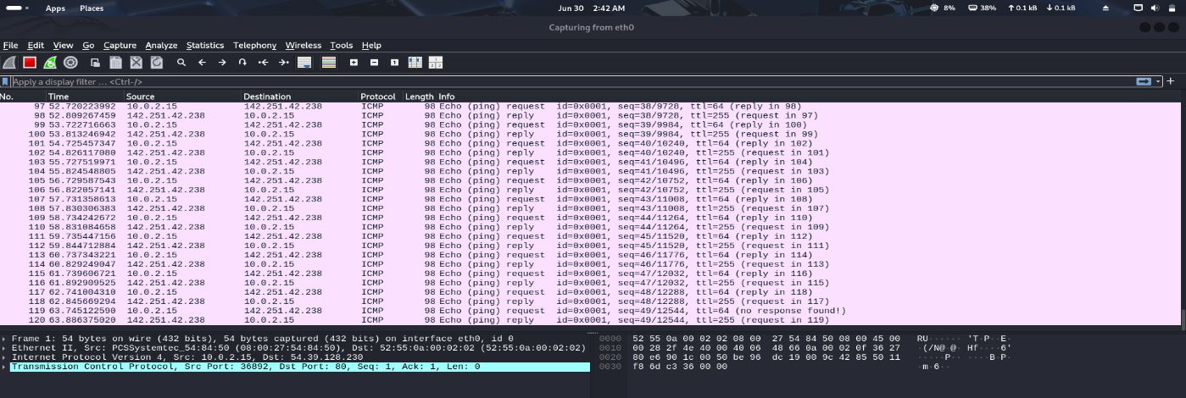

* Multiple ICMP Echo request and reply packets between source (10.0.2.15) and destination (142.251.42.238)
* Packet sequence numbers correlating with the ping command output
* Protocol identification showing ICMP traffic
* Timestamps indicating packet transmission times
* Frame details showing 98-byte packets with 64-byte payload

**3: Ping Statistics Summary (Google.com) :**

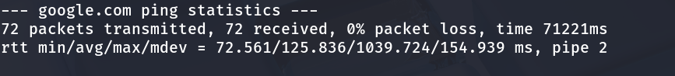

The ping statistics summary shows:

* Total Packets: 72 transmitted, 72 received
* Packet Loss: 0% (perfect connectivity)
* Total Time: 71221ms (approximately 71 seconds)
* RTT Statistics: min/avg/max/mdev = 72.561/125.836/1039.724/154.939 ms
* Pipe Value: 2 (indicating network performance)

**4: Ping Test to Facebook.com :**

Secondary Connectivity Test

This shows a ping test to facebook.com (163.70.140.35) demonstrating:

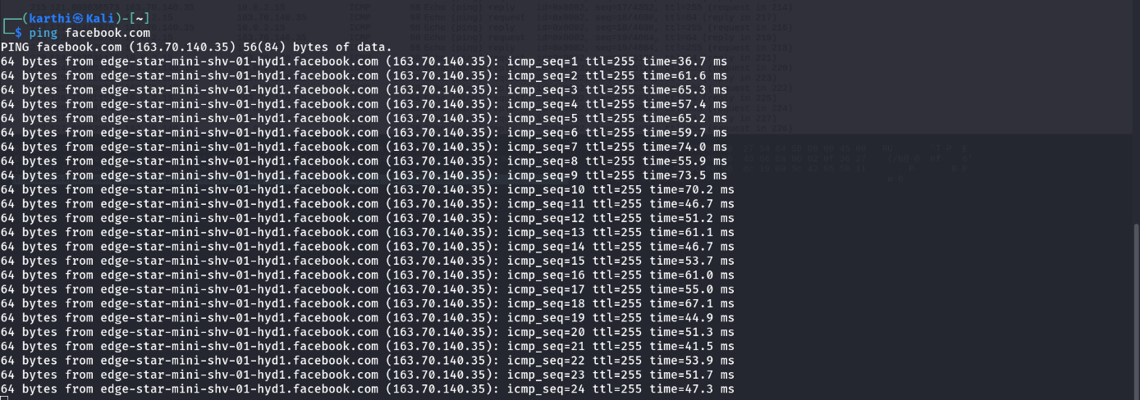

* Successful DNS resolution to Facebook's edge server
* Response times ranging from 36.7ms to 74ms
* Consistent TTL value of 255
* Lower latency compared to Google ping test
* Packet size of 64 bytes maintained

**5: Facebook ICMP Traffic Capture :**

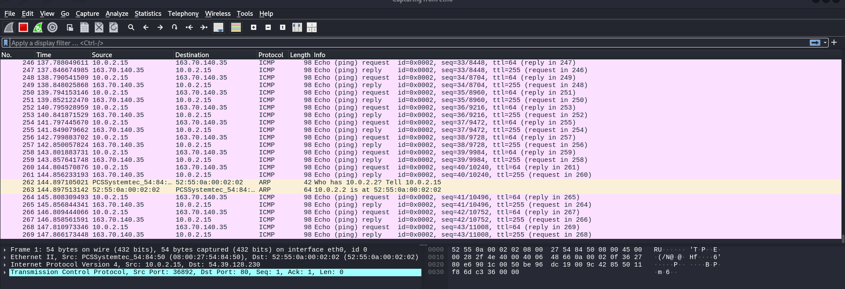

Wireshark capture showing extended ICMP traffic to Facebook servers:

* Longer capture session with more packet entries
* Mix of ICMP Echo requests and replies
* Additional ARP (Address Resolution Protocol) packets visible
* Source IP 10.0.2.15 communicating with destination 163.70.140.35
* Frame numbers extending beyond 250, indicating sustained network activity

**6: Facebook Ping Statistics :**

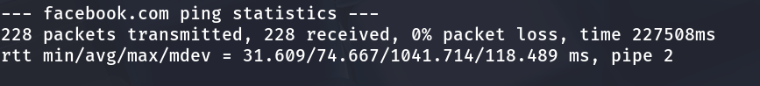

Facebook ping statistics reveal:

* Total Packets: 228 transmitted, 228 received
* Packet Loss: 0% (excellent connectivity)
* Total Time: 227508ms (approximately 227 seconds)
* RTT Statistics: min/avg/max/mdev = 31.609/74.667/1041.714/118.489 ms
* Pipe Value: 2

**7: TCP Protocol Analysis**

**Only TCP establishments using filter.**

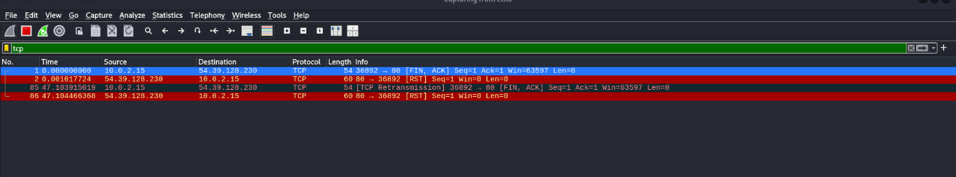

This capture shows TCP (Transmission Control Protocol) packets:

* TCP connection initiation with SYN, ACK flags
* Port 36892 communication
* Protocol transitions from ICMP to TCP
* Connection establishment sequence visible
* Different colored highlighting indicating protocol types

**8: DNS Protocol Capture**

**Only DNS establishments using filter.**

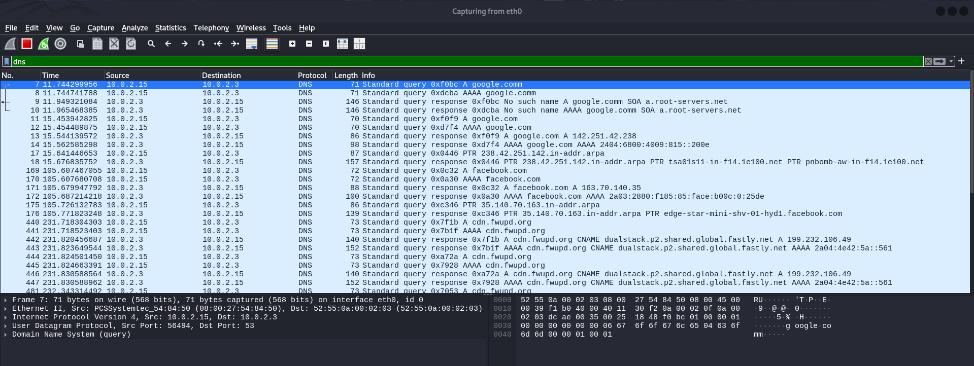

DNS query and response packets captured showing:

* Standard DNS queries for domain resolution
* Query types including A records for google.com
* DNS responses with resolved IP addresses
* Port 53 communication (standard DNS port)
* Multiple DNS transactions for different domains

**9: UDP Protocol Traffic**

**Only UDP establishments using filter.**

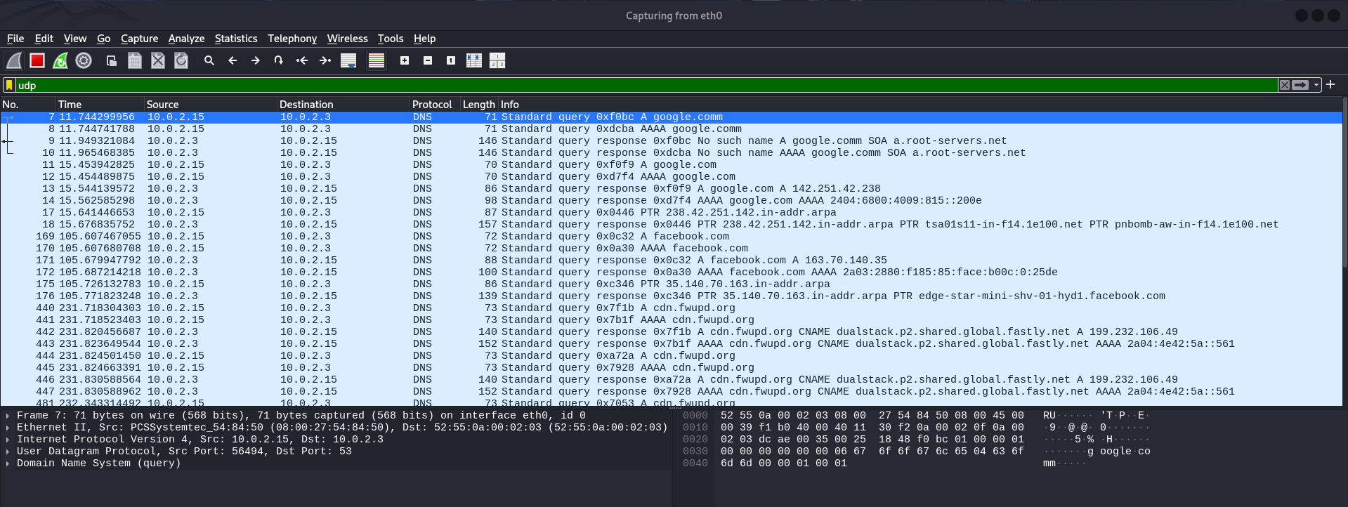

UDP traffic capture displaying:

* DNS queries using UDP protocol (faster, connectionless)
* Various domain lookups including google.com, facebook.com
* CDN and content delivery network queries