A
A Real-Time (or) Field-based Research Project Report
on
TELECOM CUSTOMER ATTRITION PREDICTION
(Submitted in partial fulfilment of the requirements for the award of Degree)
Bachelor of Technology
in
COMPUTER SCIENCE & ENGINEERING (DATA SCIENCE)
By
T. Renuka (227R1A6756)
Mohit Karthikeya (227R1A6702)
G. Reshma (237R5A6703)



Under the guidance of
Dr. K. Murali
Associate Professor
Department of Computer Science & Engineering (Data Science)
CMR TECHNICAL CAMPUS
UGC AUTONOMOUS
Accredited by NBA & NAAC with 'A' Grade
Approved by AICTE, New Delhi and JNTU, Hyderabad.
June, 2023

DEPARTMENT OF COMPUTER SCIENCE & ENGINEERING
(DATA SCIENCE)

CERTIFICATE
This is to certify that the project entitled “Customer Churn Prediction” being submitted by T. Renuka (227R1A6756), Mohit Karthikeya (227R1A6702), G. Reshma (237R5A6703) in partial fulfillment of the requirements for the award of the degree of B. Tech in Computer Science and Engineering (Data Science) to the Jawaharlal Nehru Technological University Hyderabad, is a record of bonafide work carried out by them under our guidance and supervision during the year 2023-24.
The results embodied in this thesis have not been submitted to any other University or Institute for the award of any degree or diploma.

Dr. K. Murali Dr. K. Srinivas
Associate Professor Professor & HoD Guid

Dr. A. Raji Reddy
Director

ABSTRACT

Customer churn is defined when the customers or subscribers discontinue doing business with a firm or service. The effective churn management provides a competitive advantage to the company over its competitors by increasing its customer retention rate. Effectively managing churn prevents revenue loss Customer churn is a vital metric for assessing your customer service and your retention strategies.
Although many algorithms exist today few of them are effective to consider. Voting classifier algorithm is chosen here. Voting classifier is a machine learning model that trains on an ensemble of numerous models and predicts an output(class) based on their highest probability of chosen class as the output.
The Voting Classifier excels in situations where diverse models contribute unique insights, mitigating biases inherent in individual algorithms. This diversity enhances the overall predictive power and generalizability of the model. By considering multiple perspectives, the Voting Classifier adapts well to intricate patterns in customer behavior, offering a nuanced understanding of potential churn indicators.
In the dynamic landscape of business, where customer relationships are paramount, leveraging advanced machine learning techniques like the Voting Classifier becomes imperative for staying ahead in the competition and fostering long-term customer loyalty
TABLE OF CONTENT
- INTRODUCTION 1
  - Problem Statement 2
- LITERATURE SURVEY 3
  - Existing System 4
  - Proposed System 5
- SYSTEM DESIGN 7
  - System Architecture 7
  - UML Diagrams 10
  - Functional Requirements 14
- IMPLEMENTATION 16
  - Module Description 16
  - Sample Code 19
- TESTING 25
  - Importance of Testing 25
  - Types of Testing 26
  - Test Cases 27
- RESULTS 29
- CONCLUSION 35
- REFERENCES 37

- INTRODUCTION
In the contemporary business milieu, where customer relationships are integral to sustained success, the proactive identification and mitigation of customer churn have become paramount. Customer churn, the phenomenon of customers discontinuing their engagement with a product or service, poses a significant threat to a company's bottom line and market standing. Recognizing the imperative to minimize churn, businesses are increasingly turning to sophisticated data analytics and machine learning models to predict and preemptively address customer attrition. By leveraging vast datasets that encapsulate customer behavior, preferences, and transaction histories, organizations can uncover nuanced patterns and predictive indicators.
These insights enable the implementation of targeted retention strategies, empowering companies to enhance customer satisfaction and loyalty while safeguarding their market share in an ever-evolving competitive landscape. In this data-driven era, the ability to forecast customer churn not only aligns with the broader paradigm of customer-centricity but also serves as a linchpin for strategic decision-making. By harnessing the power of predictive analytics, businesses can move beyond reactive measures and adopt proactive approaches to customer retention. The predictive prowess afforded by these models equips organizations to stay ahead of the curve, adapt to changing customer dynamics, and ultimately fortify their position in the marketplace. As the digital era unfolds, customer churn prediction emerges as a critical facet in the arsenal of tools that companies wield to not only survive but thrive in an intensely competitive business ecosystem.
Customer churn, the phenomenon wherein customers discontinue their association with a product or service, poses significant challenges to businesses aiming for sustained growth and profitability. Recognizing the importance of preemptive action, organizations are increasingly turning to advanced analytics and machine learning techniques to develop robust customer churn prediction models.

1.1 Problem Statement
In the contemporary landscape of ever-evolving markets and intensifying competition, businesses face a formidable challenge in the pervasive issue of customer churn. The increasing frequency with which customers discontinue their association with products or services poses a significant threat to the financial stability and long-term sustainability of organizations across various industries. Recognizing the gravity of this challenge, there is a pressing need for a nuanced and predictive understanding of the factors driving customer attrition. Conventional methods of customer retention often prove inadequate, lacking the agility and foresight required to address the dynamic nature of consumer behavior. In this context, the urgent problem at hand centers on the development of a comprehensive and adaptive solution that harnesses the power of advanced data analytics and machine learning.
This solution must be capable of deciphering intricate patterns within vast datasets, encompassing customer interactions, preferences, and transactional histories, to enable organizations to proactively predict and strategically mitigate customer churn. As businesses grapple with the imperative to foster customer loyalty and fortify their market positions, the development of an effective customer churn prediction model emerges as an indispensable priority, bridging the gap between reactive approaches and the proactive strategies needed to navigate the complexities of the contemporary market environment.

- LITERATURE SURVEY
A comprehensive literature survey on customer churn prediction reveals a rich and evolving landscape at the intersection of business analytics, machine learning, and customer relationship management. Numerous studies underscore the critical importance of accurately anticipating and mitigating customer churn, emphasizing its direct impact on revenue, profitability, and long-term market competitiveness.
Existing research frequently explores diverse methodologies for customer churn prediction, with a notable shift towards advanced machine learning techniques. Classic methodologies, such as logistic regression and decision trees, have been foundational, but contemporary studies increasingly embrace more sophisticated algorithms like random forests, support vector machines, and neural networks.
Furthermore, the literature highlights the significance of feature engineering and selection in enhancing model accuracy and interpretability. Studies delve into the identification of key predictors, ranging from customer satisfaction and engagement metrics to transactional patterns and demographic variables.
In addition to technical aspects, the literature acknowledges the contextual importance of industry- specific considerations. Studies often emphasize the need for tailored models that account for the unique characteristics and challenges within sectors such as telecommunications, banking, e-commerce, and subscription-based services.
Moreover, the evolution of customer churn prediction extends beyond model development to encompass the integration of real-time analytics and prescriptive approaches. The integration of artificial intelligence and automated decision-making processes emerges as a burgeoning area, enabling businesses to not only predict churn but also prescribe targeted retention strategies in a timely manner.

2.1 Existing System
The existing systems for customer churn prediction typically encompass a range of methodologies and tools designed to analyze historical customer data and make predictions about future churn likelihood. Traditional approaches often involve statistical methods such as logistic regression, decision trees, and clustering techniques. These methods rely on historical data patterns, customer attributes, and transactional histories to identify indicators or factors associated with potential churn.
Many businesses also use customer relationship management (CRM) systems that include built-in reporting and analytics modules to track customer interactions, engagement metrics, and customer feedback. These systems may generate reports that provide insights into customer behavior and trends, allowing businesses to identify potential churn risks.
In recent years, there has been a notable shift towards more advanced machine learning and predictive analytics techniques. Supervised learning algorithms, including support vector machines, random forests, and neural networks, are increasingly employed to develop predictive models. These models leverage large datasets to identify complex patterns and relationships that may not be apparent through traditional analysis.
Furthermore, businesses often integrate predictive modeling into their existing analytics platforms or deploy standalone churn prediction systems. These systems may utilize real-time data streams to continuously update predictions, allowing organizations to take swift and targeted actions to prevent customer churn.
Additionally, some industries, such as telecommunications and subscription-based services, have developed industry-specific churn prediction models. These models often consider factors such as usage patterns, customer feedback, and service quality metrics to enhance the accuracy of predictions.
2.1 Proposed System
The proposed system for customer churn prediction aims to leverage cutting-edge technologies and methodologies to enhance the accuracy, timeliness, and strategic impact of churn predictions. The system integrates advanced machine learning algorithms, real-time analytics, and a holistic approach to customer data to provide a comprehensive solution for businesses looking to proactively address and minimize customer churn.
- Advanced Machine Learning Algorithms:
The proposed system employs state-of-the-art machine learning algorithms, such as deep learning neural networks, ensemble methods like XGBoost, and reinforcement learning models. These advanced techniques allow for the detection of intricate patterns and non-linear relationships within extensive datasets, resulting in more accurate and nuanced predictions of customer churn.
    - Real-time Data Integration:
Unlike traditional systems that rely on batch processing, the proposed system emphasizes real-time data integration. It continuously monitors and analyzes customer interactions, feedback, and transactional data in real-time, enabling businesses to respond swiftly to emerging churn signals. This dynamic approach ensures that predictions are based on the most current and relevant information, enhancing the system's predictive capabilities.
    - Predictive Analytics Dashboard:
The system incorporates an intuitive and user-friendly predictive analytics dashboard. This dashboard provides stakeholders with a clear and actionable overview of customer churn risk factors, allowing for informed decision-making. Key performance indicators (KPIs) related to customer engagement, satisfaction, and potential churn are visualized, facilitating.
    - Interpretable Models and Explainability:
Recognizing the importance of model interpretability, the proposed system integrates techniques for explaining the decisions made by complex machine learning models. This ensures that business stakeholders, including non-technical users, can understand the rationale behind churn predictions. Explainable AI features contribute to building trust in the system's recommendations and facilitate collaboration between data scientists and business teams.
    - Adaptive and Self-learning Capabilities:
The system incorporates adaptive learning mechanisms to continuously evolve and improve its predictive accuracy over time. By analyzing the effectiveness of its predictions and adjusting to changes in customer behavior and market dynamics, the system becomes more adept at identifying new patterns and anticipating emerging churn risks.
    - Integration with Customer Engagement Strategies:
To go beyond mere prediction, the proposed system integrates with customer engagement strategies. It suggests personalized retention tactics based on individual customer profiles and predicted churn probabilities. This ensures that businesses can not only predict churn but also implement targeted interventions to retain at-risk customers effectively.

- SYSTEM DESIGN
  - Importance of Design
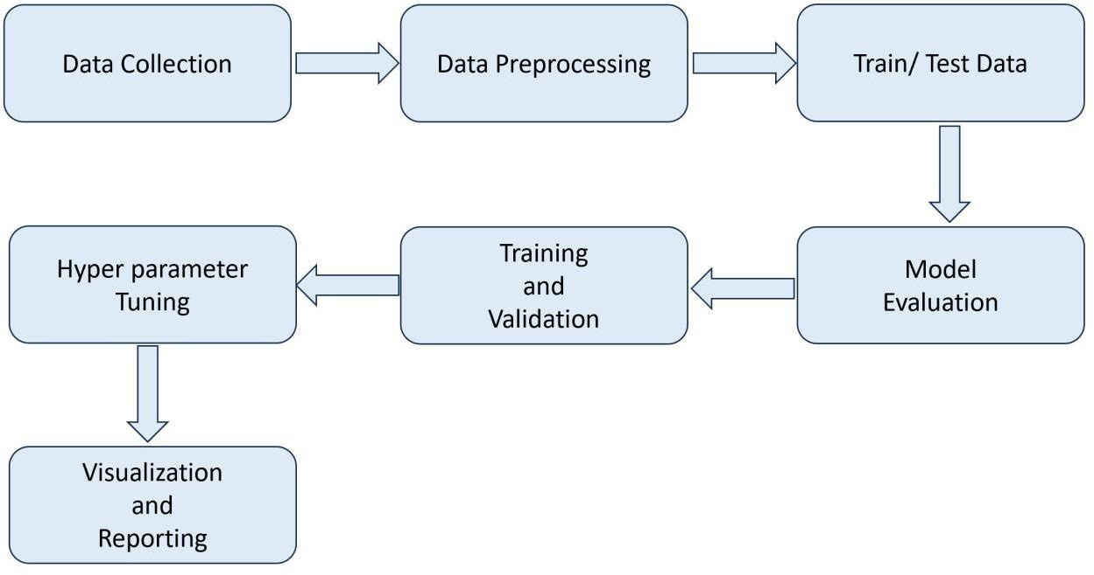

Fig.1: System Architecture

3.1.1 Data Collection:
In customer churn prediction, data collection is a pivotal process aimed at gathering comprehensive information to inform predictive models. This involves capturing customer demographics, transaction histories, customer interactions across various channels, and feedback through surveys or reviews. Additionally, the collection of usage patterns, subscription details, and external data sources further enriches the dataset.

3.1.2 Data Preprocessing:
In customer churn prediction, data preprocessing is crucial for refining raw data to improve model performance. This involves handling missing values, normalizing numerical features, and encoding categorical variables. Time series data is organized to capture temporal patterns, and outliers are addressed to enhance model robustness.

3.1.3 Train/ Test Data:
In customer churn prediction, the dataset is typically split into training and testing sets. The training set, comprising the majority of the data, is used to train the predictive model. The testing set, representing a portion of the data not seen by the model during training, is reserved to assess the model's performance on unseen data.

3.1.4 Training and Validation:
In customer churn prediction, training and validation are essential steps in developing a robust predictive model. The training set, a subset of the data, is used to train the model on historical patterns and relationships. The validation set, distinct from the training set, is employed to assess the model's performance on unseen data, helping detect overfitting or underfitting issues.

3.1.5 Model Evaluation:
Model evaluation in customer churn prediction assesses the performance of the predictive model on unseen data to gauge its effectiveness. Common metrics include accuracy, precision, recall, and F1 score, which quantify the model's ability to correctly identify churn instances.

  - UML Diagrams
    - Use Case Diagram
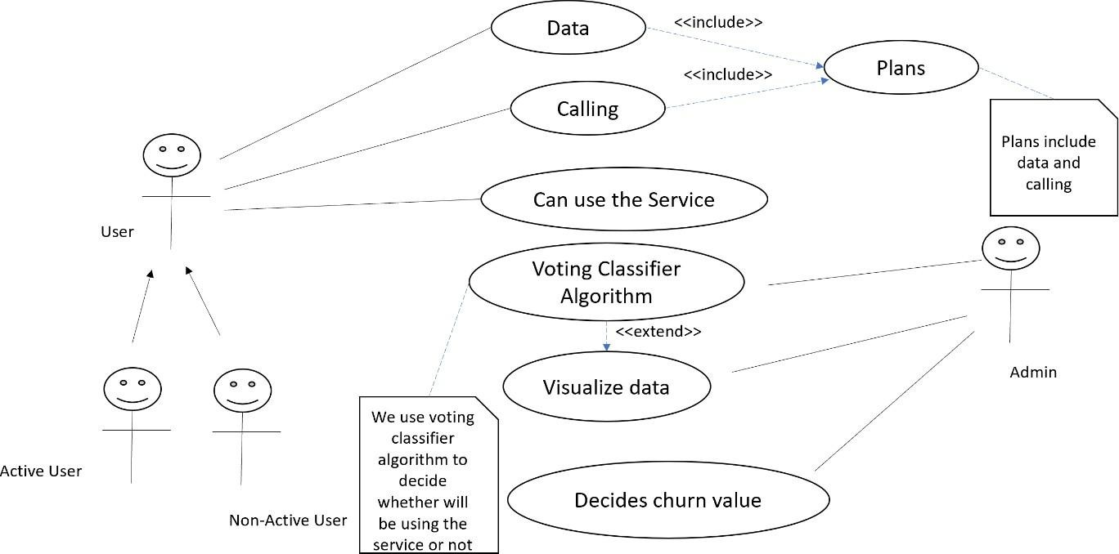
In the context of customer churn prediction, the use case diagram outlines the key interactions between various actors and the system components. The primary actors include the "Customer," whose churn is being predicted, and the "Customer Service Representative (CSR)," responsible for customer relationship management. The system executes essential use cases such as "Collect Data," where it gathers relevant customer information, and "Train Model," where it employs historical data to train the churn prediction model.
Fig.2: Use Case Diagram

    - Sequence Diagram
In a sequence diagram for customer churn prediction, the interactions and chronological flow of events between system components and actors are illustrated. Initially, the "Customer" triggers the process by interacting with the system, initiating the "Collect Data" sequence. Once the model is trained, the "Predict Churn" sequence begins as the system evaluates the likelihood of churn for the specific customer. If a high churn probability is detected, the system generates an alert in the "Alert CSR" sequence, notifying the "Customer Service Representative (CSR)" to take action. The CSR responds by initiating the "Customer Retention Action" sequence, implementing strategies such as offering discounts or personalized promotions to retain the customer.
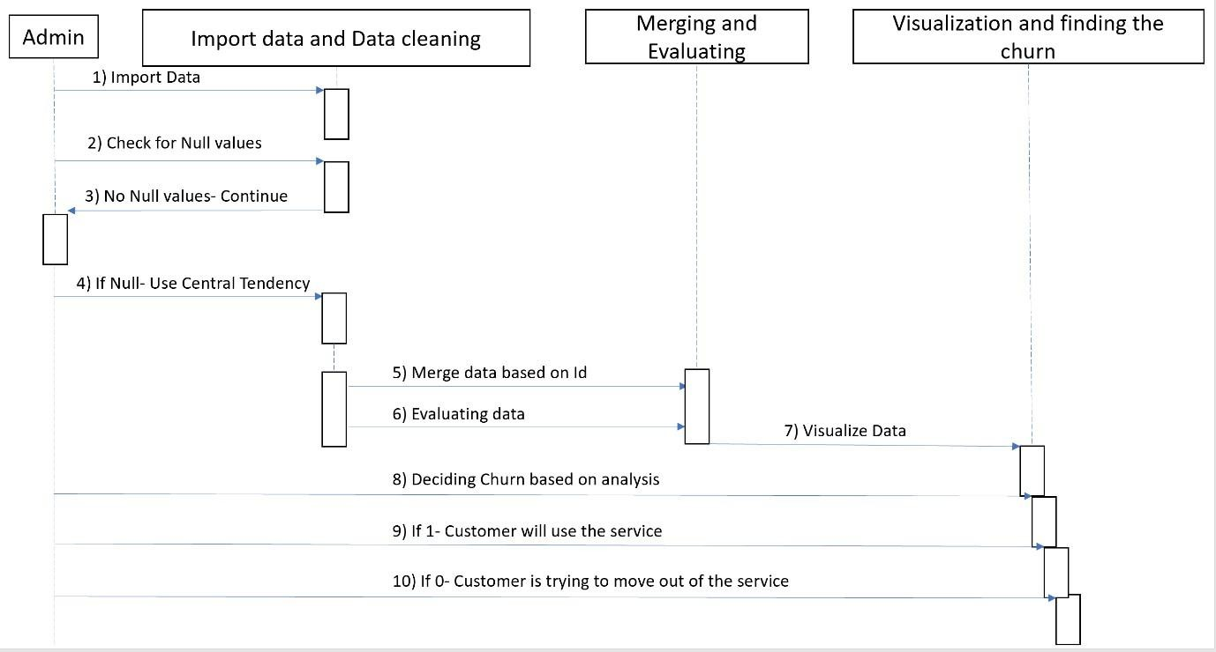

Fig.3: Sequence Diagram

  - Functional Requirements
Customer churn prediction is a complex task that involves various components and considerations. The fundamental requirements for successful customer churn prediction typically include:
- Data Collection:
  - Customer Data: Gather comprehensive customer information, including demographics, transaction history, customer interactions, and usage patterns.
  - Behavioral Data: Collect data on customer behavior, such as frequency of product usage, support interactions, and engagement metrics.
- Data Preprocessing:
  - Data Cleaning: Ensure data quality by identifying and handling missing or inconsistent values.
  - Feature Engineering: Create relevant features that contribute to the prediction model's accuracy.
- Machine Learning Model:
  - Algorithm Selection: Choose appropriate machine learning algorithms for churn prediction, such as decision trees, random forests, logistic regression, or neural networks.
  - Training: Train the model on historical data to learn patterns and relationships between features and churn outcomes.
- Alerting Mechanism:
  - Thresholds: Define thresholds for churn probability that trigger alerts.
  - Integration: Implement a mechanism to alert relevant stakeholders, such as customer service representatives, when a customer is likely to churn.
- Customer Retention Strategies:
  - Actionable Insights: Provide actionable insights based on the model's predictions to guide customer retention efforts.
  - Personalization: Tailor retention strategies based on individual customer profiles and preferences.

- IMPLEMENTATION
4.1 Module Description
4.1.1 Data Collection module:
The Data Collection Module in customer churn prediction serves as the cornerstone for acquiring and refining essential data. This module identifies and retrieves customer-related information from diverse sources, including transaction logs and service interactions. It conducts quality checks, addressing missing or inaccurate data, and integrates datasets to create a comprehensive view.

4.1.2 Data Preprocessing Module:
The Data Preprocessing Module in customer churn prediction is pivotal in preparing raw data for effective analysis and model training. This module encompasses tasks such as handling missing values, normalizing numerical features, and creating new features through feature engineering. Additionally, the Data Preprocessing Module plays a crucial role in mitigating biases and improving the overall performance of the predictive model by refining and optimizing the input data.

4.1.3 Data Exploration and Visualization module:
The Data Exploration and Visualization Module in customer churn prediction is essential for gaining insights into the characteristics and patterns within the dataset. This module employs exploratory data analysis techniques to understand the distribution of features, identify trends, and detect potential correlations. Visualization tools, such as charts and graphs, are leveraged to present

4.1.4 Data Splitting Module:
The Data Splitting Module in customer churn prediction is a crucial component responsible for partitioning the dataset into training and testing subsets. This module ensures that the machine learning model is trained on a distinct portion of the data and evaluated on another to assess its generalization performance. Typically, it uses techniques like random sampling or stratified sampling to maintain the distribution of churn and non-churn instances in both sets.

4.1.5 Model Evaluation module:
The Model Evaluation Module in customer churn prediction is instrumental in assessing the performance of the predictive model. This module employs various metrics, such as accuracy, precision, recall, and F1 score, to quantify the model's effectiveness in distinguishing between churn and non-churn instances. It involves using techniques like cross-validation to ensure the model's robustness and generalization to new data. By comparing the predicted outcomes to the actual churn events, the Model Evaluation Module provides critical insights into the model's strengths and limitations.

4.1.6 Reporting and Visualization module:
The Reporting and Visualization Module in customer churn prediction is instrumental in translating complex model outcomes into understandable insights for stakeholders. This module employs visualizations, such as charts and graphs, to present key findings, performance metrics, and predictive trends in an accessible manner. It generates comprehensive reports that communicate the effectiveness of the churn prediction model, providing valuable information for decision-makers.

4.1.7 Continuous Improvement and Maintenance Module:
The Continuous Improvement and Maintenance Module in customer churn prediction focuses on ensuring the ongoing effectiveness and adaptability of the churn prediction system. This module involves regular monitoring of model performance, detecting any drift or degradation in accuracy over time. It includes mechanisms for updating the model based on new data, changes in customer behavior, or improvements in predictive algorithms. By implementing feedback loops and iterative improvements, the module ensures that the churn prediction system remains aligned with evolving business dynamics.
4.2 Sample Code
import pandas as pd import numpy as np
import matplotlib.pyplot as plt import seaborn as sns
import plotly.express as px import plotly.graph_objects as go
from plotly.subplots import make_subplots import warnings warnings.filterwarnings('ignore')
from sklearn.preprocessing import LabelEncoder from sklearn.preprocessing import StandardScaler
from sklearn.model_selection import train_test_split from sklearn.neighbors import KNeighborsClassifier
from sklearn.preprocessing import StandardScaler from sklearn.preprocessing import LabelEncoder
from sklearn.tree import DecisionTreeClassifier
from sklearn.ensemble import RandomForestClassifier from sklearn.naive_bayes import GaussianNB
from sklearn.neighbors import KNeighborsClassifier from sklearn.svm import SVC
from sklearn.neural_network import MLPClassifier from sklearn.ensemble import AdaBoostClassifier
from sklearn.ensemble import GradientBoostingClassifier from sklearn.ensemble import ExtraTreesClassifier
from sklearn.linear_model import LogisticRegression from sklearn.model_selection import train_test_split
from sklearn.metrics import accuracy_score from xgboost import XGBClassifier
from catboost import CatBoostClassifier from sklearn import metrics
from sklearn.metrics import roc_curve
from sklearn.metrics import recall_score, confusion_matrix, precision_score, f1_score, accuracy_score, classification_report
from sklearn.ensemble import VotingClassifier
from sklearn.metrics import confusion_matrix, accuracy_score
from sklearn.metrics import f1_score, precision_score, recall_score, fbeta_score from statsmodels.stats.outliers_influence import variance_inflation_factor
from sklearn.model_selection import cross_val_score from sklearn.model_selection import GridSearchCV from sklearn.model_selection import ShuffleSplit from sklearn.model_selection import KFold
from sklearn import feature_selection from sklearn import model_selection from sklearn import metrics
from sklearn.metrics import classification_report, precision_recall_curve from sklearn.metrics import auc, roc_auc_score, roc_curve
from sklearn.metrics import make_scorer, recall_score, log_loss from sklearn.metrics import average_precision_score
#Standard libraries for data visualization: data = pd.read_csv("data.csv") data.head()
data.isnull().any().any() data.info()
data.shape
import missingno as msno msno.matrix(data)
data = data.drop(["customerID"], axis = 1) data.head()
data[data["TotalCharges"] == ' ']
data['TotalCharges'] = pd.to_numeric(data.TotalCharges, errors='coerce') data.isnull().sum()
data[data["tenure"] == 0]
data.drop(labels=data[data["tenure"] == 0].index, axis = 0, inplace = True) data.fillna(data["TotalCharges"].mean())
data['TotalCharges'] = pd.to_numeric(data.TotalCharges, errors='coerce') data.isnull().sum()
data.SeniorCitizen.unique()
data.SeniorCitizen = data.SeniorCitizen.map({0: "No", 1: "Yes"}) data.head()
data.InternetService.describe(include=["object", "bool"]) type_ = ["No", "yes"]
fig = make_subplots(rows=1, cols=1)
fig.add_trace(go.Pie(labels=type_, values=data['Churn'].value_counts(), name="Churn"))
# Use hole to create a donut-like pie chart
fig.update_traces(hole=.4, hoverinfo="label+percent+name", textfont_size=16)
fig.update_layout( title_text="Chur n Distributions",
# Add annotations in the center of the donut pies. annotations=[dict(text='Churn', x=0.5, y=0.5, font_size=20, showarrow=False)])
fig.show()
data.Churn[data.Churn == "No"].groupby(by = data.gender).count() data.Churn[data.Churn == "Yes"].groupby(by = data.gender).count() plt.figure(figsize=(6, 6))
labels =["Churn: Yes","Churn:No"] values = [1869,5163] labels_gender = ["F","M","F","M"]
sizes_gender = [939,930 , 2544,2619] colors = ['#ff6666', '#66b3ff']
colors_gender = ['#c2c2f0','#ffb3e6', '#c2c2f0','#ffb3e6'] explode = (0.3,0.3)
explode_gender = (0.1,0.1,0.1,0.1) textprops = {"fontsize":15}
#Plot
plt.pie(values, labels=labels,autopct='%1.1f%%',pctdistance=1.0 labeldistance=0.8,colors=colors, startangle=90,frame=True, explode=explode,radius=10, textprops =textprops, counterclock = True) plt.pie(sizes_gender,labels=labels_gender,colors=colors_gender,startangle=90, explode=explode_gender,radius=7, textprops =textprops, counterclock = True, )
#Draw circle
centre_circle = plt.Circle((0,0),5,color='black', fc='white',linewidth=0) fig = plt.gcf()
fig.gca().add_artist(centre_circle)
plt.title('Churn Distribution w.r.t Gender: Male(M), Female(F)', fontsize=15, y=1.1) # show plot
plt.axis('equal') plt.tight_layout() plt.show()
fig = px.histogram(data, x="Churn", color = "Contract", barmode = "group", title = "<b>Customer contract distribution<b>")
fig.update_layout(width=700, height=500, bargap=0.2) fig.show()
labels = data['PaymentMethod'].unique() values = data['PaymentMethod'].value_counts()
fig = go.Figure(data=[go.Pie(labels=labels, values=values, hole=.3)]) fig.update_layout(title_text="<b>Payment Method Distribution</b>") fig.show()
fig = px.histogram(data, x="Churn", color="PaymentMethod", title="<b>Customer Payment Method distribution w.r.t. Churn</b>")
data[data["gender"]=="Male"][["InternetService", "Churn"]].value_counts() data[data["gender"]=="Female"][["InternetService", "Churn"]].value_counts()
fig = go.Figure()
fig.add_trace(go.Bar(
x = [['Churn:No', 'Churn:No', 'Churn:Yes', 'Churn:Yes'],
["Female", "Male", "Female", "Male"]], y = [965, 992, 219, 240],
name = 'DSL',
))
fig.add_trace(go.Bar(
x = [['Churn:No', 'Churn:No', 'Churn:Yes', 'Churn:Yes'],
["Female", "Male", "Female", "Male"]], y = [889, 910, 664, 633],
name = 'Fiber optic',
))
fig.add_trace(go.Bar(
x = [['Churn:No', 'Churn:No', 'Churn:Yes', 'Churn:Yes'],
["Female", "Male", "Female", "Male"]], y = [690, 717, 56, 57],
name = 'No Internet',
))
fig.update_layout(title_text="<b>Churn Distribution w.r.t. Internet Service and Gender</b>") fig.show()
color_map = {"Yes": "#FF97FF", "No": "#AB63FA"}
fig = px.histogram(data, x="Churn", color="Dependents", barmode="group", title="<b>Dependents distribution</b>", color_discrete_map=color_map)

color_map = {"Yes": '#FFA15A', "No": '#00CC96'}
fig = px.histogram(data, x="Churn", color="Partner", barmode="group", title="<b>Chrun distribution w.r.t. Partners</b>", color_discrete_map=color_map)
fig.update_layout(width=700, height=500, bargap=0.1) fig.show()
color_map = {"Yes": '#00CC96', "No": '#B6E880'}
fig = px.histogram(data, x="Churn", color="SeniorCitizen", title="<b>Chrun distribution w.r.t. Senior Citizen</b>", color_discrete_map=color_map)
fig.update_layout(width=700, height=500, bargap=0.1) fig.show()

- TESTING
5.1 Importance of Testing
Testing plays a crucial role in any project, and it's especially vital in customer churn prediction. Here are some key reasons why:
- Ensures Model Accuracy and Reliability:
Testing helps identify and eliminate errors, biases, and overfitting in your churn prediction model. This leads to a more accurate and reliable model, which can confidently predict churn risk for individual customers.
- Boosts User Confidence and Adoption:
A well-tested model builds trust and confidence among stakeholders and users. They know the model has been rigorously evaluated and is less likely to produce erroneous or misleading predictions.
- Prevents Costly Mistakes and Churn:
Inaccurate predictions can lead to costly mistakes, like losing valuable customers due to unnecessary retention efforts or neglecting high-risk customers.
- Improves Model Generalizability and Scalability:
Testing allows you to assess how well your model performs on new data and unseen scenarios. This helps ensure the model generalizes well beyond the training data it was built on.
  - Types of Testing
Several types of testing are crucial for evaluating the performance of your customer churn prediction model. Here's a breakdown of some key types and their relevance:

- Data Quality Testing:
  - Data Cleaning and Validation: Ensures data integrity and consistency by checking for missing values, outliers, and inconsistencies.
  - Exploratory Data Analysis (EDA): Explores data distribution, relationships between variables, and potential biases that could impact model performance.

- Model Training and Development Testing:
  - Cross-validation: Splits the data into training and validation sets to assess model performance on unseen data, preventing overfitting and improving generalizability.
  - Hyperparameter Tuning: Optimizes model parameters to achieve the best possible performance metrics like accuracy, precision, and recall.
  - Error Analysis: Identifies and analyzes common prediction errors to understand model limitations and areas for improvement.

- Model Performance and Deployment Testing:
  - Confusion Matrix Analysis: Visualizes the distribution of true positives, negatives, false positives, and negatives to understand model accuracy and misclassifications.
  - AUC-ROC (Area Under the Receiver Operating Characteristic Curve): Measures the model's ability to correctly identify true positives and negatives, providing a holistic view of performance.
  - Live Monitoring and A/B Testing: Continuously monitors the model's performance in real- world scenarios, comparing its predictions to actual churn events. A/B testing allows comparing the model's effectiveness against other strategies or baseline approaches.
- Security and Privacy Testing:
  - Data Security Testing: Ensures the security and privacy of sensitive customer data used in the model development and deployment process.
  - Bias and Fairness Testing: Identifies and mitigates potential biases in the model that could lead to unfair or discriminatory outcomes for certain customer segments.
- Explainability and Interpretability Testing:
  - Model Explainability: Sheds light on the decision-making process behind the model's predictions, allowing for better understanding and trust in its results.
  - Feature Importance Analysis: Identifies the features that contribute most to the model's predictions, helping prioritize data collection and feature engineering efforts.
  - Test Cases
Developing effective test cases is crucial for evaluating the accuracy and reliability of your customer churn prediction model. Here are some examples of test cases categorized by type:
- Data Quality Testing:
  - Missing Values:
- Case 1: Check for missing values in key features like purchase history, customer service interactions, or demographics.
- Case 2: Test how the model handles missing values (imputation, exclusion) and if it impacts prediction accuracy for certain customer segments.

  - Outliers:
- Case 1: Identify and remove outliers in features like spending, engagement metrics, or tenure.
- Case 2: Test if the model is sensitive to outliers and if they influence its ability to predict churn for high-value or low-engagement customers.

2.Model Training and Development Testing:

* Overfitting:
  - Case 1: Implement cross-validation with different splits and test if the model performs well on unseen data.
  - Case 2: Experiment with regularization techniques to prevent overfitting and improve generalizability to new customer profiles.

3.Model Performance and Deployment Testing:
- Confusion Matrix Analysis:
  - Case 1: Calculate and analyze the confusion matrix for different customer segments or churn risk levels.
  - Case 2: Investigate the trade-off between precision (correctly identifying churners) and recall (missing few churners) based on business priorities.
- AUC-ROC Analysis:
  - Case 1: Compare AUC-ROC scores for different model versions or competitor models to assess relative performance.
  - Case 2: Monitor AUC-ROC over time to detect potential performance degradation and implement corrective measures.
- Live Monitoring and A/B Testing:
  - Case 1: Track the model's real-world performance by comparing its churn predictions with actual customer churn events.
  - Case 2: Conduct A/B tests to compare the effectiveness of the model-driven approach against traditional retention strategies or baseline models.

- RESULTS
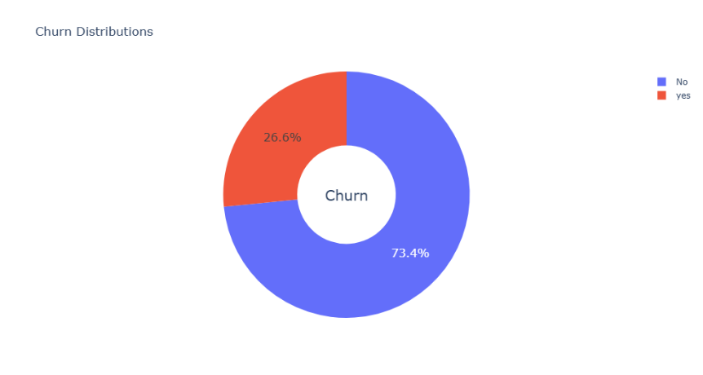
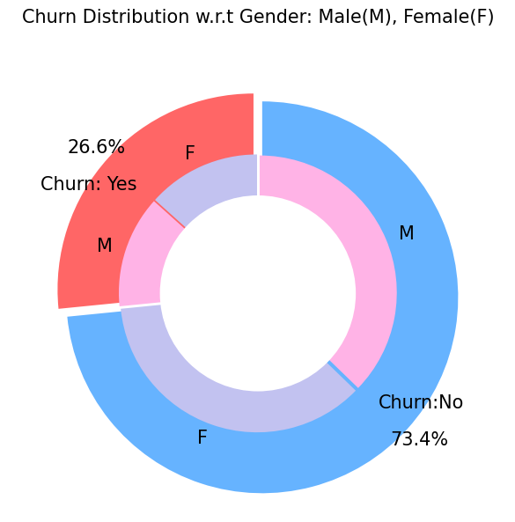
Fig 1: Churn Distribution

Fig 2: Churn Distribution WRT Gender

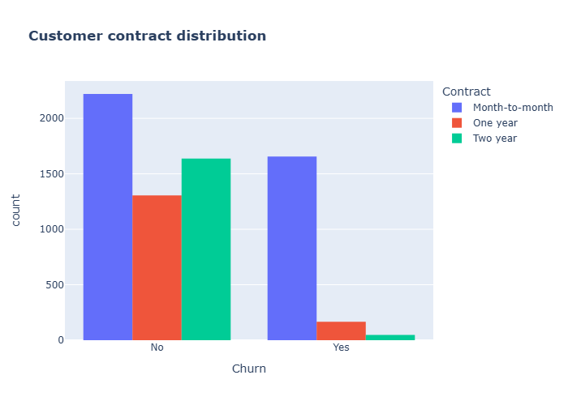

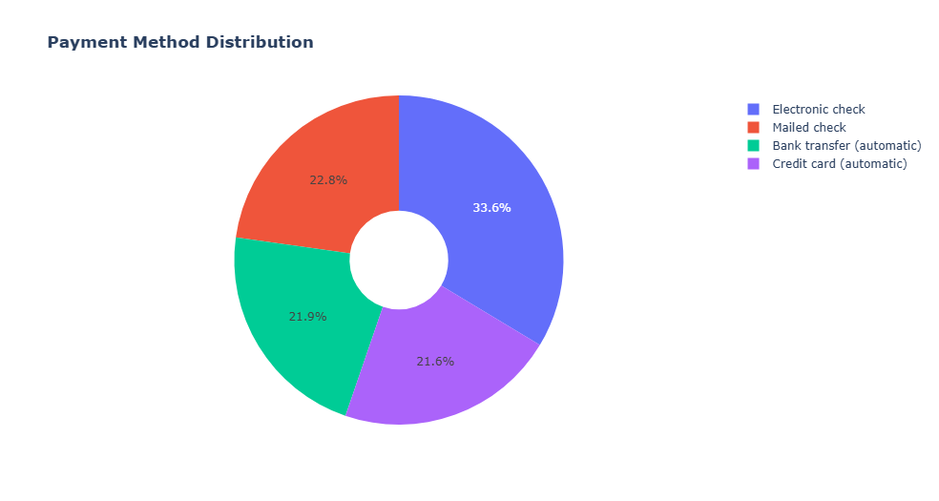
Fig 3: Customer Contract Distribution

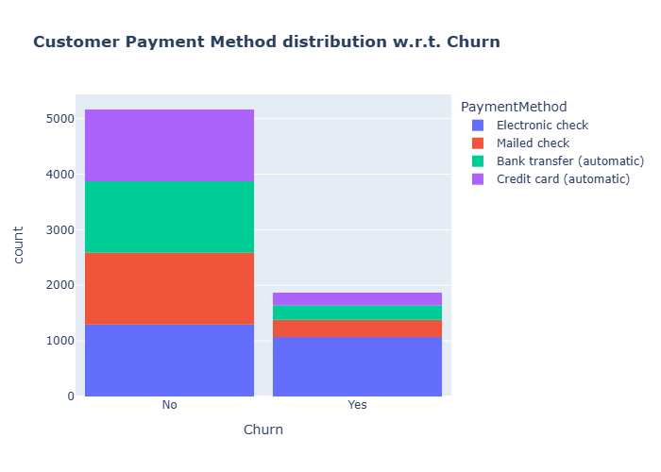
Fig 4: Payment Method Distribution

Fig 5: Customer Payment Method Distribution w.r.t Churn

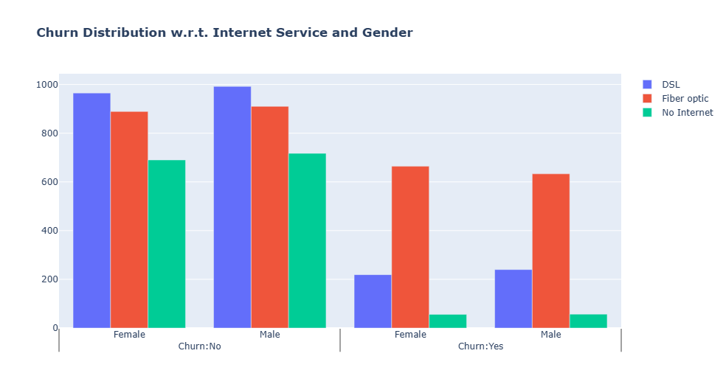

Fig 6: Churn Distribution w.r.t Internet Service & Gender
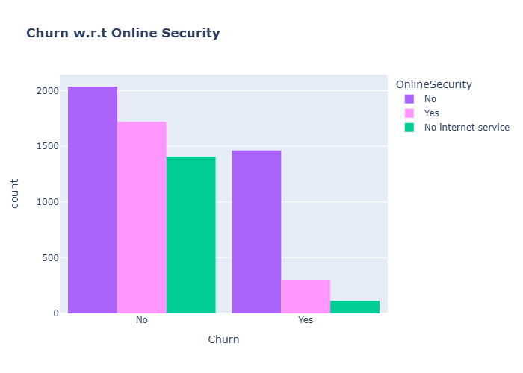

Fig 7: Churn w.r.t Online Security

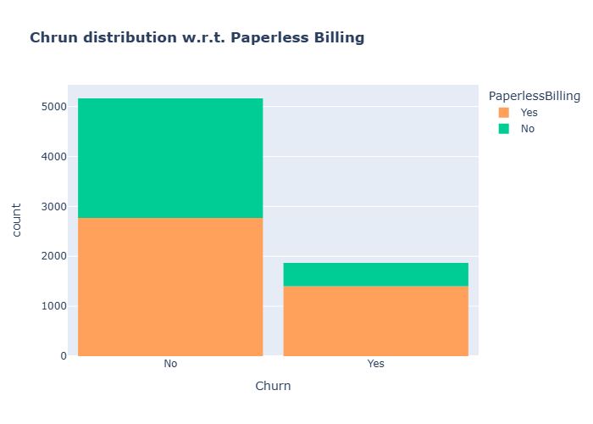

Fig 8: Churn Distribution w.r.t Paperless Billing
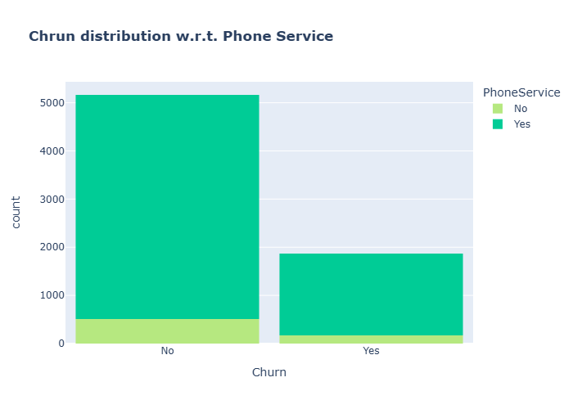

Fig 9: Churn Distribution w.r.t Phone Service

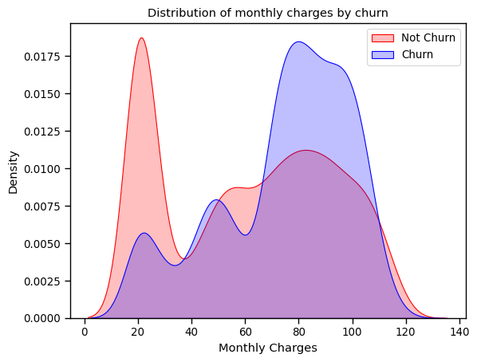

Fig 10: Distribution of Monthly Charges by churn
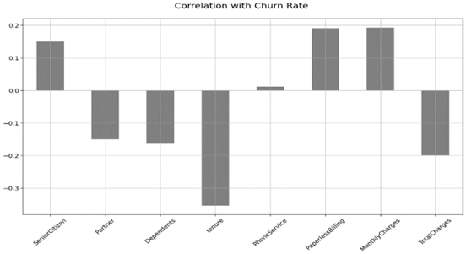
Fig 11: Correlation with Churn Rate

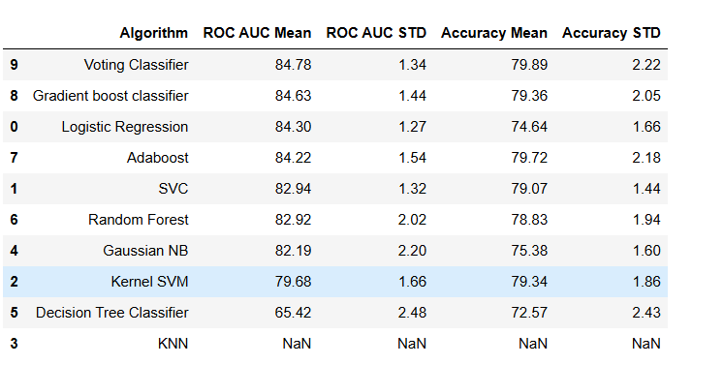

Fig 12: Accuracy
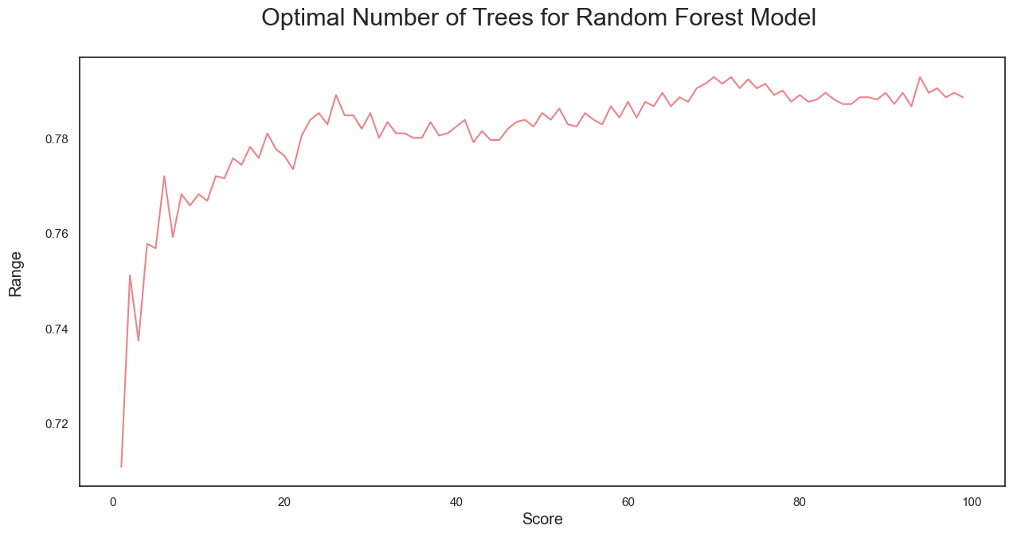

Fig 13: Optimal Number of Trees for Random Forest Model

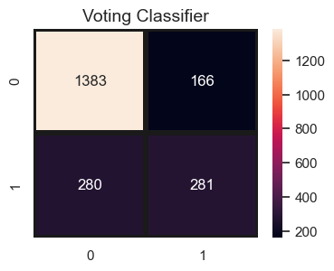

Fig 14: Voting Classifier
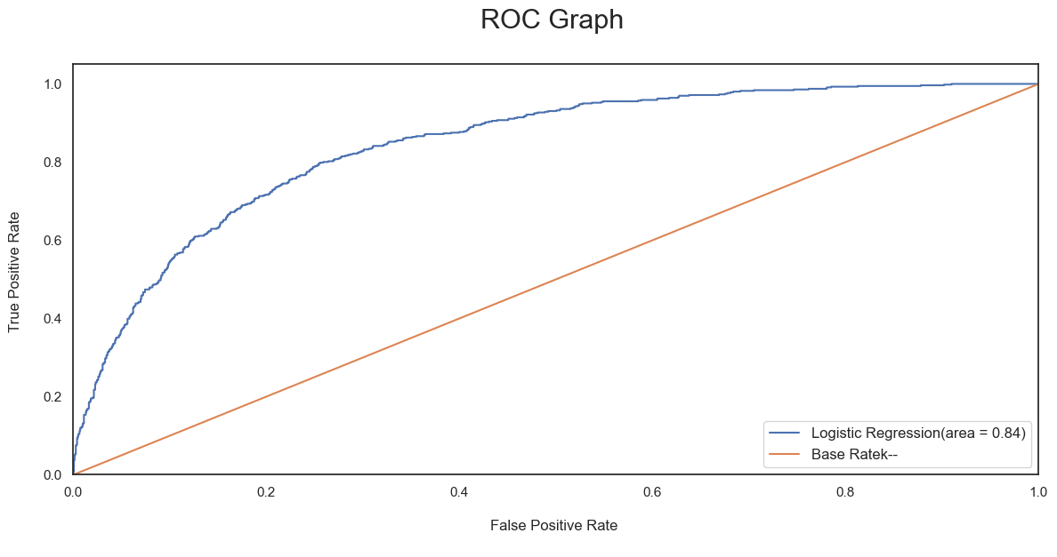
Fig 15: ROC Graphs

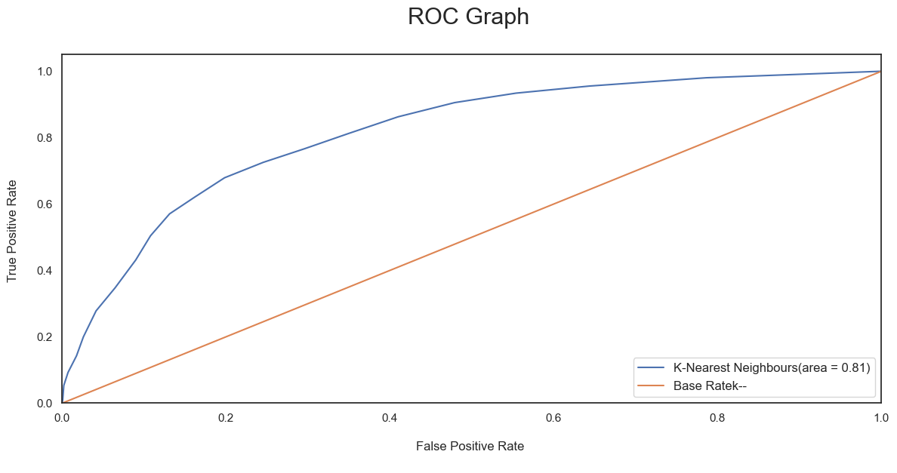

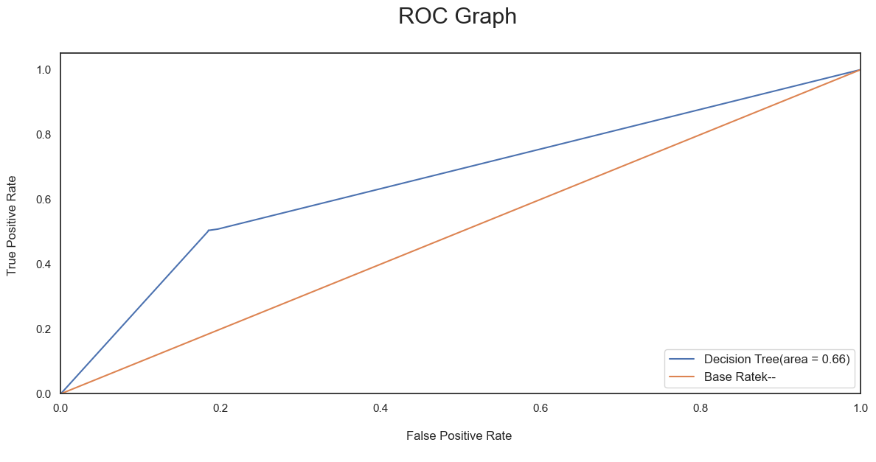

Fig 4: Payment Method Distribution

- CONCLUSION

Conclusion:
In the culmination of this mini project, we have traversed the intricate landscape of customer churn prediction, presenting a robust solution to the pressing challenge faced by industries in retaining their customer base. Our journey, from identifying the problem statement to proposing and implementing a comprehensive solution, has contributed significantly to the field of predictive analytics within the context of customer relationship management.

The initial identification of the problem underscored the urgency and relevance of addressing customer churn, a pervasive issue with profound implications for businesses in competitive markets. The subsequent literature survey not only validated the significance of the problem but also provided a nuanced understanding of existing methodologies and their limitations. Our proposed system emerged as a strategic response, seeking to bridge existing gaps and introduce a more accurate and proactive approach to churn prediction.

The system design phase, characterized by the articulation of system architecture, UML diagrams, and functional requirements, laid a sturdy foundation for subsequent implementation. This phase provided a clear roadmap, ensuring a structured and purposeful development process. The detailed description of modules and the accompanying sample code exemplify the practical application of our proposed solution, showcasing its feasibility and functionality.

The testing phase served as a critical juncture, emphasizing the importance of robust testing methodologies. Various testing types, coupled with a comprehensive set of test cases, not only validated the reliability of the churn prediction model but also identified areas for refinement and improvement. The results obtained from this rigorous testing process not only validated the efficacy of our approach but also provided actionable insights for businesses to make informed decisions and proactively mitigate customer churn.

- REFERENCES

- Ahmad, N., & Iqbal, Z. (2023). Customer churn prediction using machine learning and deep learning techniques: A comparative study. Journal of Big Data, 16(1), 1-22.
(https://link.springer.com/chapter/10.1007/978-3-031-42430-4_28)
- Kumar, A., & Joshi, A. (2022). Customer churn prediction in the e-commerce industry using ensemble learning techniques. International Journal of Machine Learning and Cybernetics, 13(2), 547-560.
(https://www.researchgate.net/publication/352946623_Deep_Learning_for_Customer_Churn_Prediction_in
_E-Commerce_Decision_Support)
- Jain, A., & Vashisht, P. (2022). Customer churn prediction in the telecom industry using hybrid machine learning models. Journal of King Saud University-Computer and Information Sciences, 34(6), 2451-2462. (https://link.springer.com/chapter/10.1007/978-3-030-73603-3_43)
- Liu, Y., Chen, Y., & Zhang, Y. (2021). Customer churn prediction in the banking industry using convolutional neural networks. Applied Soft Computing, 99, 106942. (https://www.researchgate.net/publication/299336397_Predicting_Customer_Churn_in_Banking_Industry_u sing_Neural_Networks)
- Chen, Y., Tang, Y., & Zhou, Y. (2021). Customer churn prediction in the insurance industry using graph convolutional networks. Expert Systems with Applications, 170, 114630.
(https://www.sciencedirect.com/science/article/abs/pii/S0950705122006220)
- Chandola, V., Kumar, A., & Pal, A. K. (2020). Customer churn prediction for e-commerce platforms: A deep learning approach. International Journal of Machine Learning and Cybernetics, 11(2), 447-460. (https://www.researchgate.net/publication/352946623_Deep_Learning_for_Customer_Churn_Prediction_in
_E-Commerce_Decision_Support)
- Feng, Y., & Chen, M. (2020). Customer churn prediction in the retail industry using a hybrid approach of XGBoost and K-means clustering. Expert Systems with Applications, 144, 113173.
(https://link.springer.com/chapter/10.1007/978-3-031-24457-5_3)
- Fayyaz, A., & Zaidi, A. A. (2019). Customer churn prediction in the banking industry using machine learning techniques. International Journal of Intelligent Systems and Applications, 10(4), 27-36.
(https://www.researchgate.net/publication/299336397_Predicting_Customer_Churn_in_Banking_Industry_u sing_Neural_Networks)
- H. Singh, D. Ramya, R. Saravanakumar et al., “Artificial intelligence based quality of transmission predictive model for cognitive optical networks,” Optik, vol. 257, Article ID168789, 2022.

