Coffee_Sales_Overview


Project Objective:
Maintaining a record of the coffees that were sold is a crucial part of boosting sales. The type of coffee, the time of day, the day of the week, and the month are all regarded as important variables and fields in assessing the total sales and deriving useful insights from the data set. This helped manage the menu according to the day, time, and month in order to efficiently increase sales and cut down on waste.

Dataset:
We will be using data that represents coffee sales for this project. The dataset, which has 3547 entries and columns, was obtained from Kaggle. This primarily includes details on the transactions, such as the name of the coffee, the amount of money spent on each transaction, the day, the month, and the time of day.

Metadata Of the Dataset:
hour_of_day:- The hour (0-23) at which the transaction occurred.
Money:- Revenue generated from each individual transaction.
Coffee_Name:- Name/type of the coffee sold (e.g., Latte, Espresso, Cappuccino).
Time_of_Day:- Categorical time period — Morning, Afternoon, Evening, or Night.
Weekday:- Day of the week the transaction occurred (Mon, Tue ... Sun).
Month_name:- Month of the transaction (March, April, May, June, July).
Date:- Full date of the transaction.

Exploratory Data Analysis:
Approach:
For this Project after the preprocessing work was done In Excel and after the data got ready a project setup was made in SQL.
Post the basic setup description and meta data describing the dataset was retrieved before moving into analysis.
In the EDA part the Revenue Generated and Number of Transactions and Average Price per transaction were considered as key parameters.
Based on the Parameters the Descriptive Analysis was carried out in terms of the revenue generated and number of transactions done on basis of Coffee Name, Time of Day, Weekday, Month and Hour of Day.
The Descriptive Analysis was followed by Diagnostic analysis to analyze the root cause of the results.

Project Setup in SQL:

Creating new Database called Coffee_Sales.
Create database Coffee_Sales;
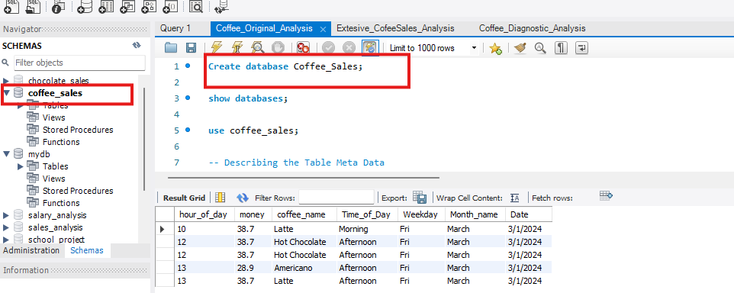

Renaming the table “coffee_original” to “coffee” for ease of use using Rename.

Selecting a sample of 5 rows of Data from the Dataset, using Select Statement to retrieve the data.
Select * from Coffee limit 5;

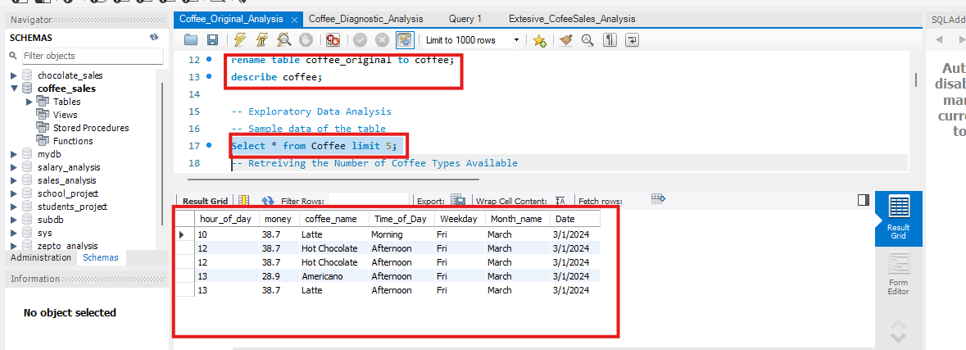

Descriptive Analysis:
Here in descriptive Analysis all the information related to what exactly happened in the sales based on the given data is included.
The Descriptive Analysis includes calculations like mentioned below.
Highest and Lowest Revenue generating Coffee Types, Time of Day, Weekdays, Months and Hours of Day.

****Coffee Type Sales Analysis****
Coffee Type Revenue Analysis
Select coffee_name Name_of_Coffee, round(sum(money),2) Total_Revenue from Coffee group by coffee_name order by sum(money) desc;
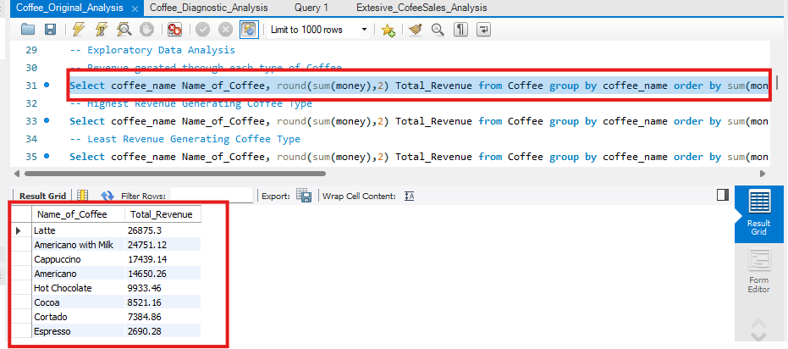
Maximum Revenue Generating Coffee Type.
Select coffee_name Name_of_Coffee, round(sum(money),2) Total_Revenue from Coffee group by coffee_name order by sum(money) desc limit 1;
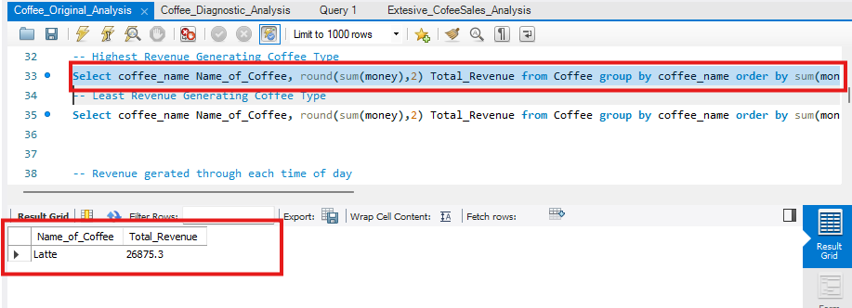
The Maximum Revenue Generating Coffee Type is Latte with a Revenue of 26875.3 units.

Minimum Revenue Generating Coffee Type.
Select coffee_name Name_of_Coffee, round(sum(money),2) Total_Revenue from Coffee group by coffee_name order by sum(money) limit 1;
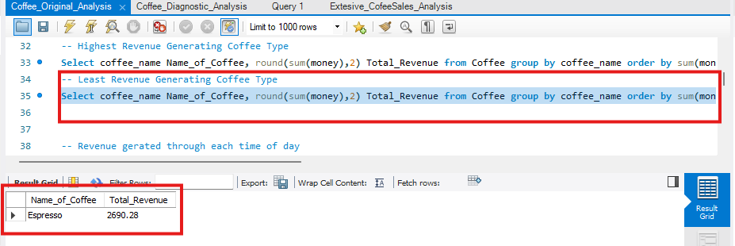
The least Revenue generating Coffee Type is Espresso with 2690.28 units

**Coffee Type Revenue Summary**
***Time of Day Sales Analysis***
Retrieving the Revenue generated at each Time of Day.
Select Time_of_Day, round(sum(money),2) Total_Revenue from Coffee group by Time_of_Day order by sum(money) desc;
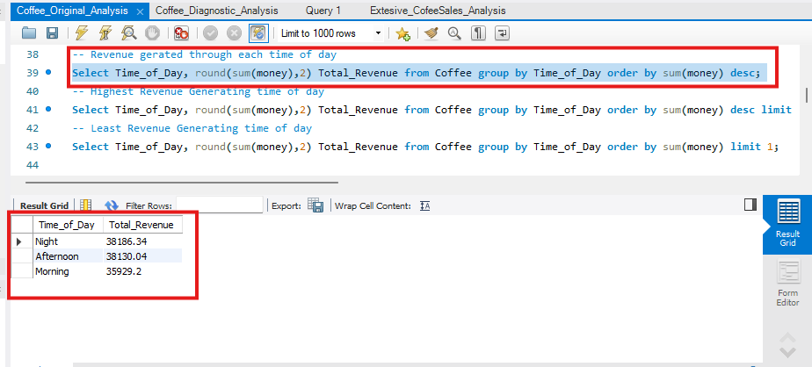
Retrieving the Highest Revenue Generating Time of Day.
Select Time_of_Day, round(sum(money),2) Total_Revenue from Coffee group by Time_of_Day order by sum(money) desc limit 1;
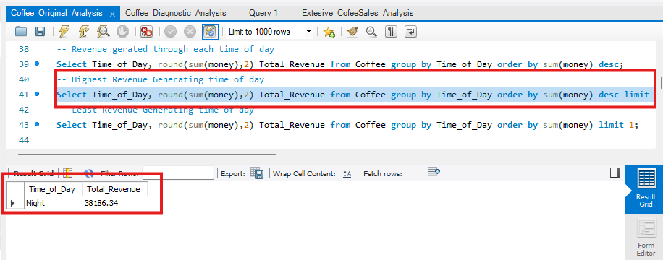
The Highest Revenue Generating Time of Day is Night with a revenue of 38186.34 units.

Retrieving the least revenue generating Time of Day.
Select Time_of_Day, round(sum(money),2) Total_Revenue from Coffee group by Time_of_Day order by sum(money) limit 1;
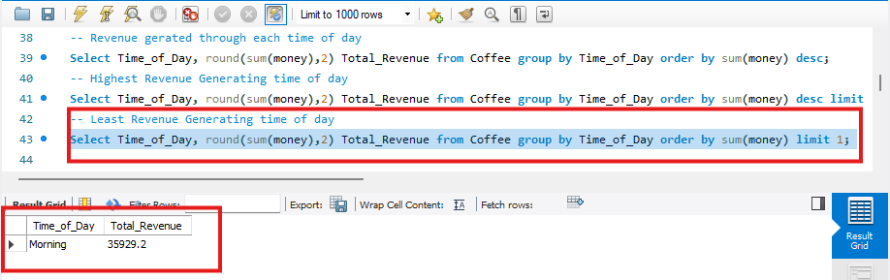
The Least Revenue Generating Time of Day is Morning with a revenue of 35929.2 units.

***Weekday Sales Analysis***
Retrieving the Revenue generated on each Weekday.
Select Weekday, round(sum(money),2) Total_Revenue from Coffee group by Weekday order by round(sum(money),2) desc;
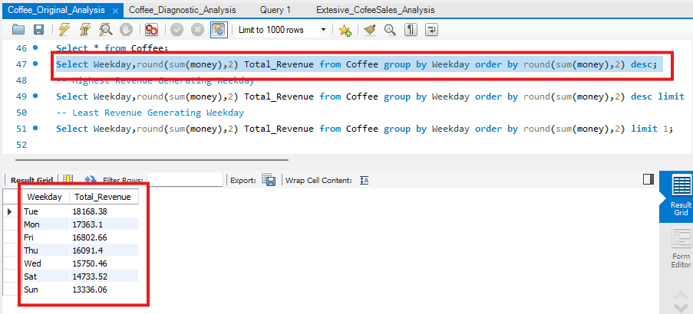
Retrieving the Highest Revenue Generating Weekday.
Select Weekday, round(sum(money),2) Total_Revenue from Coffee group by Weekday order by round(sum(money),2) desc limit 1;
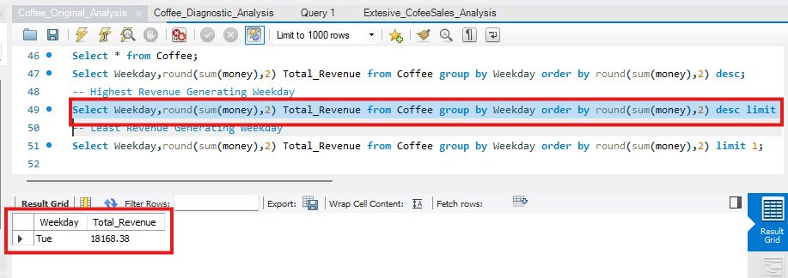
The Highest Revenue Generating Day of the Week is Tuesday with a revenue of 18168.38 units.

Retrieving the Least Revenue Generating Weekday.
Select Weekday, round(sum(money),2) Total_Revenue from Coffee group by Weekday order by round(sum(money),2) limit 1;
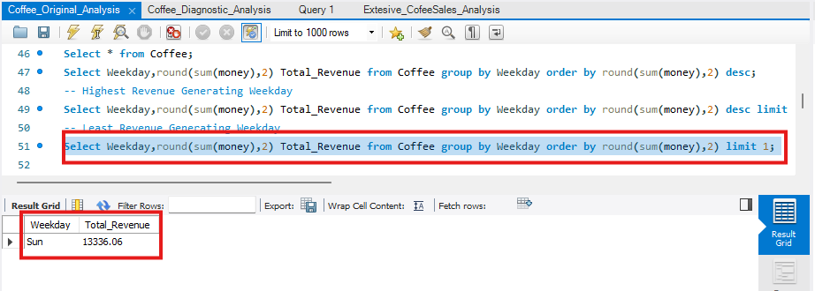
The Least Revenue Generating Day of the Week is Sunday 13336.06.

****Monthly Sales Analysis****
Monthly Revenue Analysis
Select Month_name, round(sum(money),2) Total_Revenue from Coffee group by Month_name order by round(sum(money),2) desc;
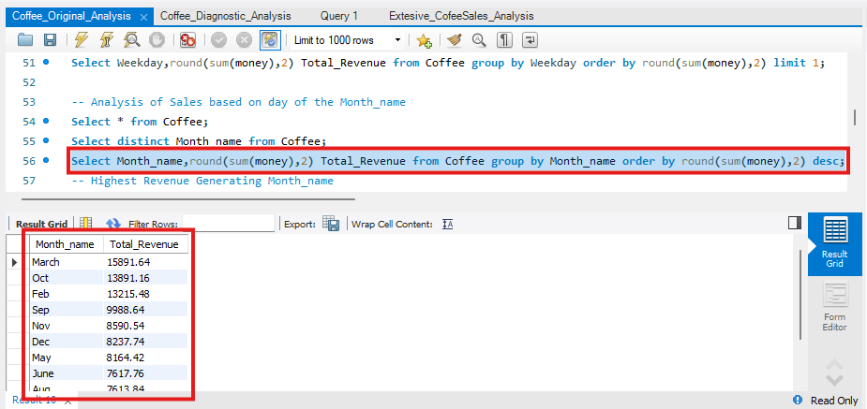
Maximum Revenue Generating Month.
Select Month_name, round(sum(money),2) Total_Revenue from Coffee group by Month_name order by round(sum(money),2) desc limit 1;
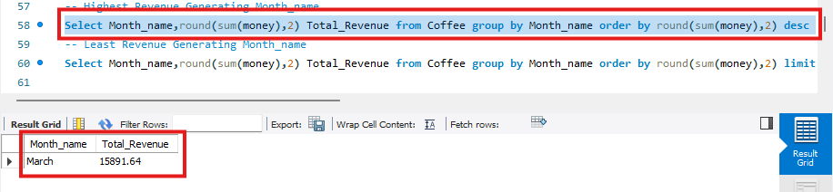
The Maximum Revenue Generating Month is March 15891.64 units.

Minimum Revenue Generating Month.
Select Month_name, round(sum(money),2) Total_Revenue from Coffee group by Month_name order by round(sum(money),2) limit 1;
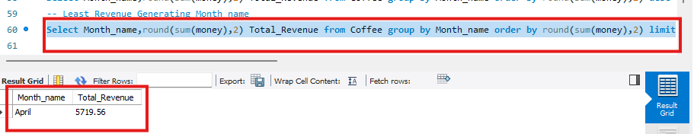
The least Revenue generating Month is April with revenue of 5719.56.

***Hourly Sales Analysis***
Retrieving the Revenue generated at each Hour of the Day.
Select hour_of_day, round(sum(money),2) Total_Revenue from Coffee group by hour_of_day order by round(sum(money),2) desc;
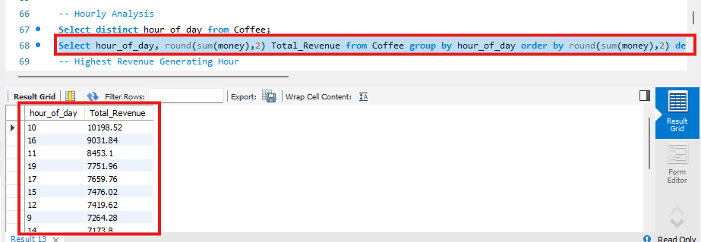
Retrieving the Highest Revenue Generating Hour.
Select hour_of_day, round(sum(money),2) Total_Revenue from Coffee group by hour_of_day order by round(sum(money),2) desc limit 1;
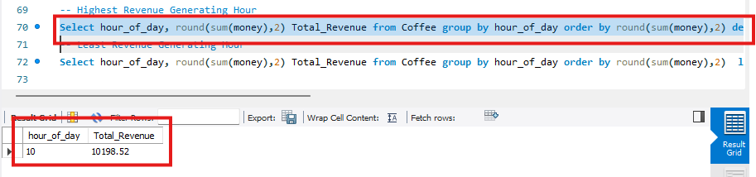
The Highest Revenue Generating Hour of the Day is 10 AM with Revenue of 10198.52 units.

Retrieving the Least Revenue Generating Hour.
Select hour_of_day, round(sum(money),2) Total_Revenue from Coffee group by hour_of_day order by round(sum(money),2) limit 1;
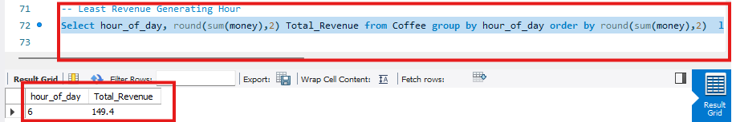
The Least Revenue Generating Hour of the Day is 6 AM with a revenue of 149.4 units.

Descriptive Analysis Summary:
Coffee Type
Highest Revenue Generating Coffee Type Latte.
Lowest Revenue Generating Coffee Type Espresso.
Time of Day
Highest Revenue Generating Time of Day Night.
Least Revenue Generating Time of Day Morning.
Weekday
Highest Revenue Generating Day of the WeekTuesday.
Least Revenue Generating Day of the WeekSunday.
Month Name
Highest Revenue Generating Month March.
Least Revenue Generating Month April.
Hour of the Day
Highest Revenue Generating Hour of the Day 10 AM.
Least Revenue Generating Hour of the Day 6 AM.

***Diagnostic Analysis***
It was the process of analyzing root cause and answering how exactly the things happened.

**Key Parameters in Analyzing the Root Cause**
Volume of Sales (Number of Transactions).
Average Price per Transaction (Total Revenue / Number of Transactions).
The Product of Average Price per Transaction with the total Number of Transactions.

In this section we try to figure out the root cause of each of the results that were retrieved as part of Descriptive analysis.
This part of diagnostic analysis includes answers for following questions like.
Why is Latte the highest revenue generating coffee type while Espresso is the least.
Why is Night the highest revenue generating time of day while Morning is the least.
Why is Tuesday the highest revenue generating weekday while Sunday is the least.
Why is March the highest revenue generating month while April is the least.
Why is 10 AM the highest revenue generating hour while 6 AM is the least.

Q1) Why is Latte the Most Revenue Generating Coffee Type and Espresso the least?
Based on Number of Units Sold Latte-757 units. -- Espresso – 129 Units.
Select coffee_name, count(coffee_name) units_sold from Coffee group by coffee_name order by count(coffee_name) desc;
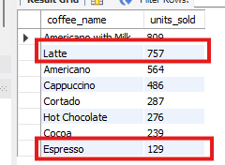

Based on Average Price – Latte--35.5 units - - Espresso – 20.85
Select coffee_name, round(sum(money)/count(coffee_name),2) avg_price from Coffee group by coffee_name order by round(sum(money)/count(coffee_name),2) desc;
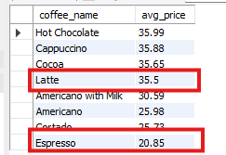
Based on the Product of Number of Units sold with Average Price Latte-26873.5 units—Espresso-2689.65 units.

Select coffee_name, count(coffee_name) units_sold, round(sum(money)/count(coffee_name),2) avg_price, round(count(coffee_name)*round(sum(money)/count(coffee_name),2),2) Avgprice_Unitssold_Product from Coffee group by coffee_name order by round(count(coffee_name)*round(sum(money)/count(coffee_name),2),2) desc;

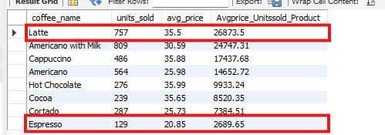
Based on Units Sold, Average Price and Product of Units Sold and Average price, Latte is the highest and Espresso is the least.

Q2) Why is Night the Most Revenue Generating Time of Day and Morning the least?
Based on Number of Units Sold Morning – 1181 – Night --1161
Select Time_of_Day, count(coffee_name) units_sold from Coffee group by Time_of_Day order by count(coffee_name) desc;
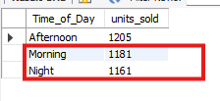
Based on Average Price Night – 32.89 -- Morning – 30.42
Select Time_of_Day, round(sum(money),2) Total_Revenue, count(Time_of_Day) no_of_Transactions, round(sum(money)/count(Time_of_Day),2) Avg_Price from Coffee group by Time_of_Day order by round(sum(money)/count(Time_of_Day),2) desc;
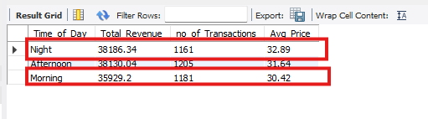
Based on the Product of Number of Units sold with Average Price.
Night – 38186.34 – Morning – 35929.2
Select Time_of_Day, round(sum(money),2) Total_Revenue, count(Time_of_Day) no_of_Transactions, round(sum(money)/count(Time_of_Day),2) Avg_Price, round(count(Time_of_Day)*(sum(money)/count(Time_of_Day)),2) Avgprice_Unitssold_Product from Coffee group by Time_of_Day order by round(count(Time_of_Day)*(sum(money)/count(Time_of_Day)),2) desc;
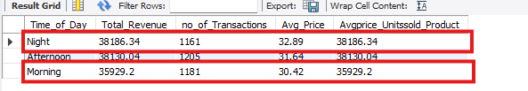
Even though the number of units sold for Night are slightly less than Afternoon, Night has the highest average price. The product of number of units sold and average price is greater for Night making it the highest revenue generating time of the day.

Q3) Why is Tuesday the highest revenue generating Weekday while Sunday is the least revenue generating?

Number of Transactions Tuesday – 572 Highest – Sunday – 419 Least
Select Weekday, count(Weekday) from Coffee group by Weekday order by count(Weekday) desc;
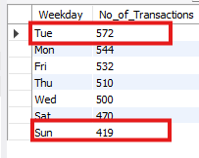
Tuesday has the highest number of transactions compared to other days.

The Average Price – Tuesday—31.76 -- Sunday—31.83
Select Weekday, count(Weekday), round(sum(money)/count(Weekday),2) Avg_Price_Transaction from Coffee group by Weekday order by round(sum(money)/count(Weekday),2) desc;
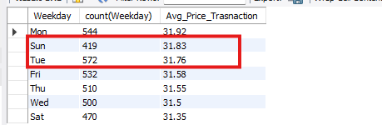
The number of transactions and the average price per transaction for Tuesday are highest compared to others.
Select Weekday, count(Weekday), round(sum(money)/count(Weekday),2) Avg_Price_Transaction, round((sum(money)/count(Weekday))*count(Weekday),2) Avgprice_Unit_Product from Coffee group by Weekday order by round((sum(money)/count(Weekday))*count(Weekday),2) desc;
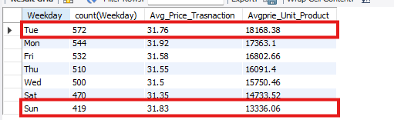
The Number of transactions for Tuesday is Highest whereas for Sunday it was least.
The Product of Average Price per transaction and total number of transactions for Tuesday is high and for Sunday it was low.
Even though Sunday has the Second highest Average Price per Transaction the Revenue is least because the number of units that were sold are very low compared to other weekdays.

Q4) Why is March the highest revenue generating Month and April is the lowest revenue generating Month.

Number of Transactions – March--494 transactions – April--168 transactions
Select Month_name, count(Month_name) from Coffee group by Month_name order by count(Month_name) desc;
The number of transactions for March is highest with 494 transactions.
The number of transactions for April is least with 168 transactions.
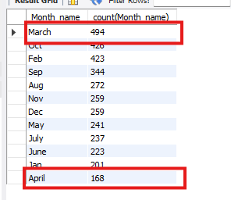
Average Price Per Transaction for Each Month March--32.17 -- April 34.05.
Select Month_name, count(Month_name), round(sum(money)/count(Month_name),2) Avg_Price_Transaction from Coffee group by Month_name order by round(sum(money)/count(Month_name),2) desc;
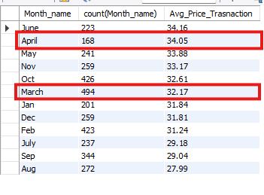

Product of Average Price Per Transaction and Number of Transactions
March -- 15891.64 April -- 5719.56
Select Month_name, count(Month_name), round(sum(money)/count(Month_name),2) Avg_Price_Transaction, round((sum(money)/count(Month_name))*count(Month_name),2) Avgprice_Unit_Product from Coffee group by Month_name order by round((sum(money)/count(Month_name))*count(Month_name),2) desc;
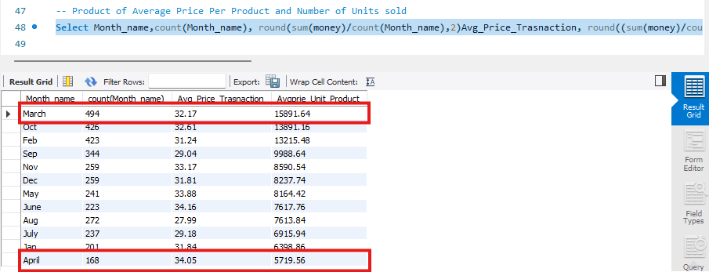
Even though the Average Price of Transaction for April is high compared to March, April(34.05) > March(32.17), There was a huge difference in the volume of Sales March(494) >> April(168).
All the Above factors contribute to making March as Highest revenue generating month making April the lowest revenue generating month.

Q5) Why is 10 AM the highest revenue generating Hour and 6 AM is the lowest revenue generating Hour.

Number of Transactions 10 AM -- 31.09 -- 6 AM -- 29.88

Select hour_of_day, count(hour_of_day) No_of_Transactions from Coffee group by hour_of_day order by count(hour_of_day) desc;
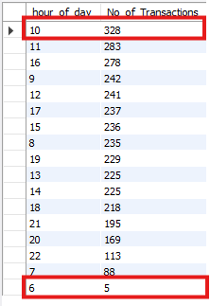
The number of transactions for 10 AM is highest with 328 transactions.
The number of transactions for 6 AM is least with 5 transactions.

Average Price Per Transaction for Each Hour of Day – 10 – 31.09 – 6 – 29.88
Select hour_of_day, count(hour_of_day) No_of_Transactions, round(sum(money)/count(hour_of_day),2) Avg_Price_Transaction from Coffee group by hour_of_day order by round(sum(money)/count(hour_of_day),2) desc;
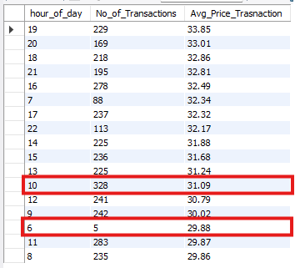

Product of Average Price Per Transaction and Number of Transactions
10 AM -- 10198.52
6 AM -- 149.40

Select hour_of_day, count(hour_of_day), round(sum(money)/count(hour_of_day),2) Avg_Price_Transaction, round((sum(money)/count(hour_of_day))*count(hour_of_day),2) Avgprice_Unit_Product from Coffee group by hour_of_day order by round((sum(money)/count(hour_of_day))*count(hour_of_day),2) desc;
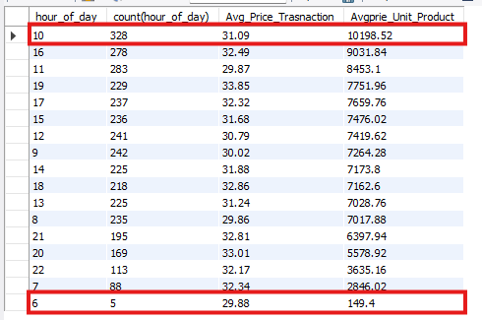
Even though the Average Price of Transaction for 10 AM(31.09) is not the highest, there was a huge difference in the volume of Sales 10 AM(328) >> 6 AM(5).
All the Above factors contribute to making 10 AM as Highest revenue generating hour of the day making 6 AM the lowest revenue generating hour of the day.

Summary of Diagnostic Analysis:
Latte is the highest revenue generating coffee type due to the highest number of units sold and competitive average price making the product of units sold and average price the greatest among all coffee types. Espresso being the smallest drink has the least units sold and lowest average price making it the least revenue generating.

Even though the number of units sold for Night are slightly less than Afternoon, Night has the highest average price per transaction. The product of number of units sold and average price is greatest for Night making it the highest revenue generating time of the day. Morning has both the lowest volume and lowest average price making it the least revenue generating.

Tuesday has the highest number of transactions AND the highest average price per transaction, making its revenue product the largest among all weekdays. Sunday, while having the second highest average price per transaction, has the fewest transactions overall resulting in the lowest total revenue.

The number of transactions for March is highest with 494 transactions compared to April which has only 168 transactions. Even though the Average Price of Transaction for April(34.05) is slightly higher than March(32.17), the huge difference in volume of sales March(494) >> April(168). March -- 15891.64 and April -- 5719.56. All the above factors contribute to making March the highest and April the lowest revenue generating month.

10 AM has the highest number of transactions with 328 compared to 6 AM which has only 5 transactions. The product of Average Price per transaction with number of transactions is 10 AM -- 10198.52 and 6 AM -- 149.40 which was the least. All the Above factors contribute to making 10 AM as Highest revenue generating hour and 6 AM as the lowest revenue generating hour of the day.

***Recommendations***
In the Month of April the Sales are getting dropped because as the April Month will be getting hot and the Demand of Hot Coffee will get dropped, So we have to focus more on cold coffee kind of drinks and bringing variants in Iced teas, Iced Coffees or find a scope to induce new drinks like lemonade that was best fit for Summer.

As Espresso is generating the least revenue it was good to give Espresso as a drink sample as complimentary to valuable customers.

As we observe Morning is the time where the revenue was least in order to boost the sales, So we can go for a kind of quick grab variants acting as an easy grab products that are like quick and handy shots of caffeine in a pocket friendly price, this move targets the customers who were susceptible to price as we live in a price sensitive market, targeting middle and lower middle class consumers and bringing the coffee in an affordable price might help them.

Sunday shows lower transaction volume but relatively higher average spend, indicating a shift toward leisure-oriented consumption. To capitalize on this, the business can position Sundays as an experience-driven day by introducing value-based combo offerings, expanding snack and dessert options, and piloting family-oriented products such as ice cream. These initiatives can help increase footfall while maintaining premium pricing.

