Chocolate_Sales_Overview:
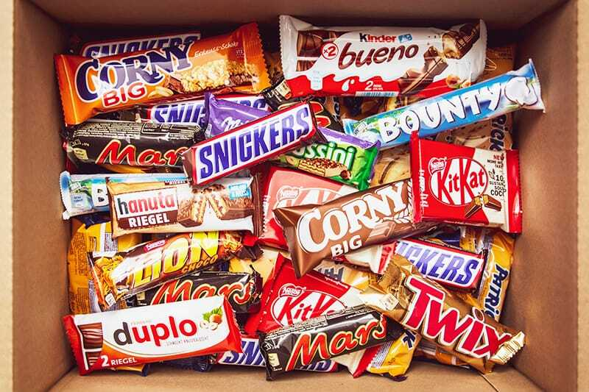

Project Objective:
A key component of increasing sales is keeping up a supply chain of chocolates with a range of brands suitable for every occasion. To monitor the supply chain management that was being circulated across several countries and to manage the stock at the inventories, it is imperative to analyze every single dynamic of the data generated as part of the sales.
An analysis that condenses the KPIs from the generated data shows a profound impact on enhancing product distribution to boost the sales.

Dataset:
For this Project we will be working with a data representing the Chocolate Sales . The dataset was derived from Kaggle consisting of 9 Columns and 500 records.
That mainly contains information of the transactions, involving the details of Brand, Product type, Unit Price, Total units sold, Country and Date of the transaction and Revenue generated for each of the transaction. Additionally containing the information of Sales Channel and Methods of payment for each of the transactions.

Metadata Of the Dataset:
Sales_Id:- Id of the Sale All 500 Unique values
Date Date of the transaction/Sale happened
Brand Brand Name of the Chocolate that was sealed.
Product Type Type of the Chocolate.
CountryCountry in which the transaction happened.
Sales Channel:- Through which platform the sales happened.
Payment Method:- Method of payment(Cash,Card,Digital Wallet).
Price_USD:- Price of each unit in US Dollars.
Units_Sold:- How many of the units each sold.
Revenue_USD:_ Revenue generated in US Dollars Units_Sold*Price_USD.

Project Approach and EDA:
The Data set was taken from Kaggle.
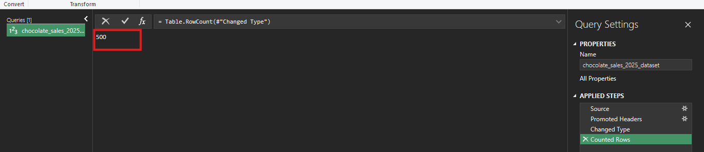

Exploratory Data Analysis:
Approach:
For this Project after the preprocessing work that was done In Excel and after the data got ready a project setup was made in SQL.
Post the basic setup description and meta data describing the dataset was retrieve before moving into analysis.
In the EDA part the Revenue Generated and Number of Units Sold and Average Price per unit were considered as key parameters.
Based on the Parameters the Descriptive Analysis in terms of the Brand, Product Type, Country and Month of Sales were retrieved.
The Descriptive Analysis was followed by Diagnostic analysis to analyze the root cause of the results.

Project Setup in SQL:
Creating new Database called Chocolate_Sales.
Create database Chocolate_Sales;
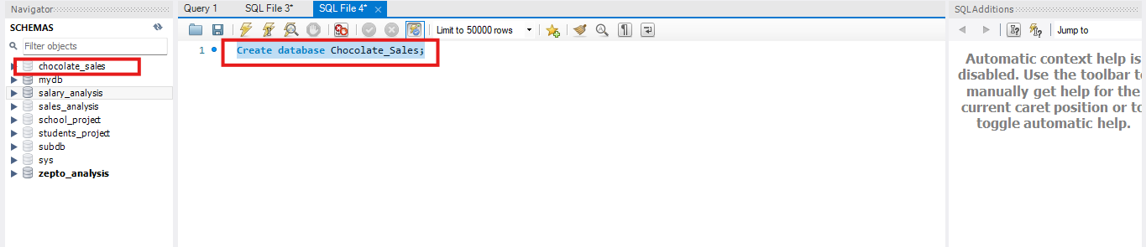

Importing the Chocolate Sales Data using the Data import Wizard Option. 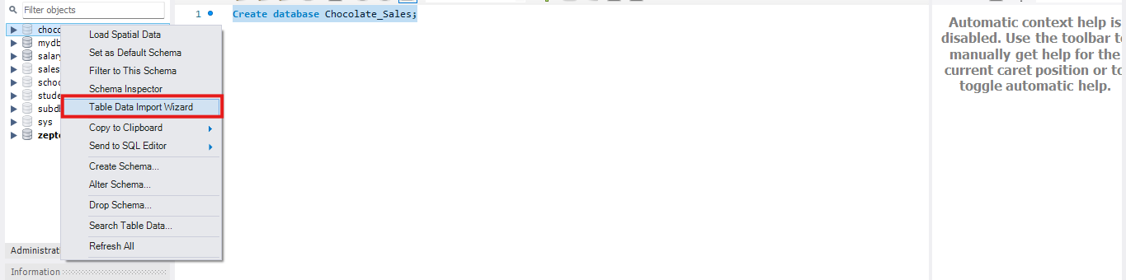

Using the Database Chocolate_Sales that was created to start the analysis.
use Chocolate_Sales;

Getting an Overview of the Table Columns and the Datatypes of Each Column using the Command Describe table_name.
Describe chocolate_sales_2025_dataset;

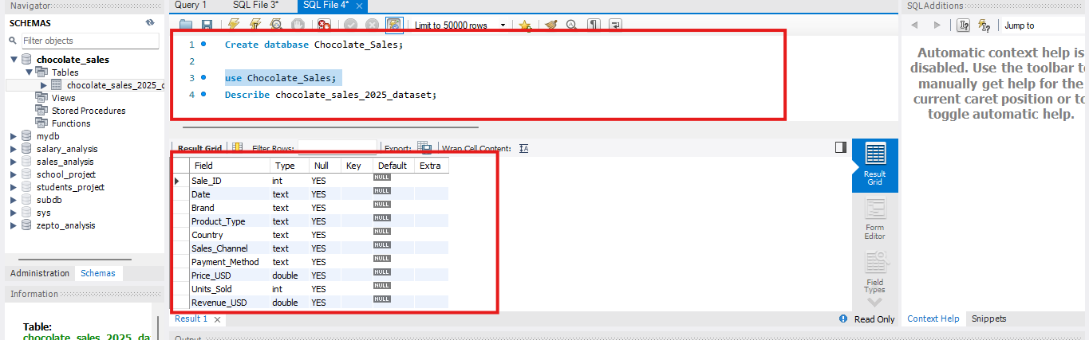

Renaming the table “chocolate_sales_2025_dataset” to “Choco” for ease of use using Rename.

Selecting a sample of 5 rows of Data from the Dataset, using Select Statement to retrieve the data.

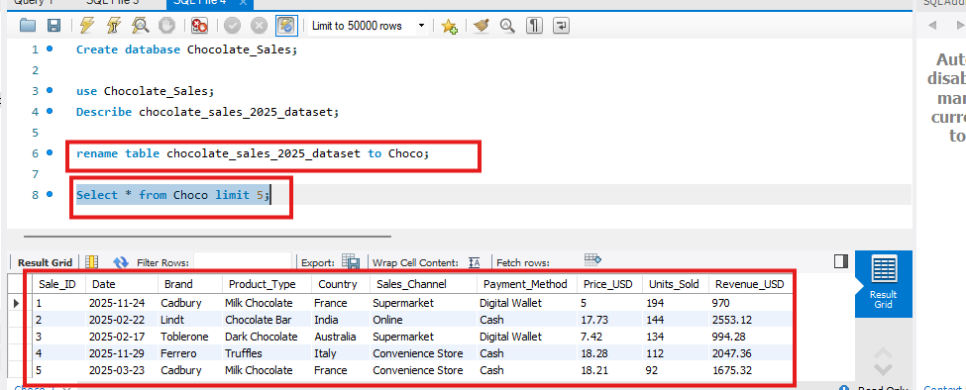

Descriptive Analysis:
Here in descriptive Analysis all the information related to what exactly happened in the sales based on the given data included.
The Descriptive Analysis includes calculations like mentioned below.
Highest and Lowest Revenue generating Brands, Product Types, Months, Countries.

****Monthly Sales Analysis****
Mothly Revenue Analysis
Select Monthname(Date) Monthname, round(sum(Revenue_USD),2) Revenue from Choco group by Monthname order by Revenue DESC;
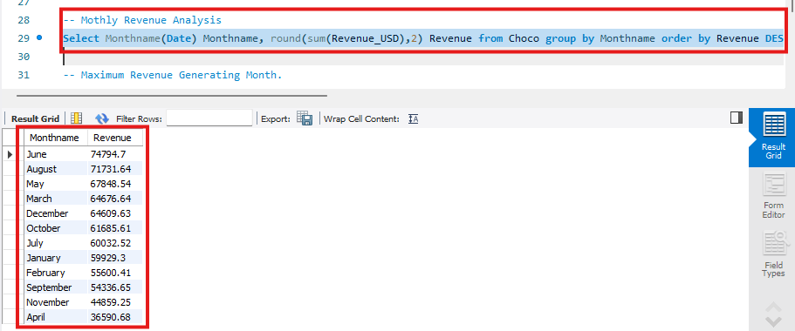

Maximum Revenue Generating Month.
Select Monthname(Date) Monthname, round(sum(Revenue_USD),2) Revenue from Choco group by Monthname order by Revenue DESC limit 1;
The Maximum Revenue Generating Month is June.
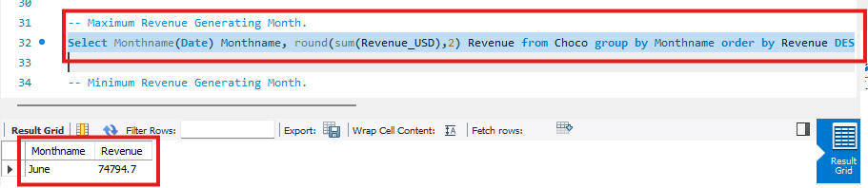

Minimum Revenue Generating Month.
Select Monthname(Date) Monthname, round(sum(Revenue_USD),2) Revenue from Choco group by Monthname order by Revenue limit 1;
The least Revenue generating month is April.
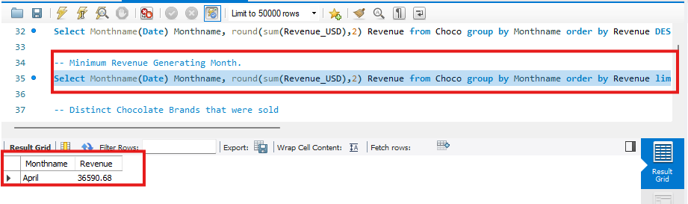

**Monthly Sales Timeline**

***Country Wise Sales Analysis***

Retrieving the Revenue generated at each Country.

Select Country, round(Sum(Revenue_USD),2) Total_Revenue from Choco group by Country order by Total_Revenue DESC;
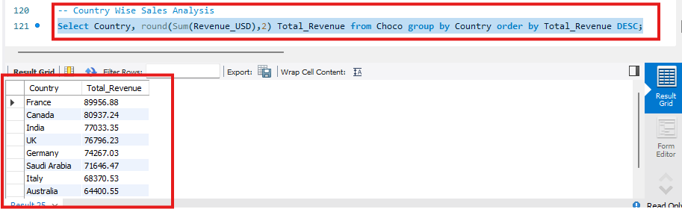

Retrieving the Highest Revenue Generating Country.
Select Country, round(Sum(Revenue_USD),2) Total_Revenue from Choco group by Country order by Total_Revenue DESC limit 1;

The Highest Revenue Generating Country is France with a Revenue of 89956.88 Dollars. 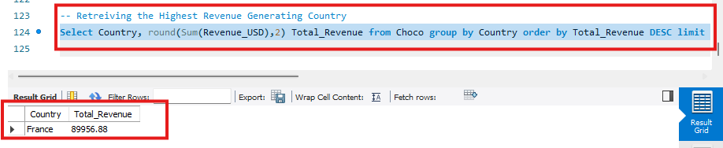

Retreiving the least revenue generating Country
Select Country, round(Sum(Revenue_USD),2) Total_Revenue from Choco group by Country order by Total_Revenue limit 1;

The Least Revenue Generating Country is USA with sales of 54082.88 Dollars. 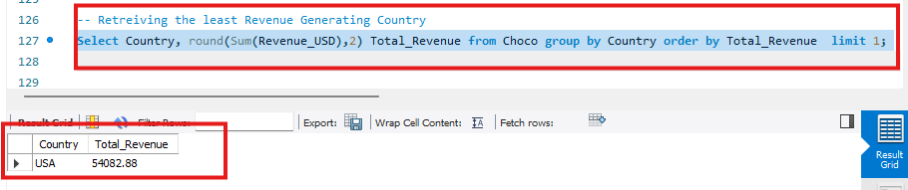
Country Wise Sales Summary.

**Countrywise Units Sold Analysis**

Country Wise Units Sold Analysis
Select Country, Sum(Units_Sold) Total_Units_Sold from Choco group by Country order by Total_Units_Sold DESC;
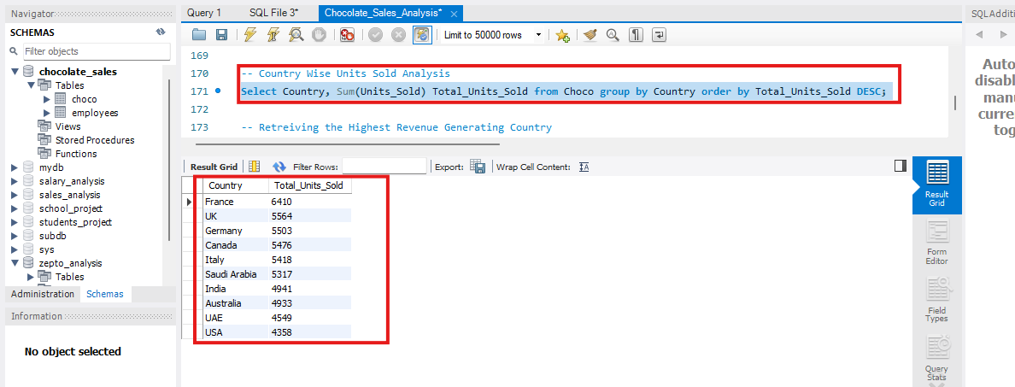

Retreiving the Maximum Units Country
Select Country, Sum(Units_Sold) Total_Units_Sold from Choco group by Country order by Total_Units_Sold DESC limit 1;
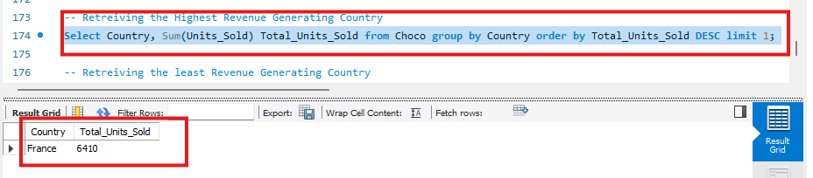

Retreiving the Minimum Units Sold Country
Select Country, Sum(Units_Sold) Total_Units_Sold from Choco group by Country order by Total_Units_Sold limit 1;
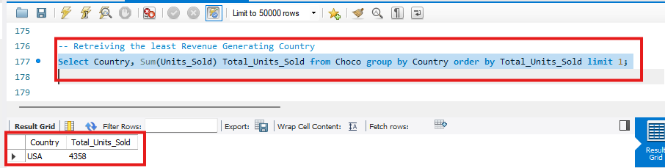

***Performance of each Brand of Chocolates****
1)Total Number of Distinct brands that were Selling Chocolates.(Using Count Keyword).
Select count(distinct Brand) from Choco;
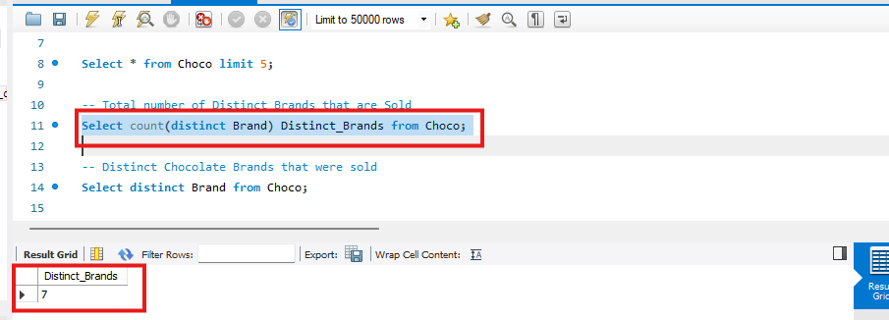

2)List of Distinct Brands that were Selling the Chocolates (Using Distinct Keyword).
Select distinct Brand from Choco;
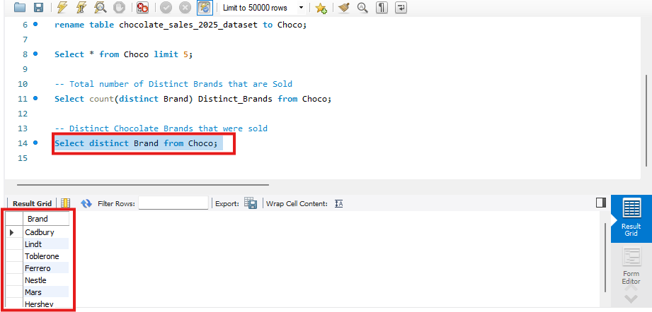

****List of Distinct Products that were sold****
Select distinct Product Type from Choco;

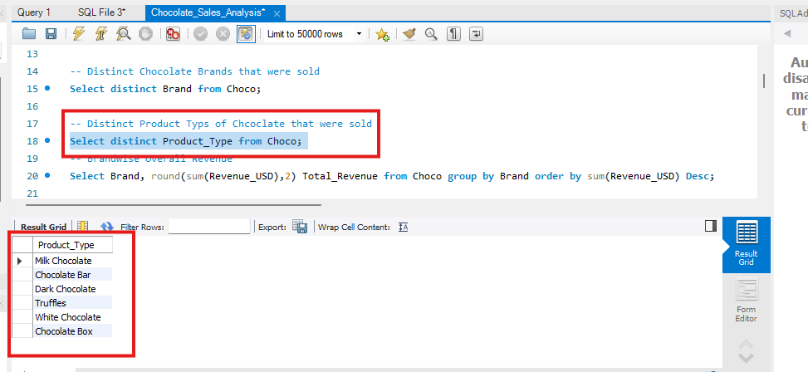

3)Retrieving the Total Revenue generated by each brand and ranking them from high to low (Using Group by and aggregate function Sum and order by to order the records according to revenue). Rounding the revenue to 2 digits.

Select Brand, round(sum(Revenue_USD),2) Total_Revenue from Choco group by Brand order by sum(Revenue_USD) Desc;
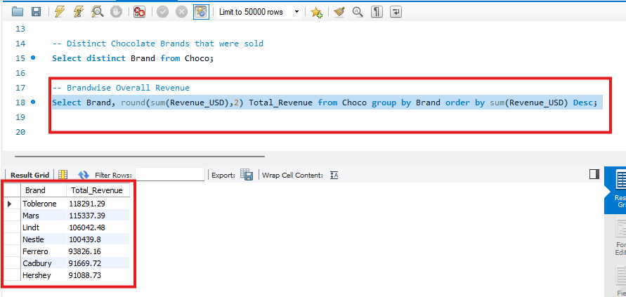

***Brand Wise Sales***
4)Retrieving the Brand that made the highest revenue. (Using Group by and aggregate function Sum and order by clause and limit).

Select Brand, round(Sum(Revenue_USD),2) Total_Revenue from Choco group by Brand order by Total_Revenue Desc limit 1;
The Brand with Highest Revenue is Toblerone with revenue of Dollars 118291.29

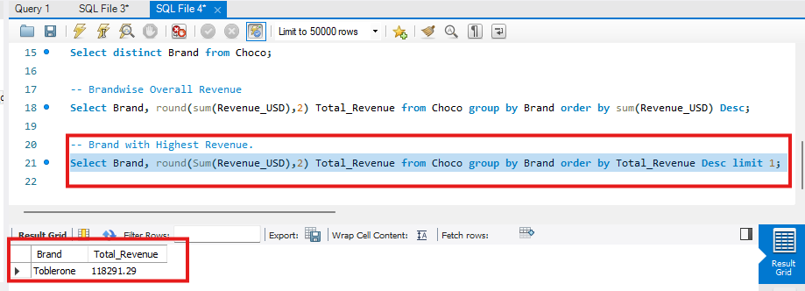

5)Retrieving the Brand that made the lowest revenue. (Using Group by and aggregate function Sum and order by clause and limit).

Select Brand,round(sum(Revenue_USD),2) Total_Revenue from Choco group by Brand order by Total_Revenue ASC limit 1;

The Brand with Lowest Revenue is Hershey total revenue in Dollars $91088.73

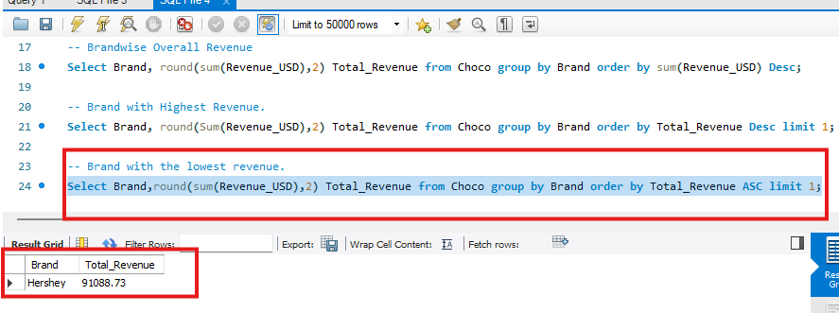

Brand wise Revenue Summary.

***Product wise Sales Performance***
6)Retrieving the Sum of Sales for each Product Type and Ordering them based on Total Revenue.
Select Product_Type, round(sum(Revenue_USD),2) Total_Revenue from Choco group by Product_Type order by Total_Revenue desc;

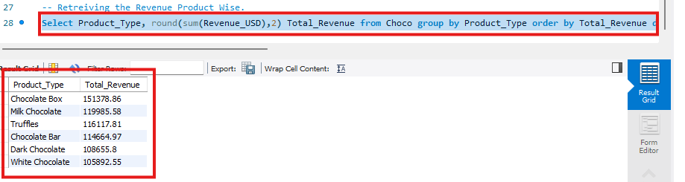

7)Retrieving the Product Type with Maximum Revenue
Select Product_Type,round(sum(Revenue_USD),2) Total_Revenue from Choco group by Product_Type order by Total_Revenue desc limit 1;

Chcolate Box is the Prodcut that made the maximum Revenue with over 151378.86
Dollars.

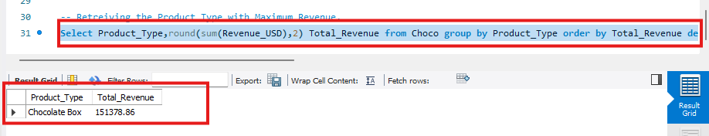

8)Retrieving the Product Type with Least Revenue
Select Product_Type,round(sum(Revenue_USD),2) Total_Revenue from Choco group by Product_Type order by Total_Revenue asc limit 1;

White Chocolate is the Product that made the least Revenue of 105892.55
Dollars.
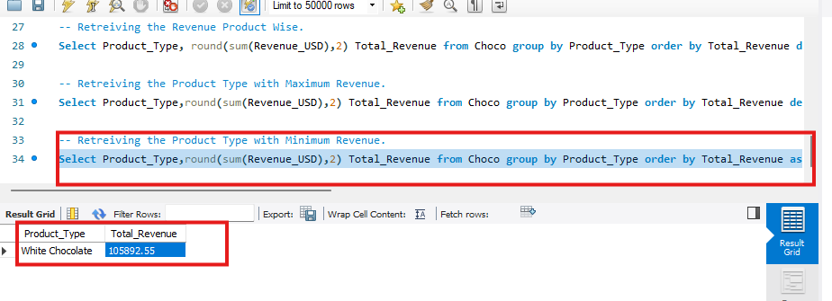

Product Type Sales Summary.

***Product Type Wise units Sales Analysis***
Retreiving the Product Type and number of units Sold
Select Product_Type,sum(Units_Sold) Units_Sold from Choco group by Product_Type order by Units_Sold desc;
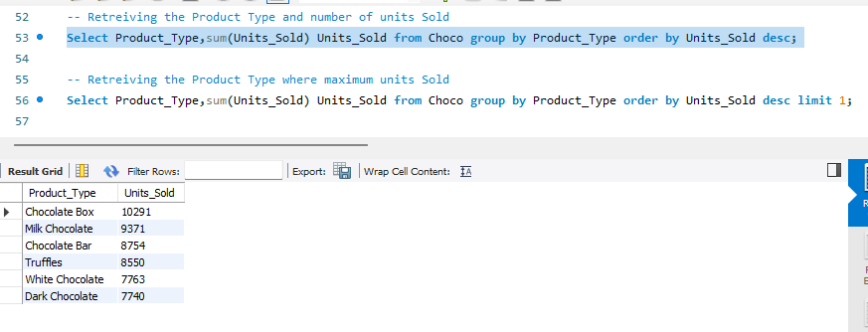

Retreiving the Product Type where maximum units Sold
Select Product_Type,sum(Units_Sold) Units_Sold from Choco group by Product_Type order by Units_Sold desc limit 1;
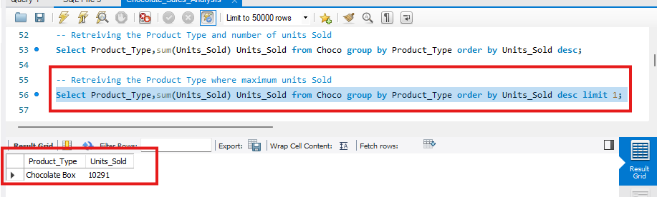

Retrieving the Product Type where minimum units Sold
Select Product_Type,sum(Units_Sold) Units_Sold from Choco group by Product_Type order by Units_Sold limit 1;
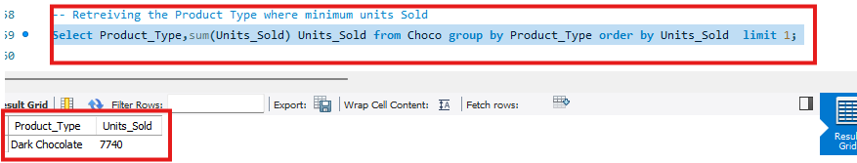
Product Wise Units Sales.

Descriptive Analysis Summary:
The highest Revenue Generating Country is France with a Sales of $89956.88.
The lowest Revenue Generating Country is USA with a Sales of $54082.88.
The Country where most of the chocolate units are sold is France with about 6410 units being sold.
The Country where least of the chocolate units are sold is USA with about 4358 units being sold.
The highest revenue generating month is June with a revenue of $74794.7
The least revenue generating month is April with a revenue of $36590.68
The Highest revenue generating brand is Toblerone with a revenue of $118291.29
The least revenue generating brand is Hershey with a revenue of $91088.73
The Highest revenue generating product type is Chocolate Box with a revenue of $151378.55
The least revenue generating product type is White Chocolate with a revenue of $105892.55
The product type with most number of units sold is Chocolate Box with 10291 units being sold.
The product type with least number of units sold is Dark Chocolate with 7740 units being sold.

***Diagnostic Analysis***
Diagnostic Analysis:- It was the process of analyzing root cause and answering how exactly the things happened.

**Key Parameters in Analyzing the Root Cause**
Volume of Sales(Number of Units Sold).
Number of Transactions done.
Average Price of Product (Total Revenue/Number of units sold)
The Product of Average price of a product with the total units sold.

In this section we try to figure out the root cause of each of the results that were retrieved as part of Descriptive analysis.
This part of diagnostic analysis includes answers for following questions like.
Why did the sales dropped in the month of April.
Why are the sales high in the month of June.
Why France is highest revenue generating country whereas USA is the lowest.

Q1)Why is revenue drop in the month of April?
The Number of Transactions in the month of April are very low compared to the remaining months, the sales/transactions are about 28.
The total number of units sold in the month of April were very low compared to all the other months a total of 2719 units sold.

Reason 1:- The Number of Sales/Transacitons Commenced on the month of April are very low.
April was having only 28 sales transactions.
Select monthname(Date) Month,count(Sale_ID) No_of_Sales from Choco group by monthname(Date) order by count(Sale_ID) desc;
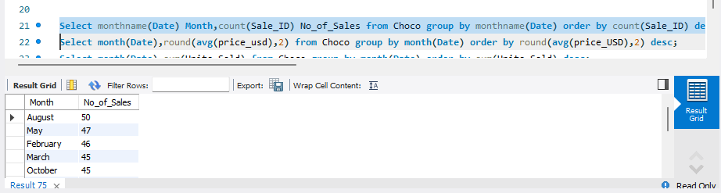
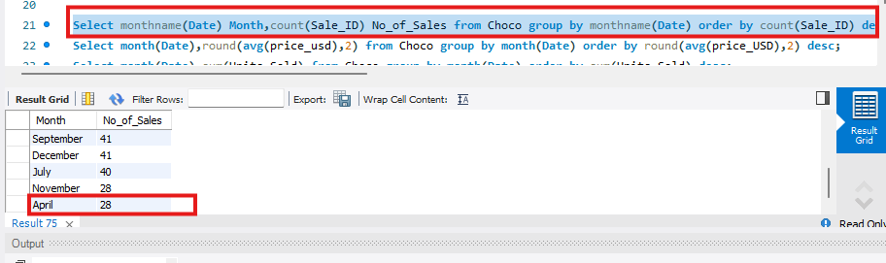

Reason 2:- The Number of Units Sold on the month of April are very low.
Total Number of units that were sold in the moth of April were 2719 which was the least compared to the units sold in remaining months.
Select monthname(Date) Month,sum(Units_Sold) Total_Units_Sold from Choco group by monthname(Date) order by sum(Units_Sold) desc;
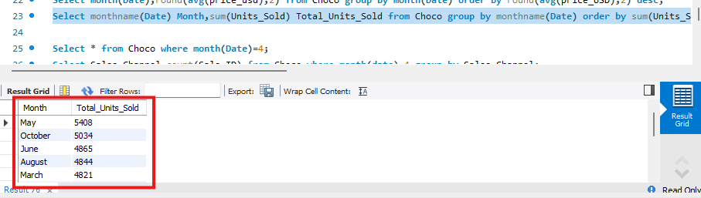
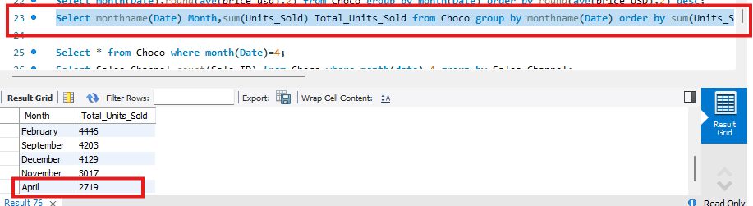

Select month(date),sum(units_sold) Total_Units_Sold ,round(sum(Revenue_USD)/sum(Units_Sold),2) avg_price,round(sum(units_sold) * round(sum(Revenue_USD)/sum(Units_Sold),2),2) Product_Profit from Choco group by month(date) order by sum(units_sold) * round(sum(Revenue_USD)/sum(Units_Sold),2) desc;
Average price 13.46 and Product Profit is 36597.74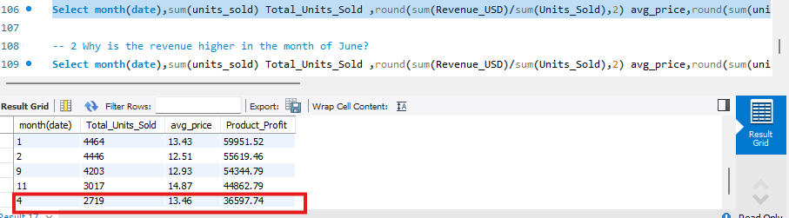

Question 2:- Why is the revenue higher in the month of June?
Being the Second highest in the terms of average price of a product sold and due to huge volume of sales June was able to genrate the highest revenue.
Select month(date),sum(units_sold) Total_Units_Sold ,round(sum(Revenue_USD)/sum(Units_Sold),2) avg_price,round(sum(units_sold) * round(sum(Revenue_USD)/sum(Units_Sold),2),2) Product_Profit from Choco group by month(date) order by sum(units_sold) * round(sum(Revenue_USD)/sum(Units_Sold),2) desc;
Average Price 15.37 and Product_Profit is 74775.05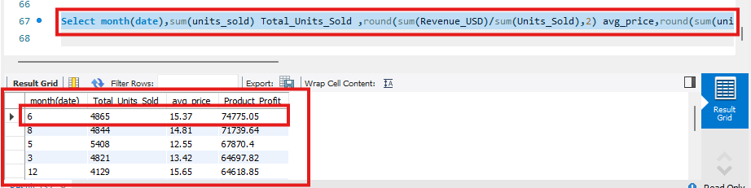

Question 3:- Why France is highest revenue generating Country?
France is the country where highest number of units sold.A total of 6410 units sold.
Second highest number in terms of number of transactions which has the number of units sold even more higher than germany making it to generate more revenue.
A total of 58 transactions done.
France posses highes number of units sold and the higesht average price per product sold making it to generate High revenue.
Select Country,count(Sale_ID) No_Of_Transactions from Choco group by Country order by count(Sale_ID) desc;
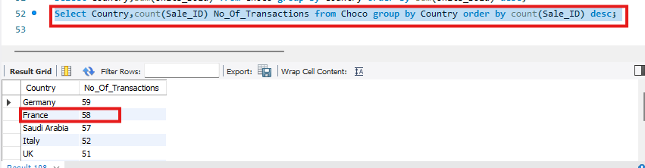
Total Number of units sold 6410
Select Country,sum(Units_Sold) No_of_Units_Sold from Choco group by Country order by sum(Units_Sold) desc;
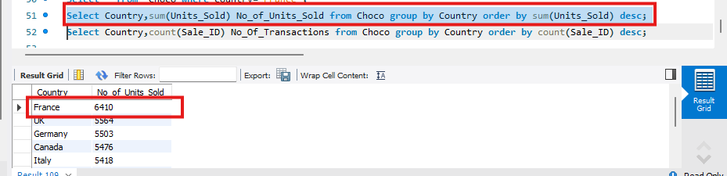
France has the highest Average Price of 14.03.
Select Country,sum(units_sold) Total_Units_Sold ,round(sum(Revenue_USD)/sum(Units_Sold),2) avg_price,round(sum(units_sold) * round(sum(Revenue_USD)/sum(Units_Sold),2),2) Product_Profit from Choco group by Country order by sum(units_sold) * round(sum(Revenue_USD)/sum(Units_Sold),2) desc;
Average Price 14.03 and Product_Profit 89932.3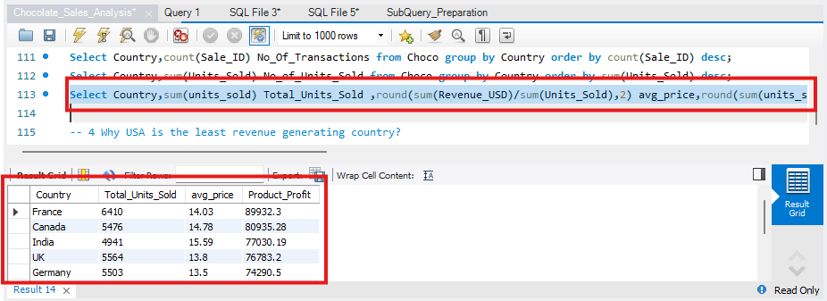

Q4)Why USA is the least revenue generating country?
The number of sales/transactions done are very low compared to other countries
A total number of transactions of 43.

The number of units sold were least as per the other countries.
Total of 4358 units sold.

Total Number of transactions/Sales 43
Select Country,count(Sale_ID) No_Of_Transactions from Choco group by Country order by count(Sale_ID) desc;
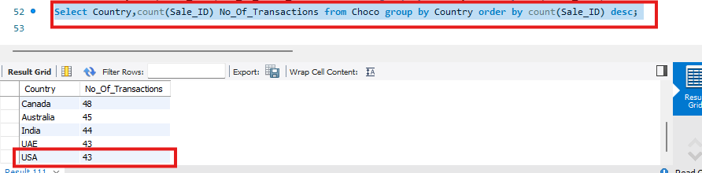

The number of units sold 4358
Select Country,sum(Units_Sold) No_of_Units_Sold from Choco group by Country order by sum(Units_Sold) desc;
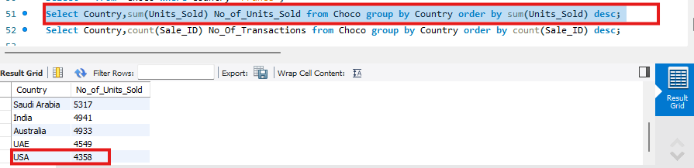

Select Country,count(Sale_ID),sum(units_sold),round(sum(Revenue_USD)/sum(Units_Sold),2) avg_price from Choco group by country order by round(sum(Revenue_USD)/sum(Units_Sold),2) desc;
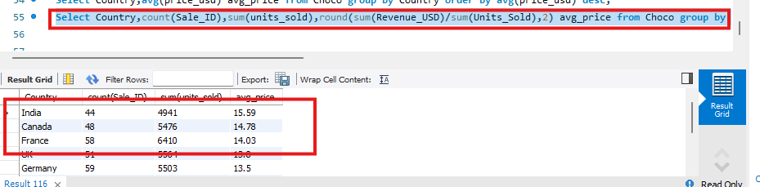
From the above query we can understand that even if the average price is slightly low compared to India and Canada for France the number of sales and units sold are comparitively high from the other countries making it to generate more revenue.

Select Country,sum(units_sold) Total_Units_Sold ,round(sum(Revenue_USD)/sum(Units_Sold),2) avg_price,round(sum(units_sold) * round(sum(Revenue_USD)/sum(Units_Sold),2),2) Product_Profit from Choco group by Country order by sum(units_sold) * round(sum(Revenue_USD)/sum(Units_Sold),2) desc;
Average Price 12.41 and Product_Profit 54082.78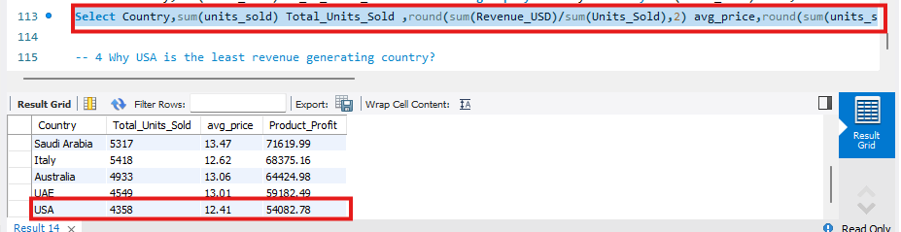

Q5)Why chocolate box is generating the maximum revenue ?
The Product Chocolate box has a high average price of 14.71 dollars and also the number of units sold are high 10291 compared to other product types making it the maximum revenue generating Product type.
With a Profit of 151380 dollars.
Select Product_Type,sum(units_sold) Total_Units_Sold ,round(sum(Revenue_USD)/sum(Units_Sold),2) avg_price,round(sum(units_sold) * round(sum(Revenue_USD)/sum(Units_Sold),2),2) Product_Profit from Choco group by Product_Type order by sum(units_sold) desc;
Average price 14.71 Product Profit is 151380.61.
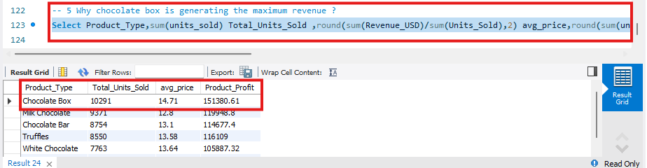

Q6)Why white chocolate Is generating the lowest revenue?
White Chocolate has the second least products about 7763 getting sold followed by dark chocolate which has least number of units 7740 getting sold, but the average price of White Chocolate is 13.64 and dark chocolate is 14.04 creating a difference in the product the composes the profit. Making White chcoclate the least revenue generating Product type.
With a profit of 105887 dollars.
Select Product_Type,sum(units_sold) Total_Units_Sold ,round(sum(Revenue_USD)/sum(Units_Sold),2) avg_price,round(sum(units_sold) * round(sum(Revenue_USD)/sum(Units_Sold),2),2) Product_Profit from Choco group by Product_Type order by sum(units_sold) desc;
Average price 13.64 Product Profit is 105887.32
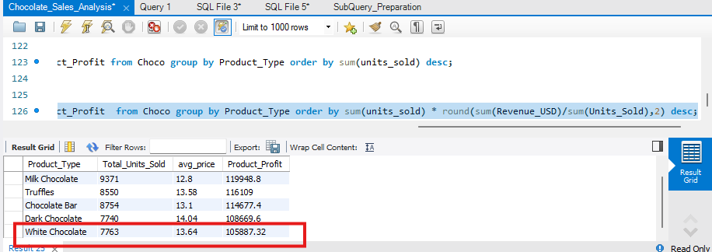

Summary of Diagnostic Analysis:
As the number of trsnasctions 28 done and the total number of units 2719 sold in the month of April was less compared to the other months is the main reason for April being the least revenue generating month. Average price 13.46 and Product Profit is 36597.74 is very low compared to other months.
June was able to generate the most revenue due to the enormous volume of sales 4865 units being sold and the second-highest average price about $15.37 of a product sold.
Average Price 15.37 and Product_Profit is 74775.05 is very high compared to other months.
The nation with the most units sold is France.6410 copies were sold in total. It has the second-highest number of transactions and even more units sold than Germany, which means it makes more money. 58 transactions were completed in total. And the Product of Average price with the number of units sold is high Making France the Highest revenue generating Country. Average Price 14.03 and Product_Profit 89932.3 which was the highest among the countries.
When compared to other nations, the volume of sales and transactions is extremely low 43 transactions in total.
The quantity of units sold were least as per the other countries 4358 copies were sold in total, making the United States the least profitable firm.
Average Price 12.41 and Product_Profit 54082.78 which was the least among the countries.
The product chocolate box is the most profitable product type due to its high average price of $14.71 and high number of units sold (10291) in comparison to other product kinds.
Chocolate boxes are the product type that generates the most revenue, with a profit of $151,380. Average price 14.71 Product Profit is 151380.61 which was maximum among others

White chocolate sells the second fewest units—roughly 7763—followed by dark chocolate, which sells the fewest units—7740. However, the average price of white chocolate is 13.64, while that of dark chocolate is 14.04, resulting in a difference in the product that makes up the profit. White chocolate is the product type that generates the least amount of money.
White chocolate is the least profitable product type, with a profit of 105887.
Average price 13.64 Product Profit is 105887.32 which was lowest among the others.

***Reccomendations***
The Key thing is to focus on the volume of sales getting generated for each Brand,Product type, Country.
To Ananlyze key matrix of product of number of units sold to the average price, incase of decrease in profit it was majorly due to the decline in volume of sales. So better range of quantites and different types of packing of chocolates can boost the volume of sales.
The Markenting campaings could be done efficiently in the month of April to reduce the losses and see a growth in the sales in that month.

