DAA WEEK3 SUBMISSION

Name: Davasam Karthikeya Section: AIMLB Reg No: 230962326

Date: 25/01/2025

1) Write a program to sort a set of integers using selection sort algorithm and analyze its time efficiency. Obtain the experimental result of order of growth. Plot the result for the best and worst case.
Code:
#include <stdio.h>
#include <stdlib.h>

void SelectionSort(int *Array,int length){
int OpsCount = 0;
for (int i = 0; i < length; i++)printf("%d ",Array[i]);
for(int i = 0; i < length; i++){
int small_index = i;
for(int j = i+1; j < length; j++){
if(Array[j]<Array[small_index])small_index=j;
OpsCount++;
}
int temp = Array[i];
Array[i] = Array[small_index];
Array[small_index] = temp;
}
printf(" OpsCount: %d \n",OpsCount);
}

int main(){
// int Arr[] = {5,4,3,2,1};
// SelectionSort(&Arr[0],5);
int N = 5;
int NoOfSamples;printf("Enter No of Samples:");scanf("%d",&NoOfSamples);
for(int i = 0; i < NoOfSamples;i++){
int *Arr = (int*)malloc(N*sizeof(int));
for(int j = 0;j<N;j++)Arr[j] = N-j;
SelectionSort(Arr,N);
N += 5;
}

return 0;
}

Sample Input/Output:
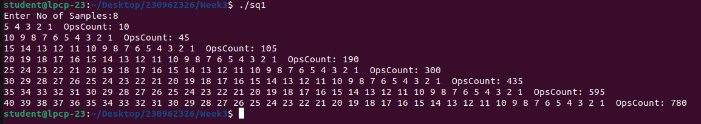

Graph:

2) Write a program to sort set of integers using bubble sort. Analyze its time efficiency. Obtain the experimental result of order of growth. Plot the result for the best and worst case.
Code:
#include <stdio.h>
#include <stdlib.h>

void BubbleSort(int *Array,int length){
int OpsCount = 0;
for(int i = 0; i < length; i++)printf("%d ",Array[i]);
for(int i = 0; i < length-1; i++){
for (int j = 0; j < length-i-1; j++){
OpsCount++;
if(Array[j+1] < Array[j]){
OpsCount++;
int temp = Array[j+1];
Array[j+1] = Array[j];
Array[j] = temp;
}
}
}
printf(" OpsCount: %d \n",OpsCount);
}

int main(){
int N = 5;
int NoOfSamples;printf("Enter No of Samples:");scanf("%d",&NoOfSamples);
for(int i = 0; i < NoOfSamples;i++){
int *Arr = (int*)malloc(N*sizeof(int));
for(int j = 0;j<N;j++)Arr[j] = N-j;
BubbleSort(Arr,N);
N += 5;
}
return 0;
}

Sample Input/Output:
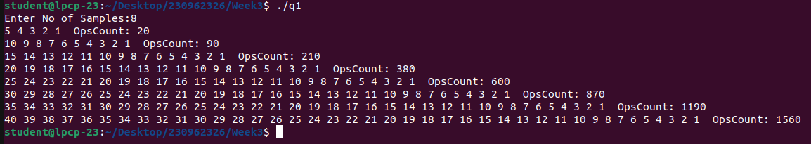

Graph:

3) Write a program to implement brute-force string matching. Analyze its time efficiency.
Code:
#include <stdio.h>
#include <string.h>

void BruteForceStringMatch(char string[],char search[]){
int i = 0,j=0,OpsCount = 0;
int len1 = strlen(string),len2 = strlen(search);
while(i < len1 && j < len2){
OpsCount++;
if(string[i] == search[j]){
i++;j++;
}else{
i++;
}
}
if(j == len2)printf("%s is found between index (%d,%d) OpsCount: %d \n",search,j,i-j-1,OpsCount);
else printf("%s not found in %s \n",search,string);
}

int main(){
int N = 5;
int NoOfSamples;printf("Enter No of Samples:");scanf("%d",&NoOfSamples);
for(int i = 0; i < NoOfSamples;i++){
char string[N];
for(int i = 0;i<N;i++)string[i] = 'a';
string[N-1] = 'b';
BruteForceStringMatch(string,"ab");
N += 5;
}
return 0;
}

Sample Input/Output:
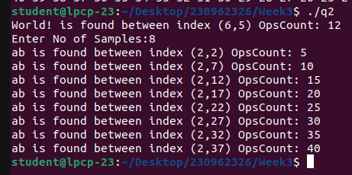

Graph:

4) Write a program to implement solution to partition problem using brute-force technique and analyze its time efficiency theoretically. A partition problem takes a set of numbers and finds two disjoint sets such that the sum of the elements in the first set is equal to the second set. [Hint: You may generate power set]
Code:
#include <stdio.h>
#include <stdlib.h>

char isPartition(int arr[], int len, int sum, int *opCount) {
(*opCount)++;
if(sum == 0) return 1;
else if(len == 0) return 0;
else if(arr[len - 1] > sum) return isPartition(arr, len - 1, sum, opCount);
return isPartition(arr, len - 1, sum, opCount) || isPartition(arr, len - 1, sum - arr[len - 1], opCount);
}
void main() {
int opCount, sum, trCount = 50, *arr;
for(int len = 2; len <= 10; len++) {
opCount = 0;
arr = calloc(len, sizeof(int));
for(int trial = 0; trial < trCount; trial++) {
sum = 0;
for(int i = 0; i < len; i++) {
arr[i] = rand() * trial * (i + 1);
sum += arr[i];
}
for(int i = len - 1; i > 0; i--) {
int w = rand() % i;
int t = arr[i];
arr[i] = arr[w];
arr[w] = t;
}
isPartition(arr, len, sum / 2, &opCount);
}
free(arr);
printf("Op. count: %d for size %d\n", opCount / trCount, len);
}
}

Sample Input/Output:
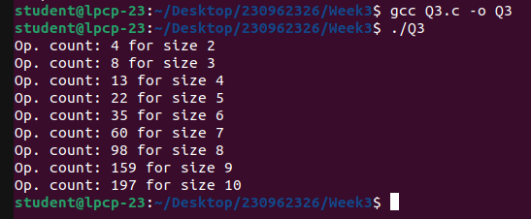
Graph:

