DAA WEEK2 SUBMISSION

Name: Davasam Karthikeya Section: AIMLB Reg No: 230962326

Date: 11/01/2025
1) write a program to implement EUCLID’s algorithm to find GCD of two numbers
Code:
#include <stdio.h>
int EuclidGCD(unsigned int m, unsigned int n) {
int r,opcount = 0;
while(n!=0) {
opcount++;
r = m %n;
m = n;
n = r;
}
return opcount;
}

int main(){
int TestCases;
printf("Enter no of TestCases: ");scanf("%d",&TestCases);
int nums1[TestCases],nums2[TestCases];
for(int i = 0; i < TestCases; i++){
printf("Enter TestCase %d number1: ",i+1);scanf("%d",&nums1[i]);
printf("Enter TestCase %d number2: ",i+1);scanf("%d",&nums2[i]);
}
for(int i = 0; i < TestCases; i++){
int ops = EuclidGCD(nums1[i],nums2[i]);
printf("(m+n): %d ops: %d \n",nums1[i]+nums2[i],ops);
}
}

Sample Input/Output:-
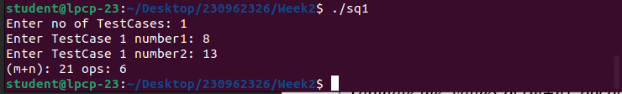
Graph:

2) Write a program to find GCD using consecutive integer checking method and analyze its time efficiency.
Code:-

#include <stdio.h>

int min(int number1, int number2){
return (number1<number2)?number1:number2;
}

int GCD(int number1, int number2){
int opercount = 0;
int nmin = min(number1,number2);
for(;nmin > 0;nmin--){
opercount++;
if((number1 % nmin == 0) && (number2 % nmin == 0))return opercount;
}
}

int main(){
int TestCases;
printf("Enter no of TestCases: ");scanf("%d",&TestCases);
int nums1[TestCases],nums2[TestCases];
for(int i = 0; i < TestCases; i++){
printf("Enter TestCase %d number1: ",i+1);scanf("%d",&nums1[i]);
printf("Enter TestCase %d number2: ",i+1);scanf("%d",&nums2[i]);
}
for(int i = 0; i < TestCases; i++){
int ops = GCD(nums1[i],nums2[i]);
printf("(m+n): %d ops: %d \n",nums1[i]+nums2[i],ops);
}
}

Sample Output/Input:
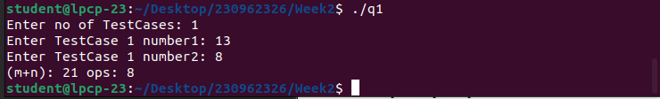
Graph:

3) Write a program to find GCD using middle school method and analyze its time efficiency.
Code:
#include <stdio.h>
#include <stdlib.h>
int PrimeFactors(int *factors, int number){
int k = 0,count = 0;
while(number %2 == 0){
count++;
factors[k++] = 2;
number /= 2;
}
for(int i = 3;i<= number;i+=2){
count++;
while(number % i == 0){
count++;
factors[k++] = i;
number /= i;
}
}
return count;
}

int MiddleSchoolGCD(int number1, int number2){
//int factors1[100],factors2[100];
int *factors1 = (int*)calloc(100,sizeof(int));
int *factors2 = (int*)calloc(100,sizeof(int));
int gcd = 1;
int ops1 = PrimeFactors(&factors1[0],number1);
int ops2 = PrimeFactors(&factors2[0],number2);
int i = 0, j = 0;

while(factors1[i] && factors2[j]){
if(factors1[i] < factors2[j])i++;
else if(factors1[i] > factors2[j])j++;
else {i++;j++;gcd*=factors1[i];}
ops1++;
}
return ops1 + ops2;
}

int main(){
int TestCases;
printf("Enter no of TestCases: ");scanf("%d",&TestCases);
int nums1[TestCases],nums2[TestCases];
for(int i = 0; i < TestCases; i++){
printf("Enter TestCase %d number1: ",i+1);scanf("%d",&nums1[i]);
printf("Enter TestCase %d number2: ",i+1);scanf("%d",&nums2[i]);
}
for(int i = 0; i < TestCases; i++){
int ops = MiddleSchoolGCD(nums1[i],nums2[i]);
printf("(m+n): %d ops: %d \n",nums1[i]+nums2[i],ops);
}
}

Sample Input/Output:
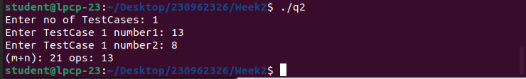
Graph:

