DAA WEEK8 SUBMISSION

Name: Davasam Karthikeya Section: AIMLB Reg No: 230962326

Date: 01/03/2025

1) Write a program to create a heap for the list of integers using top-down heap construction algorithm and analyze its time efficiency. Obtain the experimental results for order of growth and plot the result.
Code:
#include <stdio.h>

void swap(int *a, int *b){
int tmp = *a;*a = *b;*b = tmp;
}

void heapify(int arr[], int N, int i){
int largest = i;
int l = 2 * i + 1;
int r = 2 * i + 2;
if(l < N && arr[l] > arr[largest])largest = l;
if(r < N && arr[r] > arr[largest])largest = r;
if(largest != i){
swap(&arr[i], &arr[largest]);
heapify(arr, N, largest);
}
}
void buildHeap(int arr[], int N){
int startIdx = (N / 2) - 1;
for(int i = startIdx; i >= 0; i--)heapify(arr, N, i);
}
void printHeap(int arr[], int N){
printf("Array representation of Heap is:\n");
for (int i = 0; i < N; ++i)printf("%d ",arr[i]);
printf("\n");
}
int main(){
int arr[] = {1, 3, 5, 4, 6, 13, 10, 9, 8, 15, 17};
int N = sizeof(arr) / sizeof(arr[0]);
buildHeap(arr, N);
printHeap(arr, N);
return 0;
}

Sample Input/Output:
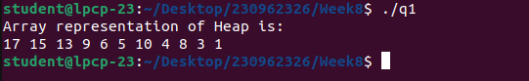

Graph:

2) Write a program to sort the list of integers using heap sort with bottom up max heap construction and analyze its time efficiency. Prove experimentally that the worst case time complexity is O(n log n)
Code:
#include <stdio.h>
#include <stdlib.h>

int op = 0;
void heapify(int h[],int n){
int i,k,v,heapify,j;
for(i=(n/2);i>=1;i--){
k=i;v=h[k];heapify=0;
while(heapify==0&&2*k<=n){
op++;
j=2*k;
if(j<n)
if(h[j]<h[j+1])j=j+1;
if(v>=h[j])heapify=1;
else{
h[k]=h[j];
k=j;
}
}
h[k]=v;
}
return;
}
void HeapSort(int arr[], int n){
int k = 0;
for(int i = 1; i<n; i++){
heapify(arr, n - k);
int temp = arr[1];
arr[1] = arr[n-k];
arr[n-k] = temp;
k++;
op++;
}
}
int main(){
int arr[20], n;
printf("Enter the Number of Elements :");
scanf("%d", &n);
printf("Enter the Elements : \n");
for(int i = 1; i<=n; i++)
scanf("%d", &arr[i]);
HeapSort(arr, n);printf("The Sorted List is : ");
for(int i = 1; i<=n; i++)
printf("%d ", arr[i]);
printf("\n");
printf("Count = %d\n", op);
return 0;
}

Sample Input/Output:

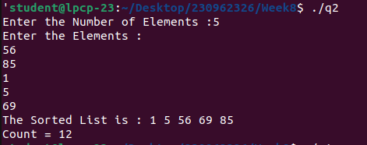

Graph:

