FCV WEEK1 SUBMISSION

Name: Davasam Karthikeya Section: AIMLB Reg No: 230962326

1. Write a simple program to read, display, and write an image.
Code:-
import cv2 as cv

img = cv.imread('img.jpg')
cv.imshow('image', img)

cv.waitKey(0)
# Writing same image
cv.imwrite('img.jpg', img)

cv.destroyAllWindows()

Output:-
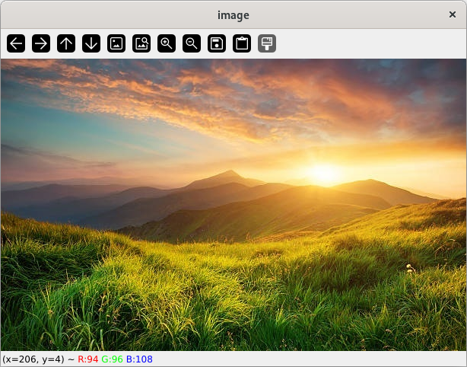

2. Write a simple program to read and display a video file.
Code:-
import cv2 as cv

VideoCapture = cv.VideoCapture('video.mp4')

while True:
ret, frame = VideoCapture.read()

if not ret:
break

cv.imshow('Video', frame)

if cv.waitKey(1) & 0xFF == ord('k'):
break

VideoCapture.release()
cv.destroyAllWindows()

Output:-
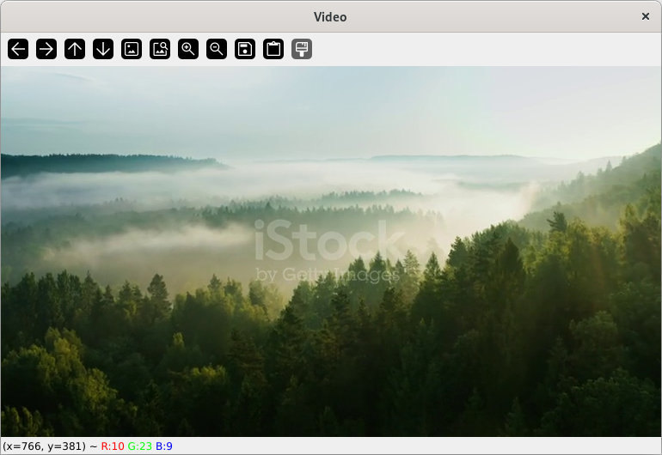

3. Write a simple program to Extracting the RGB values of a pixel.
Code:-
import cv2 as cv

# Load Image
img = cv.imread('img.jpg')

print(f'R: {img[0][0][2]} G: {img[0][0][1]} B: {img[0][0][0]}')

Output:-

4. Write a simple program to draw rectangle.
Code:-
import cv2 as cv
import numpy as np

plain_img = np.zeros((300,300,3))

rect_img = cv.rectangle(plain_img, (50,50), (250,250), (255,255,255), 5)

cv.imshow("Image", rect_img)
cv.waitKey(0)

cv.destroyAllWindows()

Output:-
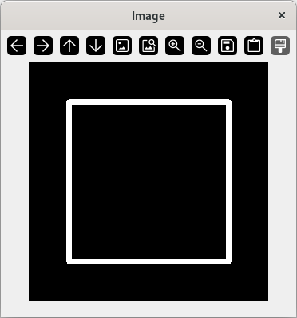

5.Write a simple program to Resizing the Image.
Code:-
import cv2 as cv

img = cv.imread('img.jpg')

resized_img = cv.resize(img, (500, 500), interpolation=cv.INTER_AREA)
cv.imshow('image', resized_img)

cv.waitKey(0)

cv.destroyAllWindows()

Output:-
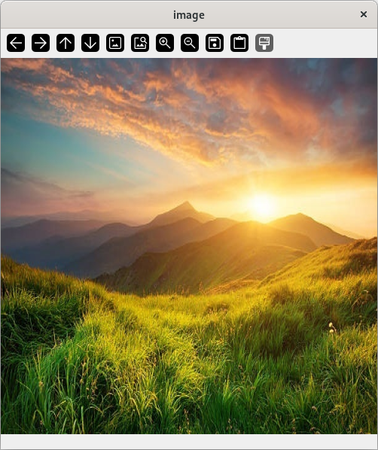

6. Write a simple program to Rotating the Image.
Code:-
import cv2 as cv

img = cv.imread('img.jpg')
img = cv.rotate(img, cv.ROTATE_90_CLOCKWISE)

cv.imshow('image', img)

cv.waitKey(0)
cv.destroyAllWindows()

Output:-
