FCV WEEK2 SUBMISSION

Name: Davasam Karthikeya Section: AIMLB Reg No: 230962326

1. Write a program to read an image and perform histogram equalization.
Code:-
import cv2 as cv

img = cv.imread('Week1/img.jpg')

grayscale = cv.cvtColor(img, cv.COLOR_BGR2GRAY)
hist = cv.equalizeHist(grayscale)

cv.imshow('image', img)
cv.imshow('hist', hist)
cv.waitKey(0)

Output:-
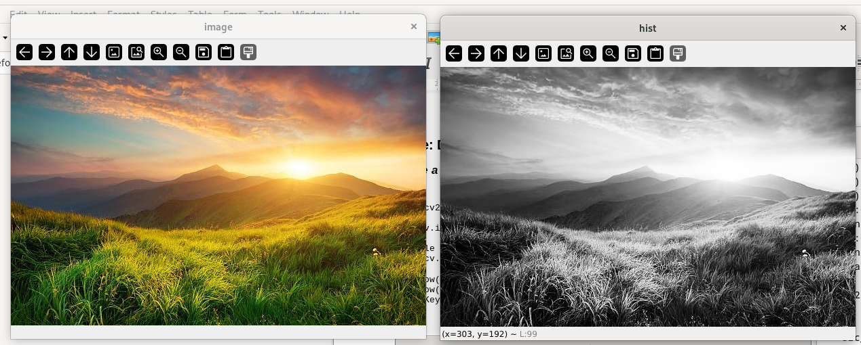

2. Write a program to read an input image, reference image, and perform histogram specification.
Code:-
import cv2
import numpy as np

def calculate_cdf(histogram):
cdf = histogram.cumsum()
normalized_cdf = cdf / float(cdf.max())
return normalized_cdf

def calculate_lookup(src_cdf, ref_cdf):
lookup_table = np.zeros(256)
lookup_val = 0
for src_pixel_val in range(len(src_cdf)):
lookup_val
for ref_pixel_val in range(len(ref_cdf)):
if ref_cdf[ref_pixel_val] >= src_cdf[src_pixel_val]:
lookup_val = ref_pixel_val
break
lookup_table[src_pixel_val] = lookup_val
return lookup_table

def match_histograms(src_image, ref_image):
src_hist, _ = np.histogram(src_image.flatten(), 256, [0, 256])
ref_hist, _ = np.histogram(ref_image.flatten(), 256, [0, 256])

src_cdf = calculate_cdf(src_hist)
ref_cdf = calculate_cdf(ref_hist)

lookUP_TABLE = calculate_lookup(src_cdf, ref_cdf)

result = cv2.LUT(src_image, lookUP_TABLE)

return cv2.convertScaleAbs(result)

img = cv2.imread('Week2/aspens_in_fall.jpg')
ref_img = cv2.imread('Week2/forest-resized.jpg')
cv2.imshow('Orig_Img', img)
cv2.imshow('Ref_img', ref_img)

img_b, img_g, img_r = cv2.split(img)
ref_img_b, ref_img_g, ref_img_r = cv2.split(ref_img)

matched_image = cv2.merge([match_histograms(img_b, ref_img_b), match_histograms(img_g, ref_img_g), match_histograms(img_r, ref_img_r)])
cv2.imshow('Histogram Matched', matched_image)
cv2.waitKey(0)

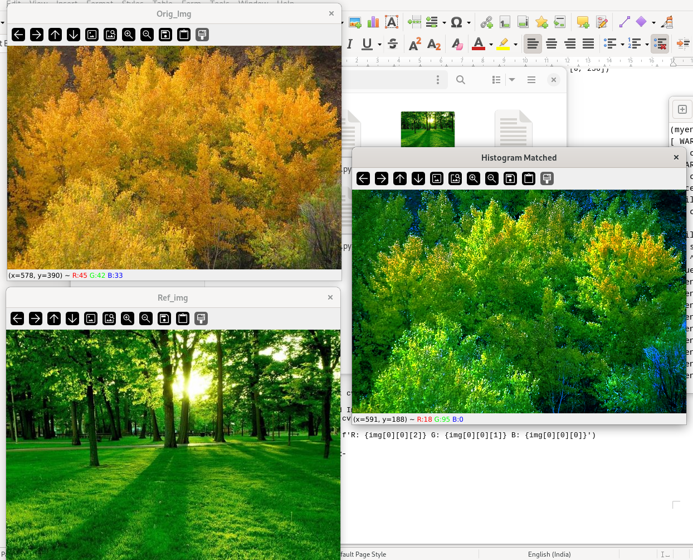
Output:-

3. Write a program to Resizing the Image and cropping an image.
Code:-
import cv2 as cv

img = cv.imread('Week1/img.jpg')

resized_img = cv.resize(img, (500, 500), interpolation=cv.INTER_AREA)
cropped_img = img[100:200, 100:200]
cv.imshow('resized_image', resized_img)
cv.imshow('cropped_image', cropped_img)

cv.waitKey(0)

cv.destroyAllWindows()

Output:-
