FCV WEEK5 SUBMISSION

Name: Davasam Karthikeya Section: AIMLB Reg No: 230962326

1. Implement basic feature extraction algorithms given below:
i Harris corner detection
ii FAST corner detection.
Apply it to different images and visualize the detected keypoints.
Code:-
import cv2 as cv
import numpy as np

img = cv.imread('Week5/Chess_Board.jpg')

def Harris_Corners(img:cv.Mat, ksize=3, threshold=0.01):
img_gray = cv.cvtColor(img, cv.COLOR_BGR2GRAY)
gx, gy = cv.Sobel(img_gray, cv.CV_64F, 1, 0), cv.Sobel(img_gray, cv.CV_64F, 0, 1)

Ixx = gx**2
Iyy = gy**2
Ixy = gx*gy

height, width, _ = img.shape
n = (ksize-1)//2

Neighbours = [(1, 0), (-1, 0), (0, 1), (0, -1), (1, 1), (-1, -1), (1, -1), (-1, 1)]

R = np.zeros((height, width), dtype=np.float64)

for i in range(n, height-n):
for j in range(n, width-n):
ixx, iyy, ixy = 0, 0, 0
for k in range(1, n+1):
for dx, dy in Neighbours:
ixx += Ixx[i + dx*k][j + dy*k]
iyy += Iyy[i + dx*k][j + dy*k]
ixy += Ixy[i + dx*k][j + dy*k]

R[i][j] = (ixx*iyy - (ixy**2)) - (ixx + iyy)

R = cv.normalize(R, None, 0, 1, cv.NORM_MINMAX)
out = img.copy()

for i in range(height):
for j in range(width):
if R[i, j] > threshold:
cv.circle(out, (j, i), 2, (0, 0, 255), -1)

return out

def FAST_Corners(img:cv.Mat, n=12, treshold=10):
img_gray = cv.cvtColor(img, cv.COLOR_BGR2GRAY)
height, width, _ = img.shape

miniCircle = [(-3, 0), (3, 0), (0, -3), (0, 3)]
bresenhamCircle = [(0, 3), (1, 3), (2, 2), (3, 1), (3, 0), (3, -1), (2, -2), (1, -3), (0, -3), (-1, -3), (-2, -2), (-3, -1), (-3, 0), (-3, 1), (-2, 2), (-1, 3)]

def isActivePixel(I, curI, treshold):
return I > curI + treshold or I < curI - treshold

output = img.copy()

for i in range(3, height - 3):
for j in range(3, width - 3):
count = 0
curI = img_gray[i][j]
activePixels = []

count = 0
for dx, dy in miniCircle:
if isActivePixel(int(img_gray[i+dx][j+dy]), int(curI), int(treshold)):
count += 1
if count < 2:
continue

for dx,dy in bresenhamCircle:
activePixels.append(isActivePixel(int(img_gray[i+dx][j+dy]), int(curI), int(treshold)))

activePixels_ext = activePixels + activePixels[:15]
for num in activePixels_ext:
if num == 1:
count += 1
if count == n:
output = cv.circle(output, (i, j), 2, (0, 0, 255), -1)
else:
count = 0

return output

img1 = FAST_Corners(img.copy(), n=10, treshold=15)
img2 = Harris_Corners(img)
cv.imshow('Image', np.hstack([img2, img1]))
cv.waitKey(0)
cv.destroyAllWindows()

Output:-
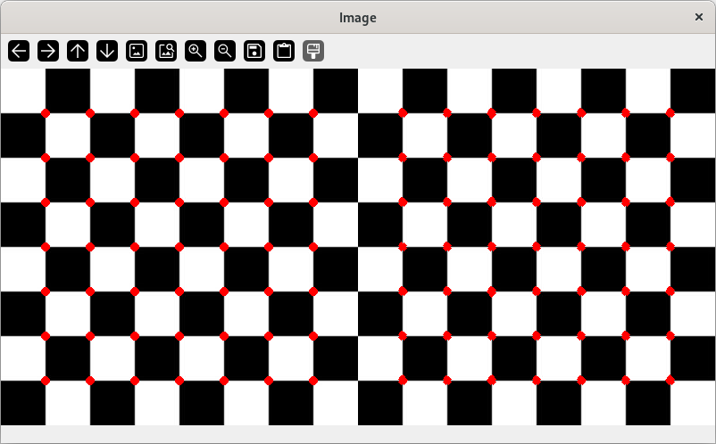

2. Implement your own version of SIFT feature descriptors and compare with OpenCV library functions.
Assess the robustness of descriptors to changes in scale, rotation, and affine transformations. Also,
compare your implementation with the descriptors available in the opencv library. Use the earlier
version of opencv (prior to OpenCV 3.4.3 ) for the SIFT.
Code:-
import cv2 as cv
import numpy as np

img = cv.imread('Week1/img.jpg')
img = cv.cvtColor(img, cv.COLOR_BGR2RGB)

sift = cv.SIFT_create()
keypoints, descriptors = sift.detectAndCompute(img, None)
keypoints_with_size = np.copy(img)

cv.drawKeypoints(img, keypoints, keypoints_with_size, color = (255, 0, 0),flags = cv.DRAW_MATCHES_FLAGS_DRAW_RICH_KEYPOINTS)

cv.imshow('Image', keypoints_with_size)
cv.waitKey(0)
Output:-
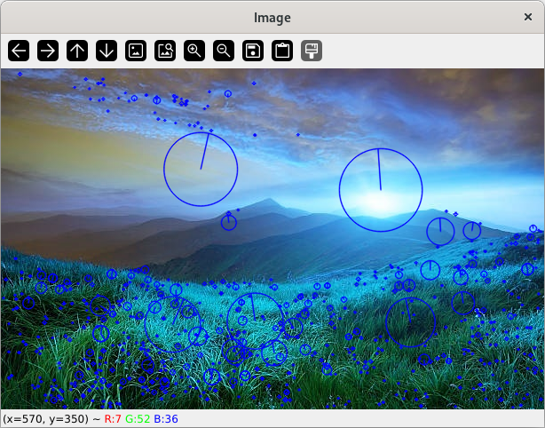

3. Implement the HoG descriptor and apply it to detect humans in images. You may follow the steps given
below:
a) Obtain a dataset containing images with humans and non-human objects. Compute HoG
for these images as references.
b) Extract HoG features using a sliding window approach.
c) Calculate a similarity score or distance metric between the HoG descriptor of the window
and a reference HoG descriptor.
c) Identify and collect windows that exceed the similarity score threshold. Choose the best
window among the overlapping windows.

Code:-
import cv2 as cv
import numpy as np
from sklearn.svm import LinearSVC
from sklearn.metrics import log_loss

dataset_train = 'INRIAPerson/train_64x128_H96/'
dataset_test = 'INRIAPerson/test_64x128_H96/'

neg_list, pos_list =[], []

with open(dataset_train+'pos.lst', 'r') as f:
pos_list = f.read().strip().split('\n')

with open(dataset_train+'neg.lst', 'r') as f:
neg_list = f.read().strip().split('\n')

X, Y = [], []

hog = cv.HOGDescriptor((64, 128), (16, 16), (8, 8), (8, 8), 9)
for file_name in pos_list:
img = cv.imread(dataset_train + file_name, 0)
X.append(hog.compute(img))
Y.append(1)

for file_name in neg_list[:300]:
img = cv.imread(dataset_train + file_name, 0)
img = cv.resize(img, (96, 160), interpolation=cv.INTER_CUBIC)

X.append(hog.compute(img))
Y.append(0)

X , Y = np.array(X), np.array(Y)

model = LinearSVC(max_iter=100)
model.fit(X, Y)

pred = model.predict(X)
print(log_loss(Y, pred))

Output:-
