PPL WEEK1 SUBMISSION

Name: Davasam Karthikeya Section: AIMLB Reg No: 230962326

1. Write a simple MPI program to find out pow (x, rank) for all the processes where ‘x” is the integer constant and ‘rank’ is the rank of the process. Write a program in MPI where even ranked process prints “Hello” and odd ranked process prints “World”.
Code:-
#include <stdio.h>
#include <mpi.h>

int int_pow(int x, int power){
int ans = 1;
while(power >= 1){
ans *= x;
power -= 1;
}
return ans;
}

int main(int argc, char *argv[]){
int x = 2;
int rank, size;

MPI_Init(&argc, &argv);
MPI_Comm_rank(MPI_COMM_WORLD, &rank);
MPI_Comm_size(MPI_COMM_WORLD, &size);

if(rank == 0)
printf("------Davasam Karthikeya, 230962326------\n");

printf("Power(%d, %d) is %d, ann caluculated from process ID: %d \n", x, rank, int_pow(x, rank), rank);

if(rank % 2 == 0){
// even ranked proc
printf("Hello, from proc id:%d \n", rank);
}else{
printf("World!, from proc id:%d \n", rank);
}

MPI_Finalize();

return 0;
}

Output:-
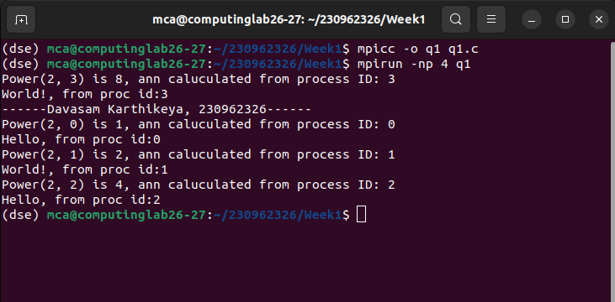

2. Write a program in MPI to simulate simple calculator. Perform each operation using different process in parallel.
Code:-
#include <stdio.h>
#include <mpi.h>

int main(int argc, char *argv[]){
int x = 2, y = 3;

int rank, size;
MPI_Init(&argc, &argv);

MPI_Comm_rank(MPI_COMM_WORLD, &rank);
MPI_Comm_size(MPI_COMM_WORLD, &size);

if(rank == 0)
printf("------Davasam Karthikeya, 230962326------\n");

switch(rank){
case 0:
printf("Value of x+y is %d, from proc 0\n", x+y);
break;
case 1:
printf("Value of x-y is %d, from proc 1\n", x-y);
break;
case 2:
printf("Value of x*y is %d, from proc 2\n", x*y);
break;
case 3:
printf("Value of x/y is %f, from proc 3\n", ((float)x)/y);
break;
}

MPI_Finalize();
}

Output:-
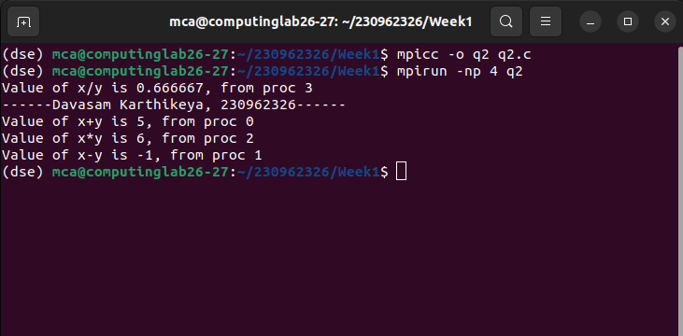

3. rite a program in MPI to toggle the character of a given string indexed by the rank of the process. Hint: Suppose the string is HELLO and there are 5 processes, then process 0 toggle “H’ to “h’, process 1 toggle ‘E’ to ‘e’ and so on.
Code:-
#include <stdio.h>
#include <mpi.h>

int main(int argc, char *argv[]){
// ques cosnts
int arr_size = 5;
char word[] = "HELLO";

int rank, size;
MPI_Init(&argc, &argv);

MPI_Comm_rank(MPI_COMM_WORLD, &rank);
MPI_Comm_size(MPI_COMM_WORLD, &size);

if(rank == 0)
printf("------Davasam Karthikeya, 230962326------\n");

if(rank < arr_size){
char prev = word[rank];
word[rank] = (word[rank] < 91) ? word[rank]+32: word[rank] - 32;
printf("In ProcID: %d, letter is toggled from %c to %c \n", rank, prev, word[rank]);
}

MPI_Finalize();

}

Output:-
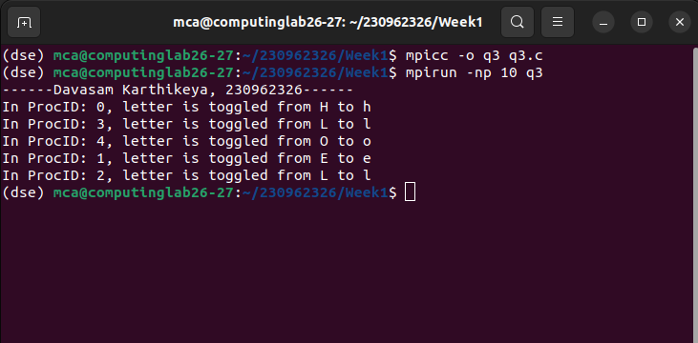

4. Write a program in MPI where even ranked process prints factorial of the rank and odd ranked process prints ranks Fibonacci number.
Code:-
#include <stdio.h>
#include <mpi.h>

int fact_number(int x){
int ans = 1;
while(x > 0){
ans *= x;
x--;
}
return ans;
}

int nthFibonacci(int n){
if (n <= 1) return n;
return nthFibonacci(n - 1) + nthFibonacci(n - 2);
}

int main(int argc, char *argv[]){
int rank, size;
MPI_Init(&argc, &argv);

MPI_Comm_rank(MPI_COMM_WORLD, &rank);
MPI_Comm_size(MPI_COMM_WORLD, &size);

if(rank == 0)
printf("------Davasam Karthikeya, 230962326------\n");

if(rank % 2 == 0)
printf("Fact(%d) is %d, from proc id:%d\n", rank, fact_number(rank), rank);
else
printf("Fib(%d) is %d, from proc id:%d\n", rank, nthFibonacci(rank), rank);

MPI_Finalize();
}

Output:-
