PPL WEEK4 SUBMISSION

Name: Davasam Karthikeya Section: AIMLB Reg No: 230962326

1. Write a MPI program using N processes to find 1! + 2! +.....+N!. Use scan. Also, handle different errors using error handling routines.
Code:-
#include <stdio.h>
#include <mpi.h>

void mpi_error_to_str(int err_code, int rank) {
if(err_code == MPI_SUCCESS)return;
char err_str[MPI_MAX_ERROR_STRING];
int result_len;
MPI_Error_string(err_code, err_str, &result_len);
printf("MPI Error, from %d: %s \n", rank, err_str);
}

int main(int argc, char *argv[]){
int size, rank;
MPI_Init(&argc, &argv);

MPI_Comm_rank(MPI_COMM_WORLD, &rank);
MPI_Comm_size(MPI_COMM_WORLD, &size);

if(rank == 0)printf("------Davasam Karthikeya, 230962326------\n");

int fact = 1, recvBuf;
for(int i=1; i<=rank+1; i++) fact = fact * i;

int err = MPI_Scan(&fact, &recvBuf, 1, MPI_INT, MPI_SUM, MPI_COMM_WORLD);

mpi_error_to_str(err, rank);

if(rank == size-1)
printf("The sum of %d factorials is %d \n", size, recvBuf);

MPI_Finalize();
return 0;
}

Output:-
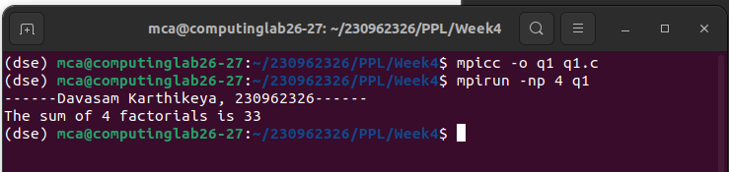

2. Write a MPI program to read a 3 X 3 matrix. Enter an element to be searched in the root process. Find the number of occurrences of this element in the matrix using three processes.
Code:-
#include <stdio.h>
#include <mpi.h>

void print_mpi_error(int err_code, int rank) {
if(err_code == MPI_SUCCESS)return;
char err_str[MPI_MAX_ERROR_STRING];
int result_len;
MPI_Error_string(err_code, err_str, &result_len);
printf("MPI Error, from %d: %s \n", rank, err_str);
}

int main(int argc, char *argv[]){
int size, rank;
MPI_Init(&argc, &argv);

MPI_Comm_rank(MPI_COMM_WORLD, &rank);
MPI_Comm_size(MPI_COMM_WORLD, &size);

int Mat[3][3], searchElem;
if(rank == 0){
printf("------Davasam Karthikeya, 230962326------\n");
for(int i = 0; i < 3; i++){
for(int j = 0; j < 3; j++){
scanf("%d", &Mat[i][j]);
}
}
scanf("%d", &searchElem);
}
int err = MPI_Bcast(&searchElem, 1, MPI_INT, 0, MPI_COMM_WORLD);
print_mpi_error(err, rank);
err = MPI_Scatter(&Mat, 3, MPI_INT, &Mat[0], 3, MPI_INT, 0, MPI_COMM_WORLD);
print_mpi_error(err, rank);

int count = 0, recvBuf;
for(int i = 0; i< 3; i++){
if(Mat[0][i] == searchElem)count++;
}

MPI_Reduce(&count, &recvBuf, 1, MPI_INT, MPI_SUM, 0, MPI_COMM_WORLD);

if(rank == 0){
printf("The number of occurances of %d in Mat is %d \n", searchElem ,recvBuf);
}

MPI_Finalize();
return 0;
}

Output:-
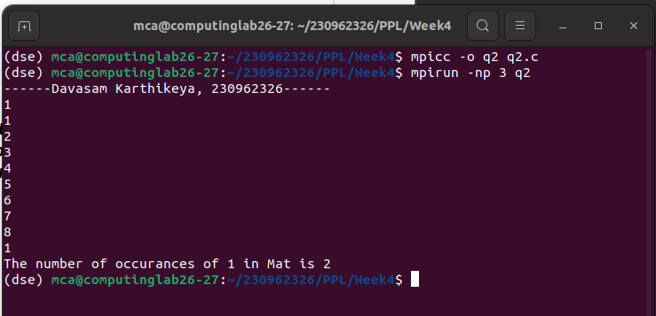

3. Write a MPI program to read 4 X 4 matrix and display the following output using four processes.
Code:-
#include <stdio.h>
#include <mpi.h>

int main(int argc, char *argv[]) {
int rank, size;
MPI_Init(&argc, &argv);

MPI_Comm_rank(MPI_COMM_WORLD, &rank);
MPI_Comm_size(MPI_COMM_WORLD, &size);

int matrix[4][4];
int row[4], scanRow[4];
int result[4][4];

if (rank == 0) {
printf("------Davasam Karthikeya, 230962326------\n");
printf("Enter 4x4 matrix:\n");
for (int i = 0; i < 4; i++)
for (int j = 0; j < 4; j++)
scanf("%d", &matrix[i][j]);
}

MPI_Scatter(matrix, 4, MPI_INT, row, 4, MPI_INT, 0, MPI_COMM_WORLD);

MPI_Scan(row, scanRow, 4, MPI_INT, MPI_SUM, MPI_COMM_WORLD);

MPI_Gather(scanRow, 4, MPI_INT, result, 4, MPI_INT, 0, MPI_COMM_WORLD);

if (rank == 0) {
printf("Output Matrix:\n");
for (int i = 0; i < 4; i++) {
for (int j = 0; j < 4; j++)
printf("%d ", result[i][j]);
printf("\n");
}
}

MPI_Finalize();
return 0;
}

Output:-
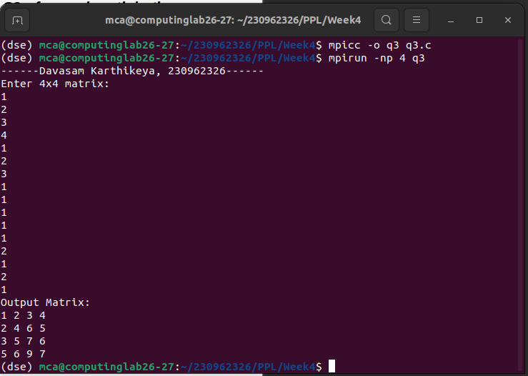

4. Write a MPI program to read a word of length N. Using N processes including the root get output word with the pattern as shown in example. Display the resultant output word in the root.
Code:-
#include <stdio.h>
#include <mpi.h>

void print_mpi_error(int err_code, int rank) {
if(err_code == 0)return;
char err_str[MPI_MAX_ERROR_STRING];
int result_len;
MPI_Error_string(err_code, err_str, &result_len);
printf("MPI Error, from %d: %s \n", rank, err_str);
}

int main(int argc, char *argv[]) {
int rank, size;
MPI_Init(&argc, &argv);

MPI_Comm_rank(MPI_COMM_WORLD, &rank);
MPI_Comm_size(MPI_COMM_WORLD, &size);

char strIn[size + 1], ch;
if (rank == 0) {
printf("------Davasam Karthikeya, 230962326------\n");
scanf("%s", strIn);
}

MPI_Scatter(strIn, 1, MPI_CHAR, &ch, 1, MPI_CHAR, 0, MPI_COMM_WORLD);

char sendBuf[size];
for (int i = 0; i < size; i++) {
if (i < rank + 1)
sendBuf[i] = ch;
else
sendBuf[i] = '\0';
}

char recvBuf[size * size];

MPI_Gather(sendBuf, size, MPI_CHAR, recvBuf, size, MPI_CHAR, 0, MPI_COMM_WORLD);

if (rank == 0) {
printf("Processed String: ");
for (int i = 0; i < size * size; i++) {
if (recvBuf[i] != '\0')
printf("%c", recvBuf[i]);
}
printf("\n");
}

MPI_Finalize();
return 0;
}

Output:-
