PPL WEEK6 SUBMISSION

Name: Davasam Karthikeya Section: AIMLB Reg No: 230962326

1. Write a program in CUDA which perfonns convolution operation on one-dimensional input arrayN of size width using a mask array M of size mask_width to produce the resultant one dimensional array P of size width
Code:-
#include <cuda.h>
#include <stdio.h>

__global__ void convolution1D(int *N, int *M, int *P, int width, int mask_width){
int i = blockIdx.x*blockDim.x + threadIdx.x;
if(i > width)return;

float pval = 0;
int start = i - (mask_width)/2;
for(int j = 0; j < mask_width; j++){
if(start + j >= 0 && start + j < width){
pval += N[start + j]*M[j];
}
}
P[i] = pval;
}

int main(){
printf("------Davasam Karthikeya, 230962326------\n");

int width, mask_width;
printf("Enter width of Input arr: ");scanf("%d", &width);
printf("Enter width of Mask arr: ");scanf("%d", &mask_width);

int N[width], M[mask_width];
for(int i = 0; i < width; i++) N[i] = 2 * i + 1;
for(int i = 0; i < width; i++) M[i] = i;

int *dM, *dN, *dP;
cudaMalloc((void **)&dM, sizeof(int) * mask_width);
cudaMalloc((void **)&dN, sizeof(int) * width);
cudaMalloc((void **)&dP, sizeof(int) * width);

cudaMemcpy(dM, &M[0], sizeof(int) * mask_width, cudaMemcpyHostToDevice);
cudaMemcpy(dN, &N[0], sizeof(int) * width, cudaMemcpyHostToDevice);

convolution1D<<<(width-1)/256 + 1, 256>>>(dN, dM, dP, width, mask_width);
int P[width];
cudaMemcpy(P, dP, sizeof(width) * width, cudaMemcpyDeviceToHost);

for(int i =0; i < width; i++)printf("%d ", P[i]);
printf("\n");

cudaFree(dM);
cudaFree(dN);
cudaFree(dP);

return 0;
}

Output:-
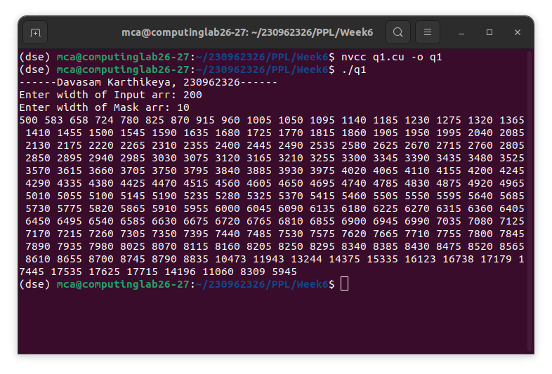

2. Write a program in CUDA to perform selection sort in parallel.
Code:-
#include <cuda.h>
#include <stdio.h>

__global__ void selectionSort(int *Arr, int *Out, int size){
int gtid = blockIdx.x * blockDim.x + threadIdx.x;
if (gtid >= size) return;

int pos = 0;
for (int i = 0; i < size; i++){
if (Arr[i] < Arr[gtid] || (Arr[i] == Arr[gtid] && i < gtid)){
pos++;
}
}
Out[pos] = Arr[gtid];
}

int main(){
printf("------Davasam Karthikeya, 230962326------\n");

int size;
printf("Enter size of Arr: ");scanf("%d", &size);

int Arr[size], Out[size];
for(int i = 0; i < size; i++)Arr[i] = rand() % 1000;

int *dArr, *dOut;

cudaMalloc((void **)&dArr, sizeof(int) * size);
cudaMalloc((void **)&dOut, sizeof(int) * size);

cudaMemcpy(dArr, &Arr[0], sizeof(int) * size, cudaMemcpyHostToDevice);

selectionSort<<<(size-1)/256 + 1, 256>>>(dArr, dOut, size);

cudaMemcpy(Out, dOut, sizeof(int) * size, cudaMemcpyDeviceToHost);

for(int i =0; i < size; i++)printf("%d ", Out[i]);
printf("\n");

cudaFree(dArr);
cudaFree(dOut);

return 0;
}

Output:-
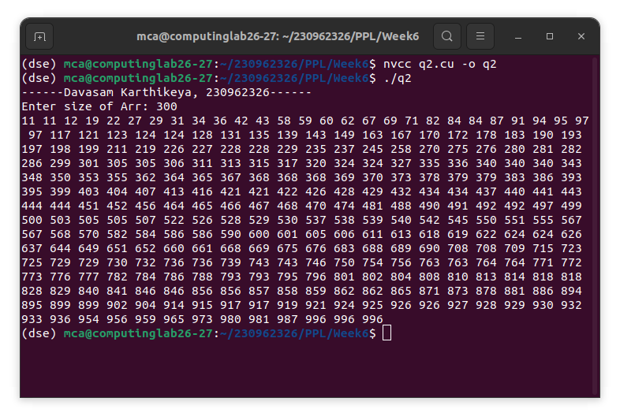

3. Write a program in CUDA to perforn odd even transposition soryt in parallel.
Code:-
#include <cuda.h>
#include <stdio.h>

__global__ void oddEvenSort(int *Arr, int size, int label){
int gtid = blockIdx.x * blockDim.x + threadIdx.x;
if (gtid >= size - 1) return;

if(gtid < size && (gtid % 2) != label)return;

if(Arr[gtid] > Arr[gtid + 1]){
int temp = Arr[gtid];
Arr[gtid] = Arr[gtid + 1];
Arr[gtid + 1] = temp;
}
}

int main(){
printf("------Davasam Karthikeya, 230962326------\n");

int size;
printf("Enter size of Arr: ");scanf("%d", &size);

int Arr[size];
for(int i = 0; i < size; i++)Arr[i] = rand() % 1000;

int *dArr;
cudaMalloc((void **)&dArr, sizeof(int) * size);

cudaMemcpy(dArr, &Arr[0], sizeof(int) * size, cudaMemcpyHostToDevice);
for(int i =0; i < size; i++){
oddEvenSort<<<(size-1)/256 + 1, 256>>>(dArr, size, i % 2);
cudaDeviceSynchronize();
}

cudaMemcpy(Arr, dArr, sizeof(int) * size, cudaMemcpyDeviceToHost);

for(int i =0; i < size; i++)printf("%d ", Arr[i]);
printf("\n");

cudaFree(dArr);

return 0;
}

Output:-
