PPL WEEK5 SUBMISSION

Name: Davasam Karthikeya Section: AIMLB Reg No: 230962326

1. Write a program in CUDA to add two vectors of length N using

a) block size as N
Code:-
#include <cuda.h>
#include <stdio.h>

#define N 200

__global__ void add(int *a, int *b, int *c){
int tid = blockIdx.x;
c[tid] = a[tid] + b[tid];
}

int main(){
int a[N], b[N], c[N];
for(int i=0; i < N; i++){
a[i] = i;
b[i] = 2*i;
}
int *dA, *dB, *dC;

int size = sizeof(int);

printf("------Davasam Karthikeya, 230962326------\n");

cudaMalloc((void **)&dA, N * size);
cudaMalloc((void **)&dB, N * size);
cudaMalloc((void **)&dC, N * size);

cudaMemcpy(dA, &a[0], N * size, cudaMemcpyHostToDevice);
cudaMemcpy(dB, &b[0], N * size, cudaMemcpyHostToDevice);

add<<<N, 1>>>(dA, dB, dC);

cudaMemcpy(c, dC, N * size, cudaMemcpyDeviceToHost);

for(int i =0; i < N; i++)printf("%d ", c[i]);
printf("\n");

cudaFree(dA);
cudaFree(dB);
cudaFree(dB);

return 0;
}

Output:-
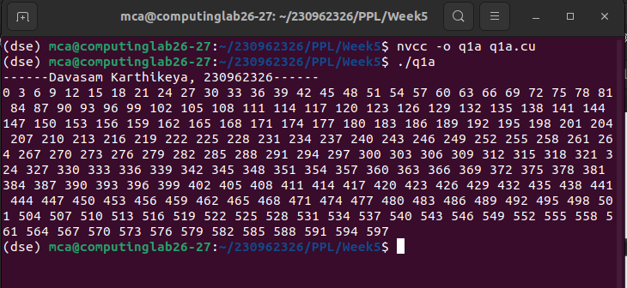

b) N threads
Code:-
#include <cuda.h>
#include <stdio.h>

#define N 200

__global__ void add(int *a, int *b, int *c){
int tid = blockDim.x * blockIdx.x + threadIdx.x;
c[tid] = a[tid] + b[tid];
}

int main(){
int a[N], b[N], c[N];
for(int i=0; i < N; i++){
a[i] = i;
b[i] = 2*i;
}
int *dA, *dB, *dC;

int size = sizeof(int);

printf("------Davasam Karthikeya, 230962326------\n");

cudaMalloc((void **)&dA, N * size);
cudaMalloc((void **)&dB, N * size);
cudaMalloc((void **)&dC, N * size);

cudaMemcpy(dA, &a[0], N * size, cudaMemcpyHostToDevice);
cudaMemcpy(dB, &b[0], N * size, cudaMemcpyHostToDevice);

add<<<1,N>>>(dA, dB, dC);

cudaMemcpy(c, dC, N * size, cudaMemcpyDeviceToHost);

for(int i =0; i < N; i++)printf("%d ", c[i]);
printf("\n");

cudaFree(dA);
cudaFree(dB);
cudaFree(dB);

return 0;
}

Output:-
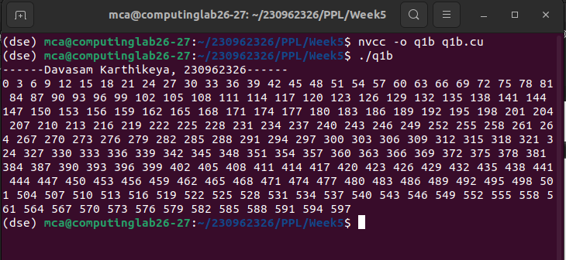

2. Implement a CUDA program to add two vectors of length N by keeping the number of threads per block as 256 (constant) and vary the number of blocks to handle N elements.
Code:-
#include <cuda.h>
#include <stdio.h>

__global__ void add(int N, int *a, int *b, int *c){
int tid = blockDim.x * blockIdx.x + threadIdx.x;
if(tid >= N)return;

c[tid] = a[tid] + b[tid];
}

int main(){
int N;
printf("Enter the value of N:");
scanf("%d", &N);

int a[N], b[N], c[N];
int *dA, *dB, *dC;
for(int i = 0; i < N; i++){
a[i] = i;
b[i] = 2*i;
}

int size = sizeof(int);

printf("------Davasam Karthikeya, 230962326------\n");

cudaMalloc((void **)&dA, N * size);
cudaMalloc((void **)&dB, N * size);
cudaMalloc((void **)&dC, N * size);

cudaMemcpy(dA, &a[0], N * size, cudaMemcpyHostToDevice);
cudaMemcpy(dB, &b[0], N * size, cudaMemcpyHostToDevice);

int blocks = (N-1)/256 + 1;
printf("Allocated %d blocks\n", blocks);

add<<<blocks, 256>>>(N, dA, dB, dC);

cudaMemcpy(c, dC, N * size, cudaMemcpyDeviceToHost);

for(int i =0; i < N; i++)printf("%d ", c[i]);
printf("\n");

cudaFree(dA);
cudaFree(dB);
cudaFree(dB);

return 0;
}

Output:-
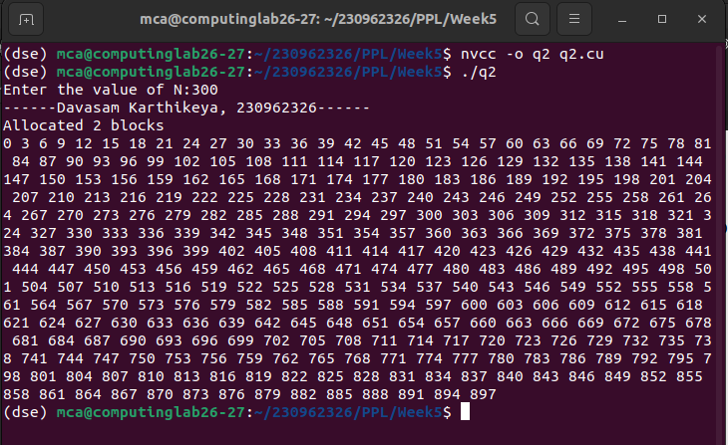

3. Write a program in CUDA to process a 1D array containing angles in radians to generate sine of the angles in the output array. Use appropriate function.
Code:-
#include <cuda.h>
#include <stdio.h>

#define N 300

__global__ void findSin(float *a, float *b){
int tid = blockDim.x * blockIdx.x + threadIdx.x;

if(tid >= N)return;
b[tid] = sinf(a[tid]);
}

int main(){
float a[N], b[N];
for(int i = 0; i < N; i++)a[i]=i;
float *dA, *dB;

int size = sizeof(float);

printf("------Davasam Karthikeya, 230962326------\n");

cudaMalloc((void **)&dA, N * size);
cudaMalloc((void **)&dB, N * size);

cudaMemcpy(dA, &a[0], N * size, cudaMemcpyHostToDevice);

findSin<<<(N-1)/256 + 1, 256>>>(dA, dB);

cudaMemcpy(b, dB, N * size, cudaMemcpyDeviceToHost);

for(int i =0; i < N; i++)printf("%f ", b[i]);
printf("\n");

cudaFree(dA);
cudaFree(dB);

return 0;
}

Output:-
