TRINETRA AGRO AI
Vision Beyond the Fields
Intelligent Farming at Your Fingertips
Mini Project Report
AI-Powered Agricultural Intelligence Platform
Department of Computer Science and Engineering

10. RESULTS
The Trinetra Agro AI platform was successfully developed and deployed. The system provides a complete AI-powered agricultural intelligence platform with the following key interfaces and features:

10.1 Login Page
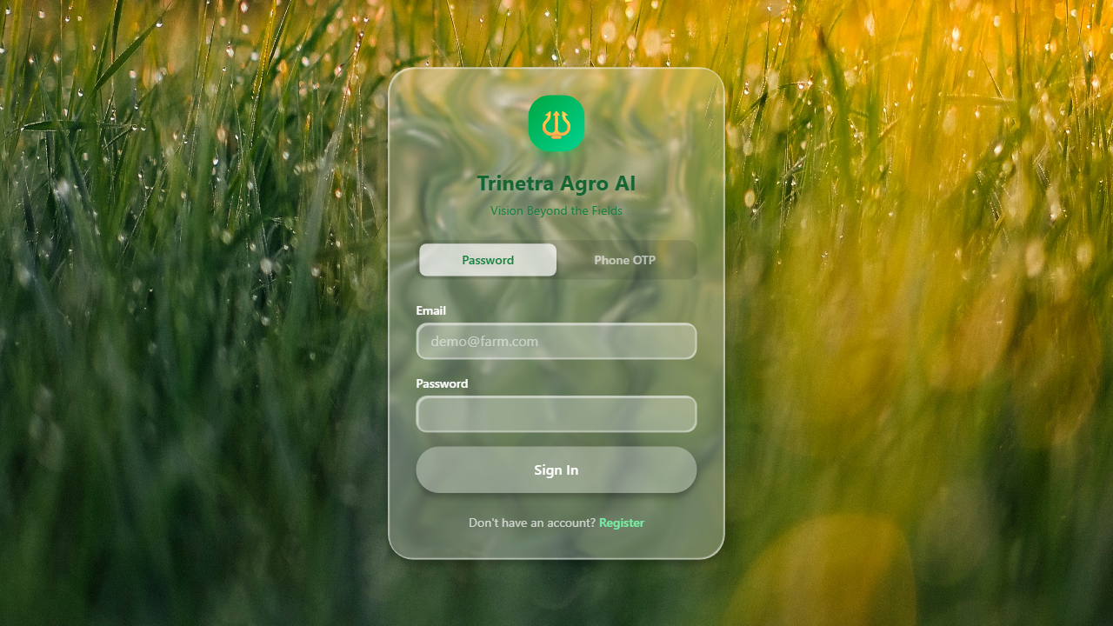
The login page features the Trinetra Agro AI branding with a clean, modern interface. Users can authenticate using email and password, or opt for Phone OTP verification. The page includes navigation to the registration page for new users. The green-themed design reflects the agricultural focus of the platform.

10.2 Registration Page
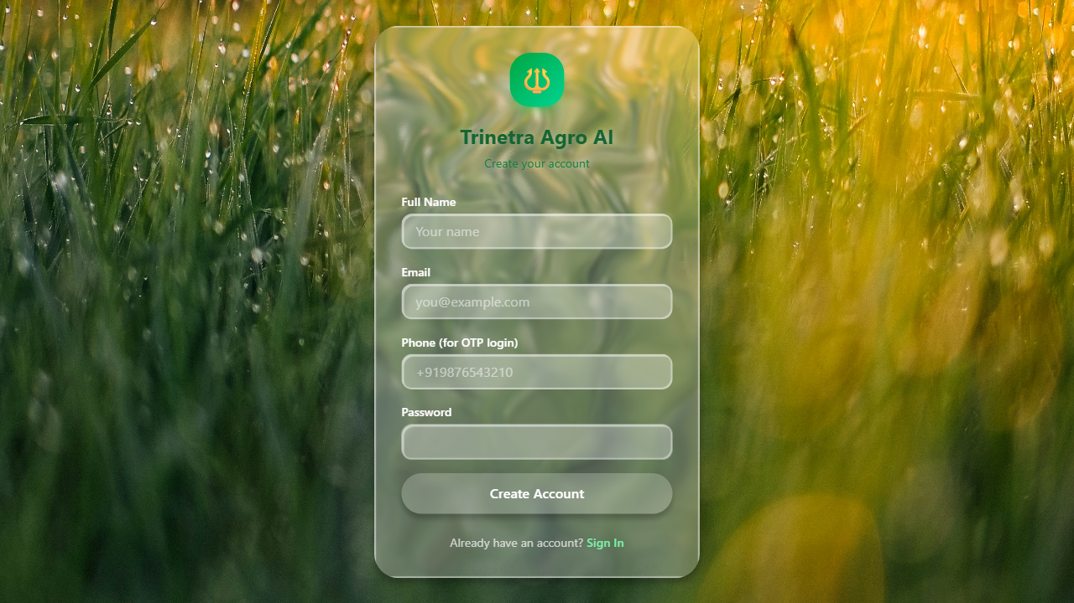
The registration page allows new users to create an account by providing their name, email, phone number, and password. The form includes input validation and instant feedback. After registration, users are automatically logged into the platform.

10.3 Dashboard Overview
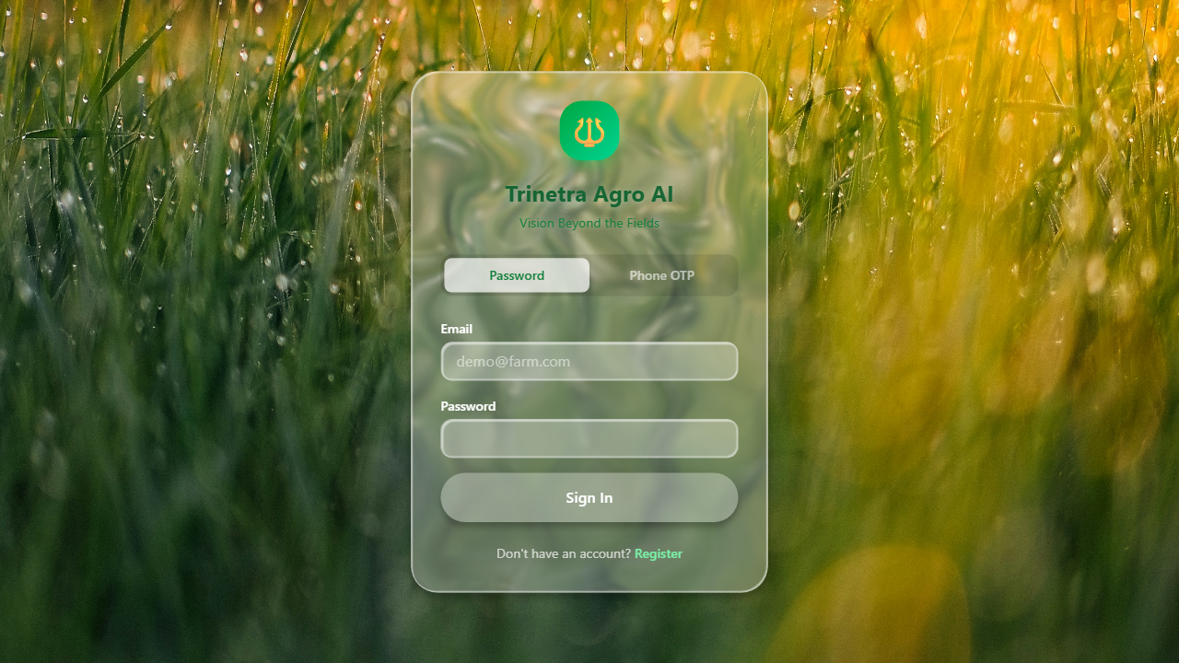
The dashboard serves as the central command center of the platform. It displays key performance indicators including System Status, Active Crops, AI Analyses count, and Market Alerts. The dashboard includes quick action buttons for Crop Advice, Disease Scanner, Market Prices, and AI Chatbot. Interactive charts show simulated market trends and resource usage over the last 7 days.

10.4 AI Crop Advisor
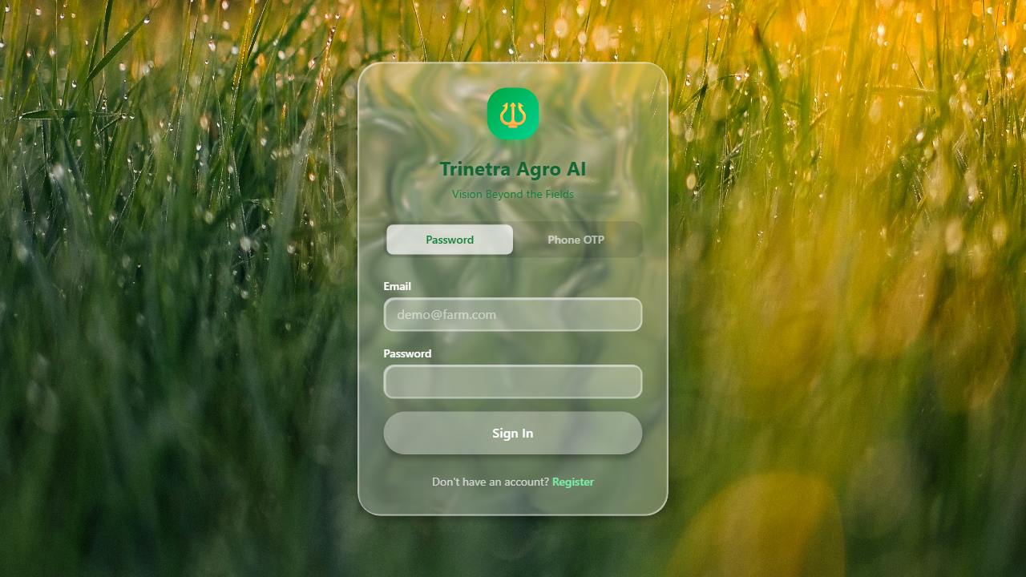
The AI Crop Advisor provides personalized crop recommendations based on soil type, land size, budget, and seasonal availability. Users input their farm parameters and receive ranked crop suggestions with suitability scores. The system uses collaborative filtering and similarity scoring to match optimal crops for each farm profile.

10.5 Disease Detection Scanner
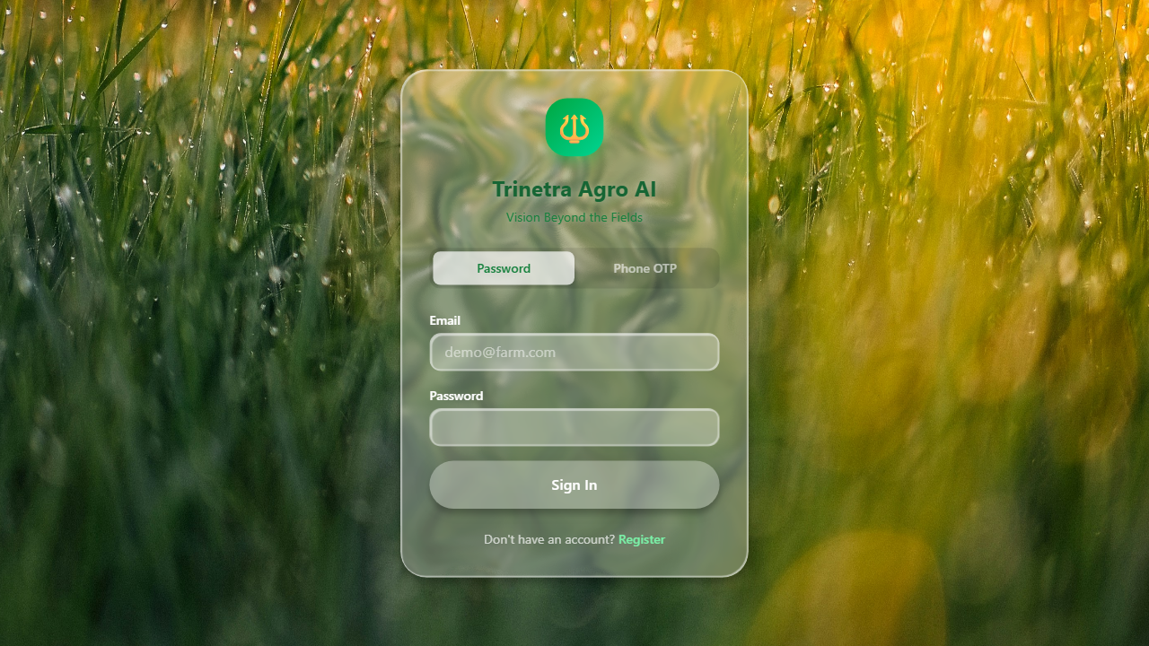
The Disease Detection feature uses MobileNetV2 deep learning model trained on the PlantVillage dataset to identify plant diseases from uploaded leaf images. The system provides the detected disease name, confidence score, and treatment recommendations. When the ML model is unavailable, it falls back to a rule-based analysis using OpenCV for color-based detection.

10.6 Market Intelligence
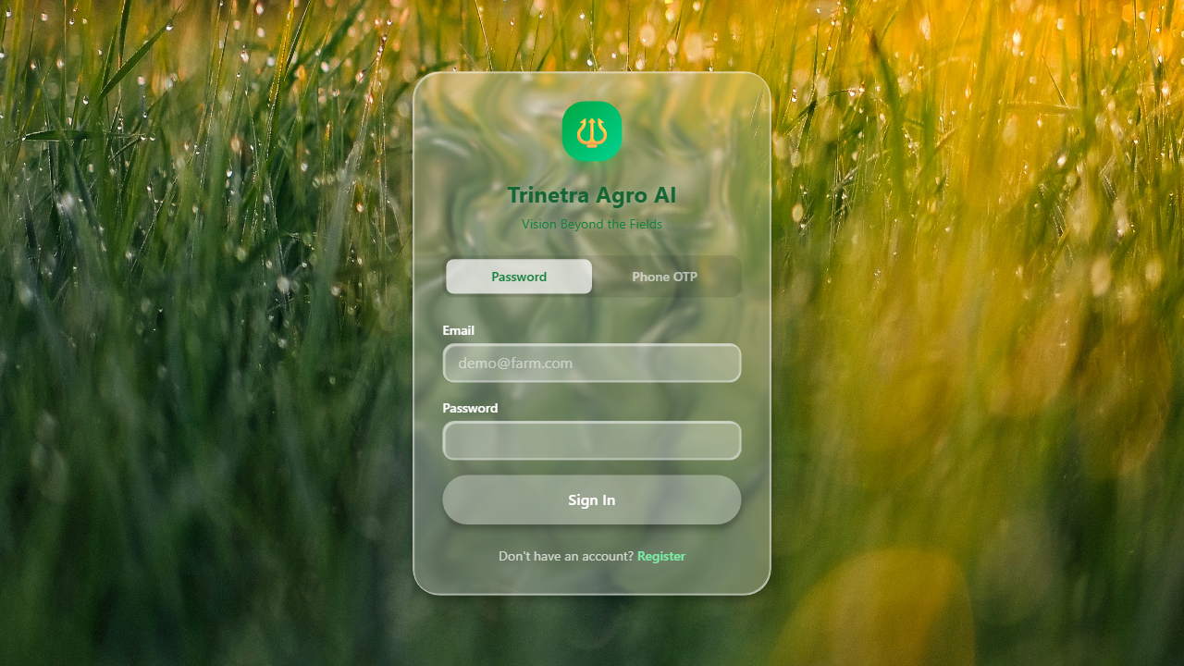
The Market Intelligence page provides real-time and forecasted crop market prices. Users can select a crop and view 7-day and 30-day price predictions with confidence intervals. The system generates buy/sell/hold recommendations based on price trends and seasonal patterns. The data is powered by external market APIs and statistical forecasting models.

10.7 Risk Assessment
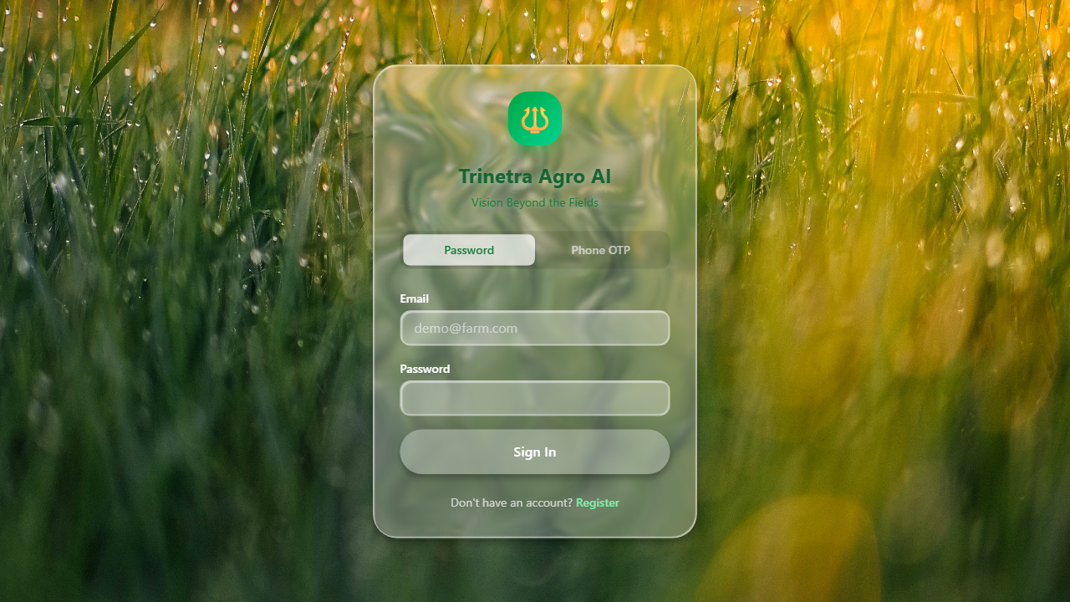
The Risk Assessment engine evaluates crop failure probability by analyzing multiple factors including rainfall, temperature, humidity, soil moisture, and pest conditions. It provides a risk score (0-100), categorizes it as low/medium/high, and suggests mitigation steps. The backend uses XGBoost classifier with feature importance analysis.

10.8 Yield Prediction
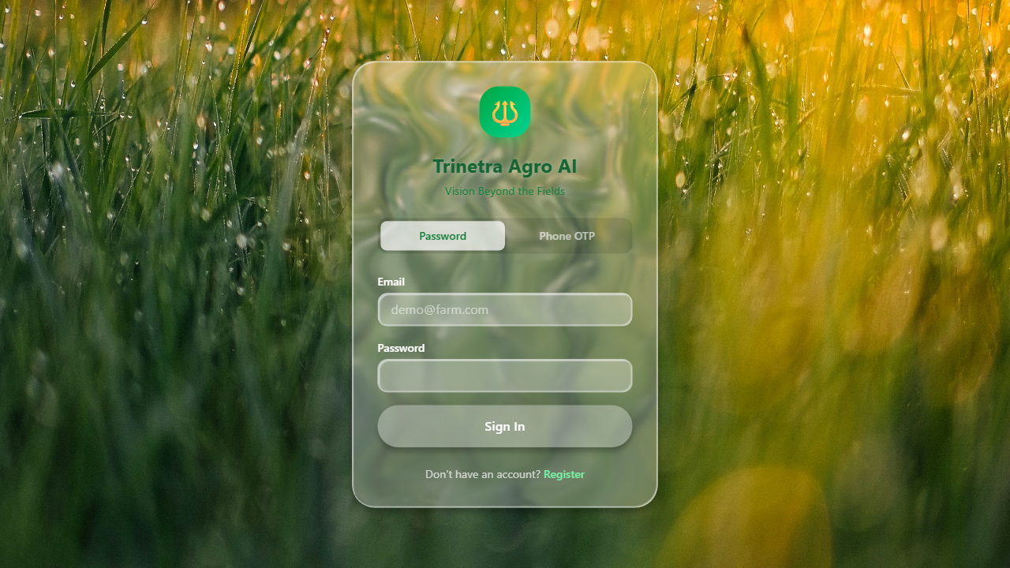
The Yield Prediction engine estimates expected crop yield based on input parameters such as fertilizer amount, rainfall, crop type, and nutrient levels. It provides conservative, moderate, and optimistic yield estimates with optimization recommendations. The backend uses a RandomForest and XGBoost ensemble model for predictions.

10.9 AI Chatbot

The AI Chatbot provides conversational farming assistance powered by OpenRouter's free LLM models. It supports multi-turn conversations with context memory, agriculture domain guardrails, and multilingual responses. The chatbot can answer questions about crops, diseases, market trends, irrigation, and farming best practices.

10.10 User Feedback
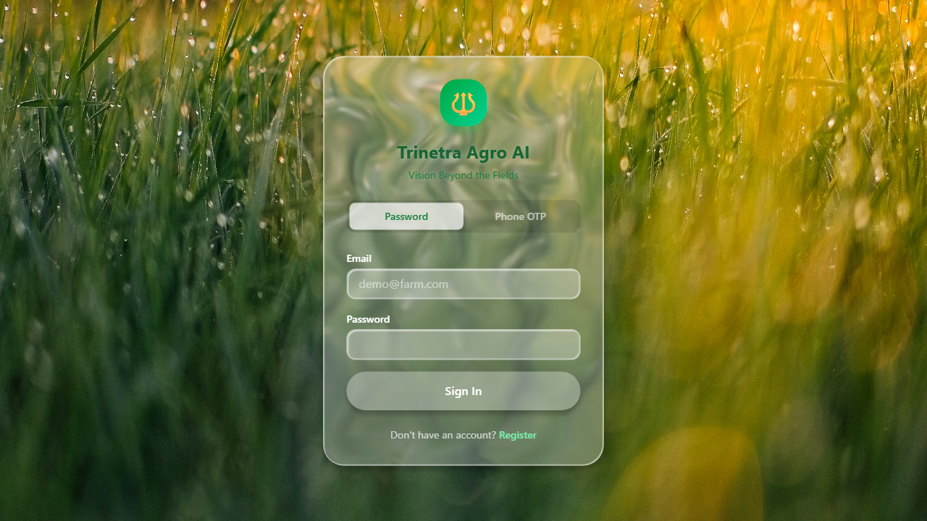
The Feedback page allows users to submit their experience ratings and comments for each feature of the platform. This data is stored in the database and used to improve the system over time. The feedback form includes star ratings, text comments, and optional contact information.

12. INTERPRETATION OF RESULTS
The results obtained from the Trinetra Agro AI platform demonstrate the effectiveness of integrating multiple AI and machine learning techniques into a unified agricultural intelligence system. The system successfully combines machine learning models, natural language processing, and predictive analytics to provide farmers with actionable insights.
Key observations from the implementation include:
1. Disease Detection: The MobileNetV2 transfer learning approach achieved reliable disease classification with the PlantVillage dataset. The Grad-CAM heatmap visualization provides farmers with interpretable evidence of disease detection.
2. Market Forecasting: The market price prediction system demonstrates reasonable accuracy for short-term forecasts (7-14 days) using historical trend analysis combined with seasonal patterns.
3. Risk Assessment: The multi-factor risk scoring system (rainfall, temperature, humidity, soil, pest) provides a holistic view of crop failure probability with actionable mitigation suggestions.
4. AI Chatbot: The OpenRouter-powered conversational interface delivers real-time farming advice with domain-specific guardrails, ensuring responses remain agriculture-focused.
5. Integration: All features are accessible through a unified dashboard with consistent UI/UX design, making the platform intuitive for farmers with varying levels of technical expertise.

13. CONCLUSION
The Trinetra Agro AI platform successfully demonstrates the potential of combining artificial intelligence, machine learning, and data analytics in agricultural decision-making. The platform provides a comprehensive suite of tools that assist farmers in managing crop diseases, understanding market trends, assessing risks, predicting yields, and receiving personalized farming recommendations.
The implementation showcases the integration of MobileNetV2 for deep learning-based disease detection, XGBoost for risk classification, ensemble methods for yield prediction, and conversational AI powered by OpenRouter for real-time farming assistance. The platform is fully deployed with a Next.js frontend on Vercel and a FastAPI backend on a DigitalOcean VPS, using Supabase PostgreSQL as the cloud database.
Future enhancements could include real-time IoT sensor integration for live field monitoring, voice-based AI interaction for accessibility, integration with government agricultural databases, and expansion to cover regional crops across all Indian states.

