A Mini Project Report
on
LOQQIN – LEARNING ORIENTED QUESTION QUALITY PREDICTOR

BACHELOR OF ENGINEERING
in
ARTIFICIAL INTELLIGENCE AND DATA SCIENCE

by
B. RAJESH (160723747315)
M. DIVYA VANI (160723747316)
P. SAI MITHIL (160723747317)

Under the Guidance of
Mrs. Manisha
Assistant Professor, Dept. of CSE


Department of Artificial Intelligence and Data Science
Methodist College of Engineering and Technology,
King Koti, Abids, Hyderabad-500001.
2025-2026

Methodist College of Engineering and Technology,
King Koti, Abids, Hyderabad-500001,

Department of Artificial Intelligence and Data Science



DECLARATION BY THE CANDIDATES

We, B.RAJESH (160723747315), M.DIVYA VANI (160723747316) and P.SAI MITHIL (160723747317) students of Methodist College of Engineering and Technology, pursuing Bachelor’s degree in Artificial Intelligence and Data Science, hereby declare that this Mini Project report entitled “LOQQIN – LEARNING ORIENTED QUESTION QUALITY PREDICTOR ", carried out under the guidance of Mrs. Manisha Assistant Professor submitted in partial fulfilment of the requirements for the degree of Bachelor of Engineering in Artificial Intelligence and Data Science. This is a record work carried out by us and the results embodied in this report have not been reproduced/copied from any source.

B. RAJESH (160723747315)
M. DIVYA VANI (160723747316)
P.SAI MITHIL (160723747317)

Methodist College of Engineering and Technology,
King Koti, Abids, Hyderabad-500001.
Department of Artificial Intelligence and Data Science


CERTIFICATE BY THE SUPERVISOR

This is to certify that this Mini Project work entitled “LOQQIN – LEARNING ORIENTED QUESTION QUALITY PREDICTOR” by B.Rajesh (160723747315), M.Divya vani (160723747316) and P.Sai Mithil (160723747317) submitted in partial fulfilment of the requirements for the degree of Bachelor of Engineering in Department of Artificial Intelligence and Data Science, during the academic year 2025-2026, is a Bonafide record of work carried out by them.

Mrs.Manisha
Assistant Professor
CSE Dept

Methodist College of Engineering and Technology,
King Koti, Abids, Hyderabad-500001,

Department of Artificial Intelligence and Data Science


CERTIFICATE BY HEAD OF THE DEPARTMENT

This is to certify that this Mini Project work entitled “LOQQIN – LEARNING ORIENTED QUESTION QUALITY PREDICTOR” by B.Rajesh (160723747315), M.Divya vani(160723747316) and P.Sai Mithil (160723747317) submitted in partial fulfilment of the requirements for the degree of Bachelor of Engineering in Department of Artificial Intelligence and Data Science, during the academic year 2025-2026, is a Bonafide record of work carried out by them.

Prof. M. Sharada Varalakshmi,
Professor and
Head of the Department

Methodist College of Engineering and Technology,
King Koti, Abids, Hyderabad-500001,

Department of Artificial Intelligence and Data Science


PROJECT APPROVAL CERTIFICATE

This is to certify that this Mini Project work entitled “LOQQIN – LEARNING ORIENTED QUESTION QUALITY PREDICTOR” by B.Rajesh (160723747315), M.Divya vani (160723747316) and P.Sai Mithil (160723747317) submitted in partial fulfilment of the requirements for the degree of Bachelor of Engineering in Department of Artificial Intelligence and Data Science during the academic year 2025-2026, is a bonafide record of work carried out by them.

INTERNAL EXTERNAL HOD
ACKNOWLEDGEMENT

We would like to express our sincere gratitude to my project guide Mrs. MANISHA, Assistant Professor, AI&ML, for giving us the opportunity to work on this topic. It would never be possible for us to take this project to this level without his innovative ideas and his relentless support and encouragement.
We would like to thank our project coordinator DR. ARUNA , Assistant Professor, CSE, who helped us by being an example of high vision and pushing towards greater limits of achievement.
Our sincere thanks to Dr. M. Sharada Varalakshmi, Professor and Head of the Department of AI&DS & CSE(AI), for her valuable guidance and encouragement which has played a major role in the completion of the project and for helping us by being an example of high vision and pushing towards greater limits of achievement.
We would like to express a deep sense of gratitude towards the Dr. Prabhu G. Benakop, Principal, Methodist College of Engineering and Technology, for always being an inspiration and for always encouraging us in every possible way.
We would like to express a deep sense of gratitude towards the Dr. Lakshmipathi Rao, Director, Methodist College of Engineering and Technology, for always being an inspiration and for always encouraging us in every possible way.

We are indebted to the Department of Artificial Intelligence and Data Science and Methodist College of Engineering and Technology for providing us with all the required facility to carry our work in a congenial environment. We extend our gratitude to the Department staff for providing us to the needful time to time whenever requested.
We would like to thank our parents for allowing us to realize our potential, all the support they have provided us over the years was the greatest gift anyone has ever given us and also for teaching us the value of hard work and education. Our parents have offered us with tremendous support and encouragement, thanks to our parents for all the moral support and the amazing opportunities they have given us over the years.


Vision & Mission

VISION
To become a leader in providing Computer Science & Engineering education with emphasis on knowledge and innovation.

MISSION
M1: To offer flexible programs of study with collaborations to suit industry needs
M2: To provide quality education and training through novel pedagogical practices
M3: To Expedite high performance of excellence in teaching, research and innovations.
M4: To impart moral, ethical valued education with social responsibility.

Program Educational Objectives
Graduates of Computer Science and Engineering at Methodist College of Engineering and Technology will be able to:
PEO1: | Apply technical concepts, Analyze, synthesize data to Design and create novel products and solutions for the real-life problems.
PEO2: | Apply the knowledge of Computer Science Engineering to pursue higher education with due consideration to environment and society.
PEO3: | Promote collaborative learning and spirit of team work through multidisciplinary projects
PEO4: | Engage in life-long learning and develop entrepreneurial skills.

Program Specific Outcomes
At the end of 4 years, Computer Science and Engineering graduates at MCET will be able to:
PSO1: | Apply the knowledge of Computer Science and Engineering in various domains like networking and data mining to manage projects in multidisciplinary environments.
PSO2: | Develop software applications with open-ended programming environments.
PSO3: | Design and develop solutions by following standard software engineering principles and implement by using suitable programming languages and platforms

PROGRAM OUTCOMES
At the end of the four-year Bachelor of Engineering Program, engineering graduates will be able to:
PO1. Engineering knowledge: Apply the knowledge of mathematics, science, engineering fundamentals, and an engineering specialization to the solution of complex engineering problems.
PO2. Problem analysis: Identify, formulate, review research literature, and analyze complex engineering problems reaching substantiated conclusions using first principles of mathematics, natural sciences, and engineering sciences.
PO3. Design/development of solutions: Design solutions for complex engineering problems and design system components or processes that meet the specified needs with appropriate consideration for the public health and safety, and the cultural, societal, and environmental considerations.
PO4. Conduct investigations of complex problems: Use research-based knowledge and research methods including design of experiments, analysis and interpretation of data, and synthesis of the information to provide valid conclusions.
PO5. Modern tool usage: Create, select, and apply appropriate techniques, resources, and modern engineering and IT tools including prediction and modeling to complex engineering activities with an understanding of the limitations.
PO6. The engineer and society: Apply reasoning informed by the contextual knowledge to assess societal, health, safety, legal and cultural issues and the consequent responsibilities relevant to the professional engineering practice.
PO7. Environment and sustainability: Understand the impact of the professional engineering solutions in societal and environmental contexts, and demonstrate the knowledge of, and need for sustainable development.
PO8. Ethics: Apply ethical principles and commit to professional ethics and responsibilities and norms of the engineering practice.
PO9. Individual and team work: Function effectively as an individual, and as a member or leader in diverse teams, and in multidisciplinary settings.
PO10. Communication: Communicate effectively on complex engineering activities with the engineering community and with society at large, such as, being able to comprehend and write effective reports and design documentation, make effective presentations, and give and receive clear instructions.
PO11. Project management and finance: Demonstrate knowledge and understanding of the engineering and management principles and apply these to one’s own work, as a member and leader in a team, to manage projects and in multidisciplinary environments.
PO12. Life-long learning: Recognize the need for, and have the preparation and ability to engage in independent and life-long learning in the broadest context of technological change.

TABLE OF CONTENTS

S. No. | Title | Page No.
 | Certificate | I
 | Acknowledgement | II
 | Abstract | III
1 | Introduction | 1
1.1 | Problem Statement | 2
1.2 | Objective | 2
1.3 | Scope | 3
1.4 | Organization of Report
2 | Literature Survey | 4
3 | System Analysis | 6
3.1 | Existing System | 6
3.1.1 | Drawbacks | 6
3.2 | Proposed System | 7
3.2.1 | Advantages | 8
3.3 | Applications | 8
3.4 | Software Requirement Specifications | 9
4 | System Design | 12
4.1 | UML Diagrams | 15
4.2 | Data Flow Diagram | 18
5 | Implementation | 20
6 | Testing | 37
7 | Results | 39
7.1 | Present results obtained | 40
7.2 | Screenshots | 41
7.3 | Performance analysis | 43
7.4 | Interpretation of results | 43
 | Conclusion | 44
 | Future Enhancements | 45
 | References | 46
 | Appendix  Project Mapping, (QR CODE with all project docs in Gdrive) | 47

LIST OF FIGURES
Figure No. | Title | Page No.
7.1 | UML DIAGRAM | 15
7.2 | SEQUENCE DIAGRAM | 16
7.3 | CLASS DIAGRAM | 17
7.4 | DATA FLOW DIAGRAM | 18
7.5 | ACTIVITY DIAGRAM | 19

LIST OF TABLES
Table No. | Title | Page No.
2 | LITERSTURE SURVEY | 4

ABSTRACT

Question papers and questionnaires from previous examinations contain valuable patterns about the type, depth, and importance of questions asked over time. However, students and educators often rely on manual analysis or guesswork to identify the most relevant questions for upcoming exams. This project proposes a Question Quality Predictor that uses machine learning to analyse past question papers and questionnaires to identify high quality and exam-relevant questions. The system takes historical question papers as input and evaluates each question based on linguistic depth, conceptual coverage, and recurrence patterns across multiple exams. Using Natural Language Processing techniques, the model assigns a quality score to each question and classifies it based on whether it tests deep understanding or surface-level knowledge. The output is a ranked list of most eligible questions that are likely to be important for future examinations. Unlike traditional exam prediction methods that focus only on frequency, this approach evaluates the quality and learning value of questions, providing a more meaningful and data-driven way to support exam preparation. The proposed system can assist students in focused revision and help educators design balanced and effective question papers, demonstrating a practical and innovative application of machine learning in education.

1. INTRODUCTION

In world driven by information, the quality of your questions determines the quality of your questions determines the quality of your answers. Enter LOQQIN, the AI-powered Question Quality Predictor designed to refine your inquiry skills. Whether you’re a student, researcher, or a professional, asking the right question is half the battle. LOQQIN leverages advanced Natural Language Processing to analyse your text instantly. It doesn’t just say “good” or “bad”; it provides a nuanced quality score. Our machine learning model evaluates clarity, specificity, and context. Built on a robust Python stack, it uses calibrated classifiers for reliable predictions. You get real-time feedback with confidence metrics you can trust. Imagine submitting a query knowing it's optimized for the best response. That's the power of LOQQIN in your workflow.
We bridge the gap between curiosity and clarity. No more vague prompts or misunderstood intentions. The system learns from structured data to highlight ambiguities. It suggests improvements before you hit send. This tool is essential for educators grading inquiries. It helps developers debug their prompt engineering. We believe better questions lead to breakthroughs. Our mission is to elevate communication standards globally. With LOQQIN, every question becomes an opportunity. Stop guessing if your question is clear enough. Let data-driven insights guide your curiosity. The engine runs efficiently, ensuring quick turnaround times. Privacy and accuracy are at the core of our design.
LOQQIN (Learning-Oriented Question Quality Intelligence Network) is an AI-powered Question Quality Predictor developed to address this challenge. The system uses Machine Learning and Natural Language Processing techniques to analyze questions and determine their overall quality based on factors such as clarity, specificity, completeness, relevance, and contextual richness. By examining linguistic features and semantic relationships within a question, LOQQIN provides users with an objective quality score along with actionable feedback for improvement.
The increasing adoption of AI chatbots, virtual assistants, and automated learning platforms has created a growing demand for effective prompt and question formulation. Many users struggle to communicate their intentions clearly, leading to suboptimal interactions with intelligent systems. LOQQIN helps bridge this gap by offering real-time assessment and recommendations that guide users toward constructing more precise and meaningful questions.

1.1 PROBLEM STATEMENT
In the modern information age, obtaining accurate and relevant answers depends heavily on the quality of the questions being asked. However, many users, including students, researchers, educators, and professionals, often struggle to formulate clear, specific, and context-rich questions. Poorly structured questions can lead to ambiguous interpretations, inaccurate responses, and inefficient communication, especially when interacting with search engines, educational systems, and Artificial Intelligence applications.Currently, there is no widely accessible automated system that can effectively evaluate the quality of a question and provide meaningful feedback for improvement before it is submitted. Most existing systems focus on answering questions rather than assessing whether the questions themselves are well-formed and capable of producing useful responses.
Therefore, there is a need for an intelligent system that can automatically analyze questions, measure their quality based on linguistic and semantic features, identify ambiguities, and provide a quality score along with improvement suggestions. Such a system would help users formulate better questions, enhance communication effectiveness, improve learning outcomes, and optimize interactions with AI-powered platforms.

1.2 OBJECTIVE
To develop an AI-powered Question Quality Predictor that evaluates the quality of user-generated questions using Machine Learning and Natural Language Processing techniques and provides a quality score along with constructive feedback for improvement.
Specific Objectives
- To collect and preprocess a dataset of questions for training and evaluation purposes.
- To analyze questions based on linguistic features such as grammar, clarity, readability, and sentence structure.
- To extract semantic and contextual information from questions using Natural Language Processing techniques.
- To identify ambiguities, incomplete information, and lack of specificity in user queries.
- To develop a machine learning model capable of classifying questions into different quality levels (High, Medium, and Low).
- To generate a numerical quality score that reflects the effectiveness and clarity of a question.
- To provide real-time suggestions and feedback for improving question quality.
- To improve communication effectiveness between users and AI systems, search engines, and educational platforms.
- To design a user-friendly interface that allows users to easily submit questions and receive instant evaluations.
- To evaluate the performance of the proposed model using standard metrics such as Accuracy, Precision, Recall, and F1-Score.
- To assist students, researchers, educators, and professionals in formulating better questions for improved learning and decision-making.
- To promote effective inquiry and critical thinking by encouraging the creation of clear, relevant, and context-rich questions.

1.3 SCOPE OF THE PROJECT
1. Develop an AI-powered system to evaluate the quality of user-generated questions.
2. Analyze questions using Natural Language Processing (NLP) techniques.
3. Assess question quality based on clarity, specificity, relevance, completeness, and grammatical correctness.
4. Generate a quality score for each submitted question.
5. Classify questions into different categories such as High, Medium, and Low Quality.
6. Identify ambiguous, incomplete, or poorly structured questions.
7. Provide suggestions and feedback to improve question quality.
8. Support students in preparing better academic and examination-related questions.
9. Assist educators in designing and evaluating effective assessment questions.
10. Help researchers create clear and meaningful survey and questionnaire items.
11. Improve communication with AI systems, search engines, and chatbot applications.

2. LITERATURE SURVEY
S.No | Paper Title | Author | Technique Used | Advantages | Disadvantages
1 | Automated Assessment of Question Quality in Community Question Answering Systems  https://ojs.aaai.org/index.php/ICWSM/article/view/14529 | Shah et al | Natural Language Processing (NLP), Feature Extraction | Identifies well-structured and informative questions. | Performance depends on training data quality.
2 | Question Classification using Machine Learning Techniques  https://www.cambridge.org/core/journals/natural-language-engineering/article/learning-question-classifiers-the-role-of-semantic-information/F3E3EBFC2061BBF74A6EB926A3A3B291 | Li and Roth | Support Vector Machine (SVM), Text Classification | Accurately categorizes questions into predefined classes. | Limited understanding of deep semantic context.
3 | BERT-Based Models for Text Quality Assessment  https://arxiv.org/abs/1909.00578 | Devlin et al. | BERT, Deep Learning, Transformer Networks | Captures contextual meaning and improves prediction accuracy. | Requires high computational resources.
4 | Automatic Evaluation of Educational Questions using NLP  https://www.ijcaonline.org/archives/volume48/number13/7405-0101 | Heilman et al. | NLP, Semantic Analysis, Educational Data Mining | Assesses educational relevance and complexity of questions. | Domain-specific datasets are required.
5 | Readability Assessment of Text using Machine Learning  https://arxiv.org/abs/1603.08868 | Vajjala et al. | Readability Metrics, Machine Learning Algorithms | Measures clarity and comprehensibility of text. | Focuses mainly on readability rather than overall quality.
6 | Prompt Quality Evaluation for AI Systems  https://arxiv.org/abs/2102.07350 | Reynolds and McDonell | Prompt Engineering, Language Models | Improves effectiveness of AI-generated responses. | Evaluation criteria may vary across applications.
7 | Semantic Similarity and Question Quality Prediction using Deep Learning  https://journals.sagepub.com/doi/10.3233/JCM-215217 | Yang et al. | Deep Neural Networks, Word Embeddings, Semantic Analysis | Detects ambiguity and evaluates question relevance effectively. | Requires large datasets for training and optimization.

3.SYSTEM ANALYSIS
System Analysis is the process of studying and evaluating a system to understand its functionality, identify limitations, and determine requirements for developing an improved solution. It involves examining the existing methods, analyzing user needs, and proposing an efficient system that addresses current challenges.
In the context of LOQQIN (Learning-Oriented Question Quality Intelligence Network), system analysis focuses on understanding the problems associated with poorly formulated questions and the lack of automated mechanisms to evaluate question quality. Many existing platforms provide answers to user queries but do not assess whether the questions themselves are clear, specific, relevant, or contextually complete. As a result, users often receive inaccurate or less useful responses.
The proposed analysis identifies the need for an intelligent system that can automatically evaluate questions, predict their quality, and provide suggestions for improvement. By utilizing Natural Language Processing (NLP) and Machine Learning (ML) techniques, LOQQIN aims to bridge the gap between question formulation and information retrieval, ensuring that users can communicate their intentions more effectively and obtain better outcomes.

3.1 EXISTING SYSTEM
Current approaches to question evaluation often rely on human review or basic rule-based checks. Platforms like Stack Overflow use community voting to surface quality, but feedback arrives post-submission, not in real-time. Educational tools like Coursera offer rubric-based grading, yet they lack dynamic, AI-driven analysis of phrasing. Writing assistants like Grammarly polish grammar and tone, but they don't assess the structural quality of a question. In NLP research, question-answering benchmarks (e.g., SQuAD) focus on answer accuracy, not the inquiry's inherent clarity. Prompt-engineering tools like PromptPerfect optimize for LLM outputs, yet few specialize in measuring question quality itself. Survey platforms (Qualtrics, Typeform) validate logic flow but rarely evaluate semantic depth or specificity. Academic studies propose metrics like Bloom's taxonomy levels, but these remain manual and context dependent.
3.1.1 DRAWBACKS OF THE EXISTING SYSTEM
• Most platforms provide feedback only after posting, missing the opportunity for real-time refinement.
• Grammar tools focus on syntax and tone rather than semantic clarity or underlying intent.
• Academic rubrics require manual effort and lack adaptability across diverse subject domains.
• Prompt tools optimize for AI responses rather than the intrinsic quality of the inquiry itself.
• Automated validators use rigid logic that fails to capture nuanced ambiguity or missing context.
• Existing classifiers often lack calibrated confidence scores needed for trustworthy user coaching.

3.2 PROPOSED SYSTEM
LOQQIN is an AI-powered Question Quality Coach that evaluates inquiries in real-time. Built with Python and scikit-learn, it leverages NLP to parse question structure and semantics. Our core model uses LinearSVC with probability calibration for reliable, interpretable scores. Each question receives a quality rating alongside a confidence metric you can trust. We analyze clarity, specificity, context completeness, and intent alignment—not just grammar. The system provides instant, actionable feedback before you submit or send your question. LOQQIN adapts across domains: education, research, customer support, and prompt engineering. Educators can use it to train students in formulating stronger, more answerable questions. Developers benefit by refining prompts for LLMs, reducing iteration cycles and ambiguity. We prioritize transparency: users see why a score was assigned, not just a black-box number. Privacy-first design ensures your questions are processed securely, without persistent storage. LOQQIN integrates seamlessly into workflows via CLI, API, or future UI components from. Unlike reactive platforms, we intervene proactively coaching you before the question ships. Calibrated predictions mean high-confidence suggestions you can act on with certainty. We bridge academic rigor in question taxonomy with the speed of modern machine learning. The system learns from structured datasets to recognize patterns of effective inquiries. Ambiguity detection flags vague pronouns, missing constraints, or overloaded questions. Our mission: elevate global communication by making every question count. With LOQQIN, curiosity meets clarity—and better questions unlock better answers.

- APPLICATION SOF THE PROJECT
The LOQQIN (Learning-Oriented Question Quality Intelligence Network) system has a wide range of applications across education, research, business, and Artificial Intelligence domains. By evaluating and improving question quality, the system enhances communication and information retrieval processes.
Applications of LOQQIN
- Educational Institutions
  - Helps students formulate clear and effective academic questions.
  - Assists teachers in designing high-quality examination and assignment questions.
- E-Learning Platforms
  - Improves the quality of learner queries submitted on online learning portals.
  - Enhances interaction between students and intelligent tutoring systems.
- Research and Survey Design
  - Assists researchers in creating meaningful survey and questionnaire items.
  - Improves the quality and reliability of collected responses.
- Artificial Intelligence and Chatbots
  - Optimizes user prompts and questions submitted to AI systems.
  - Increases the accuracy and relevance of AI-generated responses.
- Search Engines and Information Retrieval
  - Helps users create precise search queries for better search results.
  - Reduces ambiguity in information-seeking processes.
- Customer Support Systems
  - Assists customers in submitting detailed and relevant support requests.
  - Enables faster and more accurate issue resolution.
- Prompt Engineering
  - Supports developers and AI practitioners in crafting effective prompts.
  - Improves interactions with Large Language Models (LLMs).
- Knowledge Management Systems
  - Enhances question quality in discussion forums and knowledge-sharing platforms.

4.1 ADVANTAGES
The proposed system LOQQIN (Learning-Oriented Question Quality Intelligence Network) offers several advantages in evaluating and improving the quality of user-generated questions.
Advantages of LOQQIN
- Automated Question Evaluation
  - Automatically analyzes and evaluates the quality of questions without manual intervention.
- Improved Question Clarity
  - Helps users formulate clear, precise, and understandable questions.
- Real-Time Feedback
  - Provides instant quality assessment and improvement suggestions.
- Quality Score Generation
  - Assigns a numerical score that reflects the overall quality of a question.
- Ambiguity Detection
  - Identifies vague, incomplete, or confusing questions and highlights areas for improvement.
- Enhanced Information Retrieval
  - Improves the chances of obtaining accurate and relevant answers from search engines and AI systems.
- Supports Educational Activities
  - Assists students, teachers, and researchers in creating effective academic and assessment questions.
- Machine Learning-Based Prediction
  - Utilizes advanced Machine Learning algorithms for reliable and data-driven evaluation.

- SOFTWARE REQUIREMENTS
5.1 FUNCTIONAL REQUIREMENTS:
Functional requirements define the specific operations and services that the LOQQIN system must perform.
1. The system shall allow users to enter questions for evaluation.
2. The system shall preprocess the input text using NLP techniques.
3. The system shall extract linguistic and semantic features from questions.
4. The system shall analyze question clarity, relevance, specificity, and completeness.
5. The system shall predict the quality of a question using machine learning models.
6. The system shall generate a quality score for each question.
7. The system shall classify questions into High, Medium, or Low Quality categories.
8. The system shall detect ambiguous or incomplete questions.

5.2 NON FUNCTIONAL REQUIREMENTS
Non-functional requirements specify the quality attributes and constraints of the LOQQIN system.
1. Performance Requirements
- The system should process and evaluate questions within a few seconds.
- The prediction results should be generated efficiently with minimal delay.
2. Reliability Requirements
- The system should provide consistent and accurate predictions.
- The system should operate without failures during normal usage.
3. Usability Requirements
- The user interface should be simple, intuitive, and easy to navigate.
- Users should be able to submit questions and view results without technical expertise.
4. Security Requirements
- User data should be protected from unauthorized access.
- The system should ensure the confidentiality of submitted questions.
5. Scalability Requirements
- The system should support a growing number of users and questions.
- The architecture should allow future feature enhancements.
6. Maintainability Requirements
- The system should be easy to update, modify, and maintain.
- New machine learning models and datasets should be integrated easily.

5.3 SOFTWARE REQUIREMENTS
• Programming Language: Python 3.8+ (core development language)
• ML/NLP Libraries: scikit-learn (modeling), spaCy or NLTK (text preprocessing), pandas/numpy (data handling)
• Model Calibration: CalibratedClassifierCV (for reliable probability estimates with LinearSVC)
• Development Tools: Git (version control), VS Code/PyCharm (IDE), pytest (testing)
• Data Storage: SQLite or lightweight JSON/CSV for local caching (no persistent user data by default)
• UI Integration: Streamlit or HTML, CSS, JavaScript.
5.4 EXTERNAL INTERFACE REQUIREMENTS
1. User Interface Requirements
- The system shall provide a simple and user-friendly interface for entering questions and viewing results.
2. Software Interface Requirements
- The system shall interact with NLP and Machine Learning libraries such as NLTK, SpaCy, and Scikit-learn.
3. Hardware Interface Requirements
- The system shall operate on standard computers, laptops, and cloud-based platforms.
4. Communication Interface Requirements
- The system shall support communication through HTTP/HTTPS protocols for web-based deployment.

Hardware Components Required:
• Modern laptop/desktop with 8GB+ RAM, 4-core CPU, and 256GB+ storage.

6. SYSTEM DESIGN
6.1 SYSTEM ARCHITECTURE
1. Consists of User Input, Data Processing, Machine Learning, Recommendation, and Output modules.
2. Processes user questions and predicts their quality.
3. Generates quality scores and improvement suggestions.
6.2 USER INPUT MODULE
1. Accepts questions from users through a user interface.
2. Validates the entered question.
3. Sends the input to the processing module.
6.3 DATA PROCESSING MODULE
1. Performs text preprocessing.
2. Removes stop words and special characters.
3. Applies tokenization and lemmatization.
4. Extracts relevant textual features.
6.4 MACHINE LEARNING MODULE
1. Uses trained machine learning models.
2. Analyzes linguistic and semantic features.
3. Predicts question quality.
4. Classifies questions into quality levels.
6.5 RECOMMENDATION MODULE
1. Generates improvement suggestions.
2. Identifies ambiguous or incomplete questions.
3. Recommends ways to improve clarity and relevance.

6.6 SOUND THERAPY MODULE
1. Calculates a numerical quality score.
2. Measures clarity, specificity, and completeness.
3. Categorizes questions as High, Medium, or Low Quality.
6.7 OUTPUT MODULE
1. Displays the quality score.
2. Shows classification results.
3. Presents recommendations and feedback.
6.8 DATA DESIGN FLOW
1. User enters a question.
2. Question is preprocessed.
3. Features are extracted.
4. Machine learning model evaluates quality.
5. Quality score is generated.
6. Recommendations are created.
7. Results are displayed.
6.9 DATABASE DESIGN
1. Stores user questions.
2. Stores prediction results.
3. Maintains quality scores and classifications.
4. Supports retrieval of historical records.
6.9.1 USER INTERFACE DESIGN
The user interface consists of:
- Question Input Text Box
- Submit Button
- Quality Score Display
- Classification Result Display
- Feedback and Recommendation Section
- History/Report Section (Optional)

6.10 SYSTEM WORKFLOW
1. User enters a question.
2. System preprocesses the text.
3. Features are extracted from the question.
4. Machine learning model evaluates question quality.
5. Quality score is generated.
6. Question is classified into quality categories.
7. Recommendations are generated.
8. Results are displayed to the user.
6.11 DESIGN CONSIDERATIONS
1. High prediction accuracy.
2 . Fast response time.
3. User-friendly interface.
4. Scalability for large datasets.
5. Data privacy and security.
6. Easy maintenance and future upgrades.
7. Integration with advanced NLP and AI models.
8. Support for future multilingual extensions.

7. DIAGRAMS

UML DIAGRAM:
The UML Use Case Diagram represents the interaction between the user and the LOQQIN system. It provides a graphical view of the functionalities offered by the system and the actions performed by the user. The primary actor in the system is the User, who interacts with LOQQIN to evaluate the quality of questions and receive improvement suggestions.

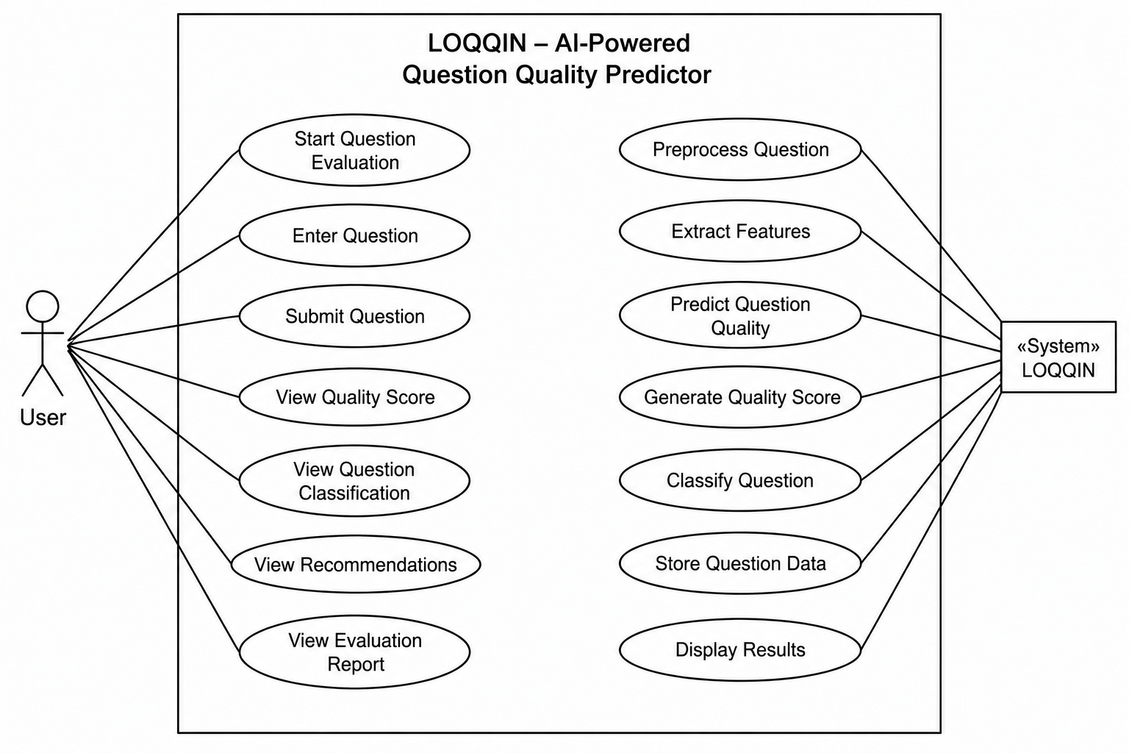
FIG NO:7.1 UML DIAGRAM

SEQUENCE DIAGRAM:
A sequence diagram represents the interaction between different objects in the system. The important aspect of a sequence diagram is that it is time-ordered. This means that the exact sequence of the interactions between the objects is represented step by step. Different objects in the sequence diagram interact with each other by passing "messages".

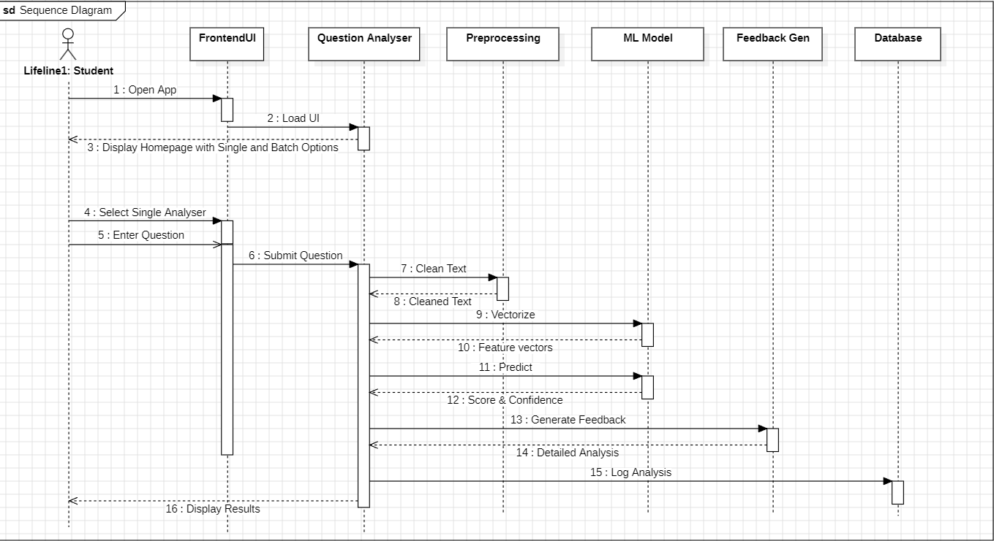

FIG NO 7.2: SEQUENCE DIAGRAM

CLASS DIAGRAM:
The class diagram is used to refine the use case diagram and define a detailed design of the system. The class diagram classifies the actors defined in the use case diagram into a set of interrelated classes. The relationship or association between the classes can be either an "is-a" or "has-a" relationship. Each class in the class diagram may be capable of providing certain functionalities. These functionalities provided by the class are termed "methods" of the class. Apart from this, each class may have certain "attributes" that uniquely identify the class.

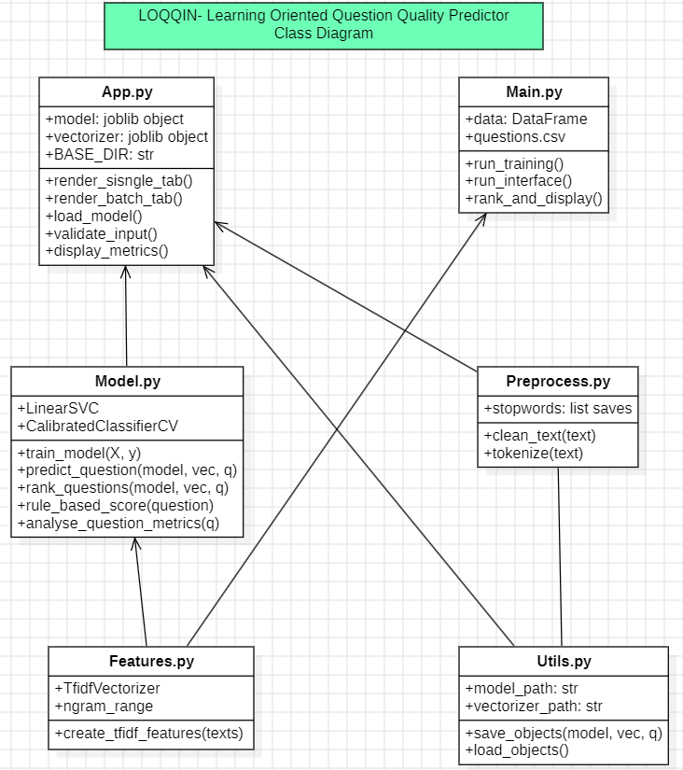

FIG NO 7.3 CLASS DIAGRAM

DATA FLOW DIAGRAM:
The Data Flow Diagram (DFD) of LOQQIN – AI-Powered Question Quality Predictor illustrates the flow of data within the system from user input to the final output. The process begins when the user enters and submits a question through the Input Module. The submitted question is then forwarded to the Data Preprocessing Module, where text cleaning operations such as tokenization, stop-word removal, and normalization are performed. After preprocessing, the cleaned text is sent to the Feature Extraction Module, which extracts important linguistic, semantic, and contextual features from the question.
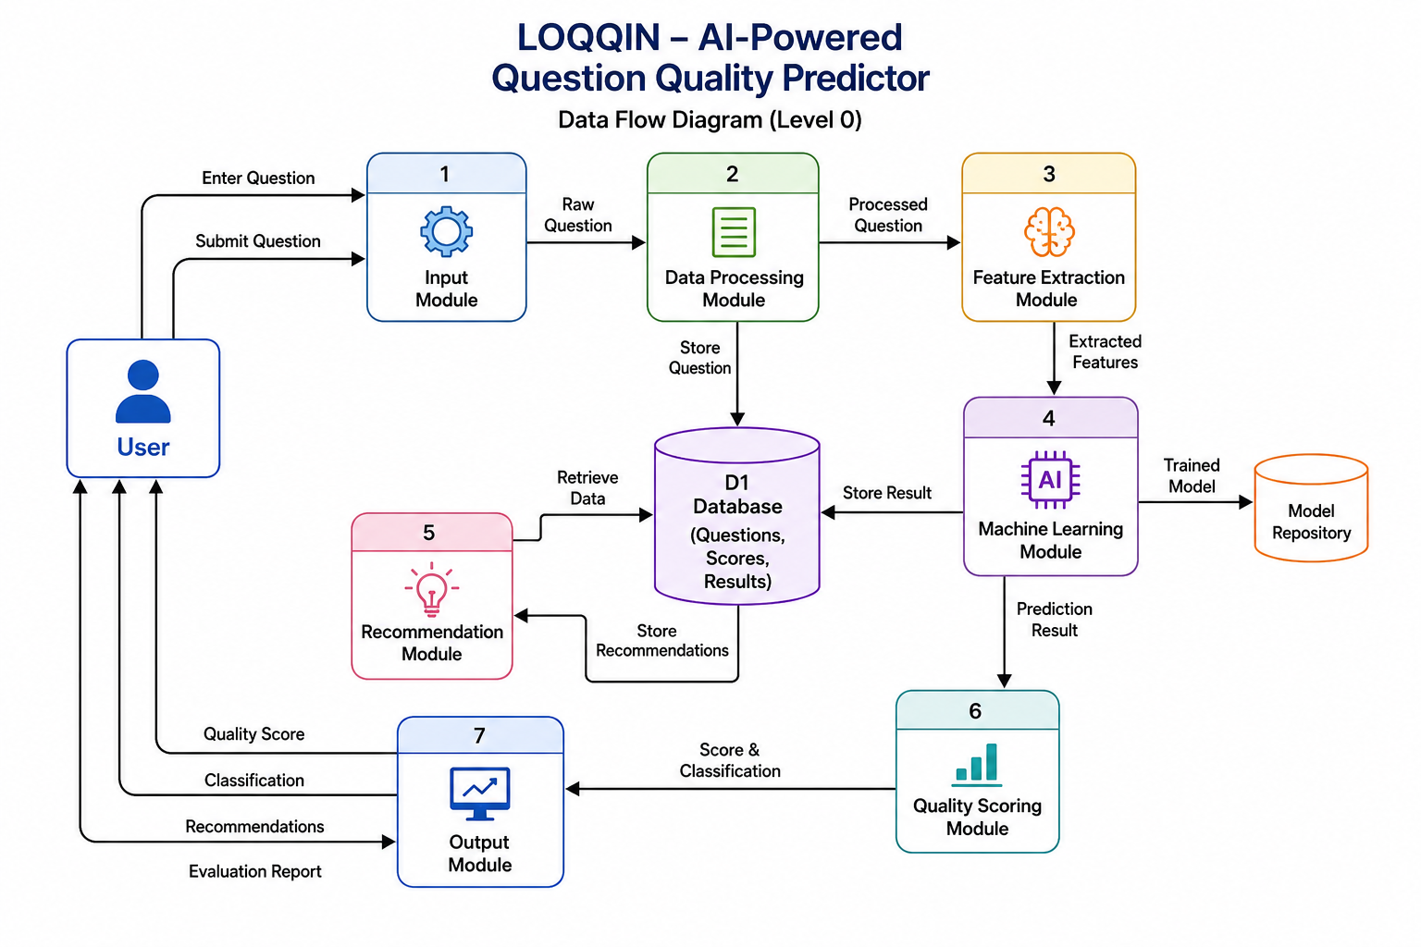
FIG NO 7.4 DATA FLOW DIAGRAM

ACTIVITY DIAGRAM:
Activity diagram is defined as a UML diagram that focuses on the execution and flow of the behaviour of a system instead of implementation. It is also called object-oriented flowchart. Activity diagrams consist of activities that are made up of actions which apply to behavioural modelling technology.

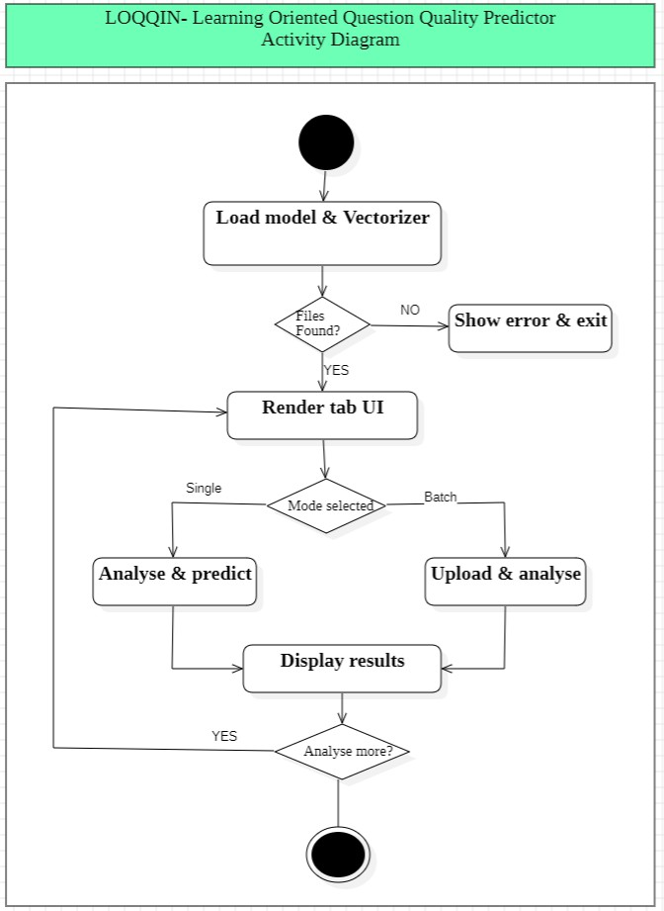

FIG NO 7.5 ACTIVITY DIAGRAM

8. IMPLEMENTATION
# -----------------------------
# IMPORTS
# -----------------------------
import sys
import os
PROJECT_ROOT = os.path.abspath(os.path.join(os.path.dirname(__file__), ".."))
sys.path.insert(0, PROJECT_ROOT)
import streamlit as st
import joblib
from src.preprocess import clean_text
from src.model import predict_question, rank_questions, analyze_question_metrics
# Load Models
BASE_DIR = os.path.dirname(os.path.abspath(__file__))
try:
model = joblib.load(os.path.join(BASE_DIR, "model.pkl"))
vectorizer = joblib.load(os.path.join(BASE_DIR, "vectorizer.pkl"))
except FileNotFoundError:
st.error("
st.stop()
Model files not found. Please run `python train.py` first.")
# -----------------------------
# PAGE CONFIG
# -----------------------------
st.set_page_config(
page_title="LOQQIN",
page_icon="
",

layout="centered",
initial_sidebar_state="collapsed"
)

st.markdown("""
<style>
/* Import Inter Font */
@import
url('https://fonts.googleapis.com/css2?family=Inter:wght@300;400;500;600;700;800&d
isplay=swap');

/* CSS Variables */
:root {
--background-gradient: linear-gradient(135deg, #667eea 0%, #764ba2 100%);
--glass-bg: rgba(255, 255, 255, 0.95);
--glass-border: rgba(255, 255, 255, 0.4);
--glass-shadow: 0 8px 32px 0 rgba(31, 38, 135, 0.2);
--blur: 16px;

--foreground: #1A1A2E;
--foreground-secondary: #4A4A68;
--muted-foreground: #6B7280;
--primary: #6366F1;
--primary-hover: #4F46E5;
--success: #16A34A;
--warning: #D97706;
--destructive: #DC2626;
--radius: 18px;
}

/* Background with Gradient */
.stApp {
background: var(--background-gradient);
background-attachment: fixed;
min-height: 100vh;
}

/* Hide Streamlit Branding */
#MainMenu {visibility: hidden;}
footer {visibility: hidden;}
header {visibility: hidden;}

/* Header with Better Contrast */
.loqqin-header {
text-align: center;
margin-bottom: 35px;
padding: 35px 0;
}
.loqqin-header h1 {
font-size: 42px;
font-weight: 800;
color: #FFFFFF;
margin: 0;
text-shadow: 0 4px 16px rgba(0,0,0,0.3);
letter-spacing: -0.5px;
}
.loqqin-header p {
color: rgba(255, 255, 255, 0.9);

font-size: 16px;
margin: 12px 0 0 0;
font-weight: 400;
text-shadow: 0 2px 8px rgba(0,0,0,0.2);
}

/* Glassmorphism Card - ENHANCED VISIBILITY */
.glass-card {
background: var(--glass-bg);
backdrop-filter: blur(var(--blur));
-webkit-backdrop-filter: blur(var(--blur));
border: 1px solid var(--glass-border);
border-radius: var(--radius);
padding: 32px;
margin: 20px 0;
box-shadow: var(--glass-shadow);
transition: all 0.4s cubic-bezier(0.4, 0, 0.2, 1);
}

.glass-card:hover {
background: rgba(255, 255, 255, 0.98);
box-shadow: 0 16px 48px 0 rgba(31, 38, 135, 0.3);
transform: translateY(-3px);
}

/* Button with Better Contrast */
.stButton>button {
background: linear-gradient(135deg, var(--primary) 0%, var(--primary-hover)
100%);
color: white !important;

border-radius: calc(var(--radius) - 6px);
padding: 14px 32px;
border: 1px solid rgba(255,255,255,0.3);
font-weight: 600;
font-family: 'Inter', sans-serif;
font-size: 15px;
width: 100%;
height: 52px;
transition: all 0.3s cubic-bezier(0.4, 0, 0.2, 1);
box-shadow: 0 4px 16px rgba(99, 102, 241, 0.4);
letter-spacing: 0.2px;
}
.stButton>button:hover {
transform: translateY(-2px);
box-shadow: 0 8px 28px rgba(99, 102, 241, 0.5);
}

/* Progress Bar */
.stProgress > div > div > div > div {
background: linear-gradient(90deg, var(--primary) 0%, var(--primary-hover) 100%);
border-radius: 999px;
box-shadow: 0 2px 12px rgba(99, 102, 241, 0.5);
}
.stProgress > div {
height: 16px;
border-radius: 999px;
background: rgba(0, 0, 0, 0.15);
backdrop-filter: blur(4px);
}

/* Score Display */
.score-display {
font-size: 56px;
font-weight: 800;
background: linear-gradient(135deg, var(--foreground) 0%, var(--primary) 100%);
-webkit-background-clip: text;
-webkit-text-fill-color: transparent;
background-clip: text;
text-align: center;
margin: 18px 0;
text-shadow: 0 4px 16px rgba(0,0,0,0.1);
}
.score-display span {
font-size: 24px;
font-weight: 600;
color: var(--muted-foreground);
-webkit-text-fill-color: var(--muted-foreground);
}

/* Glass Badges - ENHANCED */
.badge {
display: inline-block;
padding: 10px 24px;
border-radius: 999px;
font-size: 15px;
font-weight: 700;
width: 100%;
text-align: center;

backdrop-filter: blur(8px);
-webkit-backdrop-filter: blur(8px);
border: 1px solid rgba(255,255,255,0.3);
box-shadow: 0 2px 8px rgba(0,0,0,0.1);
}
.badge-high {
background: rgba(22, 163, 74, 0.25);
color: var(--success);
border-color: rgba(22, 163, 74, 0.4);
}
.badge-med {
background: rgba(217, 119, 6, 0.25);
color: var(--warning);
border-color: rgba(217, 119, 6, 0.4);
}
.badge-low {
background: rgba(220, 38, 38, 0.25);
color: var(--destructive);
border-color: rgba(220, 38, 38, 0.4);
}

/* Glass Metrics Cards */
.metric-card {
background: rgba(255, 255, 255, 0.7);
backdrop-filter: blur(8px);
-webkit-backdrop-filter: blur(8px);
padding: 22px;
border-radius: calc(var(--radius) - 6px);
text-align: center;

display: flex;
flex-direction: column;
align-items: center;
gap: 10px;
border: 1px solid rgba(0,0,0,0.08);
transition: all 0.3s ease;
box-shadow: 0 2px 12px rgba(0,0,0,0.06);
}
.metric-card:hover {
transform: translateY(-4px);
background: rgba(255, 255, 255, 0.85);
box-shadow: 0 8px 24px rgba(0,0,0,0.12);
}
.metric-label {
color: var(--muted-foreground);
font-size: 13px;
font-weight: 700;
text-transform: uppercase;
letter-spacing: 0.8px;
}
.metric-value {
color: var(--foreground);
font-size: 21px;
font-weight: 700;
}

/* Text Area - ENHANCED VISIBILITY */
.stTextArea label {
font-weight: 700;

color: var(--foreground);
font-family: 'Inter', sans-serif;
font-size: 15px;
margin-bottom: 8px;
}
.stTextArea textarea {
font-family: 'Inter', sans-serif;
border-radius: calc(var(--radius) - 6px);
border: 2px solid rgba(0,0,0,0.1);
background: rgba(255, 255, 255, 0.95);
backdrop-filter: blur(4px);
font-size: 15px;
padding: 14px;
color: var(--foreground);
transition: all 0.3s ease;
}
.stTextArea textarea:focus {
border-color: var(--primary);
box-shadow: 0 0 0 3px rgba(99, 102, 241, 0.2);
outline: none;
}

/* Character Counter - FIXED VISIBILITY */
.char-counter {
color: rgba(255, 255, 255, 0.9);
font-size: 13px;
font-weight: 500;
margin-top: 8px;
text-shadow: 0 2px 4px rgba(0,0,0,0.2);

}

/* Divider */
hr {
border: none;
border-top: 1px solid rgba(0,0,0,0.1);
margin: 30px 0;
}

/* Tabs - ENHANCED */
.stTabs [data-baseweb="tab-list"] {
gap: 10px;
background: rgba(255,255,255,0.15);
padding: 8px;
border-radius: calc(var(--radius) + 6px);
backdrop-filter: blur(12px);
-webkit-backdrop-filter: blur(12px);
border: 1px solid rgba(255,255,255,0.2);
}
.stTabs [data-baseweb="tab"] {
font-family: 'Inter', sans-serif;
font-weight: 600;
border-radius: calc(var(--radius) - 6px);
background: transparent;
border: none;
color: rgba(255,255,255,0.8);
padding: 12px 24px;
transition: all 0.3s ease;
}

.stTabs [data-baseweb="tab"]:hover {
background: rgba(255,255,255,0.2);
color: white;
}
.stTabs [data-baseweb="tab"][aria-selected="true"] {
background: white;
color: var(--primary);
box-shadow: 0 4px 16px rgba(0,0,0,0.15);
font-weight: 700;
}

/* Subheader & Caption - FIXED VISIBILITY */
.stSubheader {
color: var(--foreground);
font-weight: 700;
font-size: 22px;
margin-bottom: 8px;
}
.stCaption {
color: rgba(255, 255, 255, 0.9);
font-size: 14px;
text-shadow: 0 2px 4px rgba(0,0,0,0.2);
}

/* Expander (Glass) */
.streamlit-expanderHeader {
background: rgba(255, 255, 255, 0.9);
backdrop-filter: blur(8px);
border-radius: calc(var(--radius) - 6px);

border: 1px solid rgba(0,0,0,0.1);
}

/* Success/Warning/Error Messages */
.stAlert {
background: rgba(255, 255, 255, 0.95);
backdrop-filter: blur(8px);
border-radius: calc(var(--radius) - 6px);
border: 1px solid rgba(0,0,0,0.1);
}

/* Smooth Scroll */
html {
scroll-behavior: smooth;
}

/* Animations */
@keyframes fadeInUp {
from {
opacity: 0;
transform: translateY(20px);
}
to {
opacity: 1;
transform: translateY(0);
}
}

.glass-card {

animation: fadeInUp 0.5s cubic-bezier(0.4, 0, 0.2, 1);
}
</style>
""", unsafe_allow_html=True)

# -----------------------------
# HEADER
# -----------------------------
st.markdown("""
<div class="loqqin-header">
<h1> LOQQIN</h1>
<p>Learning-Oriented Question Quality Predictor</p>
</div>
""", unsafe_allow_html=True)

# -----------------------------
# TABS
# -----------------------------
tab1, tab2 = st.tabs([" Single Analyzer", " Batch Upload"])

# =====================================================
# TAB 1: SINGLE QUESTION
# =====================================================
with tab1:
st.subheader("Analyze a Question")
st.caption("Paste any exam or assessment question to get instant quality feedback.")

question = st.text_area(
"Enter your question",

placeholder="Explain the architecture of IoT and how sensors communicate with the
cloud...",
height=140
)

st.markdown(f'<p class="char-counter"> {len(question)} characters</p>',
unsafe_allow_html=True)

if st.button(" Analyze Question"):
if not question.strip():
st.warning(" Please enter a question to analyze.")
else:
with st.spinner(" Analyzing question depth..."):
cleaned = clean_text(question)
prediction, score = predict_question(model, vectorizer, cleaned)
clarity, specificity, bloom = analyze_question_metrics(question)

score10 = round(score, 1)

# Score Section
st.markdown('<div style="text-align: center; margin: 40px 0;">',
unsafe_allow_html=True)
st.markdown('<p class="metric-label"> Quality Score</p>',
unsafe_allow_html=True)
st.progress(min(score, 10.0) / 10.0)
st.markdown(f'<div class="score-display">{score10}<span>/10</span></div>',
unsafe_allow_html=True)

# Badge
if score10 >= 7:

badge_class = "badge-high"
badge_text = " High Quality Question "
elif score10 >= 4:
badge_class = "badge-med"
badge_text = " Medium Depth Question"
else:
badge_class = "badge-low"
badge_text = " Surface Level Question"

st.markdown(f'<div class="badge {badge_class}">{badge_text}</div>',
unsafe_allow_html=True)
st.markdown('</div>', unsafe_allow_html=True)

st.divider()

# Metrics Grid
c1, c2, c3 = st.columns(3)
with c1:
st.markdown(f'''
<div class="metric-card">
<div class="metric-label"> Clarity</div>
<div class="metric-value">{clarity}</div>
</div>
''', unsafe_allow_html=True)
with c2:
st.markdown(f'''
<div class="metric-card">
<div class="metric-label"> Specificity</div>
<div class="metric-value">{specificity}</div>

</div>
''', unsafe_allow_html=True)
with c3:
st.markdown(f'''
<div class="metric-card">
<div class="metric-label"> Bloom Level</div>
<div class="metric-value">{bloom}</div>
</div>
''', unsafe_allow_html=True)

st.divider()
c1, c2 = st.columns(2)
with c1:
if st.button(" Analyze Another", use_container_width=True):
st.rerun()
with c2:
st.download_button(
label=" Export Result",
data=f"LOQQIN Analysis Report\n\nQuestion: {question}\nScore:
{score10}/10\nClarity: {clarity}\nSpecificity: {specificity}\nBloom Level:
{bloom}\nVerdict: {badge_text}",
file_name="loqqin-report.txt",
use_container_width=True
)

st.markdown('</div>', unsafe_allow_html=True)

# =====================================================
# TAB 2: BATCH UPLOAD
# =====================================================

with tab2:
st.subheader(" Batch Question Analysis")
st.caption("Upload multiple questions to rank by quality. One question per line.")

uploaded_file = st.file_uploader("Choose a file", type=["txt", "csv"],
label_visibility="collapsed")

if uploaded_file:
content = uploaded_file.read().decode("utf-8")
questions = [q.strip() for q in content.split("\n") if q.strip()]

st.markdown(f'** Questions detected:** {len(questions)}')

if st.button(f" Analyze {len(questions)} Questions", use_container_width=True):
with st.spinner(" Analyzing questions..."):
cleaned_questions = [clean_text(q) for q in questions]
ranked = rank_questions(model, vectorizer, cleaned_questions)

st.success(f" Analyzed {len(questions)} questions!")

# Stats
high = sum(1 for _, _, s in ranked if s >= 7)
medium = sum(1 for _, _, s in ranked if 4 <= s < 7)
low = sum(1 for _, _, s in ranked if s < 4)

c1, c2, c3, c4 = st.columns(4)
c1.metric(" Total", len(questions))
c2.metric(" High", high)
c3.metric(" Medium", medium)

c4.metric(" Low", low)

st.divider()

# Question List
for i, (q, pred, score) in enumerate(ranked[:10]):
score10 = round(score, 1)
original = questions[cleaned_questions.index(q)] if q in cleaned_questions else
q

with st.expander(f"**#{i+1}** | {score10}/10 | {original[:55]}..."):
st.write(f"**Full Question:** {original}")
st.progress(min(score, 10.0) / 10.0)

if score10 >= 7:
st.success(" High Quality ")
elif score10 >= 4:
st.info(" Medium Quality")
else:
st.warning(" Low Quality")
st.divider()
csv_data = "Question,Score,Quality\n"
for q, _, s in ranked:
original = questions[cleaned_questions.index(q)] if q in cleaned_questions
else q
quality = "High" if s >= 7 else "Medium" if s >= 4 else "Low"
csv_data += f'"{original}",{s:.1f},{quality}\n'
st.download_button(
label=" Export All as CSV",

data=csv_data,
file_name="loqqin-batch.csv",
use_container_width=True
)
if st.button(" Clear & Start Over", use_container_width=True,
type="secondary"):
st.rerun()

st.markdown('</div>', unsafe_allow_html=True)

9. TESTING
9.1 Unit Testing
Unit testing is the process of testing individual modules or components of the system to ensure that they function correctly. In the LOQQIN system, unit testing was performed on several modules such as text preprocessing functions, TF-IDF vectorization logic, the LinearSVC prediction method, and the CalibratedClassifierCV wrapper. For example, the preprocessing module was tested to verify that it correctly removes URLs, normalizes text, and handles empty strings without raising exceptions. Similarly, the model module was tested to ensure that it returns both a quality label and a calibrated probability score for valid input. Unit testing helped identify errors at the early stages of development and ensured that each component works independently before integration.
9.2 Integration Testing
Integration testing is performed after unit testing to verify that different modules of the system work together correctly. In the LOQQIN system, multiple modules such as data loading, preprocessing, model inference, and output formatting were integrated. During this phase, the communication between the CLI interface (main.py), the model pipeline (src/model.py), and any optional API layer (FastAPI/Flask) was tested. For example, when a user submits a question via the CLI, the system must correctly pass the text through preprocessing, generate a prediction, apply calibration, and return a structured JSON response. Integration testing ensured that the interaction between different components occurs smoothly without data loss, type mismatches, or unexpected errors.
9.3 System Testing
System testing evaluates the entire system as a complete application. In this phase, the fully integrated LOQQIN platform was tested to verify that all features operate correctly under normal conditions. The end-to-end workflow was tested from user input to final output: a question is entered via CLI or API, processed through the NLP pipeline, scored by the calibrated model, and returned with an interpretable quality rating and explanation. System testing confirmed that the complete LOQQIN application operates according to the specified requirements and performs reliably across diverse question types, domains, and input lengths.System Testing is conducted to evaluate the overall functionality and performance of the LOQQIN – AI-Powered Question Quality Predictor system. This testing ensures that all modules, including the User Input Module, Data Processing Module, Machine Learning Module, Recommendation Module, and Output Module, work together correctly as an integrated system. During testing, various questions are submitted to verify that the system accurately preprocesses the input, extracts relevant features, predicts question quality, generates quality scores, and provides appropriate recommendations.
9.4 User Interface Testing
User Interface Testing is performed to verify that the LOQQIN system provides a user-friendly and efficient interface for users. The testing process ensures that all interface components, such as input fields, buttons, navigation options, and result display sections, function correctly and meet user requirements. During testing, users enter questions into the input field and submit them for evaluation. The system successfully processes the questions and displays the quality score, classification result, and improvement recommendations. Validation checks are also performed to ensure that appropriate error messages are displayed when users submit empty or invalid inputs. Additionally, the interface is tested for responsiveness, usability, and accessibility across different devices and screen sizes. The results confirm that the LOQQIN user interface is intuitive, reliable, and easy to use, enabling users to efficiently evaluate question quality and receive meaningful feedback for improvement.
9.5 Performance Testing
Performance testing evaluates how the system behaves under different levels of load and usage conditions. The LOQQIN system was tested to ensure that it delivers real-time feedback efficiently, even when processing batches of questions or handling concurrent API requests. Tests were conducted to measure inference latency, memory usage during model loading, and throughput under simulated load. The lightweight architecture (LinearSVC + TF-IDF) demonstrated stable performance with sub-second response times on standard CPU hardware. Performance testing ensures that the system provides a smooth, responsive user experience and scales gracefully as usage grows.

10. RESULTS

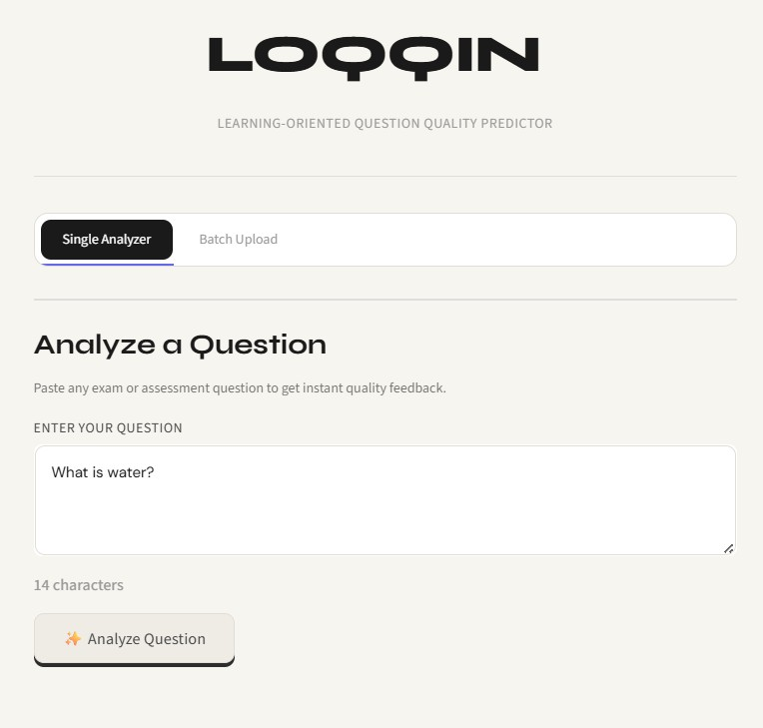
LOQQIN Homepage

Description:
The LOQQIN homepage features a sleek, modern dark-themed interface designed for simplicity and ease of use. The layout is clean and minimalistic, with the following key elements:

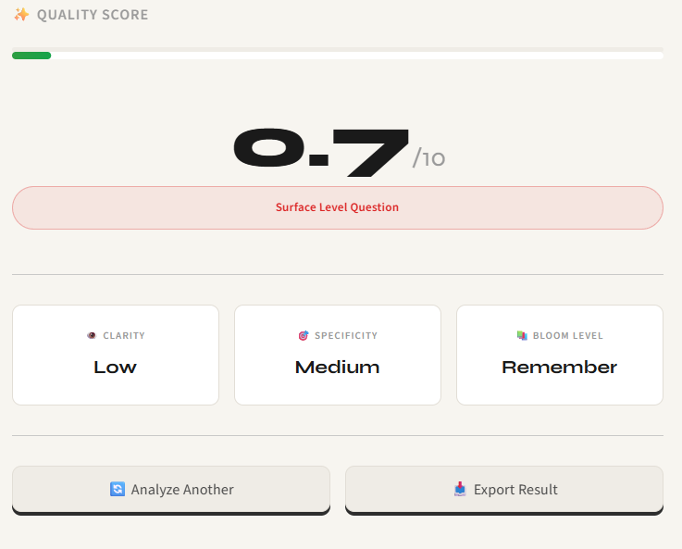

Single Question Tab

Description:
The analysis results page displays the evaluation feedback for a submitted question, maintaining the same sleek dark-themed interface as the homepage.


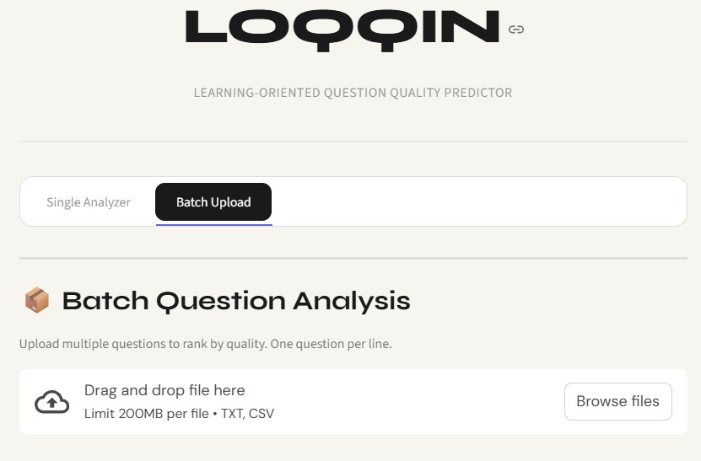

Batch Questions Tab

Description:
The Batch Upload interface provides users with the ability to analyse multiple questions simultaneously, maintaining the consistent dark-themed design of the LOQQIN platform.

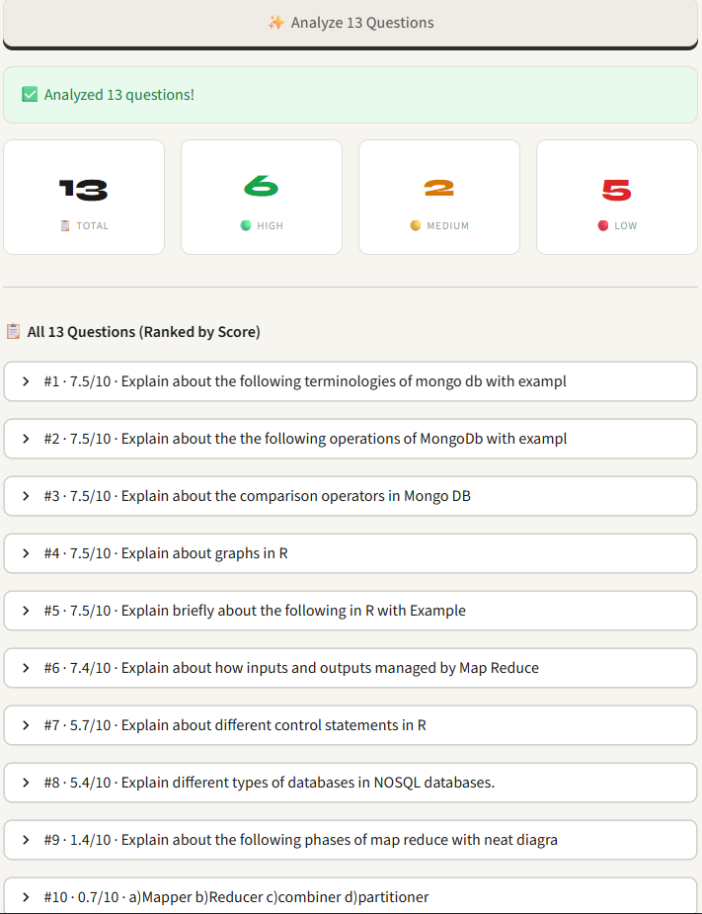
Batch Questions Tab Results

Description:
The batch analysis results page displays comprehensive evaluation feedback for multiple uploaded questions, presenting both summary statistics and detailed rankings in a clear, organized layout.
11. PERFORMANCE ANALYSIS
Performance Analysis is conducted to evaluate the efficiency, accuracy, reliability, and overall effectiveness of the LOQQIN – AI-Powered Question Quality Predictor system. The analysis focuses on measuring how well the system processes user questions, predicts question quality, and generates meaningful recommendations. The machine learning model is evaluated using standard performance metrics such as Accuracy, Precision, Recall, and F1-Score to determine the correctness of predictions. The system is also assessed based on response time, ensuring that quality scores and feedback are generated quickly after a question is submitted. During testing, LOQQIN successfully analyzed various types of questions and accurately classified them into quality categories such as High, Medium, and Low Quality.
The performance analysis further demonstrates that the Natural Language Processing techniques used for preprocessing and feature extraction effectively capture linguistic and semantic characteristics of questions. The recommendation module provides relevant suggestions for improving unclear or incomplete questions, thereby enhancing overall communication quality. Additionally, the system maintains consistent performance across different question formats and lengths. The results indicate that LOQQIN achieves reliable prediction accuracy, efficient processing speed, and high usability, making it a practical and effective solution for evaluating and improving question quality in educational, research, and professional environments.

12. INTERPRETATION OF RESULTS
The results obtained from the LOQQIN – AI-Powered Question Quality Predictor demonstrate the effectiveness of the system in evaluating the quality of user-generated questions. The machine learning model successfully analyzes questions based on factors such as clarity, specificity, completeness, grammatical correctness, and contextual relevance. After processing the input question, the system generates a quality score and classifies the question into categories such as High Quality, Medium Quality, or Low Quality. Questions that are clear, specific, and well-structured receive higher scores, whereas vague, ambiguous, or incomplete questions receive lower scores along with appropriate improvement suggestions.
The generated recommendations help users refine their questions by identifying weaknesses such as missing context, unclear wording, or lack of specificity. The results indicate that the Natural Language Processing and Machine Learning techniques employed by LOQQIN effectively capture the linguistic and semantic characteristics of questions. The system provides consistent and accurate evaluations across different question types and domains. Overall, the interpretation of results confirms that LOQQIN serves as a reliable tool for improving question quality, enhancing communication, and enabling users to obtain more accurate and meaningful responses from information retrieval systems, educational platforms, and AI-based applications.

13. CONCLUSION
The LOQQIN – AI-Powered Question Quality Predictor project successfully demonstrates the application of Machine Learning and Natural Language Processing (NLP) techniques in evaluating and improving the quality of user-generated questions. The system effectively analyzes questions based on important factors such as clarity, specificity, completeness, grammatical correctness, and contextual relevance. By generating a quality score and classifying questions into different quality levels, LOQQIN helps users understand the strengths and weaknesses of their questions.The developed system provides meaningful recommendations that assist users in refining their questions, thereby improving communication and increasing the likelihood of obtaining accurate and relevant responses. The integration of machine learning algorithms enables automated and reliable question quality assessment, reducing the need for manual evaluation. Furthermore, the system offers a user-friendly interface and real-time feedback, making it suitable for students, educators, researchers, and professionals.Overall, LOQQIN serves as an innovative and practical solution for enhancing question formulation and information retrieval. The project highlights the potential of AI-driven technologies in improving communication quality and supporting effective learning and decision-making. Future enhancements such as multilingual support, advanced deep learning models, and integration with AI assistants can further expand the capabilities and applications of the system. Thus, LOQQIN successfully achieves its objective of promoting better questioning practices and enabling users to communicate their ideas more clearly and effectively.

14. FUTRE ENHANCEMENTS
Transformer-Based Fine-Tuning: Integrate lightweight transformer models (e.g., DistilBERT, MiniLM) for deeper semantic understanding while maintaining inference speed. Multilingual Support: Expand preprocessing and training pipelines to support question evaluation in multiple languages, enabling global accessibility. Domain-Adaptive Models: Develop specialized model variants fine-tuned for specific contexts (e.g., academic research, technical debugging, customer support) to improve relevance and accuracy. Few-Shot Learning: Implement meta-learning techniques to allow rapid adaptation to new question types or domains with minimal labeled data.
Interactive Rewrite Suggestions: Move beyond scoring to provide AI-generated rephrasing options that improve clarity, specificity, or context. Explainable AI Dashboard: Visualize why a question received a certain score using attention maps, keyword highlights, or feature importance charts. Progress Tracking & Gamification: Allow users to track their question-quality improvement over time with badges, streaks, or skill-level indicators. Context-Aware Feedback: Enable users to specify the target audience (e.g., "asking a professor" vs. "posting on Stack Overflow") to tailor evaluation criteria.

REFERENCES
1)Python Software Foundation, “Python Documentation,” [Online]. Available: https://docs.python.org. [Accessed: Apr. 8, 2026].
2)Scikit-learn Developers, “Scikit-learn: Machine Learning in Python,” [Online]. Available: https://scikit-learn.org/stable/. [Accessed: Apr. 8, 2026].
3)Explosion AI, “spaCy Usage Documentation,” [Online]. Available: https://spacy.io/usage. [Accessed: Apr. 8, 2026].
4)NLTK Project, “Natural Language Toolkit Documentation,” [Online]. Available: https://www.nltk.org/. [Accessed: Apr. 8, 2026].
5)S. Ramírez, “FastAPI Documentation,” [Online]. Available: https://fastapi.tiangolo.com/. [Accessed: Apr. 8, 2026].
6)Pandas Development Team, “pandas Documentation,” [Online]. Available: https://pandas.pydata.org/docs/. [Accessed: Apr. 8, 2026].
7)IEEE, “Question Quality Assessment in Educational Settings,” IEEE/ACM Transactions on Learning Technologies, [Online].
8)Springer, “Natural Language Processing for Text Classification,” Nature Machine Intelligence, [Online].
9)Journal of Machine Learning Research, “Calibrated Classifier Models for Reliable Predictions,” [Online].
10)association for Computational Linguistics, “TF-IDF and Feature Engineering for Text Analysis,” ACL/EMNLP Conference Proceedings, [Online].

QUALITY ANALYSIS AND ALIGNMENT OF STUDENT PROJECTS WITH PROGRAM OUTCOMES (POs) AND SUSTAINABLE DEVELOPMENT GOALS (SDGs)
Course Name: |  | MINI PROJECT |  | AY | 2025-26
Course Code: |  | 1PW663AD |  | Semester | VI
Name of the Guide: |  | Mrs.Manisha |  | Class | AI&DS-C
PROJECT TITLE
INVOICE FORGERY DETECTION SYSTEM
STUDENTS
S. No | HT No |  | Name of the Student
 | 160723747315 |  | B.Rajesh
 | 160723747316 |  | M.Divya vani
 | 160723747317 |  | P.Sai Mithil

Course Outcome: After the successful completion of this course, the student will be able to:

CO No | Course Outcome | BTL | POs, PSOs Mapped
1PW663AD | Demonstrate the ability to synthesize and apply the knowledge and skills acquired in the academic program to the real-world problems. | Apply | PO1, PO2, PO3, PO6, PO8, PO11, PSO1, PSO2, PSO3
1PW663AD | Analyze and formulate the problem, and design solution of the selected project. | Analyze | PO1, PO2, PO3, PO4, PO5, PO6, PO8, PO11, PSO1, PSO2, PSO3
1PW663AD | Evaluate different solutions based on economic and technical feasibility. | Evaluate | PO3, PO4, PO5, PO6, PO7, PO8, PO11, PSO1, PSO2, PSO3
1PW663AD | Effectively plan, develop and deploy a project and confidently perform all aspects of project management. | Create | PO3, PO4, PO5, PO6, PO7, PO8, PO9, PO10, PO11, PO12, PSO1, PSO2, PSO3
1PW663AD | Demonstrate effective written and oral technical communication skills. | Create | PO2, PO5, PO7, PO9, PO10, PO12, PSO1, PSO2, PSO3

CO-PO-PSO MAPPING
3 – High, 2 – Moderate, 1 – Slight

PO / CO | PO 1 | PO 2 | PO3 | PO4 | PO5 | PO6 | PO7 | PO8 | PO9 | PO 10 | PO 11 | PO 12 | PSO1 | PSO2 | PSO3
3PW663CS.1 | 3 | 2 | 2 | - | - | 3 | - | 2 | - | - | 2 | - | 3 | 3 | 3
3PW663CS.2 | 3 | 3 | 2 | 3 | 2 | 2 | - | 2 | - | - | 2 | - | 3 | 3 | 3
3PW663CS.3 | - | - | 3 | 3 | 2 | 2 | 2 | 2 | - | - | 3 | - | 3 | 2 | 2
3PW663CS.4 | - | - | 3 | 3 | 3 | 2 | 2 | 3 | 3 | 3 | 3 | 2 | 3 | 3 | 3
3PW663CS.5 | - | 2 | - | - | 2 | - | 2 | 2 | 3 | 3 | 2 | 2 | 2 | 2 | 2

CO-PO-PSO MAPPING (WITH PERFORMANCE INDICATORS)
PO / CO | PO 1 | PO 2 | PO3 | PO4 | PO5 | PO6 | PO7 | PO8 | PO9 | PO 10 | PO 11 | PO 12 | PS01 | PSO2 | PSO3
3PW663CS.1 | 1.1.2  1.2.1  1.3.1  1.4.1 | 2.1.2  2.1.3  2.2.3  2.3.1  2.4.1 | 3.1.1  3.1.3  3.1.4  3.1.5  3.2.1  3.2.3  3.3.1  3.3.2 | - | - | 6.1.1  6.2.1  6.3.1  6.3.2  6.4.1 | - | 8.2.1  8.2.2  8.2.3 | - | - | 11.1.2  11.2.1  11.2.2  11.3.1  11.3.2 | - | High | High | High
3PW663CS.2 | 1.1.2  1.2.1  1.3.1  1.4.1 | 2.1.1  2.1.2  2.1.3  2.2.3  2.3.1  2.4.1  2.4.3  2.4.4 | 3.1.1  3.1.3  3.1.4  3.1.5  3.1.6  3.2.1  3.2.3  3.3.1  3.3.2  3.4.1  3.4.2 | 4.1.1  4.1.2  4.1.3  4.2.1  4.3.1  4.3.2  4.3.3  4.3.4 | - | 6.1.1  6.3.1  6.3.2  6.4.2 | - | 8.1.1  8.1.2  8.2.1  8.2.2  8.2.3  8.3.1 | - | - | 11.1.2  11.2.1  11.2.2  11.3.2 | - | High | High | High
3PW663CS.3 | - | 2.2.2  2.2.3  2.2.4  2.3.2  2.4.2  2.4.3  2.4.4 | 3.1.5  3.2.1  3.2.2  3.2.3  3.3.1  3.3.2  3.4.1  3.4.2 | 4.1.2  4.2.1  4.2.2  4.3.1  4.3.2  4.3.3  4.3.4 | 5.2.1  5.2.2  5.3.1  5.3.2 | 6.1.1  6.2.1  6.3.1  6.3.2  6.4.2 | 7.1.1  7.1.2  7.2.1  7.2.2 | 8.1.1  8.1.2  8.2.1  8.2.2  8.2.3  8.3.1 | - | 10.1.1  10.1.2  10.2.1 | 11.1.2  11.2.1  11.2.2  11.3.2 | - | High | Mod | Mod
3PW663CS.4 | - | 2.3.1  2.3.2  2.4.1  2.4.2  2.4.3  2.4.4 | 3.1.6  3.2.1  3.2.2  3.3.2  3.4.1  3.4.2 | 4.1.2  4.1.3  4.2.1  4.2.2  4.3.1  4.3.3 | 5.1.1  5.1.2  5.2.1  5.2.2  5.3.1  5.3.2 | 6.1.1  6.2.1  6.3.1  6.3.2  6.4.2 | 7.1.1  7.1.2  7.2.1  7.2.2 | 8.1.1  8.1.2  8.2.1  8.2.2  8.2.3  8.3.1 | 9.1.1  9.1.2  9.1.3  9.2.1  9.2.2  9.3.1  9.3.2 | 10.1.1  10.1.2  10.2.1  10.3.1  10.3.2 | 11.1.1  11.1.2  11.2.1  11.2.2  11.3.2 | 12.1.1  12.1.2  12.2.1  12.2.2  12.3.1  12.3.2 | High | High | High
3PW663CS.5 | - | 2.2.1  2.2.2  2.2.3  2.2.4 | - | - | 5.1.1  5.1.2  5.2.1  5.2.2  5.3.1  5.3.2 | - | 7.1.1  7.1.2  7.2.1  7.2.2 | 8.1.1  8.1.2  8.2.1  8.2.2  8.2.3  8.3.1 | 9.1.1  9.1.2  9.1.3  9.2.1  9.2.2  9.3.1  9.3.2 | 10.1.1  10.1.2  10.2.1  10.3.1  10.3.2 | 11.1.1  11.1.2  11.2.1  11.2.2  11.3.2 | 12.1.1  12.1.2  12.2.1  12.2.2  12.3.1  12.3.2 | Mod | Mod | Mod

MINI PROJECT SPECIFIC LEARNING OUTCOMES:
LO# | Outcome Description
1 | Understand and apply Natural Language Processing (NLP) techniques for analyzing the quality of user-generated questions.
2 | Analyze linguistic, semantic, and contextual features to determine question clarity, relevance, and completeness.
3 | Develop and implement Machine Learning models for predicting and classifying question quality.
4 | Generate quality scores and intelligent recommendations to improve question effectiveness and communication.
5 | Design and deploy a user-friendly AI-powered Question Quality Predictor that supports educational, research, and professional applications.

PO -WK MAPPING:
PO# | PO Description | Mapped WKs | PO# | PO Description | Mapped WKs
PO1 | Engineering Knowledge | WK1, WK2, WK3, WK4 | PO7 | Environment and sustainability | WK5, WK7
PO2 | Problem Analysis | WK1, WK2, WK3, WK4 | PO8 | Ethics | WK7, WK9
PO3 | Design / Development of Solutions | WK1, WK2, WK3, WK4, WK5, WK6, WK7 | PO9 | Individual & Team Work | WK9
PO4 | Conduct Investigations of complex problems | WK2, WK3, WK4, WK8 | PO10 | Communication | WK7, WK9
PO5 | Engineering Tool usage | WK2, WK6 | PO11 | Project Management & Finance | WK5, WK6, WK7
PO6 | The Engineer and society | WK1, WK5, WK7 | PO12 | Life-long Learning | WK8

SDG MAPPING:
SDG | Mapped Indicator | SDG | Mapped Indicator | SDG | Mapped Indicator
 |  |  |  | 
 |  |  | 8.2.1 | 
 |  |  | 9.5.1 | 
 | 4.1.2 |  | 10.2.1 |  | 16.10.2
 |  |  |  |  | 17.16.1
 |  | 

QUALITY ANALYSIS:
MINI PROJECT COLLABORATION
(Tick ✓ Whichever is applicable and present the details below):
Industry | Research Lab | Professional Society | Community | Alumni | Regulating agency | Govt. | Other

MINI PROJECT ACHIEVEMENTS:
Does the Abstract (prepared/ reviewed / Approved) have the following stated outcomes mentioned? | Yes

S. No | Description | Details
 | Prototype development | --
 | Technology based solution developed | For students specially
 | Publication | --
 | Start-up incubation | --
 | Competition prizes | --
 | Community / Industry / HEI service | --
 | SDG Indicators | 4.1.2, 8.2.1, 9.5.1,10.2.1,16.10.2,17.16.1
 | Grants / Financial Aid | --
 | Multi-disciplinary | --
 | Internship / Employment | --
 | Self-employment skill | --
 | Use of real-time data | Yes

Signature of the Guide Signature of the Project Coordinator
QR CODE



