**Bucket with No Public access:**

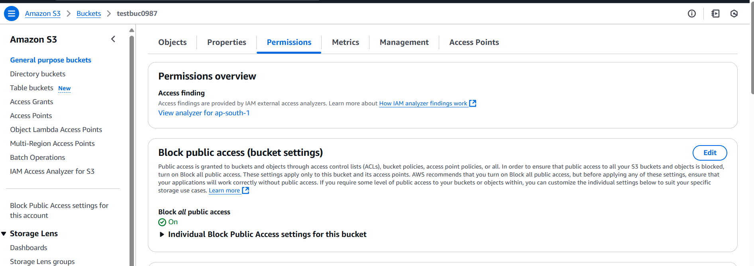

**Event log captured using cloudwatch:**

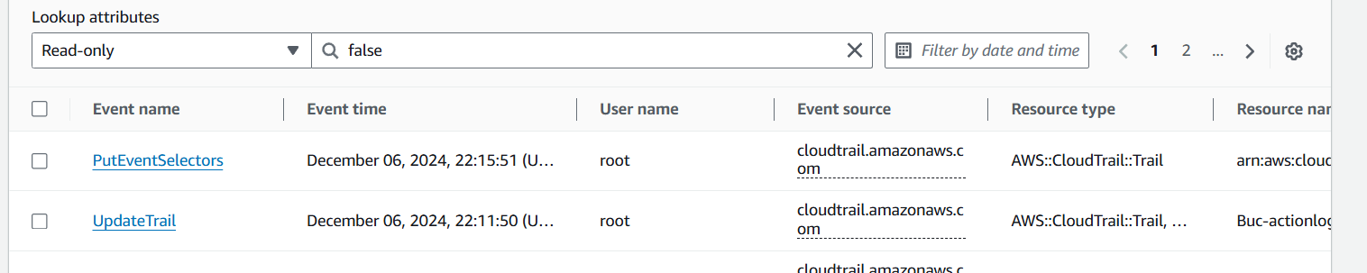

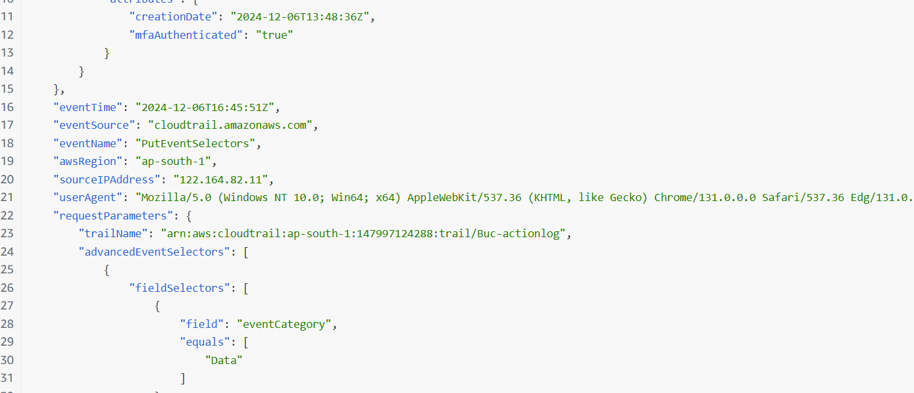

**Launch two ec2-instances and connect it to a application load balancer, where the output traffic from the server must be an load balancer IP address:**



**Load Balancer DSN: Test-ALB-1-944961301.ap-south-1.elb.amazonaws.com**

