**Linux Machine**

Volume of 5GB:

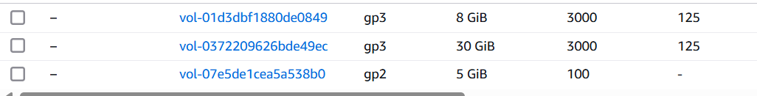

Created volume attached with EC2:

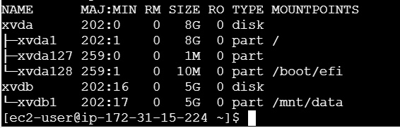

New volume created using snapshot:



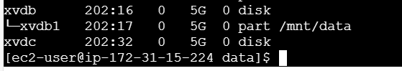

**Window’s Machine**

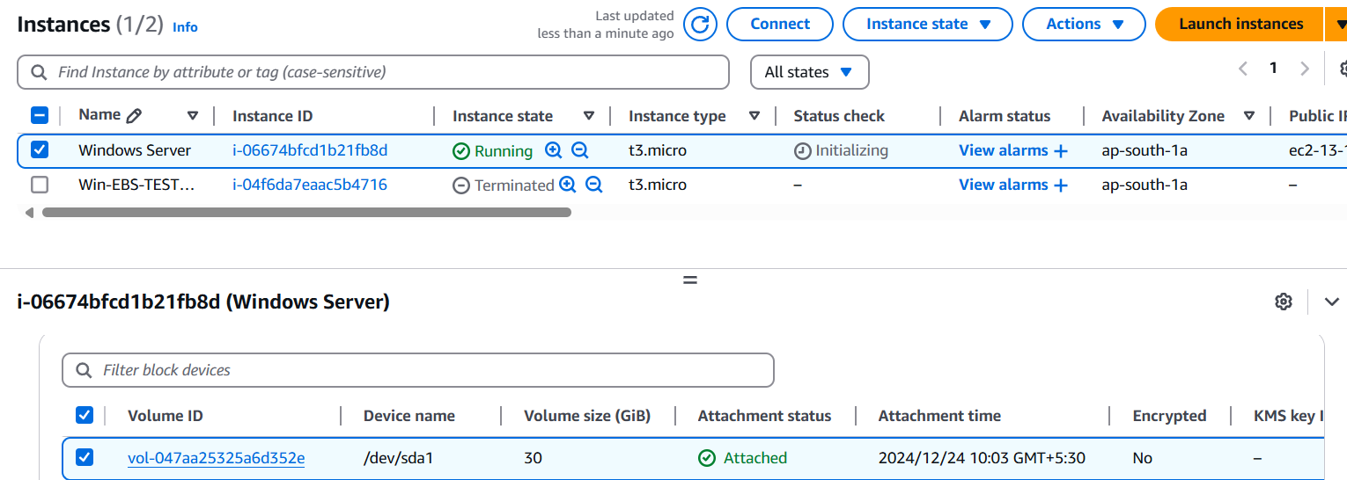

Additional volume mount to Windows:

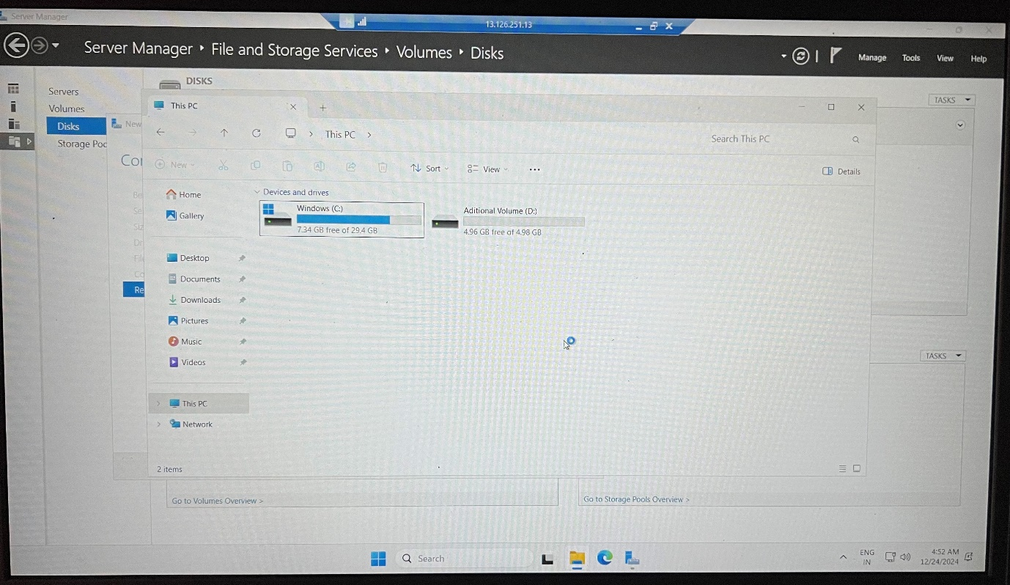

Snapshot:

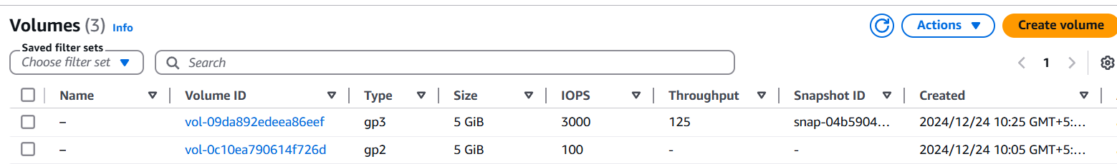

Snapshot Volume to window:

