**VPC**

**VPS Creation:**

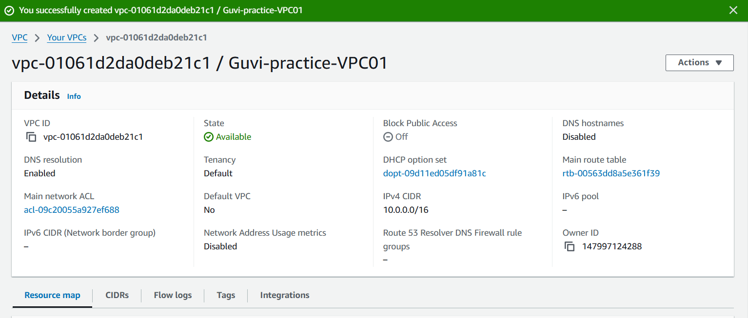

**Subnet with 256 IPs(Public & Private)**

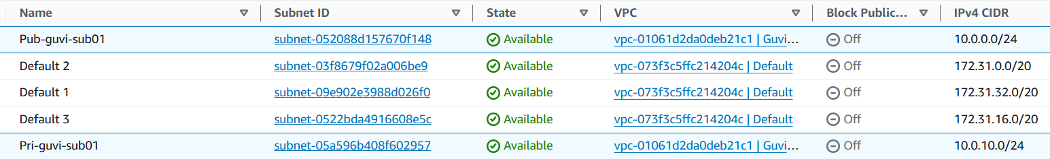

**Route Table associated with Subnets:**



**Create internet gateway & attach with VPS:**

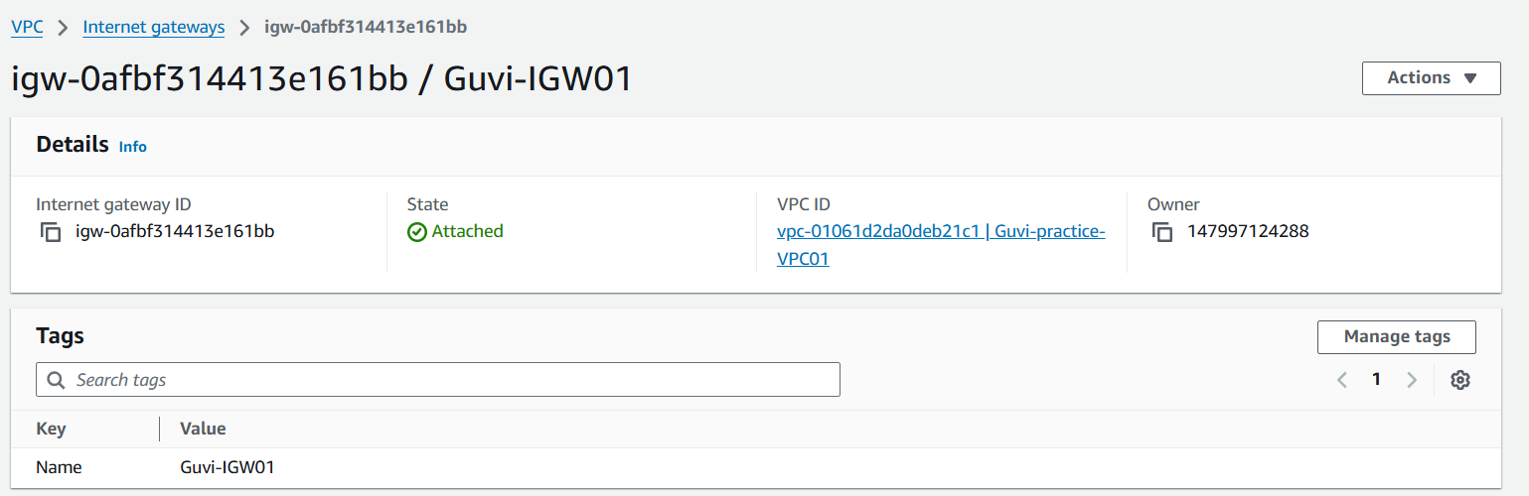

**Public RT connected with IGW:**

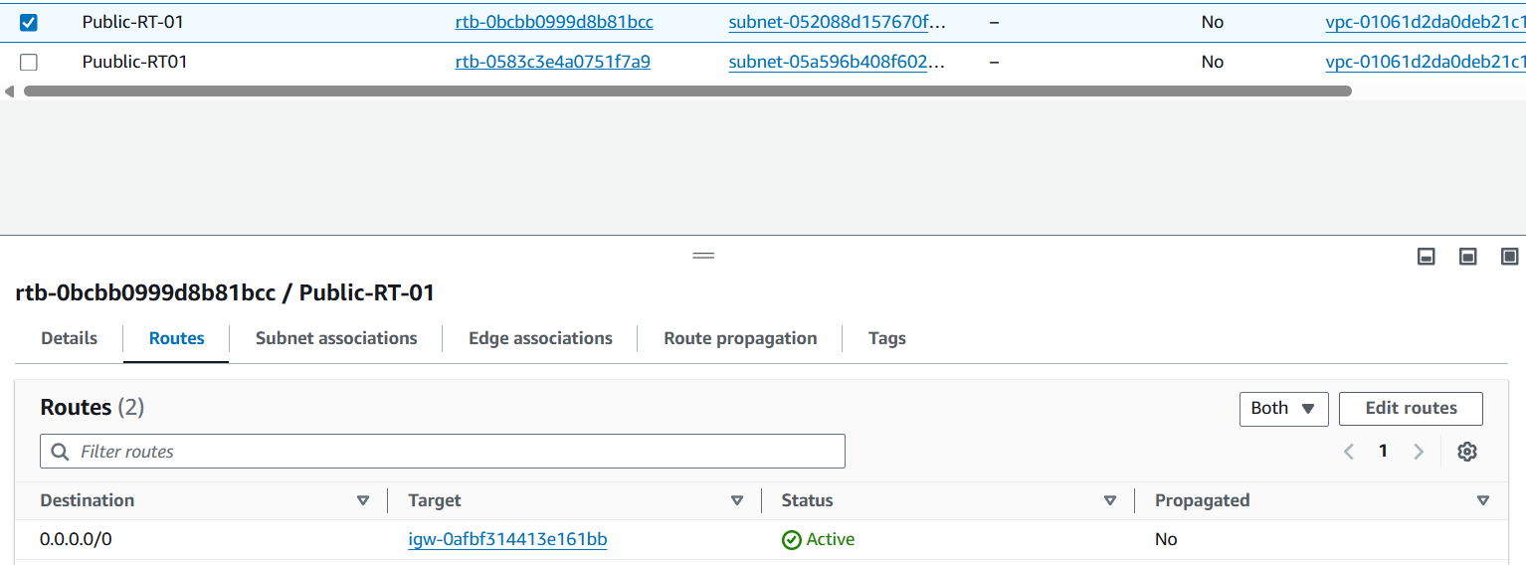

**Connect VPC with public subnet:**

