**Exercise :** 10

**Date :** 21/11/2020

**Aim :**

To create a Python program to accepts a string and calculate the number of upper case letters and lower case letters

**Program :**

def string_test(str):

d={"UPPER_CASE":0, "LOWER_CASE":0}

for i in range(len(str)):

if(str[i].isupper()):

d["UPPER_CASE"]+=1

elif(str[i].islower()):

d["LOWER_CASE"]+=1

print("No. of Upper case characters:",d["UPPER_CASE"])

print("No. of Lower case characters:",d["LOWER_CASE"])

str=input()

p=string_test(str)

**Link :**

<http://103.53.53.18/mod/vpl/forms/submissionview.php?id=325&userid=1663>

**Output :**

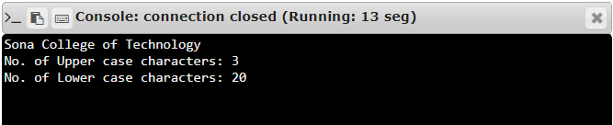

**Result :**

Thus, the program is executed and the required output is displayed.