**Exercise :** 11

**Date :** 23/11/2020

**Aim :**

To create a Python program to find the greatest common divisor of two integers using recursion.

**Program :**

def gcd(a,b):

if(a==0):

return a

elif(b==0):

return b

elif(a==b):

return b

elif(a>b):

return(gcd(a-b,b))

else:

return gcd(a,b-a)

a= int(input("Enter first number: "))

b= int(input("Enter second number: "))

c= gcd(a,b)

print("GCD is",c)

**Link :**

<http://103.53.53.18/mod/vpl/forms/submissionview.php?id=326&userid=1663>

**Output :**

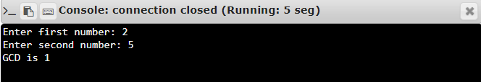

**Result :**

Thus, the program is executed and the required output is displayed.