**Exercise :** 13

**Date :** 23/11/2020

**Aim :**

To create a Python program to demonstrate a trade of shop with applied conditions.

**Program :**

class Apparel:

counter=100

def __init__(self,price,item_type):

Apparel.counter+=1

self._item_id=item_type[0]+str(Apparel.counter)

self._price=price

self._item_type=item_type

def calc_price(self):

self._price+=self._price*0.05

def get_item_id(self):

return self._item_id

def get_price(self):

return self._price

def get_item_type(self):

return self._item_type

def set_price(self,price):

self._price=price

return self._price

class Cotton(Apparel):

def __init__(self,price,discount):

super().__init__(price,'Cotton')

self._discount=discount

def calc_price(self):

super().calc_price()

price=self.get_price()

price-=price*(self._discount/100)

price+=price*0.05

self.set_price(price)

return price

def get_discount(self):

return self._discount

class Silk(Apparel):

def __init__(self,price):

super().__init__(price,'Silk')

self._points=None

def calc_price(self):

super().calc_price()

if(self.get_price()>10000):

self._points=10

else:

self._points=3

return self.set_price(self.get_price()+(self.get_price()*0.1))

def get_points(self):

return self._points

silk=int(input())

cotton=int(input())

discount=int(input())

a=Silk(silk)

print(a.calc_price())

b=Cotton(cotton,discount)

print(b.calc_price())

**Link :**

<http://103.53.53.18/mod/vpl/forms/submissionview.php?id=328&userid=1663>

**Output :**

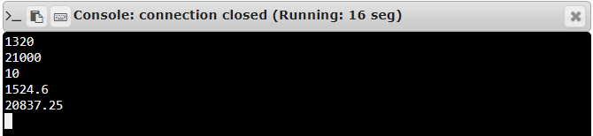

**Result :**

Thus, the program is executed and the required output is displayed.