**Exercise :** 14

**Date :** 23/11/2020

**Aim :**

To create a Python program to find validity of a string of parentheses, ‘(‘,’)’,’{‘,’}’,’[‘ and ‘]’ and these brackets must be close in correct order.

**Program :**

def areBracketsBalanced(expr):

stack=[]

open_expressions=['{','[','(']

for i in range(len(expr)):

if(expr[i] in open_expressions):

stack.append(expr[i])

else:

if not stack:

return False

curr=stack.pop()

if(curr=='{' and expr[i]!='}'):

return False

if(curr=='[' and expr[i]!=']'):

return False

if(curr=='(' and expr[i]!=')'):

return False

if stack:

return False

else:

return True

if __name__=="__main__":

expr=input()

if(areBracketsBalanced(expr)):

print("valid")

else:

print("invalid")

**Link :**

<http://103.53.53.18/mod/vpl/forms/submissionview.php?id=327&userid=1663>

**Output :**

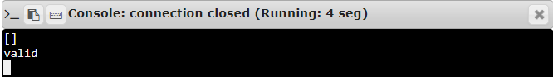

**Result :**

Thus, the program is executed and the required output is displayed.