**Exercise :** 2

**Date :** 10/10/2020

**Aim :**

To create a Python program to print the occurrences of given list. Using countX(lst,x) to count the number in the given list.

**Program :**

def countX(lst,x):

count=0

for i in range(0,len(lst)):

if(x==lst[i]):

count=count+1

return count

lst=[]

n=int(input())

for i in range(0,n):

ip=int(input())

lst.append(ip)

x=int(input())

y=countX(lst,x)

print(y)

**Link :**

<http://103.53.53.18/mod/vpl/forms/submissionview.php?id=230&userid=1663>

**Output :**

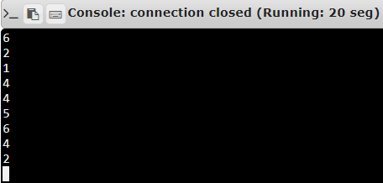

**Result :**

Thus, the program is executed and the required output is displayed.